 | International Civil Aviation Organization  WORKING PAPER
  FSMP-WG/13-WP/16
FREQUENCY SPECTRUM MANAGEMENT PANEL
WORKING GROUP

thirteenth MEETING

Virtual, 21 to 25 February 2022

Agenda Item 4: Radio Altimeter Issues

ICAO Material to Support Safe Co-existence
between 5G and Radio Altimeters

(Presented by Noppadol Pringvanich)

SUMMARY
The radio altimeter is the only mandatory sensor onboard aircraft, capable of providing a direct measurement of the clearance height above terrain and obstacles. It sources information that is the main enabler of several safety-critical aircraft functions and systems.

C-band 5G telecommunications systems operating without proper mitigations in the frequency bands adjacent or nearby to aircraft radio altimeters have the potential to cause harmful interference to radio altimeters on all types of civil aircraft during any phase of flight - most critically during approach and landing phases. Such interference poses a serious safety risk to aircraft, passengers and crew onboard, and people on the ground.

This paper discusses recent lessons learned concerning the deployment of 5G telecommunication networks and outlines the need for ICAO material to assist States in mitigating the potential risks to flight safety by 5G deployments and to support safe co-existence between 5G and radio altimeters.
ACTION by the meeting
The FSMP is invited to
  - discuss the paper and agree on the need to develop an ICAO material mentioned in paragraph 2.2.4; and
  - form an ad-hoc group within the FSMP to further progress with this activity.

- INTRODUCTION
  - The radio altimeter is a mandatory safety-critical aircraft system. It is used to determine an aircraft’s height above terrain and obstacles. Globally, operating at 4.2-4.4 GHz frequency range, these altimeters are deployed on all types of commercial and general aviation aircraft including helicopters. This altimeter system input is utilized by aircraft systems at or below 2500ft altitude Above Ground Level (AGL).
  - The information provided by the altimeter is used in many automated landing and collision avoidance systems. Undetected failure of this sensor can therefore lead to catastrophic results whilst false alerts have the potential to undermine trust in the avionics systems.
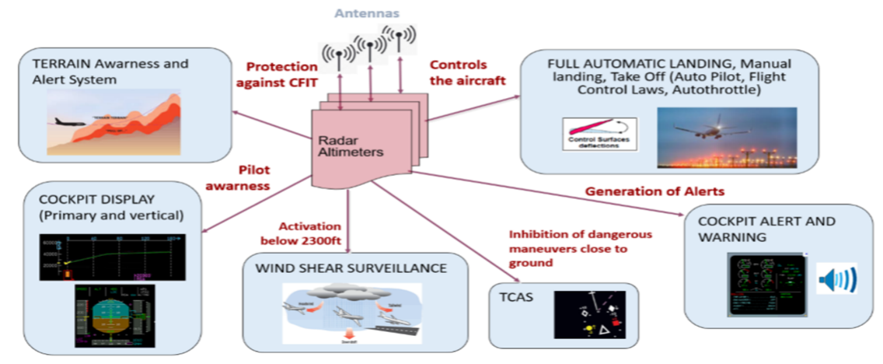

Figure 1: Functions of Aircraft Radio Altimeters

  - Interference to Radio Altimeter (RA) operations can potentially affect various equipment and systems onboard an aircraft, including
  - Autoland functions particularly in low visibility auto approach operation,
  - Class A Terrain Awareness Warning Systems (TAWS-A) including Enhanced Ground Proximity Warning Systems (EGPWS)
  - Traffic Alert and Collision Avoidance Systems (TCAS II)
  - Take-off guidance systems
  - Flight Director and Flight Control, including Automatic Flight Guidance and Control Systems (AFGCS) and Primary Flight Display of height above ground
  - Tail strike prevention systems
  - Windshear detection systems
  - Envelope Protection Systems
  - Altitude safety call outs/alerts
  - Auto-throttle and Thrust reversers
  - Stick pusher / stick shaker
  - Engine and wing anti-ice systems

  - Within each State, decisions regarding spectrum allocation rest fully with each national telecommunication regulator. Adding to the complexity, 5G deployment proposals and associated conditions vary technically from one country to another. The differences, for example, can be in terms of which spectrum will be considered for 5G; where the 5G transmitter can be located; and/or the maximum transmitting power the 5G base station can use.
- discussion
  - Safety Concerns
    - The collective global aviation community has formally recognized and expressed safety concerns arising from the potentially harmful interference to radio altimeters (4.2-4.4 GHz) deployed on all types of civil aircraft that could result from the deployment of 5G telecommunications systems in the C-band. Without appropriate mitigation, this harmful interference poses a risk to aviation operations across all ICAO member States. Below are some of the concerns expressed.
    - ICAO — In ICAO State Letter SP 74/1-21/22 dated 25 March 2021, the ICAO Secretary General notes that “harmful interference to the function of the radio altimeter during any phase of flight may pose a serious safety risk to passengers, crew and people on the ground” and encourages “Administration[s] to consider as a priority, public and aviation safety when deciding how to enable cellular broadband/5G services in radio frequency bands near the bands used by radio altimeters.”
    - IATA and IFALPA — In a problem statement endorsed by the ICAO Flight Operations Panel, IATA and IFALPA jointly stated that the radar altimeter is one of the most critical components to an aircraft’s operations; and the only sensor onboard an aircraft providing a direct measurement of the aircraft’s clearance over the terrain or other obstacles. This information is the most critical information in many automated landing and collision avoidance systems. Undetected failure of this sensor can therefore lead to catastrophic results; and false alarms have the potential to undermine trust in the avionics systems.
    - FAA — The FAA stated in its Safety Alert for Operators 21007 dated December 23, 2021 (SAFO 21007) and entitled Risk of Potential Adverse Effects on Radio Altimeters when Operating in the Presence of 5G C-Band Interference, that:

“a wide range of other automated safety systems rely on radio altimeter data whose proper function may also be affected. Anomalous (missing or erroneous) radio altimeter inputs could cause these other systems to operate in an unexpected way during any phase of flight – most critically during take-off, approach, and landing phases. These anomalous inputs may not be detected by the pilot in time to maintain continued safe flight and landings.”

The FAA SAFO was followed by Special Airworthiness Information Bulletin (SAIB: AIR-21-18R1) detailing the same concerns.
    - Further, the FAA issued Airworthiness Directive (AD 2021-23-12) for commercial operators and AD 2021-23-13 for helicopter operators because the agency determined an unsafe condition exists or could develop in transport and commuter category airplanes with a radio altimeter as part of their type design. The ADs required revising the limitations section of the existing AFM on or before 4 January 2022 to incorporate limitations prohibiting certain operations requiring radio altimeter data when in the presence of 5G C-Band wireless broadband signals as identified by NOTAM. For air transport aircraft, these limitations concerned Instrument Landing System (ILS) Instrument Approach Procedures (IAP) SA CAT I, SA CAT II, CAT II, and CAT III; Required Navigation Performance (RNP) Procedures with Authorization Required (AR), RNP AR IAP; use of Enhanced Flight Vision System (EFVS) to touchdown; Manual Flight Control Guidance System operations to landing/head-up display (HUD) to touchdown operation and Automatic Landing operations. These limitations could prevent dispatch of flights to certain locations with low visibility and could also result in flight diversions. Additionally, FAA issued addition ADs which contain operational and performance limitations to specific aircraft types. These ADs include AD 2022-02-16, AD 2022-03-05, AD 2022-03-20 and Continued Airworthiness Notification CAN-2022-01.
    - In addition to the United States FAA, other States aviation regulators including those of Australia, Canada, France, South Africa, Thailand and the United Arab Emirates have issued similar safety notices and/or ADs recognizing the need to address the safety risk.
  - Risk Mitigation Strategies and Next Steps
    - The ICAO High-Level Conference on COVID-19 (HLCC) recommendation for mitigating the risk of 5G implementation to safety-critical radio altimeter functions notes:

That States:
- consider, as a priority, public and aviation safety when deciding how to enable cellular broadband/5G services;
- consult with aviation safety regulators, subject matter experts and airspace users, to provide all necessary considerations and regulatory measures to ensure that incumbent aviation systems and services are free from harmful interference; and

That ICAO:

c) continue coordinated aviation efforts, particularly at the International Telecommunication Union (ITU), to protect radio frequency spectrum used by aeronautical safety systems.
    - As a minimum, some actions and regulatory measures need to be taken and put in place to safeguard the use of radio altimeters. Some States have set an example by cooperating with 5G network providers with regards to provision of location information for their stations, as well as details of the transmission characteristics (e.g., antenna radiation patterns, power levels) required. The measures adopted include:
- Adequate Buffer Zones: limiting the installation of 5G stations within 2-3 km of the approach ends of runways; declaring ’no-go zones’ in the vicinity of airports; establishing permanent buffer zone safeguards.
- Restricting Transmission Characteristics: limiting 5G transmission power and the angle of antennas, i.e., low power transmission around airports with a downward-looking radiation pattern for 5G transmitting station masts.
- Timely Assessment: conducting timely surveillance and test flights to proactively ascertain the actual levels of 5G transmissions and potential harmful interference effects.
2.2.3 While the airline community understands the economic importance of making spectrum available to support next generation commercial telecommunication systems, we insist that maintaining current safety levels for aircraft, passengers and flight crews must be States’/governments’ highest priority. Before deciding on spectrum allocation for 5G or conducting spectrum auctions for 5G particularly in C-band, States should ensure that every frequency allocation/assignment is comprehensively studied and is well proven not to adversely impact aviation safety and efficiency. Robust testing in coordination with aviation safety regulators and aviation subject matter experts is critically important in providing necessary information. Unmitigated risks of harmful interference to radio altimeters have resulted in increasing safety risks for aviation, flight cancellations and operational interruptions and uncertainties for airlines, negatively affecting flow of cargos and travelling publics.

2.2.4 To ensure consistency among these national measures, there is a clear need for an ICAO material to assist States in developing and putting in place an appropriate set of mitigations to address the potential risks to flight safety caused by 5G C-band deployments. Moreover, the FSMP should serve as the right technical body to develop such ICAO material to support safe co-existence between 5G and radio altimeters.
- ACTION BY THE MEETING
The FSMP is invited to
  - discuss the paper and agree on the need to develop the ICAO material mentioned in paragraph 2.2.4; and
  - form an ad-hoc group within the FSMP to further progress this activity.

