FREQUENCY SPECTRUM MANAGEMENT PANEL (FSMP)

Seventh Working Group meeting

Johannesburg, South Africa, 6 – 13 September 2018

Agenda Item 5.b: Global UAS/ Remote Piloted Aircraft System (RPAS) channel plan

On the methodologies to assign terrestrial C2 link frequency channels within the 5030-5091 MHz frequency band to a realistic UAS traffic

Presented by Florian RIBAUD (ENAC, France)
Prepared by Florian RIBAUD (ENAC, France), Christophe MACABIAU (ENAC, France), Axel GARCIA PENA (ENAC, France), Christian FLEURY (DSNA, France), Catherine RONFLE-NADAUD

SUMMARY
The study presented in this paper analyses the number of Unmanned Aircraft Systems (UAS) over an arbitrary 3000x2000 km territory that could receive C2 link frequency channel assignments using the terrestrial communication system, assumed to be given 10 MHz within the 5030-5091 MHz band. The performance of two types of channel assignment methodologies are compared (Static or Dynamic), depending on the type communication architecture considered (standalone UAS or centralized network), and conclusions and recommendations are drawn. The assumptions considered in this paper concerning the C2 link signal and C2 radio systems are based on the conclusions of Phase 1 of the Command and Control Communications Subproject of NASA’s UAS Integration in the National Airspace System Project.

- INTRODUCTION
  - Context of the study
    - In 2012, ITU WRC-12 has adopted a new terrestrial assignment to AM(R)S in the 5030-5091 MHz band. As well, ITU WRC-12 adopted footnote No. 5.443D, which outlines the interest of the 5030-5091 MHz part of the C-band AMS(R)S allocation: “In the frequency band 5030-5091 MHz, the aeronautical mobile-satellite (R) service is subject to coordination under No. 9.11A. The use of this frequency band by the aeronautical mobile-satellite (R) service is limited to internationally standardized aeronautical systems” [1] [2].
    - These allocations make possible implementation of the C2 link via both terrestrial and satellite systems on the 5030-5091 MHz band, as mentioned in [1]. In that context, the DGAC (French Civil Aviation Organization) signed a convention with the ENAC (French Civil Aviation School) Telecom research lab. The ENAC working group is tasked to investigate technical solutions to implement both terrestrial and satellite C2 link systems in the 5030-5091 MHz band.
    - A compatibility study has already been performed by the RPAS Panel of the EUROCAE working group and been presented in the Working Papers [1] and [2]. For that matter, a division of the 5030-5091 MHz band between terrestrial and satellite systems has been proposed. This sharing proposal is represented in Figure 1. The blue blocks represent the frequency bands reserved for the satellite system (two distinct blocks for the Forward and the Return links as proposed in [1] and [2]). The yellow block represent the frequency band reserved for the terrestrial system (in the middle of the 5030-5091 MHz band as proposed in [1] and [2]). The green blocks represent frequency offsets to prevent interference between terrestrial and satellite systems.

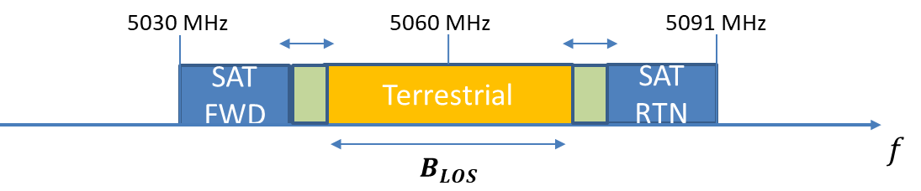
Figure 1: Proposed sharing of the 5 GHz band between terrestrial and satellite systems in FSMP Working Papers [1] and [2]
    - In that context, the ENAC working group proposes a three-step study to simulate the frequency channel assignment process to an UAS (Unmanned Aircraft Systems) traffic, with UAS using terrestrial or satellite systems on the 5030-5091 MHz band. The first step is the development of methodologies to assign C2 link frequency channels to UAS on the terrestrial system. The second step is the development of methodologies to assign C2 link frequency channels to UAS on the satellite system. The third step is the aggregation of terrestrial and satellite frequency channel assignment methodologies. The study presented in this paper concerns the first step of this project.
    - NASA Phase 1 of the C2 (Command and Control) sub-project of the NASA’s UAS integration in the National Airspace (NAS) has been completed (2012-2016). The results of the Phase 1 NASA sub-project supported the completion of C2 Terrestrial Minimum Operational performance Standards (MOPS) DO-362 by the RTCA SC-228 in Sept. 2016 [3]. It provided the development and testing of a prototype C2 link for terrestrial communications, implemented in C-band and L-band [4].
    - Phase 2 of the NASA sub-project is underway. The results of the study of Phase 2 should support the completion of C2 Satellite MOPS by the RTCA SC-228. Therefore, the second phase of the sub-project is supposed to focus on the development and testing of a satellite C2 link prototype [5]. Note that the satellite C2 link implementation will be envisaged in both Ku/Ka band and C-band.
    - The C2 link capacity study that will be presented in this paper will focus on the consolidated tests and results of Phase 1 of the NASA project, considering the terrestrial component of the C2 link communication only [4]. Thus, the assumptions considered all along the study of this paper are in line with the assumptions on the terrestrial C2 link of the RTCA MOPS DO-362 [5].
    - In particular, note that the UAS traffic considered in this preliminary study, described in the following sections, corresponds to significantly large size UAs (Unmanned Aircraft) flying at significantly high altitudes (typically above 1000 ft). This assumption was in line with the assumptions of Phase 1 of NASA sub-project. However, it should evolve at the end of Phase 2, with an extension of the C2 link terrestrial prototype to lower altitude and smaller UAS [5]. At that time, the results presented in this current paper will have to be extended to smaller and lower altitude UAS as well.
    - In addition, the results presented in this current paper will have to be extended to consider the satellite C2 link component.
  - Goal of the study
    - The goal of this paper is to compare two methodologies of assignment of frequency channels for the terrestrial C2 link of UAS (Unmanned Aircraft Systems) within a given territory.
    - The focus of these methodologies of frequency channel assignment is to provide frequency channels to the different UAS requesting an authorization to fly within a portion of airspace of the territory (using the C2 link terrestrial communication system) avoiding interference between the C2 link communications of the different Unmanned Aircrafts (UA) and the Ground Stations (GRS) of the territory. Note that the interference protection criteria considered are in line with the recommendations of MOPS DO-362 [3].
    - The performance of these methodologies will be compared through the criterion of the total number of UAS users who may receive an authorization to fly and also through the criterion of the area within which the UA is allowed to fly.
    - The study will also consider different assumptions on the future infrastructure supporting the C2 link communication service. Moreover, the results of the study will provide an estimation of the maximum number of single UAS users of the terrestrial C2 link communication system when considering a given territory, a given frequency band reserved for the C2 link terrestrial system and some specific UAS characteristics in line with the assumptions of MOPS DO-362 [3].
  - Organization of the paper
    - First, the assumptions considered all along the study about the future terrestrial system infrastructure, the C2 link signal and UAS characteristics will be presented in section 2.1
    - Then, two distinct frequency channel assignment methods will be detailed in section 2.2.
    - These frequency channel assignment methods will be applied to a simulated UAS traffic, and their performance will be compared in section 2.3.
    - Finally, the conclusion in section 2.4 will recommend the methodology that should be used depending on some hypotheses on the future UAS traffic.
    - Note also that important definitions about the terminology considered in this paper are provided in Annex 2. In particular, the definition of the Unmanned Aircraft System (composed of the UA and the GRS) is provided.

- DISCUSSION
  - Assumptions

Different assumptions about the future Terrestrial C2 link system infrastructure will be considered all along the study presented in this paper. Note that most of them are not standardized yet and are likely to be revaluate in the future. Therefore, for some assumptions, different options/values will be considered for the simulations of the study.
    - Assumptions on the UAS frequency sharing:

The first assumption concerns the sharing of the frequency band $B_{LOS}$ reserved for the Terrestrial C2 link system (see Figure 1) among the different UAS users. All the assumptions on the C2 link signal have been inspired from [3], and are detailed in Annex 3:
      - The Uplink (UL) and Downlink (DL) channels of the C2 link signal are duplexed using TDD (Time Division Duplex). An important hypothesis on the future terrestrial C2 link is provided in [3]: the UL and DL time slots of each UAS user is synchronized on the slots of a reference time frame common to each user. Therefore, all the UAs of the territory are in UL or DL mode at the same instants.
      - The terrestrial C2 link signal is divided in 50 ms long data frames, which are divided in one UL and one DL time slots of 23 ms each, separated by 2.3 ms and 2.7 ms guard times. These data frames are defined in Annex 3 and illustrated on Figure 12.
      - The UAS transmitted C2 link signal power spectrum density mask of a single frequency channel has been represented in Figure 13. Three distinct types of UAS are considered in this study, according to the classification proposed in [3] and detailed in Annex 5. The 40-dB bandwidth for the 3 classes of UAS are respectively 85 kHz, 170 kHz and 205 kHz for “Small”, “Medium” and “Large” UAS.
      - As mentioned in 1.2.2, the methodologies of frequency channel assignment rely on the interference protection between the C2 links of the different UAS users. Therefore, the interference protection criteria considered in this study play a major role in the results presented in section 2.4. The interference protection criterion is defined by a minimum signal-to-interference ratio of 13.5 dB (defined in [3]). Depending on the frequency offset between the C2 link channels of two distinct UAS, the minimum distance between the two UAS is computed using Eq. 4. Note that due to the fact that the C2 link UL and DL time slots of all UAS users are synchronized (as mentioned in 2.1.1.1), only the interference between an UA and the GRS of another UAS is considered (no UA-UA and no GRS-GRS interference).
    - Assumptions on the UAS territory sharing:
      - The position of the UAS on the territory used for this study will be characterized by the altitude of flight of the UA and its Cartesian coordinates within the horizontal plan, with respect to a cellular network. These assumptions have been inspired from [3] and [6] and are detailed in Annex 4.
      - The vertical axis has been divided in 3 altitude ranges defined in [6] and represented on Figure 14 (altitude range A: 300-1500 m, altitude range B: 1500-6000 m, altitude range C: 6000-14000 m).
      - The horizontal plane has been meshed in a network of hexagonal cells, with different size for each altitude range, as proposed in [3] and [6] and illustrated on Figure 15.
        - The cells of the network are used for the C2 link frequency channel assignments according to the following rule: a given UA authorized to fly across the whole cell or a part of the cell uses a unique frequency channel anywhere within the cell.
        - The radius of the cells ($R_{C}$) at the different altitude ranges has been computed according to the following rule: an UA flying at the minimum altitude of the altitude range considered (as defined in 2.1.2.2) must be in RLOS of the centre of the cell. Then, the maximum cell radius is computed using Eq. 6 in Annex 4. Eq. 6 provides the following cell radius for the different altitude ranges: altitude range A:${ R}_{C}=65 km$, altitude range B: $R_{C}=157 km$, altitude range C: $R_{C}=315 km$.
        - The centre of the cell is defined as the point of the cell that is in RLOS of any UA flying across the cell above the minimum altitude of the altitude range considered. It is located at the centre of the hexagon.
    - Assumptions on UAS communications:

The UAS communication management concerns the type of connection between the UA and the ground GRS for a given UAS and the criterion used for the frequency channel assignment to a given UAS in a given cell.
      - The type of connection between the UA and the ground depends on the type of GRS used by the UAS to transmit and receive the C2 link signal on the ground (the GRS to which the UA is connected). Two options will be considered: Standalone or Centralized.
        - Standalone connection: the UA is connected to its own individual GRS. In this case, it will be considered that the GRS is located at the same place as the RPS of the UAS (which might be located anywhere within the cell).
        - Centralized connection: the UA do not use an individual GRS but it is connected to a network of centralized GRS: one GRS located at the centre of each cell (one centralized GRS might be used by several centralized GRS users).
        - Two UAS using Standalone and Centralized connections are illustrated on Figure 2. In the Standalone case (left plot), the UA is connected to a single standalone GRS at the centre of the UAS Service Volume (all along the UAS mission). Note that the UAS Service Volume is defined in Annex 2. In the Centralized case (right plot), the UA is connected to the centralized GRS located at the centre of the cell in which the UA is flying at instants $t_{1}, t_{2}, t_{3}$.

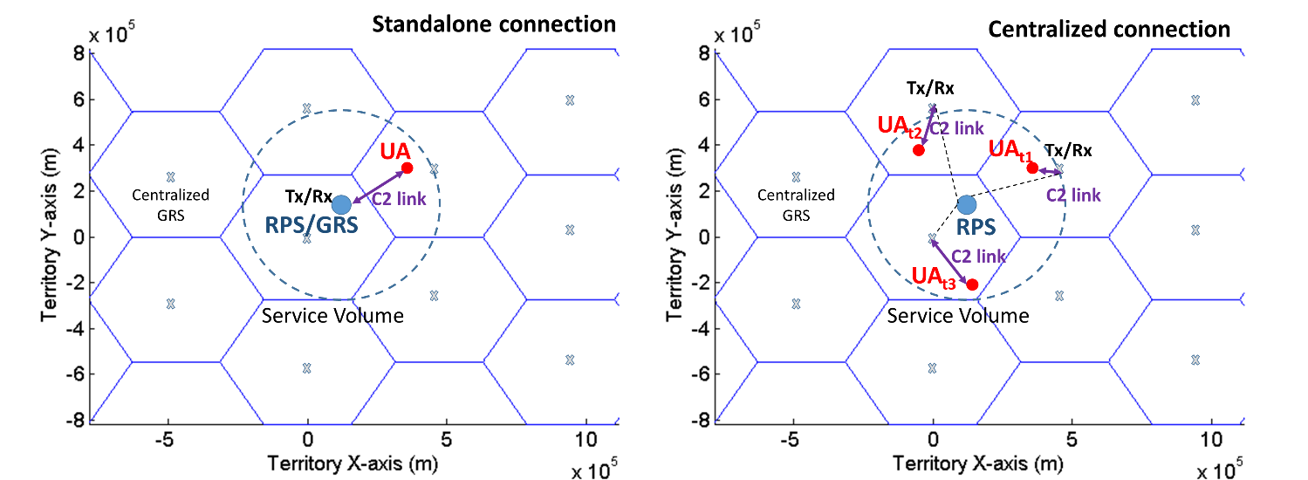
Figure 2: Illustration of Standalone and Centralized connection modes
      - When an UAS asks for an authorization to fly, it asks for a frequency channel assignment in each cell of its Service Volume. The criterion to decide if a given frequency channel may be allocated to a given UAS in a given cell depends on the channel assignment methodology. Two frequency channel assignment methodologies will be considered: Static or Dynamic. They both rely on the respect of the interference protection criteria of section 2.1.1.4 considering the position of the different UAS users within the territory. However, they use either a static or a dynamic approach.
        - Static methodology: the UAS asking for a channel assignment in a given cell may only receive a frequency channel from a pre-defined list of channels. Each cell receives a fix list of channels chosen so as to respect the interference protection criteria of 2.1.1.4.
        - Dynamic methodology: no fix list of channel is pre-defined. The UAS asking for a channel assignment in a given cell may receive any channel respecting the interference protection criteria with respect to the other UAS users.
        - The Static and Dynamic methodologies are represented on Figure 3. Each spot represents the GRS of an UAS, the grey zones represent their Service Volumes and the dotted line represents the maximum Radio Horizon of the UA at the ceilings and edges of the Service Volume. In the case Static (left plot), ${UAS}_{n}$ may only receive a frequency channel from the frequency channel list of Cell 1. In the case Dynamic (right plot), ${UAS}_{n}$ may use any frequency channel of that respects the interference protection criteria with the other UAS.

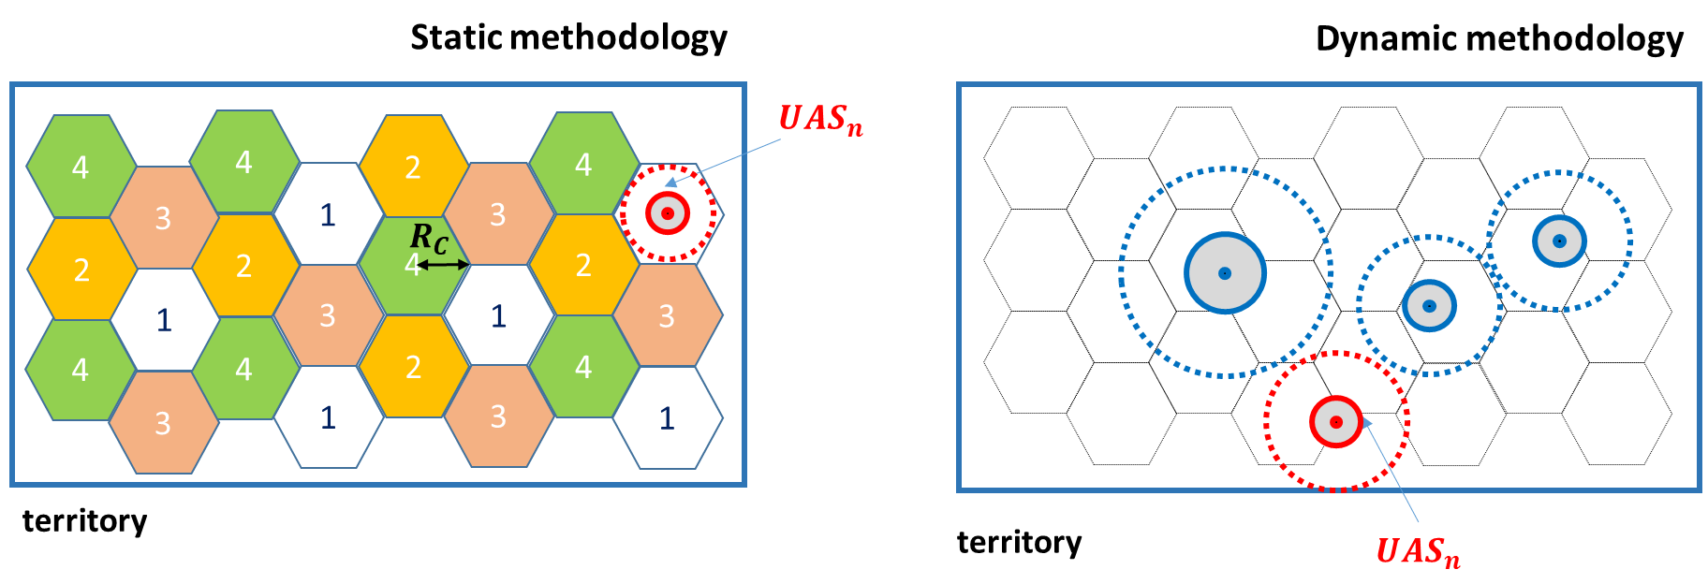
Figure 3: Illustration of the Static and Dynamic channel assignment methodologies
    - Assumptions on UAS traffic:

As represented in Figure 2, the UA may fly across multiple different cells, and then possibly require multiple channel assignments. As one free frequency channel may not be available in each cell, especially if many UAS have already received frequency channel assignments, the UAS authorization to fly must be clearly defined.
      - First, two categories of UAS will be envisaged: flexible and Not flexible:
        - Flexible UAS: UAS who accepts to conduct its operation service although only some portions of its Service Volume is available due to the impossibility of allocating a frequency channel in the cells covering the unavailable part of the Service Volume.
        - Not flexible UAS: UAS who does NOT accept to conduct its operation service if only some portions of its Service Volume is available due to the impossibility of allocating a frequency channel in the cells covering the unavailable part of the Service Volume.
      - Depending on the UAS category (Flexible or Not), the UAS authorization to take-off and the UAS authorization to fly have been defined:
        - For any UAS, the UA is allowed to take-off if and only if the UAS has received a frequency channel assignment in the cell in which the Center of the Service Volume ($C_{SV}$) is located.
        - If an UAS has received an authorization to take-off, it may receive an authorization to fly in the different cells of its Service Volume according to the following criteria:
          - If the UAS is Flexible, the UA is allowed to fly within all the cells in which the UAS has received a frequency channel assignment, and only in these cells.
          - If the UAS is Not Flexible, the UA is allowed to fly if and only if it has received a frequency channel assignment in all the cells which are intersected by its Service Volume. If it is the case, it is allowed to fly everywhere within its Service Volume. If it is not the case, it not allowed to fly anywhere.
  - Channel assignment methodologies

When an UAS asks for an authorization to fly, it asks for a frequency channel assignment in each cell intersected by its Service Volume (as mentioned in 2.1.4). This frequency channel will be used by the UAS when the UA is flying within the cell considered if the UAS receives an authorization to fly. This section is focused on the methodologies used to decide if a given frequency channel may be allocated to a single UAS in a given cell. As mentioned in 2.1.3.2, two distinct criterion of frequency channel assignment have been considered, Static and Dynamic.
    - Static assignment methodology:

Before describing the frequency channel assignment process to a single UAS using the static approach, 2 cell definition pre-steps must be defined. First, the cells of the cellular network are grouped in clusters of cells (pre-step 1). Then, each cell receives a list of frequency channels (pre-step 2). Finally, these frequency channels will be allocated to the different UAS asking for assignments during the static frequency channel assignment process.
      - Pre-step 1: Cellular network’s division of the territory in clusters of cells:
        - The clustering is defined by the frequency reuse factor ($K$), which is the number of cells per cluster. To each type of cell of the cluster is allocated one unique list of frequency channels: the list of any two cells of the cluster are disjoint. Figure 4 represents an example of clustering of the cellular network with $K=4$ cells per cluster.
        - The frequency reuse distance of the network, referred to as $D_{U}$ on Figure 4 is the minimum distance between two cells with the same list of frequency channels. It is given by Eq. 1:
$$D_{U}=R_{C}(\sqrt{3K}-2)$$ | Eq. 1
        - According to the interference protection criteria in section 2.1.1.4, an UA and a GRS of two distinct UAS using the same frequency channel (co-channel interference) must not be in RLOS of each other (otherwise the SIR is automatically below the minimum ratio). Therefore, the UA of a given UAS must be distant from the GRS of any UAS using the same frequency of more than the UA Radio Horizon. Therefore, the size of the cluster must be chosen so that:
$$D_{U}>R_{H}(h_{max})$$ | Eq. 2
        - Using the definition of the Radio Horizon provided by Eq. 3, the minimum reuse factor ($K$) has been computed for each altitude range by combining Eq. 1 and Eq. 2. The reuse-factors obtained for the 3 altitude ranges using the process of pre-step 1 are$K=7$ for altitude range A, $K=7$ for altitude range B and $K=4$ for altitude range C.

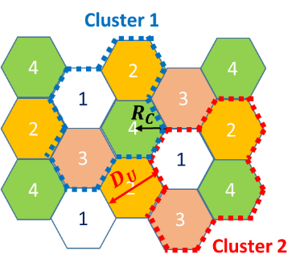
Figure 4: Illustration of the clustering of the cellular network
      - Pre-step 2: Assignment of a list of frequency channels to each cell:
        - First, the total bandwidth allocated to the terrestrial system $B_{LOS}$ must be shared between the 3 altitude ranges A, B and C. The frequency band $B_{LOS}$ is divided as represented on Figure 5. The figure must be interpreted as follows: all the frequency channels allocated to UAS at altitude range A belong to $B_{A}$. The relative bandwidth values for the different ranges of altitude $B_{A}$, $B_{B}$ and $B_{C}$ correspond to the relative density of UAS in the different altitude ranges, which are recorded in Table 6.

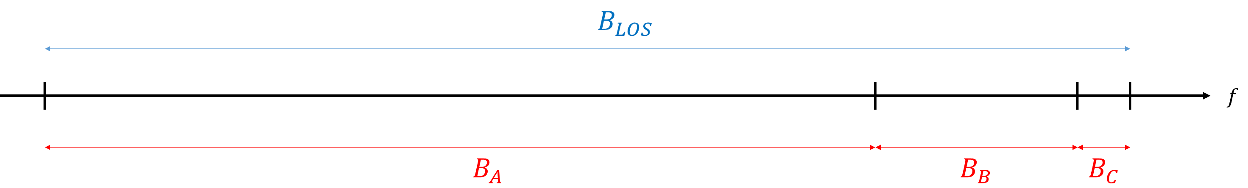
Figure 5: Assignment of frequency bandwidths to the 3 altitude ranges
        - Second, the bandwidth allocated to each altitude range must be divided between the 3 types of defined UAS. Figure 6 illustrates the division of $B_{A}$ in 3 sub-bands allocated to the frequency channels dedicated to “small”, “medium” and “large” UAS. The figure must be interpreted as follows: all the frequency channels allocated to small UAS flying in altitude range A belong to $B_{A,small}$. The relative bandwidth values for the different types of UAS (for altitude range A) $B_{A,small}$, $B_{A,medium}$ and $B_{A,large}$ correspond to the relative density of the different UAS types in the different altitude ranges, which are recorded in Table 6.

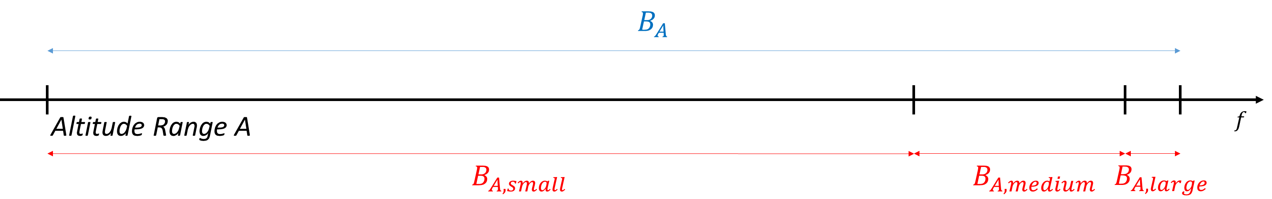
Figure 6: Assignment of frequency bandwidths to the 3 types of UAS
        - Finally, the frequency bands allocated to the different UAS types and altitude ranges must be divided into a set of frequency channels allocable to single UAS. These individual frequency channels will be grouped to form the lists of frequency channels associated to each cell. Figure 7 represents the division of the frequency band reserved for small UAS of altitude range A in frequency channels of single UAS. The index 1,2, … ,7 above the frequency channels represent one type of cell: The list of frequency channels of index $i$ are allocated to the cells of type $i$. It can be observed that two adjacent frequency channels are never allocated to the same cell. This choice has been made in order to prevent adjacent channel interference inside the same cell.

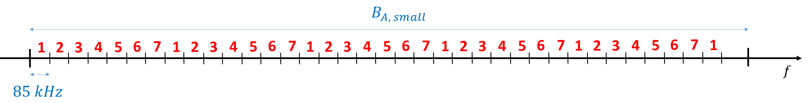
Figure 7: Assignment of frequency channels to the cells
      - Static assignment process: Assignment of the frequency channels to single UAS:

Let us consider that ${UAS}_{n}$ is requesting a frequency channel assignment in ${CELL}_{k}$. The criterion for the frequency channel assignment to ${UAS}_{n}$ depends on the type of connection of the UAS Standalone or Centralized (defined in 2.1.3.1).
        - If ${UAS}_{n}$ uses a Centralized connection, it may receive an assignment in ${CELL}_{k}$if and only if (1) and (2) are satisfied:
- (1): A frequency channel $c_{n}$ whose bandwidth value corresponds to the bandwidth required for the type of ${UAS}_{n}$ (small, medium or large, see Table 3) is still available in the frequency channel list of ${CELL}_{k}$.
- (2): The frequency channel $c_{n}$ causes no interference to the UAS using an adjacent channel in a neighbouring cell (using the interference protection criteria of 2.1.1.4).

In that case, the frequency channel $c_{n}$ is allocated to ${UAS}_{n}$ in ${CELL}_{k}$ and it is withdrawn from the channel list of ${CELL}_{k}$ (not available for the following UAS). Otherwise, the frequency channel assignment is denied.
        - If ${UAS}_{n}$ uses a Standalone connection, it may receive an assignment in ${CELL}_{k}$ if and only if (1), (2) and (3) are satisfied:
- (1): A frequency channel $c_{n}$ whose bandwidth value corresponds to the bandwidth required for the type of ${UAS}_{n}$ (small, medium or large, see Table 3) is still available in the frequency channel list of ${CELL}_{k}$.
- (2): The frequency channel $c_{n}$ causes no interference to the UAS using an adjacent channel in a neighbouring cell (using the interference protection criteria of 2.1.1.4).
- (3): The GRS of ${UAS}_{n}$ is located in ${CELL}_{k}$ (the GRS and the UA of ${UAS}_{n}$ use the same frequency channel and therefore, they cannot be located in two different cells of the same cluster).

In that case, the frequency channel $c_{n}$ is allocated to ${UAS}_{n}$ in ${CELL}_{k}$ and it is withdrawn from the channel list of ${CELL}_{k}$ (not available for the following UAS). Otherwise, the frequency channel assignment is denied.
    - Dynamic assignment methodology:

Contrary to the static assignment methodology, the dynamic assignment methodology considers no static frequency channel assignment to the cells. Therefore, there is no pre-step cell definition in dynamic methodology.
      - Dynamic assignment process: Assignment of the frequency channels to single UAS:

Let us consider that ${UAS}_{n}$ is requesting a frequency channel assignment to fly within ${CELL}_{k}$ (considering that $n-1$ other UAS already received some frequency channel assignments in multiple cells). The criterion for the frequency channel assignment to ${UAS}_{n}$ depends on the type of connection of the UAS Standalone or Centralized (defined in 2.1.3.1).
        - If ${UAS}_{n}$ uses a Centralized connection, it may receive the frequency channel assignment $c_{n}$ in ${CELL}_{k}$if and only if (1) and (2) are satisfied:
- (1):${UA}_{n}$ causes no interference with the different GRS of the $n-1$ other UAS while ${UA}_{n}$ is flying within ${CELL}_{k}$ using frequency channel $c_{n}$ (considering the co-channel and adjacent-channel interference protection criteria of 2.1.1.4).
- (2): ${GRS}_{k}$ (located at the center of ${CELL}_{k}$ ) causes no interference with the UA of the $n-1$ other UAS while ${UA}_{n}$ is flying within ${CELL}_{k}$ using frequency channel $c_{n}$.
        - If ${UAS}_{n}$ uses a Standalone connection, it may receive the frequency channel assignment $c_{n}$ in ${CELL}_{k}$if and only if (1) and (2) are satisfied:
- (1):${UA}_{n}$ causes no interference with the different GRS of the $n-1$ other UAS while ${UA}_{n}$ is flying within ${CELL}_{k}$ using frequency channel $c_{n}$ (considering the co-channel and adjacent-channel interference protection criteria of 2.1.1.4).
- (2): ${GRS}_{n}$ (which might be located outside ${CELL}_{k}$) causes no interference with the UA of the $n-1$ other UAS while ${UA}_{n}$ is flying within ${CELL}_{k}$ using frequency channel $c_{n}$.
    - Advantages and drawbacks:

To finish, the advantages and drawbacks of these two assignment approaches should be mentioned:
      - First, the Static methodology requires fewer implementation effort than the Dynamic methodology. Indeed, for the Static methodology, the frequency channel that must be allocated to a given UAS by the Frequency Provider is chosen among a pre-defined list of frequencies, depending on the cell in which the UA is located. On the contrary, for the Dynamic methodology, the Frequency Provider must take into account the position of each UAS of the territory and the frequency channel that they are using in the different cells, and then, estimate the optimal frequency channel to allocate to the UAS making the assignment request.
      - Moreover, it can be expected that the Frequency Provider will have an easier control of the total UAS traffic over the territory with pre-defined static frequency assignments in fix geographical zones (cells), than with flexible sets of frequency channels dynamically spread on the whole territory, especially if the case of dense UAS traffic.
      - However, the dynamic method has the advantage of being flexible. In the case of an increased UAS density in some particular zones of the territory, the dynamic method is able to provide more frequency channels in a given geographical area, whereas the Static method only has a limited list of frequency channels for a given geographical area.
  - Results
    - Simulation parameters:

This section introduces the simulations of frequency channel assignment to a realistic UAS traffic that have been performed in this study. Note that the results of the study (number of UAS receiving an authorization to fly) depend on the parameters of the simulation, like the size of the territory, the total frequency bandwidth, the C2 link service class of the different UAS or the transmitted spectrum mask. The parameters chosen to illustrate this paper should be as representative of future UAS systems as possible.
      - The territory chosen in this study is a 3000 km large, 2000 km wide and 14000 m high cube. The territory is divided into three altitude ranges, with the vertical limits represented in Figure 14. The territory area is meshed using hexagonal cells (one cellular network per altitude range), with the dimensions represented in Figure 16.
      - The part of the 5030-5091 MHz frequency band allocated to the Terrestrial system is considered 10 MHz wide for the example of this study, as represented on Figure 8.

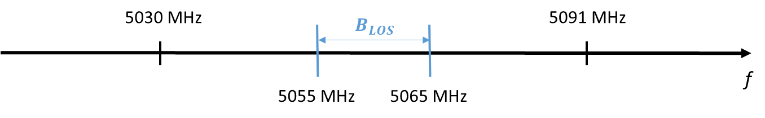
Figure 8: Frequency band of the Terrestrial system
      - The UAS traffic is built as follows:
        - A pre-defined set of random-type UAS is built. The $C_{SV}$ (Centre of Service Volume) of those UAS are randomly spread on the territory following a uniform law. Those UAS request for an authorization to fly, one after the other, in a pre-defined order.
        - Each UAS of the traffic corresponds to one specific type of UAS, according to the classification proposed in [3] (small, medium and large). The proportion of UAS corresponding to the different UAS types at the different altitude ranges provided by Table 6 has been respected. The radius of the Service Volume of a given UAS is given by the SV radius of the type of UAS considered, as provided by Table 3. Also, the power of the UA and GRS transmitters, and the gain of the UA or GRS antennas are given by the type of UAS considered, as provided by Table 7 and Table 8.
        - Each UAS of the traffic is supposed to be in one specific phase of flight (which does not change along the simulation). The phases of flight assigned to the different UAS respect the following rule: 76% UAS are in en-route phase, 24% are in take-off, landing or approach phase.
        - The altitude range in which a given UA requests a frequency assignment is given by the UAS type and the phase of flight of the UA, according to the following rule:
- The UAS of type “Small” always request assignment in the altitude range A (they always fly below 1500 m).
- The UAS of type “Medium” request assignment in the altitude range B if they are in en-route phase (76%). They request assignment in altitude range A if they are not in en-route phase (24%).
- The UAS of type “Large” request assignment in the altitude range C if they are in en-route phase (76%). They request assignment in altitude range A if they are not in en-route phase (24%).
      - The parameters of the C2 link (bandwidth, modulation, polarization) are provided in Table 7. Note that the bandwidths associated to each type of UAS are derived from the throughput requirement of the C2 link service classes in Table 4 and in Table 5.
      - Let us suppose that ${UAS}_{n}$ asks for an authorization to fly ($n-1$ UAS have already asked for an authorization). First, ${UAS}_{n}$ must ask for a frequency channel assignment in each cell in which it is supposed to fly. Depending on the frequency assignments received, the authorization to take off and the authorization to fly rules presented in 2.1.4 are applied to provide or deny the authorization of flight.
    - Simulation results:

This section is dedicated to the presentation of the results of the simulation introduced in the section 2.3.1. Two major criteria will be assessed in this section:
- Criterion 1: The number of UAS who have received an authorization to fly.
- Criterion 2: The number of cells within which an UAS is allowed to fly, compared to the number of cells in which the UAS has requested a frequency assignment.
      - Criterion 1:
        - The frequency channel assignment to the UAS traffic depicted in section 2.3.1 has been processed using the Static and the Dynamic methodologies separately. Moreover, the two types of UAS connection (Centralized or Standalone) have been tested for the UAS traffic. Therefore, 4 different simulation configurations have been considered for the frequency channel assignment: Dynamic assignment to Centralized UAS, Dynamic assignment to Standalone UAS, Static assignment to Centralized UAS and Static assignment to Standalone UAS. Note also that all the UAS of the traffic are considered Flexible according to the definition provided in section 2.1.4.1.
        - Figure 9 represents the number of UAS who received an authorization to fly (Y-axis) depending on the number of UAS who have already asked an authorization (X-axis), for the 4 configurations mentioned in section 2.3.2.1.1. In that case, only Flexible UAS were considered, according to the definition provided in section 2.1.4.1: the UAS may receive an authorization to fly although only some portions of its Service Volume is available.

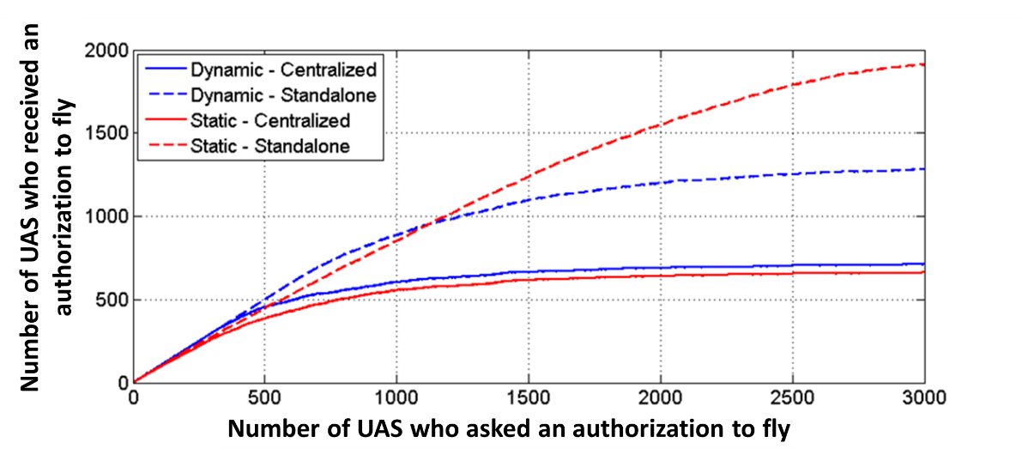
Figure 9: Number of Flexible UAS who received an authorization to fly vs number of UAS that requested authorization

        - By comparing the results of the 4 configurations of the simulation according to criterion 1, 4 major observations may be made:
          - Considering the Static assignment methodology: More UAS obtain an authorization to fly with a Standalone connection (1913 authorizations) than with a Centralized connection (661 authorizations). This is due to the fact that Centralized UAS may request frequency channel assignments in each cell of their SV, contrary to Standalone UAS who requests one only frequency channel (see 2.2.1.3). Therefore, a Centralized UAS traffic is more demanding in terms of frequency channels.
          - Considering Dynamic assignment methodology: More UAS obtain an authorization to fly with a Standalone connection (1282 authorizations) than with a Centralized connection (712 authorizations). This is due to the fact that Standalone UAS use only one GRS, whereas Centralized UAS requires one different GRS in each cell. Therefore, the interference area is larger in the case Centralized than in the case Standalone.
          - Considering UAS Standalone connection: More UAS obtain an authorization to fly with a Static (1913 authorizations) than with a Dynamic assignment methodology (1282 authorizations) because the Static methodology only allocates one frequency channel per Standalone UAS, contrary to the Dynamic methodology who may allocate one different frequency in each cell of Standalone UAS (see 2.2.1.3 and 2.2.2.1). Therefore, the Dynamic methodology is more demanding in terms of frequency channel assignments.
          - Considering UAS Centralized connection: The performance of the Static methodology is close to the performance of the Dynamic methodology (660 and 710 authorizations). This is due to the fact that the use of fixed GRS at the centre of the cells impairs the flexibility of the Dynamic method.
        - Figure 10 represents the number of UAS who received an authorization to fly (Y-axis) depending on the number of UAS who have already asked an authorization (X-axis), for the 4 configurations mentioned in section 2.3.2.1.1. In that case, only Not Flexible UAS were considered, according to the definition provided in section 2.1.4.1: the UAS may receive an authorization to fly only if the entire Service Volume is available.

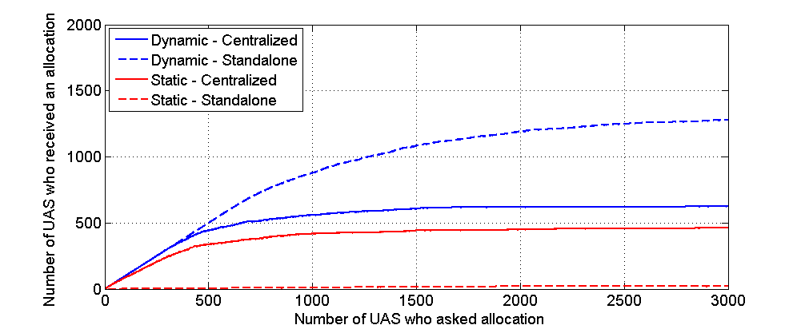
Figure 10: Number of Not Flexible UAS who received an authorization to fly vs number of UAS who requested authorization
        - By comparing the number of UAS authorizations to fly in the case of Flexible UAS and in the case of Not Flexible UAS (Figure 9 and Figure 10), 2 major observations can be made:
          - The simulations considering either Flexible or Not Flexible UAS (respectively Figure 9 or Figure 10) provide the same results concerning the comparison of the Static and Dynamic assignments in the case Standalone connection and the comparison of the Standalone and Centralized connections in the case of a Static assignment.
          - The fact to use Not Flexible UAS instead of Flexible UAS has different impacts on the results presented in the previous sections, depending on the configuration of the simulation:
- Dynamic assignment – Centralized connection: the number of UAS receiving an authorization to fly is slightly lower with Non Flexible UAS (625 for Not Flexible versus 712 for Flexible).
- Static assignment – Centralized connection: the number of UAS receiving an authorization to fly is slightly lower with Non Flexible UAS (462 for Not Flexible versus 661 for Flexible).
- Dynamic assignment – Standalone connection: the number of UAS receiving an authorization to fly does not depend on the flexibility of the UAS (1279 for Not Flexible versus 1282 for Flexible).
- Static assignment – Standalone connection: the number of UAS receiving an authorization to fly strongly depends on the UAS flexibility (21 for Not Flexible versus 19132 for Flexible). This is due to the fact that the Standalone UAS are only allowed to fly within the cell in which the GRS is located in the case of Static frequency channel assignment (see 2.2.1.3.2). Therefore, Standalone UAS may receive a Static channel assignment only if they are Flexible, unless the SV is small compared to the size of the cell (see 2.3.2.1.3.1).
        - The number of UAS receiving an authorization to fly, in the 4 configurations of the simulation, considering Flexible UAS on one side and Not Flexible UAS on the other side, are summarized in Table 1.
Table 1: Number of UAS receiving an authorization to fly in the different configurations
 |  | Standalone | Centralized
Static | Flexible | 1913 | 661
Static | Not Flexible | 21 | 462
Dynamic | Flexible | 1282 | 712
Dynamic | Not Flexible | 1279 | 625

      - Criterion 2:
        - Figure 11 represents the ratio between the area in which a given UA is allowed to fly (cells in which it received an assignment) and the total area requested by the UAS (area of the SV). The Y-axis represents the ratio and the X-axis represents the UAS who received an authorization to fly. The 4 plots corresponding to the 4 simulation configurations are represented.
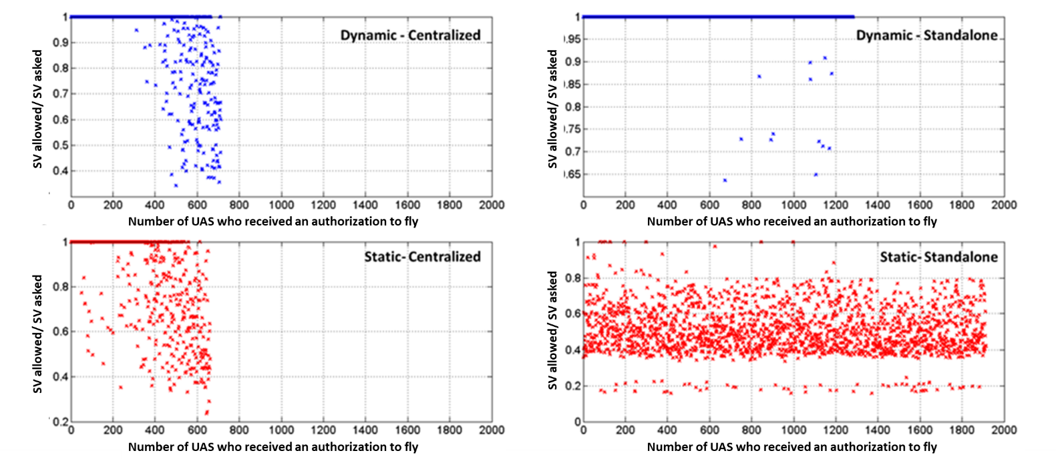
Figure 11: Ratio between the area allowed and the area of the UAS Service Volume

        - Table 2 summarizes the mean and standard deviations of the ratio between the area in which the UA is allowed to fly and the total area requested by the UAS (area of the SV), in the 4 configurations of the simulation, considering Flexible UAS on one side and Not Flexible UAS on the other side. For the statistics of Table 2, the total number of UAS who received an authorization to fly are divided in 4 groups: The column 0-25% represents the 25% first UAS who received an authorization to fly, the column 25%-50% represents the following 25% and so on. Note that the ratio between the area in which the UA is allowed to fly and the total area requested by the UAS for Not Flexible UAS is always 100% per definition.

Table 2: Mean and Standard Deviations of the Ratio between area allowed and total area requested in the different configurations
 |  | Standalone |  |  |  | Centralized
 |  | 0-25% | 25-50% | 50-75% | 75-100% | 0-25% | 25-50% | 50-75% | 75-100%
Static | Flexible | $m$=52.4%  $σ$=13.7% | $m$=51.4%  $σ$=12.5% | $m$=51.1%  $σ$=12.8% | $m$=49.1%  $σ$=12.3% | $m$=97.7%  $σ$=9.29% | $m$=95.5%  $σ$=11.7% | $m$=82.2%  $σ$=19.7% | $m$=65.5%  $σ$=19.8%
Static | Not Flexible | $m$=100%  $σ$=0.00% |  |  |  | $m$=100%  $σ$=0.00%
Dynamic | Flexible | $m$=100%  $σ$=0.00% | $m$=100%  $σ$=0.00% | $m$=99.6%  $σ$=3.37% | $m$=99.4%  $σ$=3.59% | $m$=100%  $σ$=0% | $m$=99.9%  $σ$=0.98% | $m$=94.4%  $σ$=13.7% | $m$=76.5%  $σ$=20.5%
Dynamic | Not Flexible | $m$=100%  $σ$=0.00% |  |  |  | $m$=100%  $σ$=0.00%
        - The following conclusions can be drawn from the observations of Table 2:
          - Almost all Standalone UAS using a Dynamic assignment methodology are allowed to fly within the entire SV. Therefore, this configuration has the best performance with respect to the criterion 2.
          - A significant number of Centralized UAS are not allowed to fly in the entire SV, with both Static and Dynamic assignment methodologies. Therefore, these two configurations have intermediate performance with respect to the criterion 2.
          - Almost no Standalone UA using the Static assignment methodology is allowed to fly within the entire SV. Therefore, the use of the Static assignment methodology has significantly poor performance with respect to criterion 2.
  - Conclusion
    - Conclusion 1:
      - For UAS using Standalone connection, more UAS were authorized to fly with a Static assignment (1913 UAS/3000) than with Dynamic assignment (1282 UAS/3000), according to Figure 9 (criterion 1). However, it could be observed that almost no UA could fly within the whole Service Volume if the SV spans over more than one cell (criterion 2). Therefore, it could be concluded that the Static assignment is not appropriate for Not Flexible Standalone UAS, except if their SV is small compared to the size of the cells. To the contrary, almost all UAS could use their whole SV with the Dynamic assignment. Therefore, it can be concluded that the use of a Dynamic assignment method could be recommended for Standalone UAS, especially if they are Not Flexible.
      - For UAS using Centralized connection, it could be observed that Static and Dynamic approaches had similar performance concerning both criterion 1 and criterion 2 (number of UAS allowed to fly and number of frequency channels allocated). However, it was mentioned in section 2.2.3 that the Static assignment requires fewer implementation effort than the Dynamic assignment, and might be more adapted to future Frequency Provider implementations. Therefore, for Centralized connection UAS, a Static assignment methodology could be recommended.
      - The results of the studies presented in [8] conclude that the future development of the C2 link service, most of the UAS traffic will be constituted by Centralized UAS. To do so, a future centralized GRS network would be developed. Therefore, according to the conclusion of 2.4.1.3, the Static assignment methodology could be envisaged to provide frequency channels to the UAS connected to the centralized GRS network. However, it can be expected that some UAS could not have access to the centralized network (terrain obstruction, incompatible infrastructure,). According to the conclusion of 2.4.1.1, it could be recommended to dedicate one part of the total terrestrial bandwidth $B_{LOS}$ to allocate frequency channels to these Standalone UAS using the Dynamic methodology.
    - Conclusion 2:
      - As observed in section 2.3.2.1.2 and section 2.3.2.1, the most favourable configuration is the use of Standalone UAS and Dynamic assignment methodologies. In that case, 1282 UAS over 3000 tested UAS could receive an authorization to fly on the territory of 3000x2000 km, on 10 MHz wide terrestrial frequency band and considering the UAS C2 link data classes mentioned in Annex 5.
      - However, as mentioned in [8], future UAS traffics are in favour of the implementation of a centralized GRS network. In that case, the use of a Static assignment method could be recommended (see conclusion 1), but only 660 UAs would be allowed to fly.
      - The number of UAS receiving an authorization presented in this conclusion can be used to extend these conclusions to their territories or terrestrial system bandwidths. Indeed, it can be considered that these figures are proportional to the territory area and the terrestrial system bandwidth.
    - Future works:
      - According to conclusion 1, a future use of the Static assignment methodology might be envisaged. However, this methodology presents some limitations in terms of density of UAS traffic that it can support, which is slightly lower than dynamic methodology, even with Centralized UAS. Therefore, some enhancements to the Static methodology could be considered in order to improve the performance of this approach.
      - In conclusion 1, it was envisaged to use both Static and Dynamic assignment methodologies for Centralized and Standalone UAS respectively, on distinct frequency sub-bands. Therefore, the hybridization of these two assignment approaches should be considered, in a new simulation. One specific sub-band of the $B_{LOS}$ band would be allocated to the Stadalone UAS, on which the channel assignment would be dynamic, and one specific sub-band would be allocated to the Centralized UAS, on which the channel assignment would be static.
      - Only 2 performance criteria of the frequency assignment methodologies were presented. Some other criteria should be considered for a more thorough comparison, like the impact of the increase of the density of the UAS traffic in a given geographical area on the two methodologies for example.
      - In order to extend the conclusions of this paper, more realistic simulation parameters should be considered: larger geographical zone with realistic relief and non-uniform UAS distributions (congestion near cities or airports). As well, a more realistic transmitted C2 link spectrum density mask should be envisaged, with additional filters at bend edges to increase the 65 dB off-channel rejection.
      - Finally, a similar study of channel assignment methodologies should be performed on the smaller size and lower altitude UAS, and on the satellite system, using the future conclusions of phase 2 of the NASA study for example.
- ACTION BY THE MEETING
  - The meeting is invited to:
- note and review the contents of this working paper;
- endorse the proposed spectrum assignment methodologies of section 2.2 and the assumptions of section 2.1 or propose other assumptions and methodologies.

— END —
ANNEX 1 – REFERENCE DOCUMENTS

ID | Date | Document | Authors | Reference of the document
[1] | Sept. 2016 | On the Sharing of the AMS(R)S assignment in the 5030-5091 MHz frequency band between a satellite and a terrestrial system to provide UAS C2 | C. Fleury  N. Van Wambecke  J. Mettrop  A. Munro | FSMP-WG/03-WP/10
[2] | March 2017 | Considerations for establishment of channel plans for the AMS(R)S and AM(R)S assignments in the 5030-5091 MHz frequency band for use by satellite and terrestrial systems supporting UAS C2 Links | C. Fleury  N. Van Wambecke  M. Neale  D. Nellis | FSMP-WG/04-WP/09
[3] | Sept. 2016 | Command and Control (C2) Data Link Minimum Performance Standards (MOPS) (Terrestrial): RTCA MOPS DO-362, Updated version | RTCA Inc. | RTCA SC-228 DO-362
[4] | March 2017 | UAS C2 Radio System – Final Phase 1 Development and Testing | K. Shalkhauser  R. Kerczewski | FSMP-WG/04-IP/06
[5] | March 2017 | Overview of NASA’s UAS C2 Communications Project Phase 2 | R. Kerczewski | FSMP-WG/04-IP/03
[6] | Nov. 2011 | Compatibility study to support the line-of-sight control and non-payload communications link(s) for unmanned aircraft systems proposed in the frequency band 5 030-5 091 MHz | ITU | ITU-R M.2237
[7] | Nov. 2009 | Characteristics of unmanned aircraft systems and spectrum requirements to support their safe operation in non-segregated airspace | ITU | ITU-R M.2171
[8] | Mar. 2016 | A Summary of Two Recent UAS Command and Control C2 Communications Feasibility Study | D. S. Ponchak  E. Auld  G. Church  S. Henriksen | IEEE

ANNEX 2 – TERMINOLOGY

- Drone communication definition
- C2 link: Control and Command communication between the drone (UA) and the Remote Pilot (RPS). It has been further defined in [3]. It includes all the functions mentioned in the document ITU-R M.2171 [7].
- UA (Unmanned Aircraft): it is the drone aircraft, which is connected to the Ground Radio Station (GRS) and communicating with the Remote Pilot Station (RPS).
- RPS (Remote Pilot Station): station where the Remote Pilot commanding the UA is located.
- GRS (Ground Radio Station): radio station on the ground connected to the UA, which transmits and receives the C2 link signal supporting the RPS-UA communication.
- UAS (Unmanned Aircraft System): set formed by one or several Unmanned Aircrafts (UA) and their Remote Pilot Stations (RPS), connected to one single Ground Radio Station (GRS).
- UL (Uplink): Communication link from GRS to UA in the Terrestrial system.
DL (Downlink): Communication link from UA to GRS in the Terrestrial system.
- SAT (Satellite): satellite system relaying the C2 link communication between a GRS and an UA (if the Satellite system is used).
- FWD (Forward Link): Communication link from GRS to SAT and then to UA on the Satellite system.
- RTN (Return Link): Communication link from UA to SAT and then to GRS on the Satellite system.

- Technical definitions
- $R_{H}$ (Radio Horizon): the Radio Horizon of an antenna is the locus of the most remote points on Earth to which the antenna can transmit electromagnetic signal in direct path, depending on the UA altitude$h$. It is due to the curving of the Earth and atmospheric propagation.
$$R_{H}(km)=4.21\sqrt{h(m)}$$ | Eq. 3
- RLOS (Radio-Line-Of-Sight): a UA and a GRS are in RLOS of each other if the distance between the GRS and the UA is closer than the${ R}_{H}$.
- BRLOS (Beyond Radio Line Of Sight): when the UA and the GRS are not in RLOS of each other.
- SV (Service Volume): delimitation of the volume in which an UA is assumed to fly (defined by radius$R_{SV}$, maximum altitude $H_{SV}$ and position of the center $C_{SV}$ at ground level).
- E.I.R.P (Equivalent Isotropic Radiated Power): Transmitter’s power plus the transmitter’s antenna gain in the direction of maximum radiated power.
- SNIR (Signal-to-Interference Ratio): Power of the desired signal in dB minus the Power of the undesired signal interferer in dB radiated in the direction of the victim receiver minus the FDR (Frequency Dependant Rejection).
- FDR (frequency Dependant Rejection): Attenuation of the interference power due to the frequency offset between the Desired and Undesired (interferer) signal.

- Channel assignment definition
- Frequency channel: Frequency band dedicated to the C2 link communication between a UA and its RPS.
- Channel assignment: Action to allocate a frequency channel to a single UAS in a determined area, to be used for the C2 link communication between UA and RPS.
- Cellular Network: Network of hexagonal cells meshing the horizontal plane, at each altitude range.
- Cell: area in which a given UA uses a unique C2 link frequency channel to communicate.
- Fly authorization: The authorization of flight is the action to allow an UA to fly within a given zone using a specific allocated channel.

ANNEX 3 – ASSUMPTIONS ON UAS FREQUENCY SHARING

The different assumptions concerning the division of the $B_{LOS}$ band into different frequency channels reserved for the terrestrial system considered in this study is related to:
- Division of the C2 link signal between the Uplink and Downlink communications.
- Definition of the frequency channel allocated to a single UAS.
- Interference protection criteria between the C2 link signals of two different UAS.

- Uplink-Downlink Duplexing Architecture
The proposed architecture is the one defined in [3], using TDD (Time Division Multiple Access). For a given UAS, the C2 link is composed of a single carrier of 50 ms frames, divided in one Uplink time slot (23 ms) and one Downlink time slot (23 ms) and guard time slots of 1.3 ms and 2.7 ms, as represented on Figure 12.
An important hypothesis on the future terrestrial C2 link is provided in [3]: the UL and DL time slots of each UAS user is synchronized on the slots of a reference time frame common to each user. Therefore, all the UAs of the territory are in UL or DL mode at the same instants.
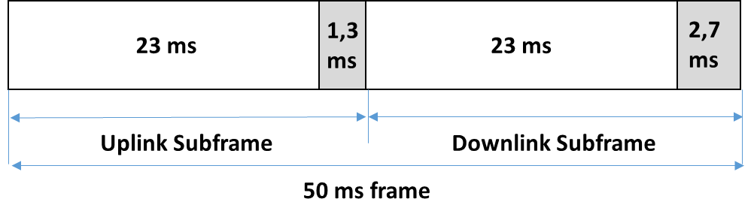
Figure 12: UAS Uplink/Downlink duplexing

- Frequency channel definition
The $B_{LOS}$ band will be divided in frequency channels that will be allocated to the different UAS of the territory. The same UAS classification as [3] has been considered in this study (“Small”, “Medium” and “Large” UAS). The characteristics of each type of UAS are reminded in Table 3 of Annex 5.
The transmitted power spectrum density mask of the C2 link signal of the different types of UAS is derived from the throughput requirements of a single UAS (estimated in [3] for the different types of UAS), the signal modulation (GMSK in [3]), a Doppler correction due to the motion of the UA and an increment due to the frequency inaccuracy (estimated 0.2 ppm in [3]). Note that the same spectral density mask is used for the receiver masks. Figure 13 represents the mask corresponding of the C2 link signal of the different types of UAS. The corresponding bandwidths are recorded in Table 3.
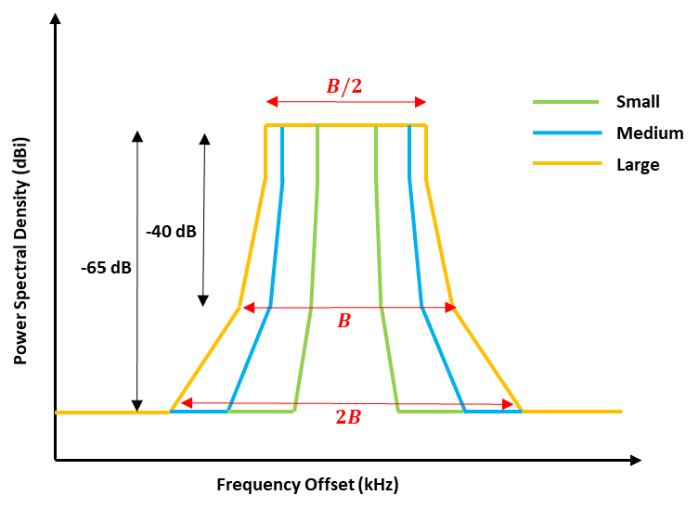
Figure 13: Mask of power spectrum density of C2 link signal transmitted by UAS to GRS for the 3 different types of UAS considered

- Interference protection criteria
The same minimum tolerable SIR (Signal to Interference Ratio) as in [3] has been considered in this study. It is given by ${\left[\frac{S}{I}\right]}_{min}=13.5 dB$.
Where the SIR is given by Eq. 4:
$${\left[\frac{S}{I}\right]}_{min}=\left(P_{T_{x}}^{D}-P_{T_{x}}^{U}\right)+\left(G_{T_{x}}^{D}-G_{T_{x}}^{U}\right)+20\log_{10}\left(\frac{d_{U}}{d_{D}}\right)+10\log_{10}\left(\frac{B_{S}^{U}}{B_{S}^{D}}\right)+\left(G_{R_{x}}^{D}-G_{R_{x}}^{U}\right)-\sqrt{{M_{T}}_{min}^{2}+{M_{T}}_{max}^{2}}-FDR(∆f)$$ | Eq. 4
Where:
- $P_{T_{x}}^{D}$ and $P_{T_{x}}^{U}$ are the Desired and Undesired transmitters output power in dBm (see Table 7).
- $G_{T_{x}}^{D}$ and $G_{T_{x}}^{U}$ are the Desired and Undesired transmitters maximum gain in dBi (see Table 7).
- $d_{D}$ is the distance between the Desired UA and its GRS or between the desired GRS and its UA.
- $d_{U}$ is the distance between the Undesired UA and the victim GRS or between the Undesired GRS and the victim UA.
- $B_{S}^{D} and B_{S}^{U}$ are the Desired and Undesired signal bandwidth (see Table 3).
- $G_{R_{x}}^{D}$ and $G_{R_{x}}^{U}$ are the gains of the victim receiver antenna in the direction of the Desired and Undesired transmitters (see Table 8).
- $M_{T}(S)$ and $M_{T}(U)$ denote the variations of the Desired and Undesired signal powers due to multipath and propagation effects (2-ray propagation model), which are supposed to follow a normal law of mean 0: $M_{T}\sim N(0,σ)$. For a given signal, $\left({{M_{T}}_{min}<M}_{T}<{M_{T}}_{max}\right)=99.8 \%$. Therefore, $P\left(M_{T}\left(S\right)-M_{T}\left(U\right)>-\sqrt{{M_{T}}_{min}²+{M_{T}}_{max}²}\right)=99.8 \%$. ${M_{T}}_{min}$ and ${M_{T}}_{max}$ are given in Table 7.
- $FDR$ is the Frequency Rejection due to the frequency offset $∆f$ between Undesired and Desired signals. Three different FDR have been considered, depending on $∆f$. If $B_{D}$ and $B_{U}$ are the 40 dB-bandwidths of the Desired and Undesired signals as defined in Figure 13:
  - Co-channel interference: The Desired and the Undesired signal share a part of their frequency channel, that is to say $∆f<\frac{B_{D}}{2}+\frac{B_{U}}{2}$. In that case, it is considered in [2] that $FDR=E_{peak}-0 dB$.
  - Adjacent channel interference: The Desired and the Undesired signal share have adjacent frequency channels: $\frac{B_{D}}{2}+\frac{B_{U}}{2}<∆f<min⁡(\frac{B_{D}}{2}+B_{U},\frac{B_{U}}{2}+B_{D})$. In that case, it is considered in [2] that $FDR=E_{peak}-40 dB$.
  - Non Adjacent channel interference: The Desired and the Undesired signal share have non adjacent frequency channels: $∆f>min⁡(\frac{B_{D}}{2}+B_{U},\frac{B_{U}}{2}+B_{D}),$. In that case, it is considered in [2] that $FDR=E_{peak}-65 dB$ (considering +7 dB peak power for the undesired signal).
- $E_{peak}$ is the modulation dependent interferer peak power spectral density. For a GMSK modulation, it has been estimated in [3] that the peak power spectral density is 7 dB above the average power spectral density of the victim receiver, that is to say $E_{peak}=7 dB$.

ANNEX 4 - ASSUMPTIONS ON UAS TERRITORY SHARING

The position of the different UAS within the territory considered will be characterized by:
- A division of the territory in altitude ranges.
- A meshing of the territory in a cellular network, with one different network for each altitude range.

- Definition of the altitude ranges
It can be expected that UAs flying at high altitudes will require more C2 link frequency resources and larger Service Volumes than UAs flying at lower altitudes. Therefore, the territory has been divided in 3 altitude ranges, defined in [3] and represented on Figure 14. The cells of the cellular network corresponding to the top altitude ranges will be larger than the cells of lower altitude ranges, so as to limit the number of cells in which the UAS flying at higher altitudes, which have larger SV, request an assignment. Note that, while flying from one altitude range to another (climb or descent), the UA will have to change C2 link frequency channel. Therefore, in order to avoid hard handover, some transition intervals should be considered between two altitude ranges.
The proportion of UAS of each type at the different altitude ranges has been estimated in [6], and recorded in Table 6. Note that a fourth altitude range D is proposed in [6], from 14000 m to 24000 m. It was not regarded in this study because it was considered that no UA will fly at that altitude in the near future.

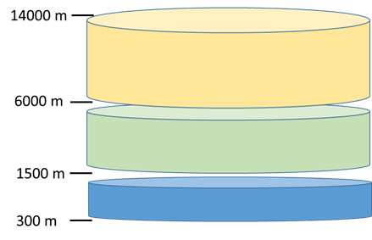
Figure 14: UA altitude ranges

- Definition of the cellular network
        - As proposed in [3] and [6], the territory has been meshed in a network of hexagonal cells, as represented on Figure 15. The cells of the network are used for the C2 link frequency channel assignments according to the following rule: a given UA authorized to fly across the whole cell or a part of the cell uses a unique frequency channel anywhere within the cell.
One different cellular network will be defined for each altitude range. The cellular network is defined by the size of the cells ($R_{C}$). According to [6], the optimal radius of the cells is computed considering that:
- $R_{C}$ should be as large as possible so as to avoid multiple handovers during the UAS operations.
- In a given cell, any UA flying at minimum altitude should be able to communicate in RLOS with a GRS located at the center of the cell. Therefore, the center of the cell must be closer than the radio horizon ($R_{H})$ of an UA flying at the edge of the cell at minimum altitude.
Finally:
$$R_{C}=R_{H}(h_{min})$$ | Eq. 5

Using the definition of the Radio Horizon in Eq. 3:
$$R_{H}(km)=4,12\sqrt{h_{min}(m)}$$ | Eq. 6

Note that $h_{min}$ depends on the altitude range considered. The radius obtained for each range is displayed on Figure 16.

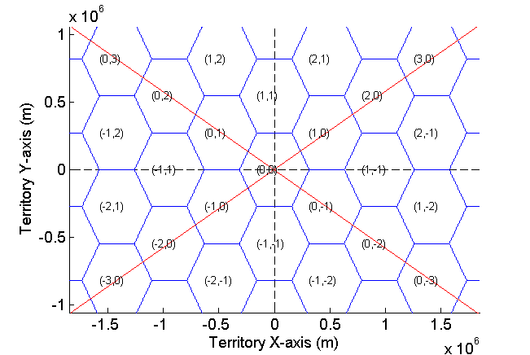
Figure 15: Example of cellular network
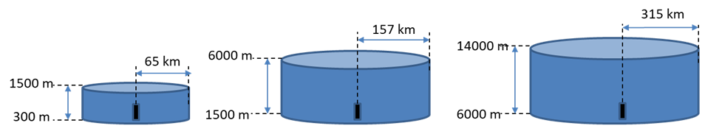
Figure 16: Size of the cells considered at the different altitude ranges

ANNEX 5 -CHARACTERISTICS OF UAS SYSTEMS

A classification of the UAS in 3 UAS types is proposed in [3]. The parameters of Service Volume, maximum altitude of flight and speed are provided in Table 3. The C2 link data class associated to each type of UAS corresponds to the different functions of the C2 link required by the specific UAS. The Uplink and Downlink functions of the C2 link comprised by the different data classes are inspired of [3] and displayed in Table 4 and Table 5. The bandwidth requirements for each C2 link Service Class has been estimated in [3] and is provided in Table 3. The functions considered are detailed in [3] and [6].
Table 3: Categories of UAS proposed in [3]
UAS category | Service Volume Radius (km) | Service Volume Ceiling | Maximum Speed | C2 link Service Class | 40-dB bandwidth
Small | 65 | 1500 m | 110 km/h | 1 for UL  1 for DL | 85 kHz
Medium | 130 | 6000 m | 220 km/h | 3 for UL  3 for DL | 170 kHz
Large | 185 | 14000 m | 1200 km/h | 3 for UL  4 for DL | 205 kHz

Table 4: Downlink Service Classes
Data Type | Service Class 1 | Service Class 2 | Service Class 3 | Service Class 4
Telemetry | X | X | X | X
Voice |  | X | X | X
Navaid & Data display |  |  | X | X
Detect and Avoid Targets |  |  | X | X
Weather Radar |  |  |  | X

Table 5: Uplink Service Classes
Data Type | Service Class 1 | Service Class 2 | Service Class 3
Telecommand | X | X | X
Voice |  | X | X
Navaid Setting |  |  | X

The density of the UAS in different types of UA at the different altitude ranges has been inspired from the maximum altitude of flight of Table 3, which was provided by [3]. The following assumption has been derived: all “small” UAS are in the altitude range A, “medium” UAS are in altitude B in en-route phase and in altitude range A in other phases of flight, “large” UAS are in altitude range C in en-route phase and in altitude range A in other phases of flight. Moreover, 24% of the UAS are not in en-route phase, according to [6]. Therefore, it was considered that 24% of large and medium UAS fly in altitude range A. Considering a global proportion of 77% “small”, 18.5% “medium” and 4.5% large UAS on the whole territory [3], the resulting proportion of UAS in the different altitude ranges is displayed in Table 6:

Table 6: Density of UAs of different UAS types in altitude ranges
 | Small | Medium | Large | TOTAL
Range A | 77 % | 4.5 % | 1 % | 82.5 %
Range B | 0 % | 14 % | 0 % | 14 %
Range C | 0 % | 0 % | 3.5 % | 3.5 %
 |  |  |  | 100 %

The characteristics of the UAS systems and of the C2 link signal considered in this study are in line with the assumptions of [3]. They are provided in Table 7 and Table 8.
Table 7: Transmitter characteristics of UA and GRS
 | Unit | UA |  |  | GRS
 | Unit | Small | Medium | Large | Small | Medium | Large
$$P_{T_{x}}$$ | dBm | 37.2 | 39.2 | 40 | 37.2 | 39.2 | 40
$$G_{T_{x}} max$$ | dBi | 0 |  |  | 23
$$G_{T_{x}} slb$$ | dBi | -12 |  |  | 5.4
$$R_{s}$$ | Kbit/s | 34.5 | 103.5 | 138 | 34.5 | 103.5 | 138
$$B$$ | kHz | 85 | 170 | 205 | 85 | 170 | 205
$${M_{T}}_{max}$$ | dB | 6.7 |  |  | 6.7
$${M_{T}}_{min}$$ | dB | -23.3 |  |  | -23.3
Polarization | - | Vertical |  |  | Vertical

Table 8: Receiver characteristics of UA and GRS
 | Unit | UA |  |  | GRS
 | Unit | Small | Medium | Large | Small | Medium | Large
$$G_{R_{x}} max$$ | dBi | 0 |  |  | 23
$$G_{R_{x}} slb$$ | dBi | -12 |  |  | 5.4
$$d_{max}$$ | km | 65 | 126 | 180 | 65 | 126 | 180
Polarization | - | Vertical |  |  | Vertical

