FREQUENCY SPECTRUM MANAGEMENT PANEL (FSMP)

Seventh Working Group meeting

Johannesburg, South Africa, 6 – 13 September 2018

Agenda Item 03: Radio Altimeter and Wireless Aircraft Intra-Communications (WAIC) issues

RADIO ALTIMETER INTERFERENCE SUSCEPTIBILITY TESTING STATUS UPDATE

Prepared by Aerospace Vehicle Systems Institute
(Presented by Dave Redman)

SUMMARY
This paper reports the intermediate results of Radio Altimeter (RA) interference susceptibility testing and status of continued testing. Testing of RA susceptibility to a single representative in-band WAIC signal interference source has been completed for all altimeters and altitudes considered in this campaign. Results indicate sufficient margin for safe operation of RAs in the presence of WAIC signals. Additionally, the paper provides an overview and preliminary results from continued testing to characterize altimeters in an aggregate interference environment.

- INTRODUCTION
  - The Aerospace Vehicle Systems Institute has been conducting a test campaign to characterize the susceptibility of RAs to representative in-band WAIC signals. Experimental details and preliminary results from the testing were previously reported (FSMP-WG06-WP22). The objective of this campaign is to determine suitable RF transmission characteristics for WAIC signals to ensure safe coexistence of WAIC with RAs in the 4 200 – 4 400 MHz frequency band, as mandated by Resolution 424 of the World Radiocommunication Conference 2015 (WRC-15). The results of this testing provide input to the on-going development of regulatory documentation including Standards and Recommended Practices (SARPs), Minimum Operational Performance Standards (MOPS) and Minimum Aersopace System Performance Standards (MASPS).
  - Initial testing considered the effect of an interference signal comprised exclusively of a single candidate WAIC signal on the operation of each RA chosen for testing, which included the five major altimeter types currently used in civil Air Transport aviation. This testing has been completed for a full set of combinations of interference scenarios, RAs under test, and simulated operating altitudes. Analysis of the resulting data has indicated sufficient tolerance of RAs to WAIC signal interference.
  - Additional testing is underway to extend these measurements to include an aggregate interference signal comprised of both a single candidate WAIC signal and a combination of uncorrelated FMCW signals simulating transmissions from RAs in proximity to the RA under test. These tests and the subsequent analysis of the resulting data are expected to be completed by early October 2018 and early results are similarly promising.
- DISCUSSION
  - Single WAIC Transmission Interference Signal Results

Description of Test Procedure

As described above, the details of the single WAIC interference signal were previously described. A brief overview is provided herein. Figure 1 provides a schematic of the test setup described below.

Initial testing simulated an interference environment by generating representative WAIC signals using a vector signal generator and directly injecting these into the receive channel of the RA under test while it operated through an altitude simulator. The altitude simulator delays and attenuates the RA transmit signal according to DO-155 loop loss standards for a discrete set of altitudes (40, 500, 1500, 3000, and 5000 feet). The representative WAIC signals encompassed several candidate waveform types, bandwidths, and center frequencies in order to assess any unique performance characteristics that may exist in the RA signal processing algorithms.

The five major altimeter types currently used in civil Air Transport aviation were each subjected to the breadth of interference conditions while the reported altitude was monitored on the altmeters’ ARINC 429 output. For each waveform tested, the incident interference power level was varied from -92 dBm to -22 dBm in 2 dB steps, with a return to an interference off condition (baseline performance) between steps. The raw data were post processed in Excel and Access for statistical analysis.

Summary of Test Results

The results of the single WAIC interference signal testing are summarized in Figure 2. Each plotted point in this figure represents the lowest WAIC signal interference power at which the reported altitude exceeds a 0.5% error from the nominal altitude, or at which the RA reported a No Computed Data condition, as determined from the altitude vs. WAIC interference power sweep plots. The nominal altitude was determined by averaging the reported altitude for the given altitude simulator settings with the vector signal generator RF output turned off. It should be noted that the results summarized in FSMP-WG06-WP22 were derived from an analysis of the altitude vs. interference power plots that included some qualitative accommodation of drift in the nominal altitude due to intrinsic RA behavior, whereas the data in Figure 2 do not. Additionally, though altitudes up to 8000 feet were simulated, RAs are only required to report up to an altitude of 4000 feet.

The first five plots summarize the results of the 5 individual RAs that were tested. Generally, the plots show that the RAs behave as anticipated, with the onset of altitude errors occurring at lower interference power for higher altitudes where the RA return signal is highly attenuated.

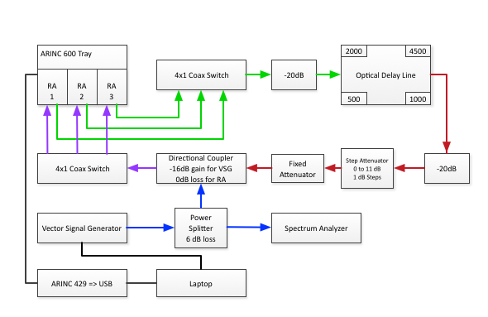

Figure 1: Reference Radio Altimeter Interference Testbed

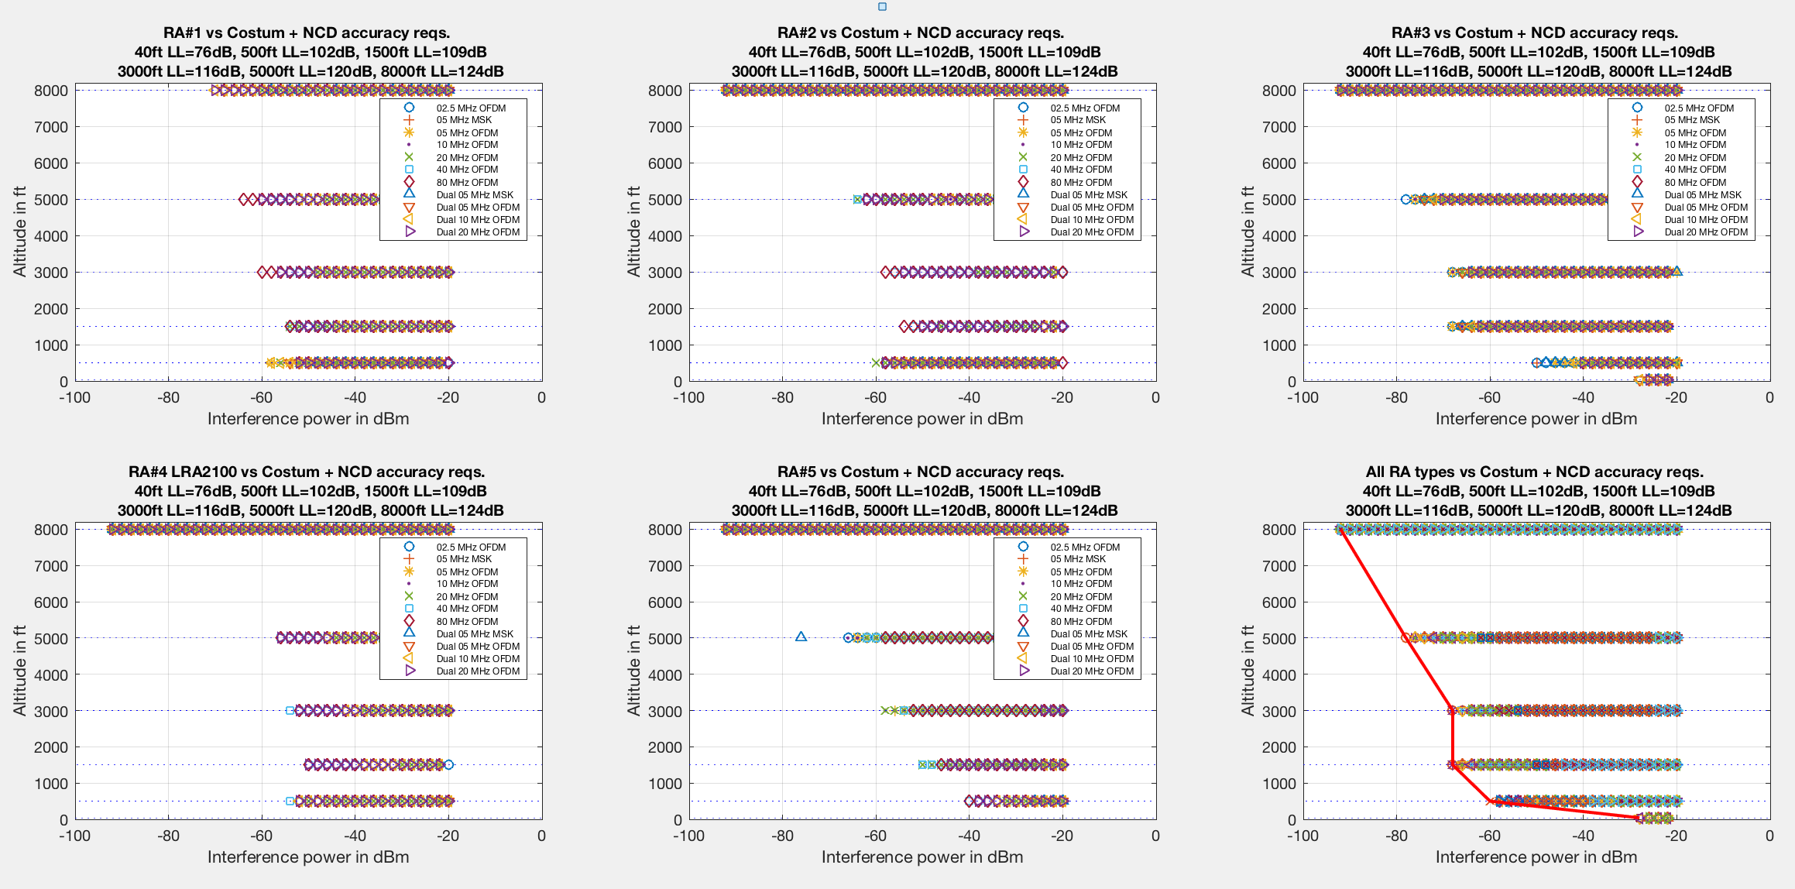
Figure 2: Summarized Results for WAIC-only Interference Testing

The aggregate plot in the lower right of Figure 2 was generated by taking the worst case (lowest WAIC interference power) for all radio altimeters for a given set of test conditions. The red line provides a guide to the eye to identify the derived safe operating conditions for WAIC – RA coexistence. The region to the left of the line represents conditions for which there are no effects on RA performance due to WAIC interference.

Again, since RAs operate at altitudes up to 4000 feet, the data from simulated altitudes of 3000, 1500, 500, and 40 feet were further analysed to determine the margin between WAIC transmission limits and the RA interference threshold.

Worst Case Scenario Considered for Interference Thresholds

From the safety of flight perspective, the most critical coexistence scenario is the approach and landing, when the aircraft under consideration may be interefered with by aircraft on ground. Figure 3 presents a schematic of of a practical worst case landing scenario considered for these studies. It depicts the approaching victim aircraft above the runway in relationship to aircraft on the ground acting as interference sources. Those aircraft include aircraft on taxiway, awaiting takeoff, and aircraft at their gates. These aircraft are modelled as isotropic radiators, each emitting WAIC signals according to an EIRP of 25dBm, which corresponds to 6dBm per MHz uniformly distributed over 80 MHz, which is the maximum bandwidth assumed for WAIC per aircraft. The described scenario is similar to a scenario analysed in Report ITU-R M.2319 but assumes 18 instead of 5 aircraft located on taxiway and apron of the airport. The Interference Path Loss (IPL) between the landing vitim aircraft and the aircraft on the ground was calculated assuming antenna pattern characteristics and propagation loss as in Report ITU-R M.2319, Annex 3. The distances shown in Figure 3 were d₁=80m, d₂=80m, d₃=87m, d₄=300m. The glide slope is assumed to be 6 degrees. This landing scenario was used to derive cumulative worst case interference thresholds discussed below.
Figure 3: Airport with 18 aircraft WAIC equipped aircraft

The aggregate WAIC interference environment observed by the Radio Altimeter of a landing aircraft is assessed in Figure 4. It also includes a red contour line representing the maximum tolerable WAIC interference power levels of the victim RA determined by testing. The figure shows that the margin between the aggregate interference power incident at the victim RA receiver during landing approach is at any time 30dB below the threshold above which the victim Radio Altimeter is impacted by interference of the WAIC equipped aircraft on ground.

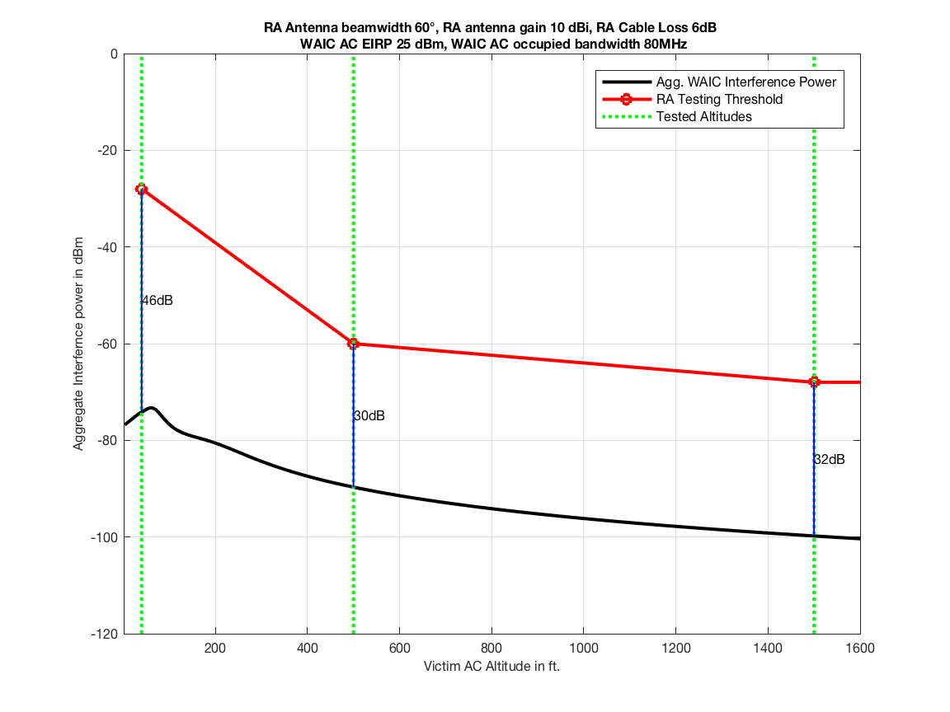
Figure 4: Aggregate WAIC interference power observed by RA of landing aircraft
  - Aggregate WAIC + External RA Interference Signal Testing

Description of Test Procedure

The test procedure described in 2.1 was amended to incorporate the effects of an aggregate interference scenario that is representative of multiple radio altimeter interference on a victim aircraft. These modifications were intended to reflect the interference geometry for the worst case landing scenario shown in Figure 3. Figure 5 shows provides a schematic of the updated test configuration. The voltage controlled oscillaors (VCOs) are driven by independent triangle waves at a mix of sweep frequencies and band widths to produce uncorrelated FMCW signals representative of the five RAs used in these studies.

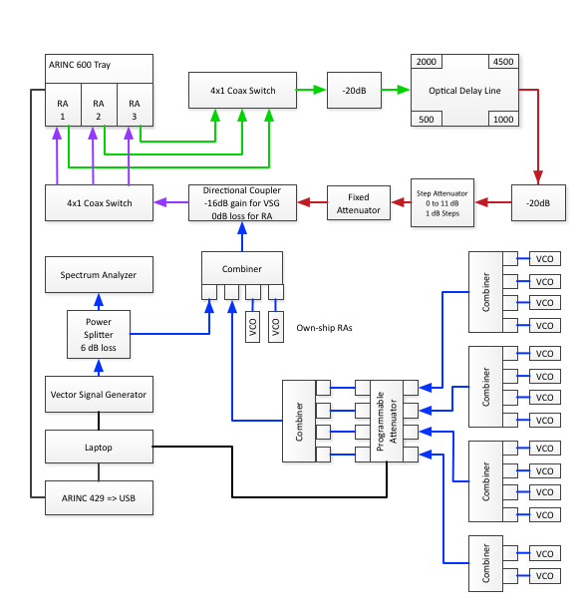
Figure 5: Aggregate Interference Test Setup

Discusssion of Preliminary Results

As these test are intended to investigate the effects of WAIC signals on a victim RA in the presence of other RAs only for the specific worst case scenario described above, we consider only altitudes of 40 ft and 500 ft. Preliminary results are presented below in Figures 6 and 7 for two of the five radio altimeters. Each figure shows the reported altitude vs WAIC interference power incident on the RA receiver for both unpowered and powered VCOs. Below these are plots showing the error and statics for the power sweep plots for the same conditions.
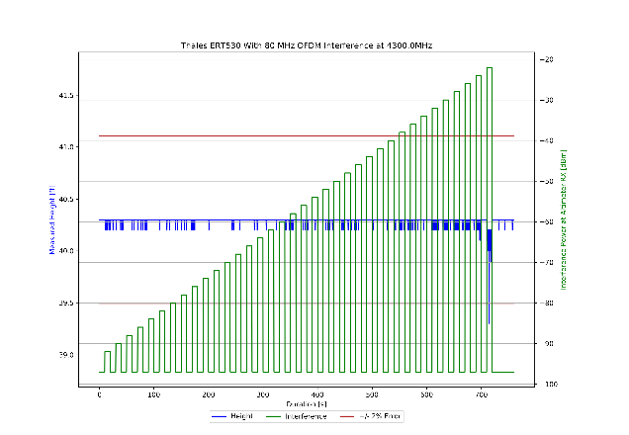  Alt v. WAIC Power - No VCO | 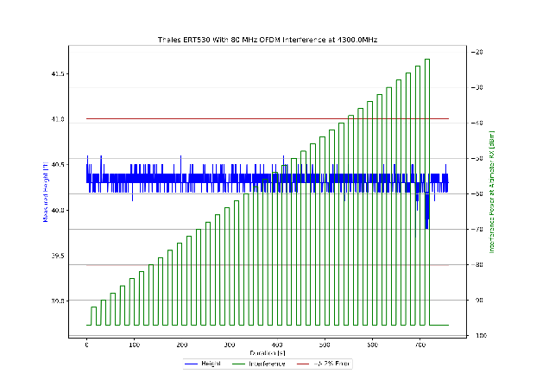  Alt v. WAIC Power – With VCOs
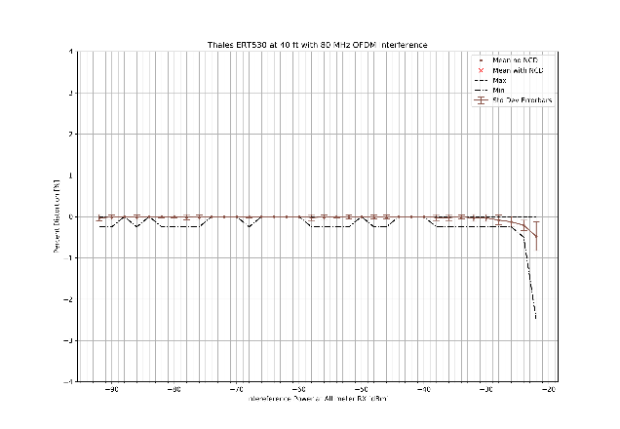  Alt. Error v. WAIC Power - No VCO | 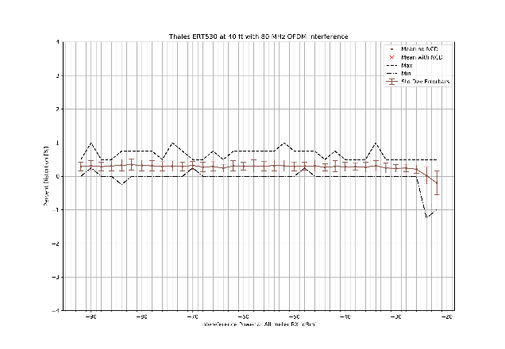  Alt. Error v. WAIC Power – With VCOs
Figure 6: RA #1 Aggregate Interference Performance Characteristics.
80 MHz OFDM WAIC interference signal + 16 FMCW

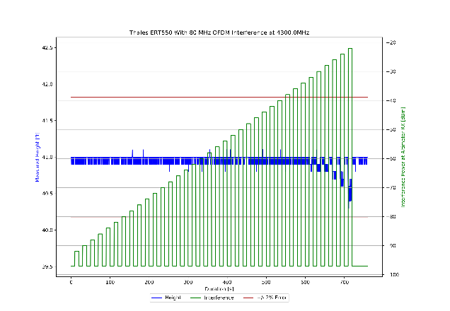  Alt v. WAIC Power - No VCO | 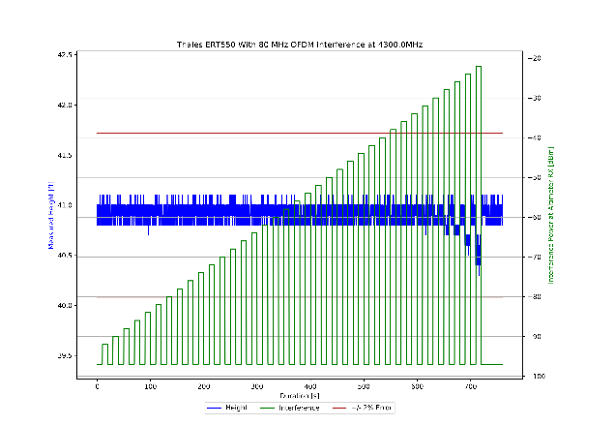  Alt v. WAIC Power – With VCOs
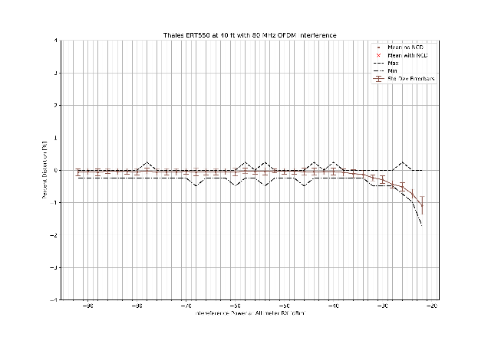  Alt. Error v. WAIC Power - No VCO | 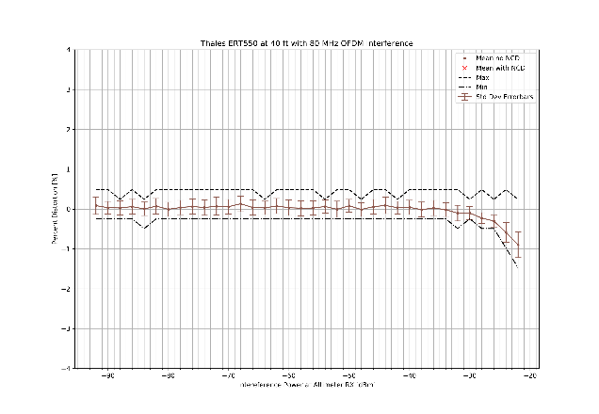  Alt. Error v. WAIC Power – With VCOs
Figure 7: RA #2 Aggregate Interference Performance Characteristics.
80 MHz OFDM WAIC interference signal + 16 FMCW

These prelimary results show that the effect of multiple RA interference sources is to raise the error floor without affecting the onset of WAIC-induced altitude errors. As both Figures 6 and 7 were from RAs produced by the same manufacturer, further tests on the remaining altimeters are required to assure that this conclusion is independent of the specific algorithms used to compute altitude. These test are anticipated to be completed in the next three weeks. Tables 1 and 2 show the current completion status.
Table 1: 40 ft altitude settting - aggregate interference
Table 2: 500 ft altitude settting - aggregate interference
- CONCLUSIONS AND RECOMMENDATIONS
  - The test results indicate that radio altimeters have an acceptable tolerance for WAIC-only interference in the worst case approach and landing scenario. The RAs show a robust worst-case interference tolerance that supports at least 30 dB margin in this case, relative to a 6 dBm/MHz EIRP WAIC transmitter power spectral density. This supports the preliminary conclusion that WAIC can safely coexist with RAs under the provisions put in place by ITU in the Recommendation M.2085.
  - The evaluation of the performance of RAs in the aggregate interference environment encountered with multiple external RAs is on going and will soon be completed. The preliminary test results indicate that conclusions derived for WAIC-only interference will still hold for multi-RA aggregate interference case. The AVSI expects to finalize the current testing by early October 2018 to be used for completing the final WAIC coexistence criteria contained in the WAIC MASPS. These final results will be presented to FSMP WG at its next 2019 meeting.
- ACTION BY THE MEETING
  - The meeting is invited to:
- note and review the contents of this information paper;
- provide comments and guidance for the completion of this study.

— END —

