FREQUENCY SPECTRUM MANGEMENT PANEL (FSMP)

Seventh Working Group meeting

Johannesburg, South Africa 6 - 13 September 2018

Agenda Item 4: Development of (planned) Material for ITU-R Studies on
- Fixed Satellite Services (FSS) for Unmanned aircraft system (UAS)

Propagation Measurement of Ka-band for Unmanned Aircraft Systems (UAS)

(Presented by NICT)

SUMMARY
This information paper is intended to provide a piece of information of the propagation characteristics of Ka-band between satellite and on-board antenna for communication links of unmanned aircraft systems (UAS).

- INTRODUCTION
  - Resolution 155 (WRC-15) resolves, that assignments to stations of geostationary FSS satellite networks operating in the frequency bands 10.95-11.2 GHz (space-to-Earth), 11.45-11.7 GHz (space to-Earth), 11.7-12.2 GHz (space-to-Earth) in Region 2, 12.2-12.5 GHz (space-to-Earth) in Region 3, 12.5-12.75 GHz (space-to-Earth) in Regions 1 and 3 and 19.7-20.2 GHz (space-to-Earth), and in the frequency bands 14-14.47 GHz (Earth-to-space) and 29.5-30.0 GHz (Earth-to-space), may be used for UAS CNPC Links in non-segregated airspace, provided that the “progress obtained by ICAO in the process of preparation of SARPs for UAS CNPC Links (resolves 18)” is considered and review its resolution at WRC-23. Meanwhile, there is a discussion on the use of Earth Stations In Motion (ESIMs) which operates in Ka-band GSO FSS networks in ITU-R (RR. 5.527A and Res.156 (WRC-15). Resolution 158 (WRC-15) resolves to invite ITU-R to study the technical and operational characteristics and user requirements of different types of ESIMs.

In order to address these issues, ICAO Remotely Piloted Aircraft System (RPAS) Panel has been studying the technical parameters required for development of the above mentioned SARPs. Therefore, it is important to grasp the propagation characteristics of Ka-band between satellite and on-board antenna of earth station because the influence of rain fade attenuation rate at the Ka-band is considered to be very much higher than at the Ku-band. There are many reports about measurements of rain attenuation on the ground at the Ka-band, however there are few reports on measuring the attenuation characteristics due to clouds.

This document aims to contribute to the works mentioned above, by providing a piece of information of the propagation characteristics of Ka-band between satellite and on-board antenna of earth station using an actual airplane.
  - This study was being conducted as a part of R&D on “narrowband technology using active electronic scanning array antenna that can be mounted on small aircrafts” supported by Ministry of Internal affairs and Communications (MIC), Japan.
- EXPERIMENT SETUP
  - We conducted a flight experiment using an aircraft mounting an aeronautical earth station by receiving a beacon signal from an actual satellite. A broadband communication satellite system ‘WINDS’ developed as an experimental communication satellite to demonstrate technology for broadband satellite communications with Internet Protocol (IP) was used in the experiment. WINDS is the geostationary satellite which put into 143 degrees east longitude and uses Ka-band (30 GHz / 20 GHz band: Uplink / Downlink). As shown in Fig. 1, the WINDS satellite has two antenna systems. One is a fixed beam, with multiple sub-beams, antenna and a multi-port amplifier (Multi Beam Antenna, MBA); another is a steerable beam antenna with an active phased array system (APAA). In this experiment, the Ka-band beacon signal from WINDS was used.
  - We developed an aeronautical earth station for WINDS, which has a Cassegrain antenna with a diameter of 45 cm as shown in Fig. 2, and a 200 W traveling wave tube amplifier. The EIRP is 58 dBW and G/T is 9.3 dB/K. It is able to communicate up to 51 Mbps for uplink using a regenerative transponder in the areas irradiated by the MBA (Multi Beam Antenna) of WINDS. The drive speed of the antenna is 25 degrees/s. The internal navigation unit is set up on the body of the aircraft, and it outputs information such as the position and altitude of the aircraft. The ACU (Antenna Control Unit) calculates the satellite direction from this information and satellite position, and controls the antenna. The satellite tracking accuracy is within ±0.5 degrees.

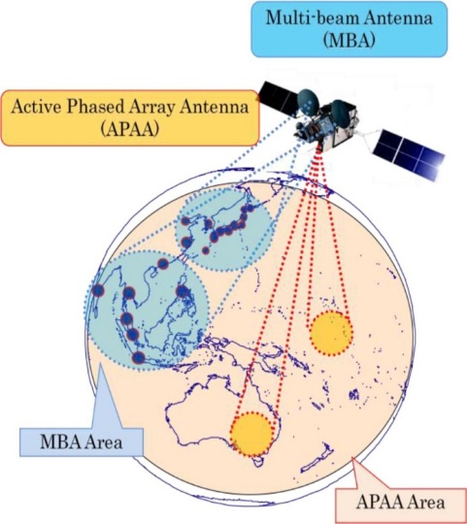

Figure 1 Service areas of the broadband communication satellite ‘WINDS’



Figure 2 Aeronautical earth station for satellite communications

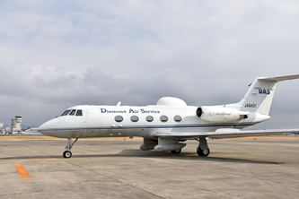

Figure 3 Gulfstream II aircraft with the earth station for WINDS
  - Fig. 3 shows the appearance of aircraft and attached antenna radome used for the experiment. The aeronautical earth station is mounted in the redome shown by a red circle in Fig. 3.
- EXPERIMENT RESULTS
  - We flew through several clouds and collected data including the received power of the beacon signal from WINDS as well as the attitude information of the aircraft in the experiment. Fig. 4 shows the airplane flight path and the altitude. The color of the flight path changes from cold color to warm color, which represents time change from takeoff to landing. The aircraft flew through several clouds on both areas of the Pacific (south areas of Fig. 4) and the Sea of Japan (north areas of Fig.4). Fig. 5 shows a satellite image of the clouds during the flight. In the Pacific area surrounded by red circles in the Fig. 5, there was a thin cloud (thickness: about 670 m) at the time of the experiment. On the other hand, there was a snow cloud (thickness: about 2160 m) in the Sea of ​​Japan surrounded by a blue circle.

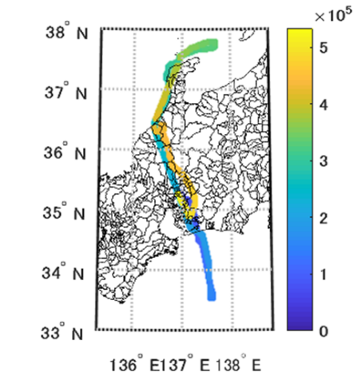

Figure 4 Airplane flight path and the altitude

Figure 5 Satellite image of the clouds during flight

Two results of the received power of the beacon signal from WINDS and the altitude of the aircraft are shown in Figs. 6 and 7 in the area above the Pacific and the Sea of Japan, respectively. From these results, there was little attenuation when passing through the clouds above the Pacific. It is thought that the cloud above the Pacific was light at that time. Meanwhile, the fluctuation of the received power was observed at about 2 dB at the up and down of the cloud over the sea of Japan. It is thought for this reason that the cloud over the sea of Japan was snow cloud.

From the results, cloud-based attenuation was not observed in thin clouds with a small water content. On the other hand, the attenuation by the clouds containing water like snow clouds was observed through the experiment.

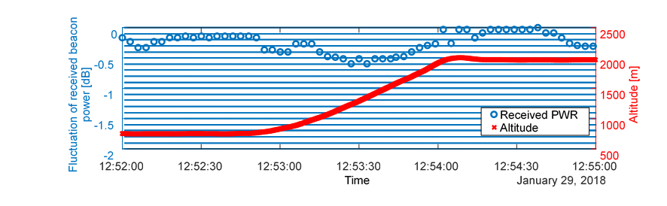

Figure 6 Received power and altitude in the area above the Pacific.

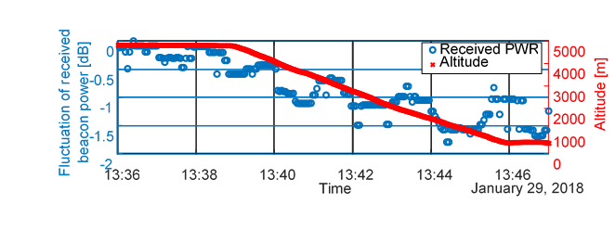

Figure 7 Received power and altitude in the area above the sea of Japan
- CONCLUSION

This paper presented a summary and some results of a measurement experiment of the Ka-band propagation using an actual airplane. From our measurement results, there was little attenuation when passing through the light clouds above the Pacific. Meanwhile, the fluctuation of the received power was observed at about 2 dB at the up and down of the snow cloud over the Sea of Japan.

— END —

