FREQUENCY SPECTRUM MANGEMENT PANEL (FSMP)

Twelfth Working Group Meeting

Montreal, Canada, 4 to 15 October 2021

Agenda Item 3: Radio Altimeter and WAIC Issues

Updates on Industry Assessment of 5G Cellular Compatibility with Radio Altimeters

(Presented by ICCAIA)

SUMMARY
This paper reports updates on activities ongoing by industry to assess compatibility of new cellular systems supporting “5G” applications in the C band with radio altimeters. A compilation of known 5G spectrum allocations being used to develop standard requirements for radio altimeters robust to future adjacent band interference is shared. Flight test results reported from Europe are reviewed against expected results based on radio altimeter tested threshold levels. The need for global safety zones to ensure compatibility for existing altimeters is reiterated with some more detailed guidance and a notional schedule. Finally, updates to the FSMP job card tasks related to Radio Altimeter adjacent band compatibility is discussed for panel consideration.

- INTRODUCTION
  - The importance of ensuring compatibility of radio altimeters (RA) with new cellular terrestrial systems has been described in a previous FSMP paper by ICCAIA [FSMP/11-WP/19]. That paper explained that temporary mitigation measures are needed to provide time to obtain data on 5G regulatory implementations and technical information. Learnings since that time continue to support those conclusions.
  - This paper will first report a summary of the terrestrial 5G cellular equipment regulations compiled so far by aviation standards organizations. An overview is given on how these data are being used to develop new radio altimeters with required robustness. Implications of the allowed terrestrial cellular power on compatibility with existing aviation altimeters is discussed. The FSMP/11-WP/19 document also requested specific information regarding regulations in place and being formulated in several administrations with respect to 5G deployment. That request remains important and useful to ensure the next generation of radio altimeters is designed for the foreseeable future use of adjacent bands by cellular networks. Once the standard is completed and new equipment is certified, compatibility with future adjacent band signals will be dependent on maintaining protection of the standard interference thresholds for those new altimeters for decades of service for safety-of-life operations.
  - Since the last FSMP meeting, new flight testing has been performed and reported to the Electronic Communications Committee (ECC) Project Team 1 (PT1). In one specific example, testing accomplished in Norway showed no interference with landing air transport aircraft radio altimeters from a terrestrial base station transmitting in the frequency range 3700-3800 MHz, from the top of a terminal building. This paper describes why this result was expected based on the radio altimeter interference thresholds from RTCA Paper No. 274-20/PMC-2073, or just RTCA 2020 report, proposes test planning needed to ensure safe testing, and proposes how to measure and test cases that are most critical for aviation safety.
  - Understanding how to predict test outcomes is closely related to understanding how to define and implement reasonable, safe, and high-confidence protection zones for aircraft and helicopters using existing altimeters. Air transport aircraft level impacts from loss of altitude and erroneous altitude range from minor to catastrophic for numerous functions that depend on altitude. No set of aircraft operational limitations can be devised that fully eliminate safety hazards that can result from RA interference. This is due to the fact that many hazards remain even during manual approach and landing with visual segments. Example protection zones proposed for Europe and Canada are referenced in a discussion of the need for global application of such zones. Some discussion is also provided on how and where to determine, implement, and transition away from those zones. A summary of impacted air transport aircraft is given, along with a notional timeline for transition to full compatibility between aircraft radio altimeters and systems operating in adjacent frequency bands.
  - In light of these points, it is proposed that the FSMP.006.01 job card related to “radio frequency and interference rejection characteristics for radio altimeters” be revisited and improved from its 2016 definition which is now past its 2019 due date. This paper attempts to further progress on the action to “conduct an aircraft fleet equipage impact analysis and develop detailed transition plans based on industry input and expected safety benefit”. The panel is requested to detail what specific technical aspects of existing and future radio altimeters should be included in ICAO guidance, and which ICAO document(s) should contain such guidance.
- DISCUSSION
  - The discussion is presented in four major sections, 2.2 through 2.5, corresponding to the subjects introduced in Sections 1.2 through 1.5.
  - Radio Altimeter Adjacent Band RF Environment
    - RTCA Special Committee 239 Working Group 2 (SC-239 WG2) was tasked with collecting regulatory spectrum allocations adjacent to the radio altimeter band to define an adjacent band RF environment. This RF environment will then be standardized and used, along with operational assumptions, to determine radio altimeter system level interference thresholds. Those interference thresholds will be ensured at the system level. Available regulations have been reviewed and summarized in terms of a maximum power spectral density (PSD) in dBm/MHz versus frequency, as shown in Figure 1. The figure does not show every state, but those represented in the figure are understood to be similar to, or representative upper limits for, regulations in these bands globally. The US (urban) and US (rural) allocations are expected to begin operation later this year, or in 2022, while most of the other regions have started deployment. It is uncertain how physically close existing base stations have been sited to aircraft operations, or what restrictions on siting are in place in some regions. Other regions have implemented protection zones or are studying them; the topic of protection zones is discussed further in paragraph 2.4 of this paper.

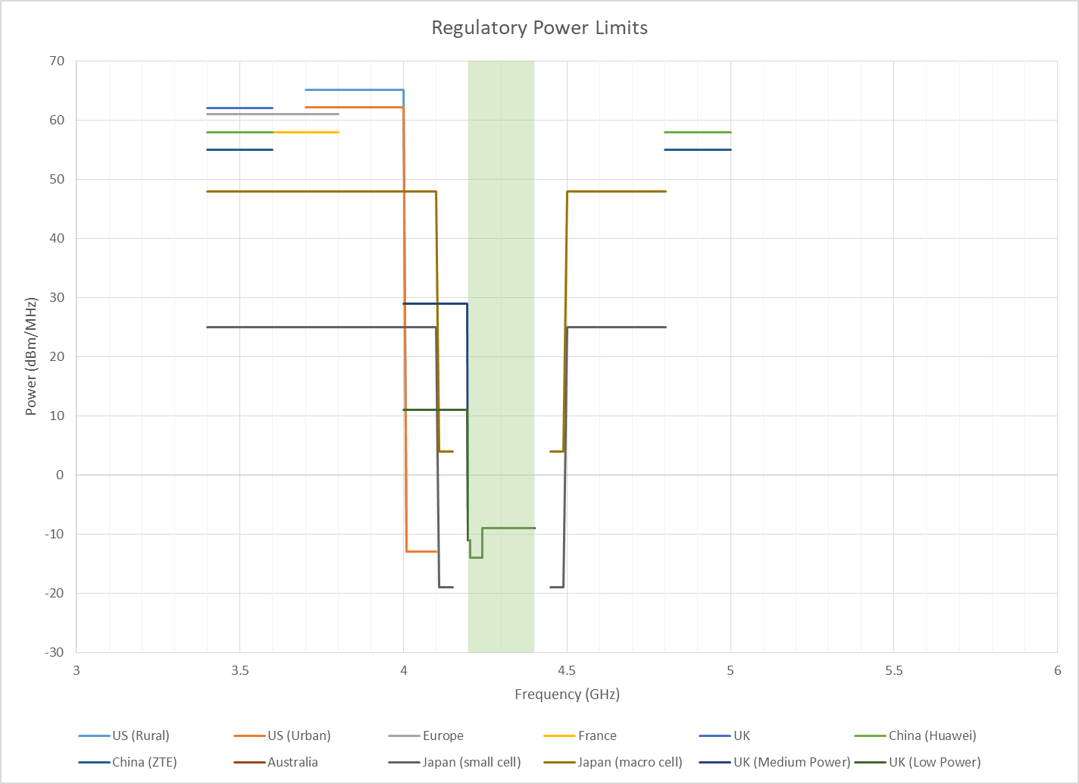
Figure 1 Summary of Maximum Power Spectral Density vs. Frequency for Regional 5G Cellular Spectrum Regulations

    - These upper limits on fundamental and spurious emissions are being used by RTCA Special Committee 239 (SC-239) to represent a snapshot of the current and envisioned future RF environment adjacent to altimeters for the development of requirements for a new generation of robust altimeters for aviation. The system level interference thresholds will be driven by the maximum allowed power at each frequency, assuming the closest expected operational distance, which may differ by altimeter categories or types. Credit for directionality of the signals may be a challenge since there are no requirements for peak power versus direction in any current regulations. Another reason not to take credit for directionality is to avoid precluding use of certain frequencies in the future for ground to air communications. SC-239 is also investigating definition of a standard airborne antenna with maximum gain limits at adjacent frequencies to allow feasibility of transceiver designs that can support these levels at very close distances and that can be tested at the box level rather than the system level.
    - It should be noted that the upper limits in Figure 1 are already very close to what is achievable in the same form, fit, and function of existing equipment for transmitters within a couple hundred feet from aircraft operations. It may not be feasible, for example, for an altimeter design to support peak power spectral density of +65 dBm/MHz at a closer-in-frequency 4100 MHz without larger physical separation distances than are allowed today by minimum obstacle clearance allowed by Terminal Instrument Procedures (TERPS). This is because filter components begin to become too expensive and large to support swapping into existing airplane architectures to support extremely high adjacent band power levels at overflight distances. In order to support the maximum levels in Figure 1 at distances allowed by obstacle clearance, the interference thresholds for altimeters will already need to be 20 to 30 dB higher than many fielded altimeters represented by the Category I threshold from the RTCA 2020 report. The details of these trades continue to be worked out at RTCA, balancing the parameters of maximum power, minimum distance, maximum altimeter antenna gain, and supported ground reflectivity to define an RF environment and interference threshold that are compatible and feasible.
    - Implications of these regulations on compatibility with existing altimeters.
      - Given an interference threshold, it is possible to determine a minimum slant distance, beyond which no impact to the currently fielded altimeters is expected. Again assuming the cellular directivity is not restricted in any way, the minimum distance, D_{min}, is that which provides path loss, at a given frequency, f, equal to the max power allowed at that frequency minus the altimeter system-level interference threshold at that frequency, in this example Free Space Path Loss (FSPL) in lieu of ITU P.528 at 1% probability for simplicity, as follows.

FSPL(D_{min},f) = P_{max}(f) – RA_{SYS_limit}(f) in dB

FSPL(D_{min},f) = 20log10(D_{min})+20log10(f)-27.55

for D in meters, f in MHz
      - Using the US power limit from Figure 1 at 3980 MHz of 65 dBm/MHz and the threshold for Category I (air transport) altimeters from the RTCA 2020 report at 3980 MHz for, say, 500 feet above terrain, or RA_{SYS_limit} of approximately -45 dBm/MHz, a minimum of 110 dB of path loss is required to provide compatibility. This is assuming that the radio altimeter antenna and coax contribute nothing to the system level gain toward the base station, which is approximately correct since typical receive antenna gain in the radio altimeter band is +10 dB while gain in the adjacent 3980 MHz band is approximately 10 dB lower for a net zero system level gain. At f = 3980 MHz we can solve for D_{min} as follows.

D_{min} = 10( (Pmax(f) - RASYS_limit(f) + 27.55 - (20log10(f))) / 20)

D_{min} = 10( (110 + 27.55 - (20log10(3980))) / 20) = 1895 meters
      - This means that, without limitations on directivity of the terrestrial transmitter (and no constraints on Line of sight geometry between basestation and airborne radio altimeter), Category I altimeters operating 500 feet above terrain could be affected (common mode loss of function or erroneous altitude outputs) up to about a nautical mile from the transmitter, assuming unfavorable ground reflectivity. Note that for an aircraft at 500 feet and transmitter a nautical mile away, even for a transmitter at a lower elevation that the airplane, the directivity of the airborne antenna will be reduced even further compared with that of boresight. Assuming an additional 10 dB of reduced airborne receive antenna gain, toward the transmitter at 3980 MHz and at a distant D_{min}, would result in a reduced D_{min} of 600 meters.
      - Similarly, given a radio altimeter system interference threshold RA_{SYS_limit} and assigning D_{min} as the closest approach distance, a P_{max} could be calculated that would be compatible with those given parameters as follows.

P_{max}(f) = RA_{SYS_limit}(f) + FSPL(D_{min},f)

For example, if an aircraft operation must tolerate about 250 feet, or 80 meters, of separation from a ground transmitter at 3980 MHz with an RA matching the Category I altimeter limit of -45 dBm/MHz at a terrain height of 500 feet, then any transmitter at that frequency, f, with a P_{max}(f) below 37.5 dBm/MHz will provide compatibility without any need to take credit for base station transmit antenna directivity. This also means that even if we did take credit for beam directivity, at the Pmax(f) of 65 dBm/MHz, the grating lobes or back-lobes of the transmitter during overflight would need to be guaranteed to be approximately 30 dB below the peak EIRP. Finally, it is important to note that taking credit for beam pointing or maximum transmitter power levels that are controlled by software without any design assurance is not wise for safety of life operations. Failures of the base station hardware or software due to weather, design, installation, etc., must not be capable to increase the P_{max} toward an aircraft beyond the level supporting compatibility.
      - The examples given in this section illustrate that without limitations on distance from aircraft, maximum transmit power, and/or beam directivity with sufficiently high probability of assurance, some current altimeters are susceptible to interference from signals at power limits allowed by spectrum regulations summarized in Figure 1 under minimum RA performance requirement conditions (e.g. worst case ground reflectivity; terrain reflection co-effficient of 0.01).
    - Importance of additional feedback on adjacent band environment and re-request.
      - Because the levels in in Figure 1 are nearing the feasible limits for altimeter designs to achieve, and the next generation of altimeters will operate for decades into the future, it is critical that all stakeholders in adjacent bands provide technical data and feedback on their current and future plans for altimeter adjacent spectrum.
      - This is a call for more inputs and feedback on Figure 1 power spectral density limits and the interpretation that these are peak levels that include peak antenna directivity, constructive multipath, or any other effects (such as PAPR) that could impact the maximum BS transmit power in the far field. .
  - Summary and Conclusions from Preliminary Flight Test Results in Europe
    - The European Conference of Postal and Telecommunications Administrations (CEPT) Electronic Communications Committee (ECC) Project Team 1 (PT1) is responsible for mobile compatibility studies and band plans in Europe. The PT1 includes a work item to study compatibility between mobile celluar operating at 3400-3800 MHz and radio altimeters at 4200-4400 MHz. At the PT1 meeting #69 in September, 2021, the paper ECC PT1(21)184 presented results of preliminary testing with radio altimeters operating near 5G cellular base station near 3800 MHz on the roof of Bergen-Flesland airport (BGO) terminal building in Norway. This test summary provides a valuable example for discussion regarding compatibility testing and its proper interpretation. While no interference to altimeters was experienced, a prediction using the RTCA 2020 report Category I altimeter interference tolerance thresholds would not have caused anticipation of interference.
    - The Norway preliminary test information and RF spectrum measurement data is documented, including antenna patterns, power, effective radiated power in the main beam direction, modulation and bandwidth. As seen in the table below, the report describes many key details, which can be used to estimate additional parameters and to determine if any impact at the aircraft altimeters should be expected:
Nominal Power | 44.7 dBm |  | Basestation transmit power from ECC PT1 paper
Peak Antenna Gain | 15.9 dB |  | not confirmed beam forming was turned on, information from ECC PT1 paper
Peak EIRP | 60.67 dBm |  | assuming 44.7 dBm + 15.9 dB Gain from antenna factor
Traffic Load | 100% |  | Using test mode. Needs further explantion on how this  was achieved along with details on TM waveform
Bandwidth | 100 MHz |  | from 3700-3800 MHz - Information from PT1 paper
Peak Transmit PSD (from Basestation) | 40.67 dBm/MHz |  | (60.67 dBm per 100 MHz) - - Information from PT1 paper
Distance between the BS and Aircraft | 500 meters |  | at touchdown point in a main beam direction - - Information from PT1 paper
Expected 5G signal PSD at Aircraft | -57.3 dBm/MHz |  | estimated using free space path loss
Measured Signal at Test Point | 40 dBµV |  | at 500 meters on ground in a main beam direction - Information from PT1 paper
PSD at Test Point | -67 dBm/MHz |  | We assume that the equipment used a 1 MHz Resolution  bandwidth for the measurement
User Category 1 Threshold (UC1) | -39 dBm/MHz |  | 200 ft terrain height @ 3750 MHz
User Category 2 Threshold (UC2) | -76 dBm/MHz |  | 200 ft terrain height @ 3750 MHz
User Category 3 Threshold (UC3) | -68 dBm/MHz |  | <200 ft terrain height @ 3750 MHz

Notice that with free space path loss and direct line of sight in the main beam of the base station, the expected PSD is -57.3 dBm/MHz, which is essentially equivalent to the worst case interference threshold from the RTCA 2020 report for Category I type altimeters. This means that even if the reflectivity of the runway were somehow the very worst case, and the altimeters tested represent the least performing altimeters, there is no real expectation of interference. Furthermore, notice that the measurement made on the ground in another main beam resulted in a much lower PSD due to shielding of the building between the base station and the ground, shielding which is similarly present for aircraft landing at the touchdown point. One possible conclusion from this test might be that a 5G base station can potentially be placed within 500 meters from aircraft on approach and landing with air transport category altimeters if the peak PSD is maintained below 40.67 dBm/MHz, which is approximately 25 dB lower than the US regulatory spectrum allocation in that frequency range. It is unclear from the preliminary test summary what the interference thresholds for some of the tested equipment were expected to be, or if those levels were experienced at the locations they were operated.

    - Regarding test planning and safety, it is advisable to coordinate with aircraft manufacturers prior to testing interference to radio altitmeters if the expected or possible effects are not well understood. It is not sufficient to perform visual approaches to maintain safety, as loss of all altimeter data or erroneous altimeter data can result in hazards with safety impacts that are not mitigated by visual segment alone. For example, reference ICAO SASP3 Flimsy02 and the RTCA 2020 report for airplane level impacts that include autoland along with a number of other hazards that could occur in visual conditions as a result of erroneous or lost altimeter data. Test aircraft crew should be informed and prepared for possible aircraft responses to unexpected test outcomes and should only participate in testing if all hazards are mitigated to the satisfaction of their regulator. It is unclear from the Norway preliminary report if all aircraft manufacturers were consulted by the operators prior to test participation; however, it is an important step toward maintaining safety, especially if commercial passenger flights are utilized in the test.
    - Test scenarios and measurements that provide additional value and meaning for validation of understanding of 5G compatibility with radio altimeters will include the following considerations:
- Measurement or estimate of the reflectivity of the terrain below the altimeter, as well as total loop loss for the altimeter transmit and receive paths, are needed in order to assess the impact on expected interference thresholds for a particular approach versus that of any arbitrary approach or other operation in the world, or versus that of the same approach in differing terrain conditions (e.g. wet, snow, ice, dry, etc.).
- Measurement or estimate of the 5G power spectral density at any potential location for aircraft operating volume for which safety hazards can be realized is needed to assess compatibility not only with the nominal approach path, but also rare-normal paths with altimeter related safety hazards.
- Measurement of the 5G power at the input of the altimeter receive port is needed to determine the interference level experienced by the altimeter for comparison with the interference threshold of the altimeter, particularly if impact on the altimeter during the test is used as a success criteria.
- Testing of a single altimeter article may result in a test outcome that does not represent the entire fleet of altimeters due to manufacturing and part variation across multiple altimeters of the same type, whereas RTCA altimeter categories represent the range of fielded altimeters and their variations.
- Electromagnetic modelling of the expected 5G PSD in three dimensional space for a test measurement would be valuable for comparison with calibrated PSD measurements.
- Flight inspection aircraft can provide a platform for calibrated measurements in a safe environment using real equipment and potentially non-normal flight paths.

Without these elements, testing outcomes may be inconclusive since variables such as ground reflectivity and airborne antenna patterns for the specific geometry tested may not apply in general, even for that particular location or approach operations.
  - Temporary Protection Zones are Needed Immediately for Continued Operational Safety
    - While 5G deployments are already under way, industry standards organizations are targeting 4Q2022 for a new standard for robust radio altimeters for aviation with a goal that existing Terminal Instrument Procedures (TERPS) criteria for obstacle clearance to provide adjacent band compatibility. The allocations in Figure 1 do not support compatibility with all aviation altimeter interference thresholds without limitations in PSD via power limits, beam pointing limits, or physical separation limits, which are not included in existing spectrum regulations. The fact that there have been very few events of altimeter effects due to cellular signals since recent deployment in adjacent bands is fortunate; however, catastrophic hazards must be extremely improbable over the life of airplane fleets that can span decades. Those hazards must also not depend on typical performance or typical placement, rather they must not happen under any foreseeable situation. That safety must be provided for each and every approach, not averaged over all approaches.

Adjacent band compatibility with different altimeter use types on platforms that have safety hazards for altimeter interference is of the highest importance. However, it will take several years before the entire aviation fleets can replace altimeters with new, more robust altimeters, or validate their existing altimeters through new testing and certification markings.

Figure 2 shows a notional timeline with temporary mitigations immediately needed to ensure continued safety during transition to full compatibility between 5G cellular, other terrestrial services using adjacent frequencies, and aviation altimeters. The first step is for industry to develop radio altimeter performance requirements based on a harmonized RF environment within aircraft operational volumes as a basis. This is planned for the end of 2022. ICAO, RTCA, and EUROCAE must harmonize the airborne RF environment with cellular and other adjacent band systems future spectrum use roadmaps for a successful outcome.

Shortly after a certification basis is available for a new generation of RA, and in the best case, some subset of existing altimeters can be tested to new standards and certify on their current aircraft for immediate compatibility. Even in the best case, aircraft with other altimeters would need to certify and equip with the new RA, which will take a number of years to coordinate and implement. In the worst case outcome, no existing altimeters can meet new standards without hardware changes, which will require a major certification program and will result in a need to replace all currently operating altimeters over a number of years.

To estimate the scope of potential RA replacement, one major air transport manufacturer representing approximately half of air transport sector, reports approximately 15,000 airplanes in service. There are three groups of altimeters operating on those airplanes, roughly representing three generations of RA equipment. All three groups were included in RA testing for the RTCA 2020 report. One group is represented by the RTCA 2020 report interference threshold and represents roughly 3000 airplanes. A second group performs somewhat better and is operating on 7000 airplanes. Finally, the third group is significantly more robust on the remaining 5000 airplanes. If only the most robust group of altimeters can meet the updated standard, then 10,000 aircraft will need to replace altimeters at an estimated cost of several billion dollars. If new hardware is required to meet the updated standard, and all altimeters must be replaced, the cost increases by billions more. Those estimates represent only half of the air transportation sector.

In any case, some aircraft and altimeters may operate until 2026, or as late as 2030, that depend on some kind of mitigation for adjacent band and spurious in-band PSD where operational hazards are identified.

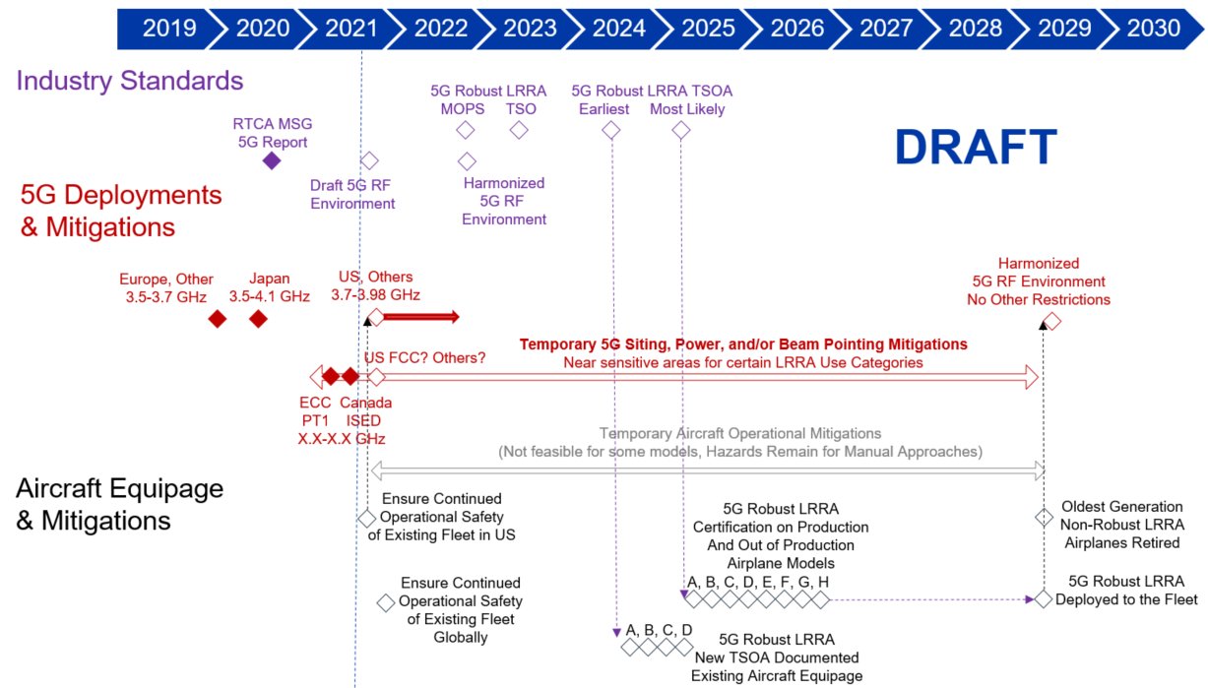
Figure 2 Notional Timeline for Radio Altimeter Upgrades and Continued Operational Safety during Transition

    - Protection zones or safety zones can be defined such that outside these zones no altimeter compatibility considerations are required for cellular base station beam pointing or power levels within their regulatory spectrum allocations (as limited globally by a harmonized RF environment). Within those zones, cellular or other operations are allowed, but special consideration must be given to protect the maximum PSD that maintains altimeter compatibility during the transition period.
    - France and Canada have both proposed temporary protection zones based on local cellular spectrum regulation and altimeter interference thresholds for reference [ECC PT1(21)006, https://www.ic.gc.ca/eic/site/smt-gst.nsf/eng/sf11725.html]. ISED Canada proposed zones only for Category III runways for certain frequencies. It is important to reiterate certain types of aircraft have safety hazards that are not mitigated by a visual approach segment or manual approaches; therefore, protection zones are likely needed at more runways, including and Category I runways for operational safety. Hazards for non-precision runways should also be considered in detail to determine if protection is needed for those as well.
    - FSMP in coordination with other industry groups should harmonize a method for defining temporary protection zones. One approach would be to agree on standard definitions for several parameters, such as the following:
- Hazard Volume – 3D volume outside which no operational hazards exist for any specific aircraft operating at a location, such as an airport or heliport,
- Safety Distance – Minimum distance D_{min}, beyond which altimeter thresholds cannot be exceeded given peak EIRP allocated at each adjacent frequency for those altimeters operating in the Hazard Volume,
- Protection Zone – 3D surface that is no closer than D_{min} to the Hazard Volume

Next, industry could standardize methods for deployment of terrestrial cellular equipment within the Protection Zones by regulated and validated limits on beam directivity and/or peak EIRP lower than the maximum allowed in the state. These temporary limits would protect altimeters operating in the area to protect safety, and these limits could change or be removed over time as the altimeters operating are updated to the latest performance standards.
  - FSMP.006.01 Job Card Review for Radio Altimeter RF Interference Characteristics
    - The job card for radio altimeter interference characteristics lists two deliverables:
WPE  No. | Document affected | Description of Amendment proposal or Action
 | Annex 10 | Referencing material from Standard Making Organisations, develop technical provisions defining technical aspects relating to radio frequency and interference rejection characteristics of the radio altimeters. Final location of material to be determined.
 | Action | Conduct an aircraft fleet equipage impact analysis and develop detailed transition plans based on industry input and expected safety benefit.

    - Since the job card FSMP.006.01 was defined, industry and Standard Making Organisations have progressed their understanding. These two actions remain valid and open with no numbers assigned.

The first action could progress using test results documented in the 2020 RTCA report to represent performance of existing altimeters in each use category. The action would need to be sustained in order to also document the new altimeter standard interference limits and how they can be used to allocate spectrum power limits, frequencies, and siting. FSMP should progress discussion on where this material should reside in ICAO documents, and revisit if FSMP or NSP or both are the proper panels to take the action.

The second action remains a valid activity although may be overcome by events. It is clear that in some regions, all existing altimeters will at least need to be recertified to higher interference levels, and in the worst case they will all need to be replaced with a new generation of altimeters. The only other way to protect safety hazards that can be catastrophic would be to permanently implement safety zones with special regulations regarding PSD adjacent to altimeters where hazards are possible. The action could be progressed by comparing the costs associated with higher density, lower power cellular networks around airports with costs to replace the entire installed altimeter base.
    - Additional actions to develop ICAO guidance material could be considered by FSMP and/or NSP; some examples for consideration are as follows:

• ANSP Guidance and/or SARPs for current altimeter limits vs current RF environment

• Define Protection Zones with beam pointing and/or power limits inside

• Interference thresholds for current altimeters measured vs 5G waveforms / bandwidths

• ANSP Guidance/SARPs for transition to future altimeters vs future adjacent band environment

• Minimize or eliminate safety zones with less restricted power and beam pointing

• New interference thresholds defined for arbitrary waveforms / bandwidths

• Goal for existing TERPs to be sufficient to provide compatibility

• ANSP Guidance for evaluation of conforming and/or exceptional cases

• Define cases inconsistent with current or future interference limits assumptions / requirements

• Consider flight inspection techniques to assess compatibility

• Consider design assurance of cellular infrastructure

• ANSP Guidance on Procedure Development

• Do not design approach paths that violate RA threshold assumptions

• May not be needed if TERPS guarantee assumed separation (goal)

Finally, while ICAO guidance material is important, it will take several years to develop and will not provide a strategy for ensuring continued operational safety in the near-term. ICAO and industry groups need to also urgently work together on a strategy and actions to provide a common basis and plan for continued operational safety.

- ACTION BY THE MEETING
  - The meeting is invited to:
- note and provide feedback on paragraphs 2.2, 2.3, and 2.4 and their subsections as partial progress toward the FSMP Action to conduct aircraft fleet equipage impact analysis and develop detailed transition plans.
- consider this paper as progress toward actions in Job Card FSMP.006.01 regarding radio altimeter compatibility with adjacent bands, aircraft fleet equipage impacts, and detailed transition plans, and
- discuss paragraph 2.5 and subsections and consider updating Job Card FSMP.006.01 with specific strategy, deliverables, and schedule to support altimeter adjacent band compatibility standards guidance and nearer-term continued operational safety.
— END —

