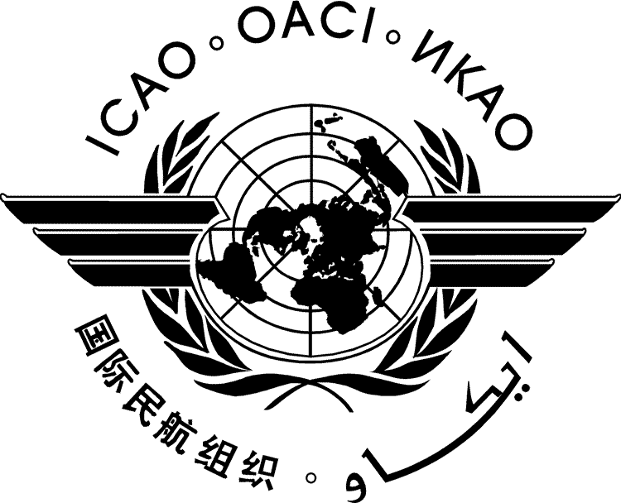 | International Civil Aviation Organization  WORKING PAPER
  FSMP-WG/12-WP/19
  2021-10-06
FREQUENCY SPECTRUM MANAGEMENT PANEL
WORKING GROUP

twelfth MEETING

Virtual,4 to 15 October 2021

Agenda Item 10 Any Other Business

Requirement for the Definition of a Minimum Spectral Mask in ICAO Standards and Recommended Practices

(Presented by John Mettrop)

SUMMARY
This document addresses the need for ICAO Standards and Recommended Practices (SARPs) to contain a minimum definition of a spectral mask for all ICAO defined aeronautical safety of life systems.

ACTION
The FSMP-WG is invited to:
- Review the content of this paper.
- Support the need for ICAO SARPs to contain a minimum set of spectral parameters for all ICAO defined aeronautical safety of life systems.

- INTRODUCTION
  - Aviation is a heavily regulated industry whose standards were primarily defined in an era where aviation generally had exclusive access to the frequency bands allocated to aeronautical safety services (AM(R)S, AMS(R)S, ARNS and ARNSS) and spectrum planning was able to take account of adjacent frequency band use.
  - As the demand for mobility connectivity has increased so has the demand for spectrum. That demand has reached a point that every opportunity for sharing, or reallocation must be investigated. This has reached a point where considerations that would have been included in the past can no longer be assumed to apply and assumptions about the performance of transmitters and receivers complying not only with the requirements of the Radio Regulations but also guidance provided in other ITU documentation.
- discussion
  - Recent issues such as LTE vs S-band, IMT vs L-band satellite communications and 5G vs radio/radar altimeters have highlighted that the spectral mask of aeronautical systems are not well defined, nor in line with current radio regulatory expectations within aeronautical standards. In each of the three examples given the problem has centred around the ability of the aeronautical systems to reject the wanted signal of the potential interference source.
  - Additionally, when asked for characteristics of systems in the past aviation has struggled to provide sufficient detail to immediately provide an answer to the request. Even when looking through SARPs and EUROCAE/RTCA standards it has been hard to find.
  - It is therefore proposed that the following minimum set of spectral characteristics be introduced as a minimum into aeronautical standards. Noting that ICAO SARPs are the only aeronautical standard that is formally globally applicable then it is suggested that these parameters or information from which these parameters can be derived be included in SARPs rather than EUROCAE/RTCA standards

Transmitter

Maximum transmit power

Necessary Bandwidth

Transmitter emission mask (frequency offset vs roll-off)

Receiver

Necessary Bandwidth (accounting for tolerances, doppler shift etc)

Noise floor

Protection Requirement

Receiver selectivity mask (frequency offset vs roll-off)
  - My intention: if the meeting agrees to the concept of including a set of minimum spectral parameters for both the transmitter and receiver in SARPs; to then review current SARPs, ETSI, EUROCAE and RTCA documentation to identify what information is currently present. This should help identify where there may be potential issues in the future and hence allow pro-active activity to address any potential issue before it becomes an issue
- ACTION BY THE MEETING
  - The FSMP is invited to:
  - Review the content of this paper.
  - Support the need for ICAO SARPs to contain a minimum set of spectral parameters for all ICAO defined aeronautical safety of life systems.

