FREQUENCY SPECTRUM MANAGEMENT PANEL (FSMP)

Eighth Working Group Meeting

Montréal, Canada, 21-29 January 2019

Agenda Item 9: Any Other Business

PROPOSAL FOR A MODERNIZED HF AERONAUTICAL COMMUNICATIONS SYSTEM

(Presented by Sai Kalyanaraman)

SUMMARY
Proposal to modernize HF aeronautical communications via application of standard waveforms and channel bandwidths proven in State aircraft applications to significantly improve HF data rate, voice clarity, and link availability. This paper seeks feedback from the FSMP on the proposal, and how the system could be implemented in the current HF spectrum rules at the ITU-R and nationally.

- INTRODUCTION
  - Historically, HF Radio communications has been recognized as the long range communication system by default for safe, efficient air travel over long range routes beyond the range of ground-based VHF radios. However, modern technology now provides alternate solutions, namely satellite communications (SATCOM; such as Inmarsat and Iridium for aeronautical use) which are now authorized by regulatory authorities for use in long range aeronautical communications.

  - SATCOM based voice and data solutions have made great strides in increasing automation and convenience in the air transport industry through allowing routine air traffic communications to become faster and less prone to interference and human error. These solutions have provided the air transport industry with an alternative to HF for long range communications. Over time, HF voice and data has become less favourable in comparison due to the relative audio quality, difficulty of use, and inability to deliver Future Air Navigation System (FANS) messages in a timely manner, but still provides a suitable fallback from SATCOM.

  - Current HF analog single sideband systems are susceptible to static crashes from lightning and man-made noise, as well as selective fading as the atmosphere continually changes. Future HF voice systems can move to more advanced digital voice as many CODECS (Coder/Decoders) are now available commercially. Some are available with low intellectual property cost and are not export controlled. These can be implemented in conjunction with modern signalling schemes to automate call setup, allowing flight crews to enjoy voice quality very similar to, and complementary with, the digital voice provided on SATCOM systems.

  - Modem technology embodied in US MIL-STD-188-110 has been the industry collection of state-of-the-art designs for the last 27 years. MIL-STD-188-110()/141() are publicly available and are not export controlled. The current HF Data Link (HFDL) ARINC 635/753 modem design was derived from early versions of this standard (-110A) when it was developed by industry between 1992 and 1995. Since 2012, -110C and now -110D (Dec 2017) has been updated with more powerful and faster modem technology using wider bandwidths and adaptive equalization. In addition, MIL-STD-188-141D App G provides for Automatic Link Establishment which allows the HF radios to find and link on the best available frequency at the current time. This allows the operator to just use the system without having to understand HF radio propagation. These standards have been extensively tested over the last decade and are currently in use by armed forces all over the world.

  - The use of spectrally efficient modulation techniques and wide-band consecutive 3 kHz HF channels will enable technology improvements that will increase the throughput of such wideband channels for the purpose of digital voice and high rate data transmissions.

  - SATCOM systems for safety services exhibit characteristics that prohibit simultaneous operations. Further, they only operate in the L-Band, giving them common space weather vulnerability. These factors create challenges in claiming that two L-Band SATCOMS are dissimilar systems from a safety analysis point of view. Rather, a prudent approach would be to utilize terrestrial HF communication in conjunction with L-Band SATCOM, as these two systems can be shown to be dissimilar with respect to failure modes induced by space weather. They are complementary, as space weather rarely impacts both L-Band and HF bands at the same time. This greatly reduces the probability of complete loss of long range communications.

  - Terrestrial and space-based systems work well together in a complementary and synergistic fashion to offer better performance, reliability and availability than either system alone. Having both space-based and terrestrial means of long range communication mitigates single point of failure concerns associated with vulnerabilities which differ for each system (e.g., solar events, rain fade, jamming, hardware failures, etc.).
DISCUSSION
- Legacy HFDL (ARINC 753, ARINC 635) represented an initial effort to create an HF-based data communication system for the commercial air transport industry. This system, however, was created within the confines of the 3 kHz channel assignment framework established for the Aeronautical HF spectrum. While the objective of creating a data communications network utilizing High Frequency radio spectrum was achieved, the system has limitations because of the limited bandwidth of the assigned channels and the modulation scheme used.
  - Legacy HFDL (ARINC 753, ARINC 635) represented an initial effort to create an HF-based data communication system. In order to maximize throughput, application of MIL-STD-188-110() to commercial aviation communications requires system optimization. There are three primary ways to increase the data rates of HF modems:
- Increase modulation complexity in the current 3 kHz bandwidth
- Utilize multiple 3 kHz non-contiguous channels with multi-carrier waveforms
- Utilize multiple 3 kHz contiguous channels "bonded" into a single channel n X 3kHz wide
For channels of a constant bandwidth, research has shown that increasing the complexity of the modulation results in the need for higher signal-to-noise ratios and higher linearity RF power amplifiers due to higher peak-to-average power ratios. Bonding contiguous channels effectively increase the channel bandwidth, allowing lower order modulations to achieve equivalent data rates. Higher order modulations are more susceptible to multipath and fading effects, requiring more complex processing than lower order modulations. Furthermore, multi-carrier waveforms require increased complexity of transmitters, antenna matching and compensation for atmospheric effects when compared to single carrier waveforms on a channel with wider bandwidth.

  - Development of the next generation of HF data communications, “HF Next,” would directly address the technical limitations of legacy HFDL and human factors concerns associated with analog single sideband HF voice communications and provide the following benefits:
- RCP-240: The HF Next system will be designed to specifically address the throughput and availability limitations of HFDL that prevent it from achieving RCP-240 compliance for the delivery of FANS traffic.
- Digital Voice: The HF Next architecture will provide for a digital voice capability that will address the frequent complaint that HF voice is noisy and difficult to use.
- Flight Crew Workload: The HF Next protocol will contain a method of automatically assigning frequencies to aircraft radios that would preclude aircrews from needing to obtain frequency assignments from ANSPs and their Communications Service Providers. Frequencies would automatically be assigned and managed by the system.
More efficient modulation techniques using wider than 3 kHz channel assignments (as specified in Paragraph 2.6) are required to accomplish all of these objectives. Implementation of the proposed improvements is feasible due to the under-utilization of the allocated spectrum.

Benefits to Industry:
  - HF oceanic communications can be managed as a provided service rather than a national asset, bringing economies of scale to utilization of RF spectrum. Just as ANSPs use SATCOM service providers (such as Iridium and Inmarsat) for communications within their airspace as an alternative to operating their own constellation, managing HF communications for aeronautics can be approached in the same way. HF frequencies can be consolidated and used more efficiently in groups that provide benefit to many nations, more so than they can be used individually by specific ANSPs or CSPs.

  - MIL-STD-188-110D specifies a wide-band HF modulation scheme that has been successfully demonstrated by the U.S. military as a means to utilize HF spectrum in greater bandwidths than 3 kHz for passing large amounts of data efficiently. A 2016 wide-band HF flight test using a U.S. Air Force C-17 aircraft and 6 HF ground stations in the United States successfully achieved the following goals:
- Established an HF link to “best” station using 4G ALE
- Established an HF link to specific ground stations using 4G ALE
- Conducted real-time chat between aircraft and ground
- Conducted full-motion streaming video from aircraft to ground; which is
  - believed to be first transmission of live video from aircraft to ground using HF radio
- Conducted large file transfer (> 1 MB) from ground to aircraft
- Conducted half-duplex, digital voice audio communication between aircraft and ground using Mixed Excitation Linear Prediction – Enhanced (MELPe) standard
- Conducted 4G ALE soundings from both aircraft and ground stations to collect Link Quality Assessment (LQA) information; and
- Transmitted/received test data streams between aircraft and ground stations to collect signal strength, signal-to-noise ratio, and bandwidth availability information under various flight conditions, which achieved a
  - ground-to-air: average data rate of 38.32 kbps, maximum data rate of 96 kbps
  - air-to-ground: average data rate of 19.2 kbps, maximum data rate of 48 kbps
  - Table D-II, taken from MIL-STD-188-110D, shows the theoretical data speeds that can be achieved with advanced modulation waveforms on contiguous channels utilized as a wide-band channel.

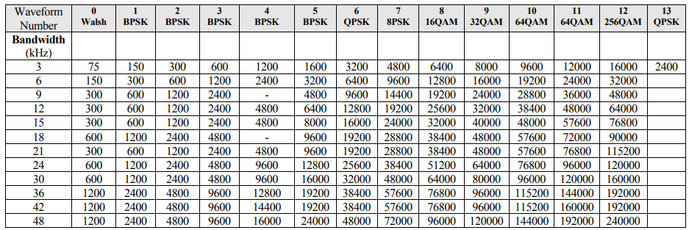

TABLE D-II from MIL-STD-188-110D
Modulation used to obtain each data rate.

  - Compliance with spectral emission masks defined in MIL-STD-188-141D ensures that interference outside of the assigned multi-channel bands is no greater than the interference of individually utilized channels.

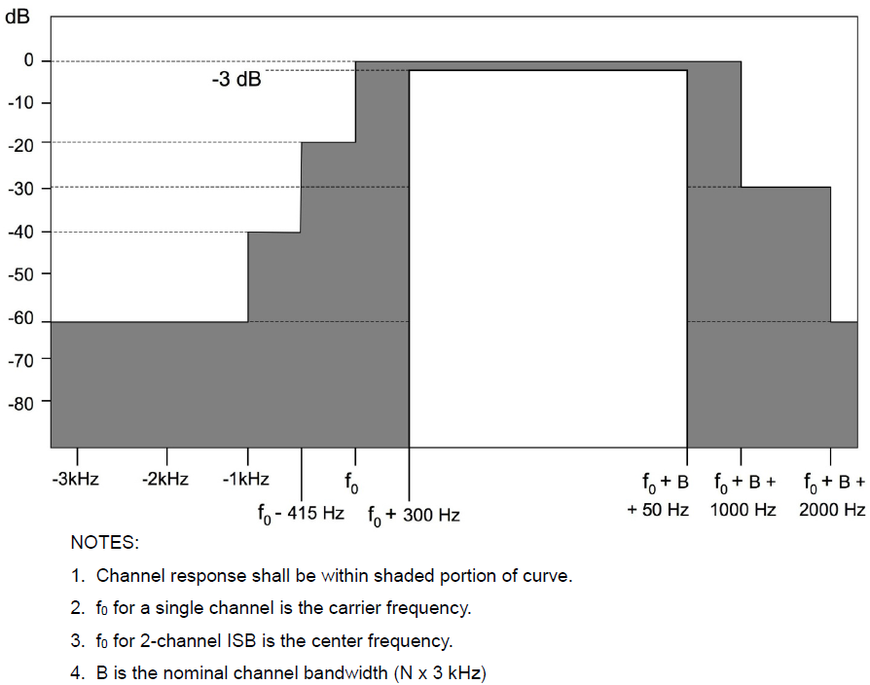
FIGURE 4 from MIL-STD-188-141D
Overall channel response for single or dual channel WBHF equipment

  - CONCLUSION:
    - Utilizing contiguous 3 kHz HF frequency assignments and advanced modulation techniques for the purposes of fielding a wide-band HF communications system benefits industry and provides a complementary system for use in conjunction with satellite based systems to provide a long range communications solution that:
- Offers improved voice quality, higher data rates, and automated operation.
- Ensures polar coverage
- Provides link-diverse long range communication paths that can be used simultaneously
- Eliminates single point of failure in a dual L-Band solution
    - The described modernized HF terrestrial based system, working in synergy with a space based SATCOM system, offers aeronautical communications safety services with optimal performance and availability.

- ACTION BY THE MEETING
  - The meeting is invited to:
    - Review and endorse the proposed advanced modulation and channel bonding and provide recommended options to take the system forward;
    - Add agenda item for further discussion on this topic at the next FSMP.
— END —

