Flimsy 4

Elements for a DRAFT LIAISON STATEMENT TO WORKING PARTY 5B

Preparation for WRC-23 agenda item 1.9

Review of Appendix 27 of the Radio Regulations to accommodate digital aeronautical HF technologies

The International Civil Aviation Organization (ICAO) thanks Working Party 5B (WP 5B) for its liaison statement (Doc 3L/25) on WRC-23 Agenda Item 1.9.

In response, ICAO provides the below preliminary technical characteristics on Wideband HF (WBHF) systems. Two types of WBHF systems are currently contemplated: systems that combine contiguous 3 kHz channels into a single wideband channel, and systems that combine non-contiguous 3 kHz channels into a single wideband channel. The characteristics that follow should be representative of the future WBHF systems using contiguous channels. Characteristics for systems operating on non-contiguous channels will be provided in the future.

It should also be noted that the ICAO standardization process has been impacted by COVID-19 delays, and therefore the below preliminary information is intended to provide the ITU-R with a starting point in the development of its work towards completing WRC-23 Agenda Item 1.9. If these characteristics should change, or if additional characteristics are identified, ICAO will inform WP 5B.

Considerations in the design of wideband HF systems using contiguous 3 kHz channels:
- The WBHF modulation waveforms will fall under the same J2D emission designator as the existing HF Datalink (HFDL), operating in the existing AM(R)S allocations, as defined in ITU-R Rec M.1458-0.
- The WBHF signal will comply with the legacy HFDL spectral mask regarding adjacent channel power as defined in ITU-R Rec M.1458-0 (see table 1 and figure 1 below), with the goal of ensuring compatibility with legacy systems operating in the same or adjacent MF/HF frequency bands.
- The WBHF channels will be defined around the reference frequency and bandwidth of the wideband channel (see Wideband Spectral Mask diagram). Reference frequency and assigned frequency of individual 3 kHz channels comprising a bonded wideband utilization would remain unchanged.

Table 1: Proposed Wideband HF Spectral Emission Mask Table

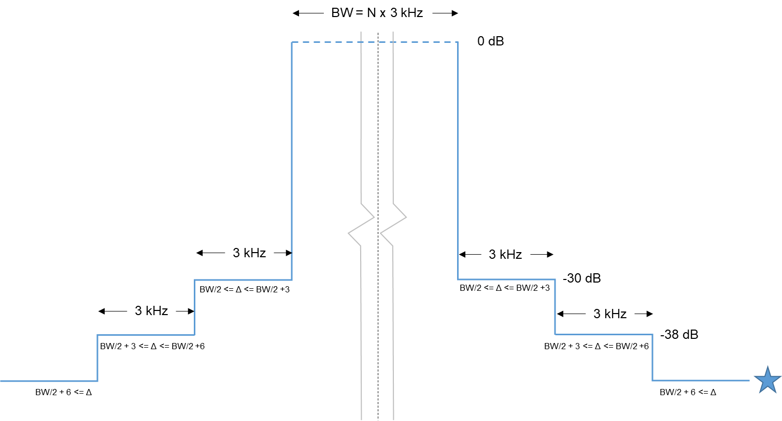
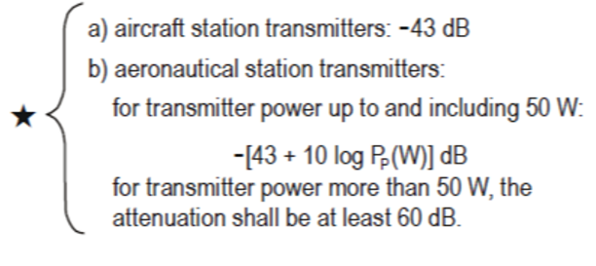
Figure 1 - Proposed Wideband HF Spectral Mask. Note: N is the number of bonded contiguous channels
Note: Assigned frequency is offset by BW/2 - 100 kHz above SSB carrier reference frequency, as with legacy HFDL

