FREQUENCY SPECTRUM MANAGEMENT PANEL (FSMP)

Fifteenth Working Group meeting

Montreal (hybrid meeting), 22 Aug – 1 Sep 2022

Agenda Item 5) : Development of (planned) Material for ITU-R Studies on
g) Other

EFVS in the Frequency band 31.8-33.4GHz (Ka) and the 95-100GHz (W).

(Presented by Fleury Christian, French Civil Aviation -DGAC)

SUMMARY
The frequency band 31.8-33.4 GHz (32 GHz band) and the 95-100 GHz are allocated to Radionavigation and FIXED services. To be considered in ITU studies, the frequency band 31.8-33.4 GHz and the frequency band 95-100 GHz needs to be recognized through a clear positioning to ICAO as bands identified for EFVS/EVS applications

- INTRODUCTION
  - Enhanced Flight Vision Systems (EFVS),

EFVS is a term used by some States to identify an EVS system, that consist in displaying an image provided by a forward-looking sensor in a Heads-Up Display, to enhance pilots’ natural vision and allow approach and landing in degraded weather conditions. EFVS systems use different sensing technologies, which include forward-looking infrared, millimetre wave radar or low-light level intensification; additional technologies may be developed in the future.
    - EFVS operations as reflected in the ICAO Annex 6 offer the following benefits:
- They provide options for operators to serve non-CATII/III runways in very poor RVR conditions;
- Although the operator should assess the suitability of the selected aerodrome, they do not require additional airport infrastructure;
- They do not require new approaches to be designed and expand capacities of already published Instrument Approach Procedures (IAP);
- They contribute to reducing the environmental footprint, by allowing direct access to secondary airports, reducing diversions as well as holding times and go-arounds;
- They reinforce crew awareness of the surrounding environment during approach, landing and taxiing, and thus, with appropriate training, contribute to flight safety in critical phases of the flight.

    - The current worldwide fleet of aircraft equipped with EFVS is estimated at over 3,000, mostly in the business aviation and cargo sectors. A few regional aircraft have recently been equipped as well, and new developments are underway with the two largest commercial aircraft manufacturers. For most operators or aircraft owners, investment in this technology is motivated by the need to serve secondary airports in the largest range of weather conditions, as well as by the value found in such systems in terms of situational awareness.
    - EFVS using a sensor in the frequency band 31.8-33.4 GHz (Ka Band).

In the Radio Regulation, the frequency band 31.8-33.4 GHz is allocated to Radionavigation and Fix services (also space research and inter-satellite in part of the band) where the footnote 5.547A Administrations should take practical measures to minimize the potential interference between stations in the fixed service and airborne stations in the radionavigation service in the 31.8-33.4 GHz band, taking into account the operational needs of the airborne radar systems. (WRC-2000) apply.

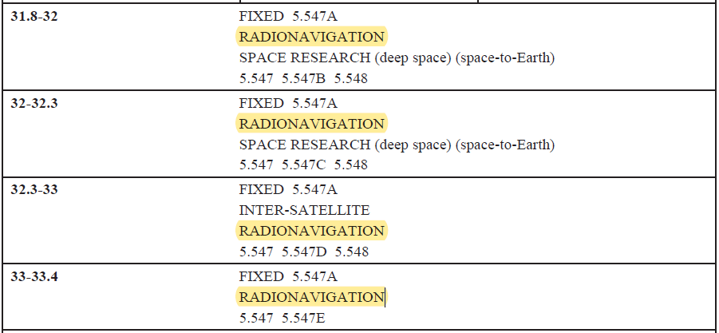

January 2017, Recommendation ITU-R M.1466 “Characteristics of and protection criteria for radars operating in the radionavigation service in the frequency band 31.8-33.4 GHz” was updated. Since, studies and trials have shown that a bandwidth of 364Mhz (including guard band) is necessary to meet the required performance.
      - Fix services in the frequency band 31.8-33.4 GHz.

During WRC-19 study cycle, the 31.8-33.4 GHz frequency band was considered for an IMT allocation but was abandoned because coexistence between IMT and RNS was not feasible. IMT allocation was made in the 24.25-27.5GHz (26 Ghz band) frequency band during the WRC19.

Due to IMT allocation in the 26 GHz frequency band, radio relay link (Fixed Service) will have to move to another frequency band and some administrations are focusing on the frequency band 31.8-33.4 GHz due to high-capacity capability.

Fix services Radio-frequency channel arrangement in the band 31.8-33.4 GHz

Fix Service occupied spectrum: 31.8 to 33.4 GHz

Centre gap = 56 MHz for the 3.5, 7, 14 and 28 MHz channel separation, 140 MHz for the 56 MHz and 112 MHz channel separation.

Example Fix Service using 112MHz channels

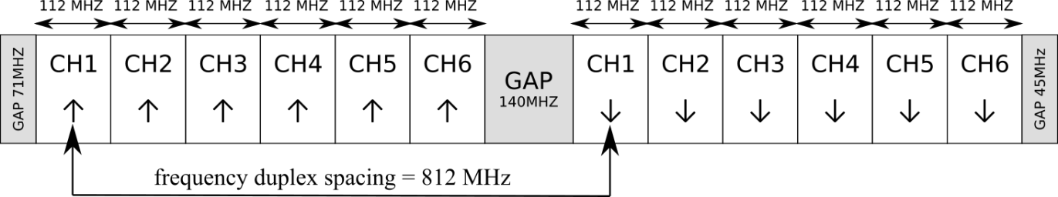

      - Spectrum coexistence between the EFVS and the FIX service where needed

To minimize the constraint on the FIX service channels and thus to be spectrum efficient, it was decided to use the center gap (140 or 56MHz) and “xx” MHz each side of the center gap to reach the EFVS necessary bandwidth.

FIGURE 3

Example EVFS using 364 MHz bandwidth

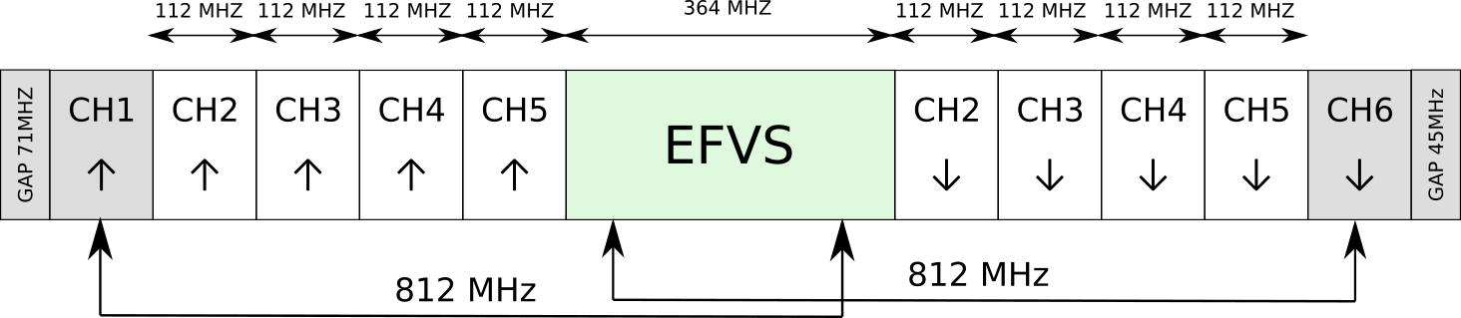

    - EFVS using a sensor in the frequency band 95-100 GHz (W band).

Like EFVS using the Ka-band, EFVS using the W band shares its band with other services. To be considered in the on-going and future ITU studies, EFVS using these two frequency bands shall be known and recognized at ITU level.

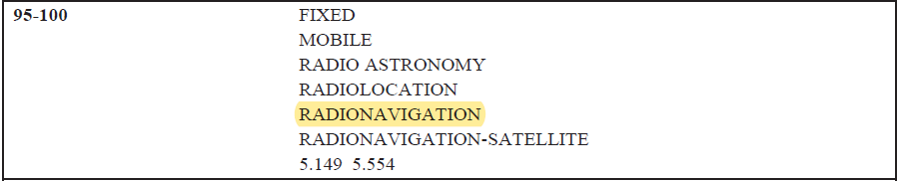
- DISCUSSION
  - Although it has evolved since the early 2000s, the technology of EFVS systems remains currently based on infrared/electro-optical sensors. In some bad weather conditions (low clouds, fog, …), this technology offers limited operational benefit because of weak atmosphere penetration. As a consequence, these current technologies do not systematically provide the enhanced flight visibility required to support operations in lower visibility range.
  - On the contrary, radar technology offers an ability to detect runways independently of weather conditions. Therefore, the industry has significantly invested over the past years in these solutions and studies are currently under way with several aircraft manufacturers, aiming at integrating this radar technology into civil aircraft.
  - The perspective offered by the development of such radar-based EFVS systems is nothing less than to have an all-weather sensor that will allow, on the one hand, to increase the success rate of EFVS operations, and on the other hand, to take full advantage of the benefits offered by the EFVS regulation.
  - Besides, EFVS systems based on radar technology operate in parts of the 31.8 – 33.4 GHz (Ka band) and 95 – 100 GHz (W band). Both frequency bands are allocated to radionavigation service (RNS) as primary services in the Radio Regulations within ITU, and are also allocated to other services with which the EFVS systems have to coexist.
  - The integration of a radar sensor is a challenge due to physical constraints which, moreover, are specific to each type of aircraft. Both intended bands, Ka and W, offer two different solutions for the integration of the antenna (array of distributed radiating elements or very compact antenna), which allows to address the diversity of integrations constraints and make it possible to find a solution for each type of aircraft.

- ACTION BY THE MEETING
  - The meeting is invited to:
- Note and review this Working paper
- invite ICAO to promote the use of the 31.8-33.4 GHz and 95-100 GHz frequency bands for EFVS in the ITU.

— END —

