FREQUENCY SPECTRUM MANAGEMENT PANEL (FSMP)

Twentieth Working Group meeting

Bangkok, Thailand, 24 February to 7 March 2025

Agenda Item 8: Any Other Business

Potential interference to COSPAS-SARSAT from lunar communications

(Presented by Damian Lopez from NAV CANADA)

SUMMARY

WRC-27 Agenda Item 1.15 focuses on performing studies towards the use of frequency bands identified in Resolution 680 (WRC-23) for lunar communications. These frequency bands include the 406–406.1 MHz range, which use is limited to low-power satellite emergency position-indicating radiobeacons used for Search And Rescue (SAR).

This document provides a high level analysis of potential interference to COSPAS-SARSAT space instruments from lunar communications in the 406–406.1 MHz band.

- BACKGROUND

The COSPAS-SARSAT emergency communication system is a vital, global Search And Rescue (SAR) initiative that enhances safety and saves lives. Established in 1979 through international collaboration, COSPAS-SARSAT provides a reliable and efficient means of detecting and locating distress signals from ships, aircraft, and individuals in remote or hazardous environments. Its fundamental purpose is to support SAR organizations by significantly reducing the time needed to locate those in distress.

The system operates using an array of satellites in geostationary (GEO), medium Earth (MEO), and low Earth orbits (LEO), collectively forming a robust network. These satellites are equipped to detect emergency beacons transmitting in the 406–406.1 MHz frequency band, which has been reserved globally for international distress alerts. There are three main types of beacons used: Emergency Position-Indicating Radio Beacons (EPIRBs) for maritime use, Emergency Locator Transmitters (ELTs) for aviation, and Personal Locator Beacons (PLBs) for individual use. When activated, these beacons transmit a signal containing the beacon’s unique identification number and, in most cases, GPS coordinates, enabling rapid response (see Figure 1 below).

Once a distress signal is received by the satellites, it is relayed to ground stations known as Local User Terminals (LUTs). These terminals process the signal and determine the location of the distress beacon with remarkable accuracy. The information is then forwarded to a Mission Control Center (MCC), which analyses the data and coordinates with the appropriate SAR authorities to initiate a rescue operation. This streamlined communication ensures that assistance reaches those in need as quickly as possible.

The system’s global reach and interoperability are key to its success. COSPAS-SARSAT is used by over 200 countries and territories, making it a cornerstone of international SAR operations. Its ability to operate independently of terrestrial networks is particularly crucial in remote areas, oceans, and disaster zones where conventional communication infrastructure may be unavailable or compromised. COSPAS-SARSAT has demonstrated its effectiveness by aiding in the rescue of over 50,000 individuals since its inception.

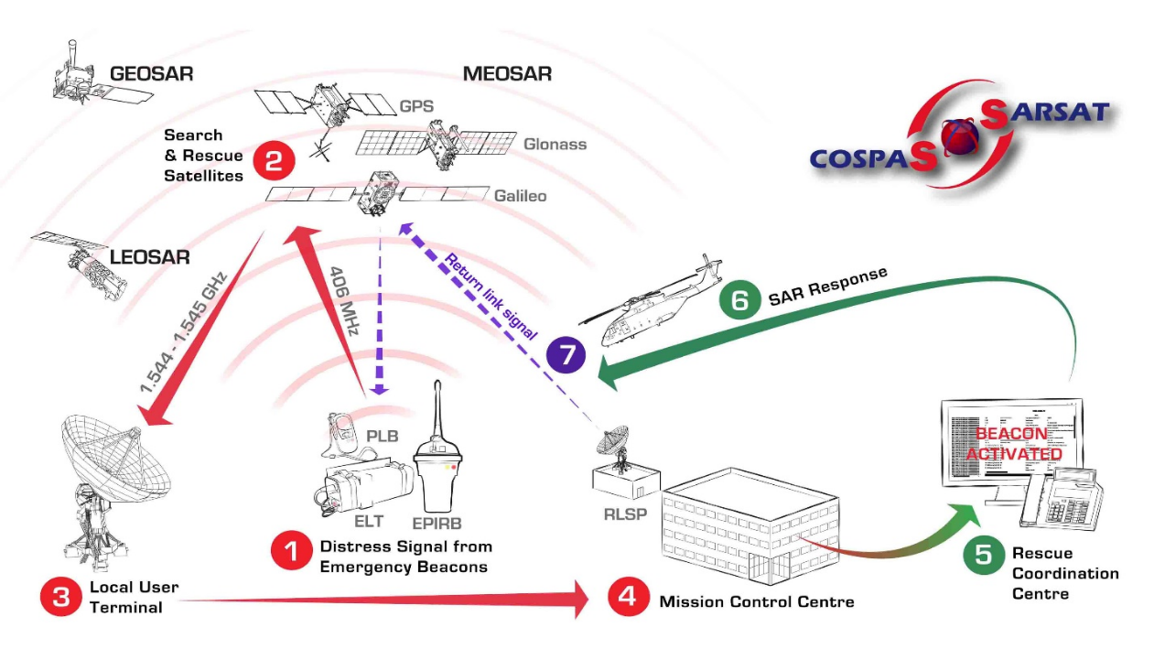
Figure 1 - COSPAS-SARSAT system overview

- DISCUSSION
  - Inclusion of 406–406.1 MHz in Resolution 680 (WRC-23)
  - This Resolution, in the recognizing section, states:

k) that the fixed and mobile (in some bands mobile, except aeronautical mobile) services are allocated on a primary basis within the frequency ranges 390-399.9 MHz, 400.05-401 MHz by No. 5.262, 420-430 MHz, 440-450 MHz, 2 400-2 690 MHz, 3 500-3 800 MHz, 5 650-5 850 MHz by No. 5.453, 7 190-7 235 MHz, 8 450-8 500 MHz and 25.25-28.35 GHz;
  - However, in the resolves section, it states:

resolves to invite the ITU Radiocommunication Sector to complete in time for the 2027 world radiocommunication conference

1) studies of the spectrum needs of systems in the SRS which may operate on the lunar surface, or systems in lunar orbit communicating with systems on the lunar surface, in the following frequency ranges or portions thereof, taking into account noting a), b) and c):

– 390-406.1 MHz, 420-430 MHz and 440-450 MHz, limited to outside the SZM

– 2 400-2 690 MHz, 3 500-3 800 MHz, 5 150-5 570 MHz, 5 570-5 725 MHz, 5 775-5 925 MHz, 7 190-7 235 MHz, 8 450-8 500 MHz and 25.25-28.35 GHz;

A key discrepancy between the frequency bands listed in the recognizing and the resolves sections is the inclusion of 406–406.1 MHz in the latter. As a result, and perhaps unwittingly, Resolution 680 invites the radiocommunication sector to consider using this distress frequency band for lunar communications.
  - Interference susceptibility of the COSPAS-SARSAT system

Radio signals from emergency beacons (EPIRB, ELT, PLB) are often very weak, yet their reliable detection from space is crucial for locating and rescuing individuals in life-threatening situations.

The criticality of the COSPAS-SARSAT system and the 406–406.1 MHz frequency band it operates in, is clearly recognised by the ITU-R in the Radio Regulations:
- Volume I, Article 4.22: “Any emission capable of causing harmful interference to distress, alarm, urgency or safety communications on the international distress and emergency frequencies established for these purposes by these Regulations is prohibited.”
- Volume I, Article 5.266: “The use of the band 406-406.1 MHz by the mobile-satellite service is limited to low power satellite emergency position-indicating radiobeacons”
- Volume I, Article 5.267: “Any emission capable of causing harmful interference to the authorized uses of the band 406-406.1 MHz is prohibited.”
- Volume I, Article 31.2: “Any emission causing harmful interference to distress and safety communications on any of the discrete frequencies identified in Appendix 15 is prohibited.”
- Volume II, Appendix 15, Table 15-2: “… 406-406.1 – This frequency band is used exclusively by satellite emergency position-indicating radio beacons in the Earth-to-space direction (see No. 5.266)…”
- Volume III, Resolution 205 (WRC-19):
  - “… resolves … 1) to request administrations not to make new frequency assignments within the frequency bands 405.9-406.0 MHz and 406.1-406.2 MHz under the mobile and fixed services;…”
  - “… urges administrations … 2) to ensure that stations other than those operated under No. 5.266 abstain from using frequencies in the frequency band 406-406.1 MHz; 3) to take the appropriate measures to eliminate harmful interference caused to the distress and safety system; …”

Emergency beacon signals can be received in space by either a Search And Rescue Processor (SARP) instrument or by a Search And Rescue Repeater (SARR) instrument. Both are shown in Figure 2 below:

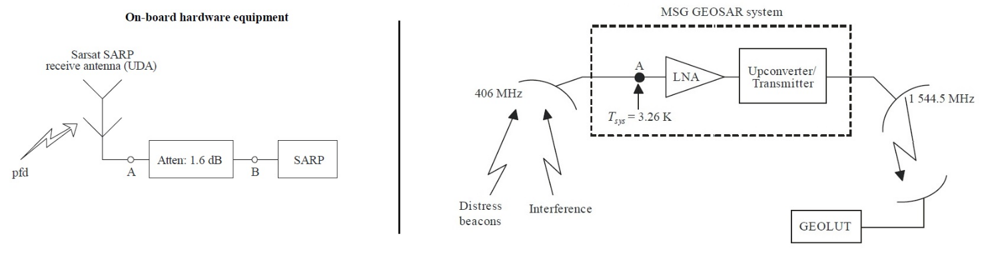
Figure 2 – COSPAS-SARSAT instruments: SARP (left) and SARR (right)

Protection criteria for both types of instruments are specified in ITU-R Recommendation M.1478-3.

It must be noted that all SARP and SARR instruments aboard LEO satellites have antennas designed to receive equally well signals straight below the satellite (nadir), signals close to the horizon, and everything in between. The characteristics of such antenna pattern, called “isoflux”, can be seen in the fragment of Table 1 in M.1478-3 shown below, where a nadir satellite angle of 0 degrees is straight downwards and 62 degrees is near the horizon. The antenna gain peaks at 62 degrees, indicating that a SARP instrument may receive lunar emissions relatively well when the Moon is close to the instrument’s horizon.

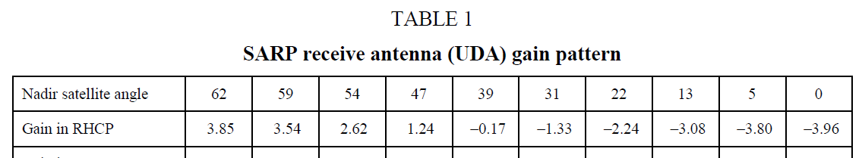

Emergency beacons initiate their transmissions with an unmodulated carrier (see Figure 3 below), which must be reliably detected by SARP and SARR instruments. Due to the extremely narrow bandwidth of this carrier (less than 40 Hz), two different types of interference are considered in M.1478-3:
- Narrowband spurious: These unwanted signals occupy a bandwidth below 40 Hz, and can degrade the performance of COSPAS-SARSAT instruments by being incorrectly identified and processed as valid beacon signals.
- Wideband noise from adjacent channels: These unwanted signals occupy a bandwidth significantly larger than 40 Hz and can degrade the performance of COSPAS-SARSAT instruments by raising the noise flor, which increases the risk of missing valid beacon signals.

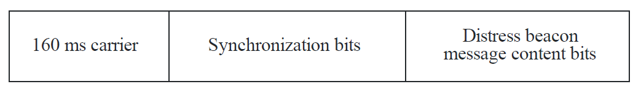
Figure 3 – COSPAS-SARSAT message format

The levels of protection required for all types of instruments are summarised in Table 4 below from M.1478-3:

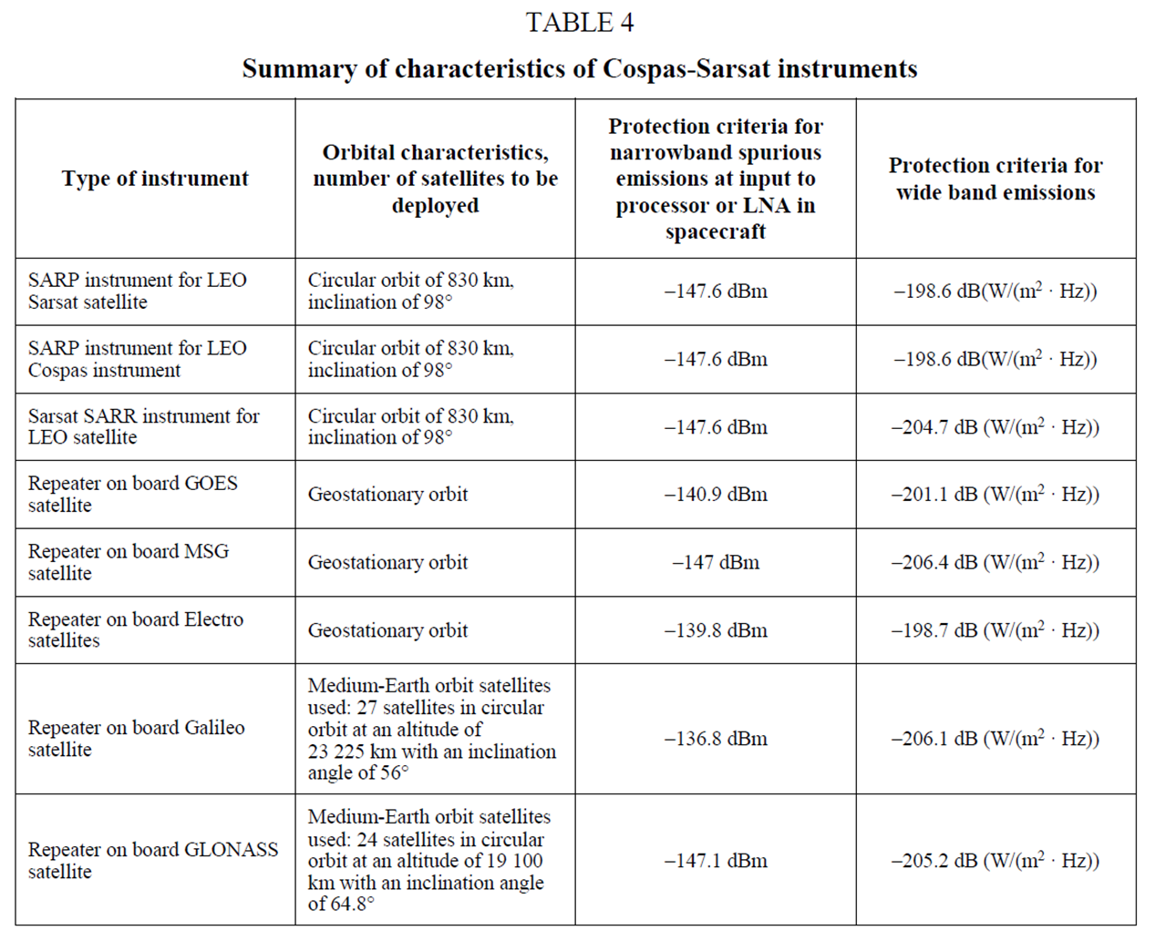

No protection criteria have been defined for co-channel interference, as they are prohibited by the Radio Regulations. However, co-channel interference from lunar voice and data emissions will almost certainly occupy a bandwidth far larger than 40 Hz, and therefore can be considered equivalent to wideband noise interference from adjacent channels.

Looking at the rightmost column in Table 4 (“protection criteria for wideband emissions”), the strictest value is -206.4 dB(W/m2/Hz) for a repeater on board an MSG satellite. This extremely low value is consistent with the low power, small antennas and challenging conditions that emergency beacons must operate within.

Estimation of maximum permissible EIRP for lunar emissions within 406-406.1 MHz

Assuming free space propagation, a transmitter’s surface flux density (SFD) at a distance d can be calculated from its effective isotropic radiated power (EIRP) as:

SFD[W/m2] = EIRP[W]/4/pi/d[m]^2 (1)
    - Which is equivalent to:

SFD[dBW/m2] = EIRP[dBW] - 20*log(d[Km]) – 71 (2)

Therefore, the EIRP required for a certain SFD at a distance d is:

EIRP[dBW] = SFD[dBW/m2] + 20*log(d[Km]) + 71 (3)

Converting EIRP & SFD to spectral densities (power per Hertz):

EIRP[dBW/Hz] = SFD[dBW/m2/Hz] + 20*log(d[Km]) + 71 (4)

Substituting SFD with the strictest protection criteria found earlier (-206.4 dB(W/m2/Hz)), and d with the shortest distance between Moon and Earth (356,400 Km), we obtain the maximum permissible EIRP spectral density:

EIRP_{max}[dBW/Hz] = -206.4 + 20*log(356400) + 71 = -24.4 dBW/Hz (5)

Given the difficulty of understanding in practical terms how problematic this value could be, we will translate it into actual EIRP values by making some assumptions on emission bandwidths (BW) and using the equation below:

EIRP_{max}[W] = 10^(EIRP_{max}[dBW/Hz]/10)*BW[KHz]*1000 (6)

Substititing EIRP_{max}[dBW/Hz] with the value found in equation (5) we obtain:

EIRP_{max}[W] = 3.66*BW[KHz] (7)

The following table shows some examples of voice and data modulations that could be used for lunar communications, showing their typical bandwidth (lower and higher values) and the corresponding maximum permissible EIRP based on equation (7):
 | Lower BW |  | Higher BW
Emission type | BW (KHz) | Max EIRP (W) | BW (KHz) | Max EIRP (W)
Digital voice (P25, TETRA, DMR) | 6.25 | 22.9 | 25 | 91.6
Analog voice (NBFM) | 10 | 36.6 | 15 | 54.9
Data (PSK, QAM, OFDM) | 8 | 29.3 | 1000 | 3660

For comparison, an EIRP of 200 W can be achieved by transmitting at 50 W through a 6 dBi collinear antenna; this is very common in land mobile radio (LMR). The approximate radio range 200 W EIRP on the Moon would be 17,500 Km (free space) or 12.5 Km (line-of-sight), assuming h_{t}=25m, h_{r}=3m, G_{r}=2.5 dBi, S_{r}=-120 dBm, L_{fading}=6 dB (see Figure 4 below). Higher EIRPs typically involve using directional antennas, which would be less likely to transmit significant power towards Earth.

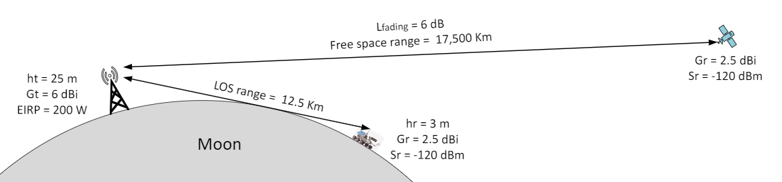
Figure 4 – Example of mobile narrowband lunar communication

Assuming that most lunar communication needs can be met with EIRPs under 200 W, high speed data communications (BW > 1 MHz) would be unlikely to exceed their maximum permissible EIRP, while lower rate data communications (BW < 100 KHz) could do it easily. Voice communications and basic telemetry (BW < 20 KHz) would be very likely to exceed their maximum permissible EIRP.

Conclusion

Based on the protection levels specified in Recommendation M.1478-3, and the estimation of Moon – Earth propagation loss, radio emissions from the Moon in the 406–406.1 MHz frequency band with EIRP exceeding -24.4 dBW/Hz could interfere with COSPAS-SARSAT instruments orbiting Earth. The likelihood of this interference would be particularly high for narrowband mobile communications, given their relatively large spectral density and use of omnidirectional antennas.
- ACTION BY THE MEETING

The meeting is invited to:
- note and review the contents of this working paper;
- consider sharing the concern discussed in this paper with the ITU-R (WP 5B and 7B), requesting either
- exclusion of the 406–406.1 MHz frequency band from Resolution 680 (WRC-23) and Agenda Item 1.15 (WRC-27); or
- a maximum EIRP limit of -24.4 dB(W/Hz) for lunar emissions towards Earth in the 406–406.1 MHz frequency band.
- consider sharing the concern discussed in this paper with affected organisations such as the IMO and COSPAS-SARSAT; and
- consider performing more detailed studies to account for additional signal losses caused by relative position and angle of transmitters on the Moon and COSPAS-SARSAT instruments.

— END —

See COSPAS-SARSAT document T.003 v5.1, section 5.
This formula is consistent with the free space loss model detailed in ITU-R Recommendation P.525-5, para 2.3.
This distance is a simplification of all possible cases, and does not consider potentially shorter distances between earthbound and lunar satellites; this simplification is reflected in point 3.d.
As per ITU-R Recommendation P.525-5, para 2.3.
Common approximation for LOS range is d[Km] = K*(sqrt(ht[m])+sqrt(hr[m])), where K=3.57 for Earth and K=1.86 for the Moon.

