

AFRICA-INDIAN OCEAN REGIONAL AVIATION SAFETY PLAN

(AFI-RASP)

Approved by and published under the authority of the Chairperson of the Africa-Indian Ocean Aviation System Planning andiimplementation Group (AASPG)

AFI-RASP 2026-2028 Edition - November 2026
RECORD OF AMENDMENTS AND CORRIGENDA

AMENDMENTS |  |  |  |  |  | CORRIGENDA
No. | Date | Title | Paragraph and Page Nº | Entered by |  | No. | Date | Entered by
Original | November 2023 | First Edition, First Issue
01 | November 2026 | Second Edition, First Issue

EXECUTIVE SUMMARY

The Global Aviation Safety Plan (GASP) presents the global strategy for the continuous improvement of aviation safety. The GASP aims to continually reduce fatalities, and the risk of fatalities, through the development and implementation of a global aviation safety strategy. A safe, resilient and sustainable aviation system contributes to the economic development of States across all regions and their industries. The GASP is the master planning document, upon which the regional aviation safety plans (RASPs) and national aviation safety plans (NASPs), respectively, are developed and implemented.
The Africa-Indian Ocean Regional Aviation Safety Plan (AFI-RASP 2026-2028 Edition) lists regionsl safety issues and sets regional safety goals and targets, in alignment with the goals and targets of the GASP 2026-2028 Edition. AFI-RASP provides a collaborative framework for the AFI States to manage operational safety risks and organizational challenges, through their respective NASPs, together with the aviation industry. The plan recognizes the need for aviation safety strategies to continuously evolve in response to changing regulatory, economic, and technological environments. The AFI-RASP is complemented by a series of safety enhancement initiatives (SEIs) to achieve its goals, contained in Appendices to the Plan. It provides the strategic direction for aviation safety management over a three-year period and requires States to allocate adequate resources and qualified personnel for the development and implementation of their NASPs.
This edition also highlights the impact of global aviation disruption events, such as pandemics and other emerging crises, emphasizing the importance of building a more resilient aviation system and establishes the foundations for the effective implementation of Safety Intelligence, enabling informed and evidence-based decision-making supported by reliable data and information.
The vision of the AFI-RASP supports the GASP vision which is to achieve and maintain the ambitious goal of “zero fatalities in commercial air transport operations by 2030 and beyond”, in line with the United Nations 2030 Agenda for Sustainable Development. Its mission is to continuously enhance aviation safety performance and resilience across the AFI region by providing a collaborative framework that brings together States and industry stakeholders. This is supported by a series of goals:

Goal 1 is to achieve a continuous reduction of operational safety risks.
Goal 2 aims to strengthen States’ safety oversight capabilities.
Goal 3 calls for the establishment and management of State safety programmes.
Goal 4 focuses on strengthening collaboration at the regional and national levels to address safety issues.
Goal 5 calls for strengthening aviation safety planning, through RASPs and NASPs.
Goal 6 aims to expand the use of industry evaluation programmes and safety data sharing programmes.

The AASPG Safety Strategy is aligned with the GASP 2026-2028 and is built around the six strategic goals supported by Safety Enhancement Initiatives (SEIs) and related actions to address organizational challenges, operational risks, and emerging safety issues.
To reduce the risk of fatalities, the AFI region has maintained the five Regional High-Risk Categories of Occurrences (R-HRCs) in the previous edition: Controlled Flight Into Terrain (CFIT), Loss of Control In-Flight (LOC-I), Mid-Air Collision (MAC), Runway Excursion (RE), and Runway Incursion (RI), which are also global high-risk categories of occurrences (G-HRCs).
The Plan also establishes a regional safety roadmap, defines the roles and responsibilities of States, regions, and industry, and promotes cooperation to address safety challenges. The AASPG, supported by the ICAO ESAF and WACAF Regional Offices, is responsible for the development, implementation, and monitoring of the AFI-RASP. Progress is regularly reviewed by the Safety Management and Oversight Sub-Group (SMO/SG) of the AASPG and monitored by the Programme Review and Coordination Committee (PRCC) of the Group to ensure that the intended safety outcomes are achieved.
The AFI-RASP was developed through extensive collaboration among States, industry stakeholders, regional and international organizations, Regional Safety Oversight Organisations (RSOOs), Regional Accident Investigation Organisations (RAIOs), and aviation experts, reflecting a strong commitment to improving aviation safety performance across the AFI region.

________________________________

TABLE OF CONTENTS

Title Page

Record of Amendments and Corrigenda …………………………………………………..…………. ii
Executive Summary…………………………………..……………………………………...…………iii
Definitions…………………………………………………………..…………………….…………....2
Abbreviations and Acronyms………………………………………………………………….……….4

Part-I: Planning……………………………………………………………………………………… 5

Chapter 1: Introduction ………………………………………………………………………….……. 5

Overview of the AFI-RASP………………………………………………………………...5

Structure of the AFI-RASP ………………………………………………………..……….5

1.3 Responsibility for the AFI-RASP Development, Implementation and Monitoring….….….7

1.4 Regional Safety Issues, Goals and Targets…………………………….……………….….20

1.5 Operational Context…………………………………………………….……………….…24

Chapter 2. Purpose of AASPG Regional Aviation Safety Plan (AFI-RASP)…..………………..…...26
Chapter 3. AFI Regional Operational Safety Risks………………………… …………..………..….27

Chapter 4. AFI Regional Organizational Challenges………................................................................33

Chapter 5. AASPG Strategic Direction for the Management of Aviation Safety …..…………..……38

Part-II: Implementation and Monitoring………………………………….………………………40

Chapter 6. Regional Aviation Safety Roadmap…………………………..………………………….40

Chapter 7. Monitoring Implementation …..……………………………..…………………….……..43

Appendices:

Appendix-1: Organizational Challenges (ORG) Roadmap……………………………………….…..44

Appendix-2: Regional Operational Safety Risks (OPS) Roadmap - Detailed SEIs: …………….… 65
Appendix-3: Performance monitoring mechanisms……………………………………………….…86
Appendix-4: SMO/SG, Terms of Reference (ToRs)………………………………..………………..96

Figures:

Figure-1: AFI-RASP development process…………………………..…………………….………….8
Figure-2: Relationship between the GASP, RASP and NASP…………………………………..….. 20

Figure-3: Critical Elements of a State’s safety oversight system……………………………….……38

Figure-4. ORG roadmap diagram …………………………………………………………….,,…….41

Tables:

Table-1: AFI-RASP goals, targets and indicators…………….………………………………………27
Table-2: Air transport occurrences in the RASG-AFI region (2023-2025)…………………………33
Table 3: Overall EI score and EI score by CE¹ for RASG-AFI………………………………………39

DEFINITIONS

Accident investigation authority. The authority designated by a State as responsible for aircraft accident and incident investigations within the context of Annex 13.

Audit. A systematic, independent and documented process for obtaining evidence and evaluating it objectively to determine the extent to which requirements and audit criteria are fulfilled.

Audit area. One of eight audit areas pertaining to the Universal Safety Oversight Audit Programme (USOAP), i.e. primary aviation legislation and civil aviation regulations (LEG), civil aviation organization (ORG); personnel licensing and training (PEL); aircraft operations (OPS); airworthiness of aircraft (AIR); aircraft accident and incident investigation (AIG); air navigation services (ANS); and aerodromes and ground aids (AGA).

Contributing factors. Actions, omissions, events, conditions, or a combination thereof, which, if eliminated, avoided or absent, would have reduced the probability of the accident or incident occurring, or mitigated the severity of the consequences of the accident or incident. The identification of contributing factors does not imply the assignment of fault or the determination of administrative, civil or criminal liability.

Critical elements (CEs). The critical elements of a safety oversight system encompass the whole spectrum of civil aviation activities. They are the building blocks upon which an effective safety oversight system is based. The level of effective implementation of the CEs is an indication of a State’s capability for safety oversight.

Effective implementation (EI). A measure of the State’s safety oversight capability, calculated for each critical element, each audit area or as an overall measure. The EI is expressed as a percentage.

Gap analysis. An evaluation that compares an existing situation to the desired one, it identifies specific steps that can be taken to reach a desired goal.

Hazard. A condition or an object with the potential to cause or contribute to an aircraft incident or accident.

Human performance. Human capabilities and limitations which have an impact on the safety and efficiency of aeronautical operations.

Incident. An occurrence, other than an accident, associated with the operation of an aircraft which affects or could affect the safety of operation.

Note. — The types of incidents which are of main interest to the International Civil Aviation Organization for accident prevention studies are listed in Annex 13, Attachment C.

Maximum mass. Maximum certificated take-off mass.

Operator. The person, organization or enterprise engaged in or offering to engage in an aircraft operation.

Safety. The state in which risks associated with aviation activities, related to, or in direct support of the operation of aircraft, are reduced and controlled to an acceptable level.

Safety audit. A USOAP CMA audit that a State requests and pays for (on a cost-recovery basis). The State determines the scope and date of a safety audit. Also see definition of audit.

Safety data. A defined set of facts or values collected for reference, processing or analysis which could be used to maintain or improve safety.

Safety enhancement initiative (SEI). One or more actions to eliminate or mitigate risks associated with contributing factors to a safety occurrence or to address an identified safety deficiency.

Safety information. Safety data processed, organized or analysed in a given context to support safety management and the development of safety intelligence.

Safety management system (SMS). A systematic approach to managing safety, including the necessary organizational structures, accountability, responsibilities, policies and procedures.

Safety oversight. A function performed by a State to ensure that individuals and organizations performing an aviation activity comply with safety-related national laws and regulations.

Safety performance. A State or a service provider’s safety achievement as defined by its safety performance targets and safety performance indicators.

Safety performance indicator. A metric used to measure and monitor a State or a service provider’s safety performance, including the progress towards achieving a safety objective.

Safety performance target. The State or service provider’s planned or intended target for a safety performance indicator over a given period.

Safety risk. The predicted probability and severity of the consequences or outcomes of a hazard.

State safety programme (SSP). An integrated set of laws, regulations, policies, objectives, processes, procedures and activities aimed at managing safety, at the State level.

Surveillance. The State activities through which the State proactively verifies through inspections and audits that aviation licence, certificate, authorization or approval holders continue to meet the established requirements and function at the level of competency and safety required by the State.

ABBREVIATIONS AND ACRONYMS

AASPG Africa-Indian Ocean Aviation Safety Planning and Implementation Group
ADREP Accident/incident data reporting
AIB Accident Investigation Board
AFI-RASP Africa-Indian Ocean Regional Aviation Safety Plan
APIRG AFI Planning and implementation regional group
ATO Approved training organization
CAA Civil aviation authority
CAST Commercial Aviation Safety Team
CFIT Controlled Flight Into Terrain
CICTT Commercial Aviation Safety Team (CAST)/ICAO Common Taxonomy Team
FIR Flight Information Region
GANP Global Air Navigation Plan
GASP Global Aviation Safety Plan
G-HRC Global High-risk category of occurrence
IDX Incident Data Exchange
iSTARS Integrated Safety Trend Analysis Reporting System
LOC-I Loss of Control In-flight
MAC Mid-Air Collision
NASP National aviation safety plan
NCLB No Country Left Behind
N-HRC National High-risk category of occurrence
PRCC Programme Review and Coordination Committee
PQ Protocol Question
RAIO Regional accident and incident investigation organization
R-HRC Regional High-risk category of occurrence
RSOO Regional safety oversight organization
SARP Standards and Recommended Practices
SEI Safety enhancement initiative
SMS Safety management system
SSC Significant Safety Concern
SSP State Safety Programme
UPRT Upset Prevention and Recovery Training
USOAP Universal Safety Oversight Audit Programme

______________________

PART-I. PLANNING

CHAPTER 1. INTRODUCTION

Overview of the AFI-RASP

    - The Africa-Indian Ocean Aviation Safety Planning and implementation Group (AASPG) is committed to enhancing aviation safety, to the resourcing of supporting activities and to increasing collaboration at the regional level. The purpose of this regional aviation safety plan for Africa-Indian Ocean (AFI-RASP) is to continually reduce fatalities, and the risk of fatalities, through the development and implementation of a regional aviation safety strategy. A safe aviation system contributes to the economic development of the AFI region, the States and the aviation industry. The AFI-RASP promotes the effective implementation of safety oversight systems of States in the AFI region, a risk-based approach to managing safety at the regional level, as well as a coordinated approach to collaboration between States in the region, RSOOs , RAIO , other regional and international organizations, and industry. All stakeholders are encouraged to support and implement the AFI-RASP as the regional strategy for the continuous improvement of aviation safety.

    - The AFI-RASP 2026-2028 Edition covers the three-year period between 2026 and 2028 and will be updated on a yearly basis, as required, for relevancy purposes.

    - Reports on the progress on implementation of the plan will be produced by the SMO Sub-Group to the PRCC on a quarterly basis. The PRCC will evaluate the effectiveness of the SEIs and their relevance and ensure that the process to manage risks continuously improves; this may contribute to the identification of new safety issues. The PRCC will be reporting to the AASPG on annual basis accordingly. AASPG is committed to enhancing aviation safety and to increasing collaboration at the regional level.

    - The AFI-RASP is in alignment with the ICAO Global Aviation Safety Plan (GASP, Doc 10004) and the national aviation safety plans of States in the region.

Structure of the AFI-RASP

    - The AFI-RASP 2026-2028 Edition presents the regional direction for the management of aviation safety at the regional level, for a period of 3 years. It comprises two parts (Planning; and Implementation and Monitoring) and seven chapters. In addition to the introduction, chapters include: the purpose of the AFI-RASP, AASPG’s strategic approach to managing aviation safety at the regional level, the regional operational safety risks identified for the AFI-RASP 2026-2028 Edition, regional organizational challenges addressed in the AFI-RASP, and a description of how the implementation of the safety enhancement initiatives (SEIs) listed in the AFI-RASP is going to be monitored.

The two parts of AFI- RASP 2026-2028 Edition are:

- Part-I. Planning includes the introduction, describes the strategic direction for the management of safety, regional operational safety risks, and regional organizational challenges. It consists of Chapters 1 to 5.

- Part-II. Implementation and Monitoring contains the implementation of the plan and safety performance monitoring with the detailed list of AFI-RASP safety actions. It consists of Chapters 6 and 7.

- Both parts are supported by appendices providing further details.

Chapter 6 presents the AASPG Region safety indicators and targets. It facilitates the identification of SEIs and their respective actions relevant for each Goal identified in the Regional Safety Strategy as follows:

Goal 1 is to achieve a continuous reduction of operational safety risks.
Goal 2 aims to strengthen States’ safety oversight capabilities.
Goal 3 calls for the establishment and management of State safety programmes.
Goal 4 focuses on strengthening collaboration at the regional and national levels to address safety issues.
Goal 5 calls for strengthening aviation safety planning, through RASPs and NASPs.
Goal 6 aims to expand the use of industry evaluation programmes and safety data sharing programmes.

    - The AASPG Regional Safety Strategy includes six (6) Goals in line with GASP 2026-2028 Edition. SEI(s) have been identified and mapped to each Goal established, including their respective actions and the following information is provided:

Goal: Goal supports the region’s strategic approach to managing safety at the regional level.

- Name: Goal #Number - SEI# Number: Description of the SEI;
- Target(s)/Metrics. Targets which serve to fulfil their respective Regional Goal;
- Rationale behind the safety issue (why it has been identified as an issue);
- Objective (What is to be achieved);
- Monitoring Progress (How to improve in the future);
- Achievements (How to achieve the objective); here, the various actions contributing to mitigate the identified risk in that area are described;
- Actions: The tasks required for the implementation of the SEI. The actions support the SEI and Targets of the Regional Goal;
- References: Indicates key documents from which the SEI is adopted, if applicable.

Example Action 1: Description of the Action to be taken
Subtask(s): if needed to be added

Owner(s): Appointed Group/State(s)/Organization(s) to further develop details for implementation of the respective Action

Priority: Low/Medium/High

Completion Date: The date by which the respective Action is expected to be implemented

Status: New/ongoing/on hold/completed. (Provide also updated progress if any)

Example Action 2: Description of the Action to be taken
Subtask(s): if needed to be added

Owner(s): Appointed Group/State(s)/Organization(s) to further develop details for implementation of the
respective Action

Priority: Low/Medium/High

Completion Date: The year(s) in which the respective Action is expected to be implemented
Status: New/ongoing/on hold/completed. (Provide also updated progress if any)

EXPECTED OUTPUT
Deliverable(s) Timeline
Description of the Result to be achieved The year in which the respective Target is expected to be
achieved

Process for the AFI-RASP Development, Implementation and Monitoring

    - The SMO Sub-Group, under the directive of the AASPG, is responsible for the development, implementation and monitoring of the AFI-RASP, in collaboration with the ICAO Regional Offices for Eastern and Southern Africa (ESAF) and Western and Central Africa (WACAF), African Civil Aviation Commission (AFCAC), international and regional organizations; and with the aviation industry. The AFI-RASP was developed in consultation with States, operators and other stakeholders in the region, and in alignment with the GASP 2026-2028 Edition, to ensure that the plan and its content reflect the needs of the aviation community at the regional and national levels. Appendices 1, 2, 3 contain SEIs related to identified regional operational risks, organizational challenges, and emerging risks. In addition, the SMO Sub-Group takes the lead and ensures that SEIs are accomplished in a timely, effective and efficient manner in coordination with States, regional organizations, and industry.

    - The key contents of the AFI-RASP are developed using an eight-step process recommended by the GASP to develop RASPs and NASPs, similar to the continuous improvement cycle, as follows:

Figure 1: AFI-RASP development process
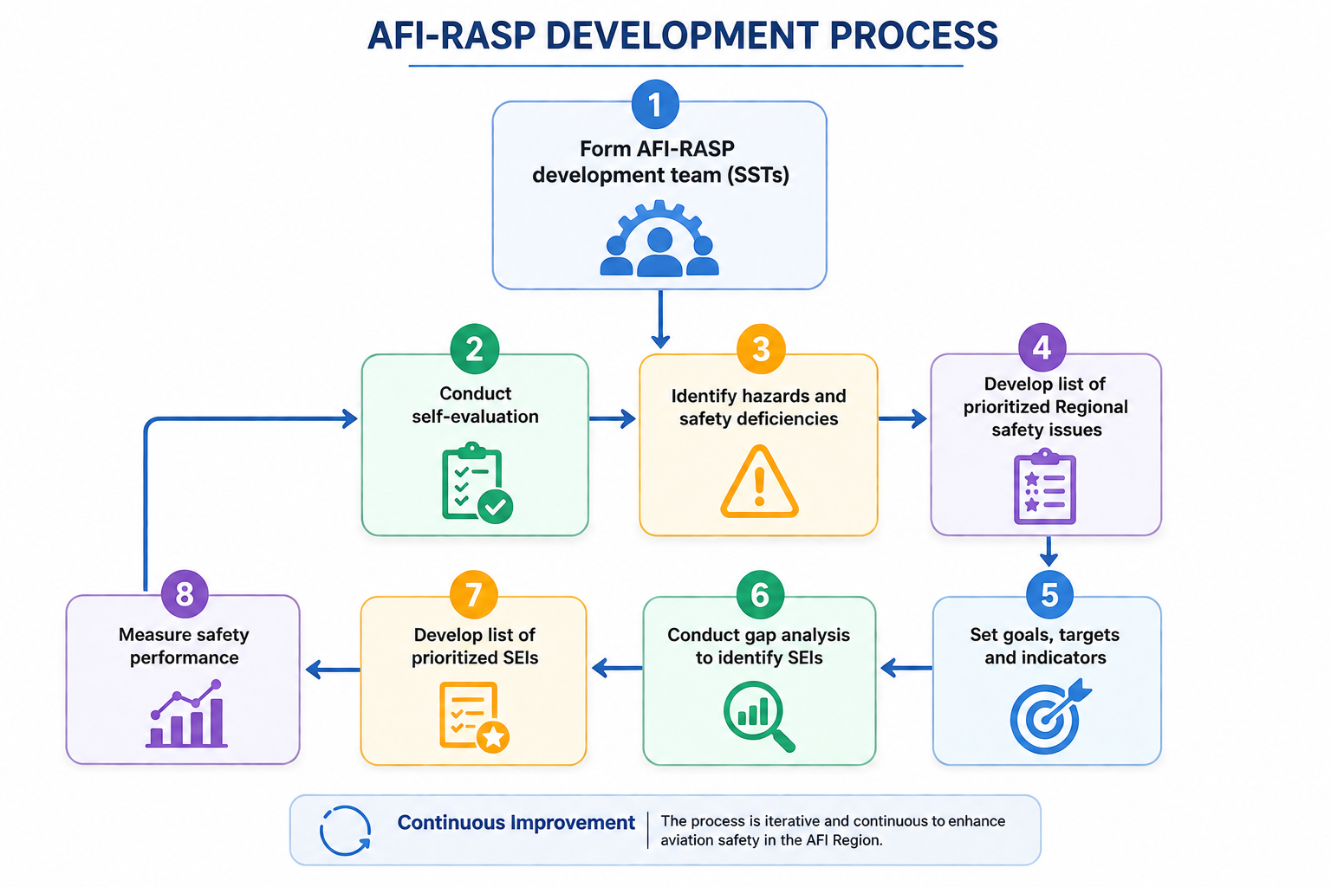
Note — The AFI-RASP should ideally connect with other regional plans, some of which may or may not be exclusively focused on civil aviation. This connection ensures the integration of the AFI-RASP to other areas of aviation and raises the visibility of aviation-related initiatives at the broader national level.
Step 1 – Form AFI-RASP development team (AFI-RASP/NASP Project Team);
Step 2 – Conduct self-evaluation;
Step 3 – Identify hazards and safety deficiencies;
Step 4 – Develop list of prioritised regional safety issues;
Step 5 – Set goals, targets and indicators;
Step 6 – Conduct gap analysis to identify SEIs;
Step 7 – Develop list of prioritised SEIs; and
Step 8 – Measure safety performance.

FORM THE AFI-RASP DEVELOPMENT TEAM (STEP 1)

        - The process for developing the AFI-RASP began by assigning a responsible entity (the AASPG – SMO Sub-Group), to lead the development of the AFI-RASP. The SMO Sub-Group has established an AFI-RASP/NASP Development Project Team to be responsible for completing steps 2 to 8 in Figure 1.

        - The AFI-RASP development process requires active engagement with stakeholders to allow for a better understanding of the operational context, the identification of hazards and safety deficiencies, and the development of possible mitigation strategies (in other words, SEIs) from the perspective of each stakeholder. Therefore, the AFI-RASP/NASP Development Project Team has identified stakeholders early in the development process. In addition to the direct stakeholders (for example, the CAA, service providers, etc.), any entity which could be involved in financing, implementing or influencing changes, or which is significantly affected by these changes, should be considered (for example, national Focal Points for NASPs, national continuous monitoring coordinators and points of contact responsible for other aviation-related national plans and programmes, such as the national air navigation plan or the national civil aviation security programme), in order to promote visibility and alignment among them.

        - Once the stakeholders have been identified, the list of participants on the AFI-RASP development was reviewed by the Project Team to ensure that all appropriate constituents are represented. Successful implementation of the AFI-RASP depends on having the appropriate stakeholders actively engaged in its development. The membership list of the AFI-RASP development SMO/SG is provided as Appendix 4 to this Plan.

        - The membership list of the AFI-RASP development SMO-Sub Group is the output from this step.

CONDUCT A SELF-EVALUATION (STEP 2)

        - Once the AFI-RASP/NASP Development Project Team is set up, it began its work with an evaluation of the current situation in the Region to obtain an understanding of its operational context. This activity is referred to as “self-evaluation”.

        - To develop the AFI-RASP, the AFI-RASP/NASP Development Project Team understands the operational context in which the AFI-RASP should be implemented. Every State in the AFI Region has a collection of factors that may contribute to or otherwise affect the management of aviation safety within the Region. A key part of the AFI-RASP development process is to identify the Region’s strengths and enablers that can promote change and to build upon these. The self-evaluation helps the Project Team to understand the Region’s operational context and should include: the analysis of established capabilities; system size and level of complexity; and available resources, using several sources of information.

        - As shown in Figure 1, the self-evaluation should be repeated at regular intervals and according to the results of safety performance measurement and developing trends. Other factors, such as a significant change in the Region’s operational context or other aviation-related regional plans and programmes may also prompt consideration of a new self-evaluation and corresponding updates to the AFI-RASP.

        - Other key aspects the SMO Sub-Group should assess are:

- the effective implementation (EI) of the eight critical elements of States’ safety oversight system in the Region; and

- the SSP establishment and management , as well as its continuous improvement.

        - These aspects allow the SMO Sub-Group to understand the Region’s safety oversight capabilities and operational context.

        - ICAO has provided several tools that can assist the AFI-RASP/NASP Development Project Team to identify specific issues related to safety oversight and SSP implementation. The Integrated Safety Trend Analysis and Reporting System (iSTARS) tools are available online at www.icao.int/safety/iStars. They include, the following applications:

- Protocol Question (PQ) Tester;

- Safety Audit Information;

- Regional Safety Briefing; and

- State Safety Briefing

        - In addition, the Universal Safety Oversight Audit Programme Continuous Monitoring Approach (USOAP CMA) Online Framework (OLF) is a suite of web-integrated applications and centralized database systems, which enables collection of safety-related information and documentation from different sources, and monitors and reports on safety oversight activities by ICAO and States. Further information about the OLF can be found on the ICAO website at www.icao.int/usoap. A dedicated website provides States with access to the OLF for the:

- completion or updates of the State aviation activity questionnaire (SAAQ);

- completion or updates of the compliance checklists through the electronic filing of differences (CC/EFOD) system;

- completion or updates of the USOAP CMA self-assessment;

- completion or updates of the State corrective action plan (CAP);

- response to mandatory information requests (MIR); and

- access to all safety-related information generated by USOAP CMA activities.

        - The AFI-RASP may call for States to incorporate and implement a series of regional SEIs into their respective NASPs. However, it is valuable for the SMO Sub-Group to understand the Region’s operational context, which will then enable it to identify hazards and safety deficiencies and prioritize regional safety issues (as part of Steps 3 and 4). This is an important part of the AFI-RASP development process to ensure the AFI-RASP will be tailored appropriately and that it will be meaningful to the Region as well as the needs of States in the Region. The SMO Sub-Group may refer to the GASP and the individual NASPs for information, but they should ensure that any global, regional or national safety issues, or SEIs to address them, are relevant to the national aviation systems before States in the Region can incorporate them into their NASPs.

        - The document containing the self-evaluation is the output from this step.

IDENTIFY HAZARDS AND SAFETY DEFICIENCIES (STEP 3)

        - Based on the results of the self-evaluation, the SMO Sub-Group can identify the hazards and safety deficiencies that need to be addressed in the AFI-RASP, as well as the stakeholders who should be involved in addressing them. In the context of the AFI-RASP development process, hazards and safety deficiencies include operational safety risks and organizational challenges (for example, lack of effective safety oversight, difficulties in implementing an SSP, etc.).

        - In addition to the self-evaluation, the SMO Sub-Group consulted the GASP 2026-2028 Edition. This document assists in determining operational safety risks and their contributing factors, as well as organizational challenges. The SMO Sub-Group also referred to the AASPG for assistance in identifying hazards and safety deficiencies. As noted in Step 2, the SMO Sub-Group did not just refer to the GASP or AASPG in an attempt to skip this step; it is valuable for the Sub-Group to determine the Region’s operational safety risks and organizational challenges. These other sources provide additional information.

        - The SMO Sub-Group conducted data-driven analyses (or use existing analyses, or other information) to determine operational safety risks and contributing factors leading to Regional high-risk categories of occurrences (R-HRCs), as well as any systemic safety deficiency (in other words, organizational challenges).

        - The SMO Sub-Group may identify hazards and safety deficiencies based on analyses from:

- mandatory reporting systems;

- voluntary reporting systems, while ensuring that the Region accords protection to safety data
captured by, and safety information derived from, these and related sources;

- accident and incident investigation reports, which may assist in identifying contributing
factors to accidents and incidents, as well as lessons learned from the analysis of occurrences;

- safety oversight activities over a defined period;

- the SSP (if applicable to the State);

- USOAP data;

- regional analysis conducted by entities such as the AASPG, regional safety oversight
organizations (RSOOs), regional accident and incident investigation organization (RAIO), and any resulting regional HRCs (R-HRCs) as well as organizational challenges; and

- G-HRCs and organizational challenges described in the GASP.

        - Based on the results of the self-evaluation and the identified hazards and safety deficiencies, the SMO Sub-Group may identify additional stakeholders with supporting capabilities, additional resources and other strengths or opportunities that can assist it in addressing the safety issues and enable SEIs. Stakeholder mapping should include all stakeholders that can contribute to the success of the AFI-RASP. Therefore, this step may result in additional stakeholders being included in the SMO Sub-Group, since they may be involved in developing, implementing and monitoring SEIs identified in the AFI-RASP.

        - The SMO Sub-Group has prepared a list of identified hazards and safety deficiencies. The list describes a series of Regional operational safety risks, including the G- and N-HRCs (that may be applicable from the GASP and NASP, respectively). The Sub-Group has also included in this list, a series of organizational challenges that exist in the States in the Region. The list of hazards and safety deficiencies will later become the basis for the regional safety issues that the AFI-RASP and NASPs will address.

        - A list of hazards and safety deficiencies is the output from this step.

      - DEVELOP LIST OF PRIORITIZED REGIONAL SAFETY ISSUES (STEP 4)

        - Once the SMO Sub-Group has completed listing the hazards and safety deficiencies, it proceeded to the next step: defining regional safety issues that should be given priority in the AFI-RASP. The identification of hazards and safety deficiencies enables the SMO Sub-Group to define a series of regional safety issues, which will later be transformed into regional safety goals and targets. During this step of the process, the SMO Sub- Group reviewed the list of hazards and safety deficiencies to be addressed in the AFI-RASP and determined which ones should be given priority. The Sub- Group used a quantitative approach (in other words, data-driven) to develop a list of prioritized regional safety issues. Where a quantitative approach is not feasible, it may rely on the knowledge and expertise of the AFI-RASP SMO Sub-Group. Highest priority was given to issues that have the greatest impact on safety, such as the R-HRCs.

        - For operational safety risks, the SMO Sub-Group categorized certain types of occurrences, such as R-HRCs, in the Region’s operational context, and consider them of the utmost priority based on the number of fatalities and risk of fatalities associated with such occurrences.

        - In addition to R-HRCs, the SMO Sub-Group may categorize certain organizational challenges as regional safety issues and consider them of priority because they impact the effectiveness of safety risk controls.

        - As a result of step 4, the SMO Sub-Group prepared a list of prioritized regional safety issues to be addressed in the AFI-RASP.

        - The list of prioritized regional safety issues is the output from this step

Note.— Before finalizing the list, the AFI-RASP/NASP Development Project Team should verify whether the list of prioritized national safety issues included in the NASP interrelates with other national and/or regional civil aviation plans (for example, the national air navigation plan).

      - SET GOALS, TARGETS AND INDICATORS (STEP 5)

        - The SMO Sub-Group has used the list of prioritized regional safety issues to set the regional safety goals and targets. Regional safety issues that were given priority (in step 4) are formulated into statements that set goals and targets within the AFI-RASP.

        - The regional safety goals are the results toward which the Region’s efforts in aviation safety are directed. They present the desired outcomes that the Region’s safety strategy (to be presented in the AFI-RASP) aims to produce. The SMO Sub-Group writes the regional safety goals in a manner that describes high-level outcomes that Region aims to achieve (for example, strengthen the Region’s safety oversight capabilities).

        - Each of the regional safety goals contain specific targets. Targets are specific desired outcomes from
the specific actions taken by the Region (and industry, where applicable) to achieve the regional safety goals, at a certain point in time. The SMO Sub-Group should write the regional safety targets in a manner that identifies who the specific actions are directed to (for example, the States).

        - Each target should also include a list of indicators that the Region will use to measure progress towards achieving the respective goal. Goals may contain more than one target and each of the targets should be linked to a series of indicators. Indicators are a measurement index used to evaluate whether the AFI-RASP yields the expected results. The indicators provide evidence about whether the desired outcomes occurred and measure the progress in the activities related to the national safety targets. The SMO Sub-Group wrote the indicators in a manner that references quantitative data (for example, number or percentage). Some indicators may refer to occurrences that are deemed an outcome of deficient management of aviation safety (for example, number of accidents). Others may refer to activities conducted by the Region or other stakeholders, deemed to improve the management of aviation safety (for example, percentage of completed corrective action plans). Some indicators may also be relevant to multiple goals or targets. Ultimately, the Region has used a series of indicators to measure the achievement of the regional safety goals (and associated targets) presented in the AFI-RASP (refer to step 8).

        - The list of regional safety goals, targets and indicators is the output from this step. The SMO Sub-Group
is aware of how the regional safety goals, targets and indicators may affect other national civil aviation plans and programmes to mitigate any potential contradictions.

CONDUCT GAP ANALYSIS TO IDENTIFY SEIs (STEP 6)

        - Once the SMO Sub-Group has set the regional safety goals and targets, it needed to identify a series of SEIs that will enable their achievement. The next step in the process is to conduct a gap analysis, which helps the Sub-Group identify specific steps to take to reach each regional safety goal and the associated targets. The SMO Sub-Group did not only focus on the weaknesses it needs to address, but also identified the strengths within the region that can facilitate closing the gap, such as existing economic frameworks, access to training, etc. To develop the SEIs for the AFI-RASP, the SMO Sub- Group conducted the gap analysis using the Global Aviation Safety Roadmap (Doc 10161), commonly referred to as “the roadmap”. The compilation of SEIs will form the action plan that supports the safety strategy presented in the AFI-RASP.

        - The roadmap contains a series of SEIs providing detailed actions to be taken when addressing the identified hazards and safety deficiencies. Using the roadmap, the SMO Sub-Group selected which SEIs, and their specific actions, will be implemented and in what order.

        - To identify SEIs that address organizational challenges, the SMO Sub-Group referred to the Organizational Challenges (ORG) Roadmap portion of the roadmap. Using data from a number of existing sources (for example, USOAP, Region’s surveillance activities and industry assessment programmes) or from the knowledge provided by subject matter experts, the SMO Sub-Group can identify the appropriate starting point within the ORG Roadmap (for example, Phase 1).

        - Following the completion of the gap analysis, the SMO Sub-Group selected a series of SEIs that are needed to address the identified hazards and safety deficiencies that will help the Region achieve the regional safety goals (and associated targets) presented in the AFI-RASP. By reviewing the identified hazards and safety deficiencies and/or results of the gap analysis in comparison to the selected SEIs, the SMO Sub-Group can select a list of potential SEIs. To determine if the Region has already completed an SEI, the SMO Sub-Group may consider the latest USOAP results or the Region’s own data if an internal evaluation was conducted. If it is determined that the Region has not completed the SEI, and that it is needed, this would then be listed as a “gap”. The SEI would then be identified as one of the SEIs that should be incorporated into the AFI-RASP. The associated actions listed under that SEI (as presented in the roadmap) would need to be listed as actions to complete this SEI. Figure 2 presents an example of the relationship between the GASP, the AFI-RASP and the NASP.

        - In addition, the SMO Sub-Group conducted a similar review of the SEIs presented in the Operational Safety Risks (OPS) Roadmap portion of the roadmap and identified those that have not been implemented to serve as safety risk mitigations for the R-HRCs. A series of SEIs should be implemented to address contributing factors leading to the R-HRCs. Some of these SEIs were derived from the OPS Roadmap; others were identified through sources such as accident or incident investigations, or safety risk assessments.

        - A list of potential SEIs is the output from this step.

      - DEVELOP LIST OF PRIORITIZED SEIs (STEP 7)

        - The gap analysis enables the SMO Sub-Group to identify SEIs that have not been implemented.
By reviewing the gaps and the associated SEIs, they can produce a list of potential SEIs. However, it is impractical to attempt to implement an AFI-RASP that addresses all SEIs listed in the roadmap. The SMO Sub-Group selected the SEIs relevant to the Region and its operational context, by listing them in order of priority. The use of performance management tools, such as the specific, measurable, achievable, relevant and timely (SMART) approach to setting goals and targets, can help frame the actions that the Region and other stakeholders carry out in the context of SEI implementation. The SMART approach may assist stakeholders in staying focused and motivated by ensuring a clear direction and by helping to set achievable targets to promote implementation. The SEIs should contribute to an overall SMART package of goals, targets and indicators.

Note.— Information on the use of SMART is found in ICAO Doc 9859.

        - When reviewing the gaps identified, the AFI-RASP/NASP Development Project Team considered evaluating the safety impact and the ability of (or ease of implementation for) the Region to effect the change for each gap.

Safety impact

        - The SMO Sub-Group evaluated how safety will be enhanced through the elimination of each identified gap and prioritized SEIs that have the greatest impact on safety. Ideally, a quantitative approach using various methodologies was applied. However, it may be difficult to apply a quantitative assessment to all SEIs, as many address the key foundation of aviation safety. With the knowledge of subject matter experts that form part of it, the AFI-RASP SMO-Sub Group can list potential actions in a manner that will have the greatest impact on safety.

Ease of implementation

        - Although the SMO Sub-Group should consider the impact on safety as the primary method to prioritize the list of potential SEIs, it should also assess the ability of stakeholders to make the changes and adapt to a new situation. The evaluation of the ability to effect a change should include:

- the existence of political will to change; and

- the availability of resources necessary to implement the change.

        - Using the list of SEIs, the SMO Sub-Group has specified which initiative should be implemented first. The list includes a manageable set of actions that represent the steps necessary to progress towards the achievement of the regional safety goals (and associated targets). Reviews of unsuccessful attempts at previous efforts to improve safety have shown that strategic plans should be developed so that they define successive activities that are achievable. The SMO Sub-Group did not select SEIs that would require significant transformations of the aviation system in a short timeframe. They identified a step-by-step approach to achieving implementation (following all the steps presented in Figure 1).

        - As a result of Step 7, the SMO Sub-Group generated a prioritized list of SEIs. This list forms the action plan to achieve the regional safety goals (and associated targets). Once a list of potential prioritized SEIs is developed, the Sub-Group was ready to begin drafting the AFI-RASP. The AFI-RASP is the master document for presenting the regional safety strategy and implementing the SEIs at the regional level.

        - The AFI-RASP does not have to contain all actions that will support each SEI in detail; some SEIs may be presented in a stand-alone document containing a detailed implementation plan (for example, for the establishment of an independent regional accident and incident investigation organisation). The AFI-RASP has provided a summary of the SEIs, associated actions, the responsible entity assigned to lead the implementation, general timelines, stakeholders involved, metrics to measure implementation, the priority assigned to each SEI and the means to monitor implementation and effectiveness. A link or reference to the detailed implementation plan may be included in the AFI-RASP.

        - A list of prioritized SEIs is the output from this step.

      - MEASURE SAFETY PERFORMANCE (STEP 8)

        - This final step, on the measurement of safety performance, is divided into two separate tasks:

- the definition of the process to monitor implementation of the AFI-RASP and its effectiveness; and

- the actual measurement of safety performance.

        - First, the SMO Sub-Group has defined how the Region will measure safety performance to monitor the implementation of the AFI-RASP and its effectiveness. At this stage, the Sub-Group has determined aspects, such as the processes to:

- monitor the implementation of the SEIs listed in the AFI-RASP;

- track performance of each regional safety target (including the use of the indicators presented in the AFI-RASP); and

- provide stakeholders with relevant up-to-date information on the progress made in achieving the regional safety goals, as well as the implementation status of SEIs.

        - The SMO Sub-Group has also defined the process for making corrections and adjustments to the AFI-
RASP and its SEIs; addressing specific situations (for example, actions in the event that regional safety goals are not met); and reporting on these points to stakeholders. The SMO Sub-Group has included a description of all these processes in a dedicated section on “monitoring implementation” in the AFI-RASP (refer to Chapter 7 for detailed guidance). This description is the output from this step.

        - Once it has defined the process for monitoring implementation, the SMO Sub-Group has all the contents necessary to finalise the drafting of the AFI-RASP, which covers all the points described in Figure 1.

        - The SMO Sub-Group’s work does not end once the AFI-RASP has been developed and turned over to the organizations or individuals responsible for leading the implementation. This is when the second task of this step begins: the SMO Sub-Group should measure safety performance to monitor the implementation of the AFI-RASP and assess its actual effectiveness in terms of improving safety at the regional level. The Sub-Group should periodically monitor the implementation of SEIs to ensure actions are being accomplished, that they are effective and that any difficulties in implementation are dealt with.

        - When the implementation of SEIs is completed, or sooner if warranted by other factors (for example, changes in the Region’s operational context resulting from disruptive events or developing trends), the SMO Sub-Group should repeat the process listed in Figure 1 starting from step 2, to ensure the hazards and safety deficiencies, safety issues, as well as the goals and targets are still relevant to the Region’s operational context; and identify other SEIs the Region may need to manage. This promotes a regular update of the AFI-RASP to address newly identified hazards and safety deficiencies and ensures continuous improvement.

Note.— The AFI-RASP/NASP Development Project Team may exist for the lifespan of each edition of the AFI-RASP (3 years), and its membership may evolve depending on its needs. The AASPG through the PRCC and the SMO Sub-Group, will maintain an ongoing coordination and monitoring of the updates to the AFI-RASP-related SEIs, including responsible persons within the States and the different stakeholder organizations.

    - The AASPG should ensure that the AFI-RASP is maintained and regularly reviewed. The AFI-RASP provides the identified safety priorities in the region and States should identify which top risks and key issues mentioned in the GASP and AFI-RASP which apply to their national context, and identify suitable mitigation actions within their NASPs. States should also add/consider other safety issues which are unique to their operational context. Furthermore, States should establish a NASP to be aligned with the GASP and AFI-RASP; and based on their operational safety needs.

    - The AASPG reviews the AFI-RASP as part of its work programme, after submission by the PRCC, and consults with States and other stakeholders on proposed amendments. The consultation is conducted through AASPG Meetings and provides the following inputs:

- review of the regional progress made in improving aviation safety performance and in the implementation of SSPs and safety management systems (SMS), as well as any relevant risk mitigations;

- recommendations by the PRCC;

- lessons learned by States, region and industry;

- possible changes in future aviation needs, regulatory contexts and other influencing factors;

- results of research, development and validation on operational and technological matters which may affect the global aviation safety roadmap; and

- proposed amendments to the GASP’s content.

    - The AFI-RASP is intended to elevate the commitment of the AFI Region to improve its safety oversight capability, which relates to the continuous reduction of regional operational risks and improvement in safety oversight capabilities and safety management of States. In particular, the AFI-RASP serves to raise awareness of safety risks and consequences to States, industry and relevant stakeholders to commit and provide resources including financial, staffing and technical expertise, to making improvements in safety management, oversight capability and operational safety performance. It also provides a basis to facilitate information sharing between relevant stakeholders who can take actions or provide support to address issues.

    - At the regional level, the AFI-RASP commits AASPG to continue the following efforts:

- Focus on the development of the current regional SEIs to address the regional High Risk Categories of occurrences (R-HRCs), which are also global: CFIT, LOC-I, MAC, RE and RI, and other priorities as identified for the AFI region in a data-driven and strategic manner, which may include organizational challenges and emerging risks;
- Continue implementation support to States and industry, including the development of guidance materials as well as the organization of training workshops to provide assistance and guidance to AFI States;
- Assist States in the development and implementation of SSP (SMS by the industry) and the NASPs;
- Promote regional government and industry collaboration for sharing best practices in safety management;
- Put in place a mechanism for the collection, analysis and sharing of safety and operational data in the region to support a comprehensive approach to risk management, and facilitate initiatives to develop Regional data collection, and analysis;
- Promote the effective implementation of AGA, with a focus on runway safety Programmes that support the establishment of Runway Safety Teams (RSTs) and implementation of
SMS;
- Support States in the development of legislative framework for Unmanned Aircraft Systems (UAS).

    - States and industry are committed to the following efforts:

- Implement, as appropriate, the GASP SEIs and AFI-RASP SEIs and their respective actions effectively and efficiently;
- Give priority to the resolution of any SSCs identified by the ICAO USOAP CMA Programme. These should draw on the necessary resources available, including technical assistance from other States and Regional Programmes to resolve the SSCs promptly; and establish mechanisms to avoid emergence of new ones;
- Give priority to the implementation of SSP by States; and SMS by the industry; and
- Use data-driven methodologies to identify HRCs, and implement collaborative solutions to reduce accident rates and fatalities in the Region, and likewise accord priority to the implementation of respective SEIs.

    - The ICAO ESAF and WACAF Regional Offices

The ICAO Eastern and Southern African; and Western and Central African Offices play a role in supporting and monitoring the achievement of the AFI-RASP goals at the regional and national levels. They promote collaboration at the regional level to enhance safety. The Regional Offices will conduct their safety planning and implementation at strategic levels, and will provide support to the AFI States at tactical levels for the achievement of their objectives and targets.

The Regional Offices will provide support to the States in the planning and implementation of their national aviation safety plans. To provide this support, the Regional Offices will coordinate with the corresponding States through on-site assistance missions or virtually, as prevailing circumstances may dictate. Such assistance will be conducted in collaboration with other stakeholders including, RSOOs, RAIOs, other States, etc.

    - Consider various options to leverage ICAO-recognized industry assessment Programmes such as the IATA Operational Safety Audit (IOSA), IATA Safety Audit for Ground Operations (ISAGO), Airports Council International (ACI) Airport Excellence (APEX) in Safety programme, etc.

    - The coordination of activities between AASPG and other stakeholders is key to the successful achievement of the AFI-RASP goals and the AFI Regional Air Navigation Plan ambitions, respectively, since increases in air navigation capacity and improvements in efficiency must be done in a safe manner and appropriate safety risk mitigations are required to prevent accidents.

Relationship with other Global Plans

    - The Convention on International Civil Aviation establishes ICAO’s objective to foster “the planning and development of international air transport”. Air transport is a key enabler for sustainable economic and social development. ICAO’s global plans are essential in supporting safe, secure, efficient, economically viable and environmentally responsible air transportation. They provide a means to advance ICAO’s Strategic Objectives. The ICAO global plans include: the GASP, the GANP and the Global Aviation Security Plan (GASeP).

    - Safety is critical when planning implementation of air navigation operational improvements, in line with the GANP, to determine if these improvements can be implemented in a safe manner. A safety risk assessment provides information to identify hazards that may arise from, for example:

a) any planned modifications in airspace usage;

b) the introduction of new technologies or procedures; or

c) as a result of the decommissioning of older navigational aids.

    - A safety risk assessment also enables the assessment of potential consequences (e.g. a mid-air collision). Based on the results of a safety risk assessment, mitigation strategies may be implemented to measure and monitor the safety performance associated with any air navigation operational improvement. Any operational improvement to enhance the performance of the air navigation system should be built based on a safety risk assessment.

    - The GASP complements the GANP by providing States and industry with the tools to implement a safety management approach through their SSP and SMS. The GANP, through the evolution of the system described in the conceptual roadmap and the operational improvements detailed in the technical frameworks, supports the goals within the GASP and the GASeP by enhancing safety and security of the air navigation system as reflected in the performance ambitions.

    - Safety and security are of paramount importance in aviation. The travelling public’s perception of a safe aviation system is also linked to how secure the system is in actuality. Fatalities that result from acts of unlawful interference affect the public’s perception of aviation safety. The GASeP provides the foundation for States, industry and other stakeholders to work together with the shared and common goal of enhancing aviation security worldwide. It aims to achieve key priority outcomes, such as developing a security culture and improving oversight. The GASP goals and targets, which are the same for AFI-RASP, support the GASeP by providing best practices and models that can be as effective in managing security as they are in safety management. These include: effective oversight, organizational culture, risk management and assurance processes. The GASeP in turn supports the GASP’s vision of zero fatalities. In accordance with Annex 17 — Security, security measures shall be implemented to protect civil aviation “against acts or attempted acts such as to jeopardize the safety of civil aviation”. Thus, effective implementation of security measures is instrumental to ensuring safety of civil aviation. Therefore, overall cumulative improvements to aviation security globally enhance not only the security of civil aviation but also contribute to safety, facilitation and operations of the international civil aviation system. There is also a need to assess safety risks stemming from mitigation strategies in the area of security. Integrated risk management principles have the benefit of enabling the best use of risk management measures implemented in both domains in order to strengthen the overall safety of civil aviation, in particular by avoiding negative interference between sector-specific mitigation strategies.

Relationship with the Global Aviation Safety Roadmap (GASR)

    - Two key elements are included in the aviation safety planning for the AFI region:

a) a strategy: what is to be achieved by a plan? This includes the analysis of challenges, the definition of goals and targets, and how to measure the achievement of these goals and targets; and

b) an action plan: how the goals and targets defined in the strategy will be achieved? This includes initiatives needed to achieve the goals and targets.

    - The AASPG has used the global aviation safety roadmap (which is now presented in a standalone ICAO manual, Doc 10161) as an action plan to assist in developing the AFI-RASP, to feed regional safety management activities and develop specific SEIs to support the strategy presented in the AFI-RASP. The use of the global aviation safety roadmap as the basis for regional and national safety action plans enhances coordination, thus reducing inconsistencies and duplication of efforts. The global aviation safety roadmap outlines specific SEIs associated with the GASP goals and targets, as well as the G-HRCs, through a structured, common frame of reference for all relevant stakeholders. Correspondingly, specific SEIs associated with AFI-RASP goals and targets have been outlined, as well as the R-HRCs. Each SEI includes a set of actions that stakeholders may use to develop and implement specific action plans.

Relationship with Global and National Aviation Safety Plans

    - The GASP establishes a global strategy for improving aviation safety. It presents global goals and G-HRCs. The AFI-RASP presents the strategic direction for the management of aviation safety for the AFI region for three years. It outlines to all stakeholders where the different regional entities involved in the management of aviation safety should target resources over the coming years. The AFI-RASP is developed in line with the GASP goals, targets and G-HRCs. However, it is based on the AFI region’s own risk assessment and address its specific operational safety risks and organizational challenges.

    - A NASP presents the strategic direction for the management of aviation safety at the national level, for a set period. It presents the national safety goals and targets, the operational safety risks and organizational challenges, as well as SEIs with specific actions to address them (i.e. an action plan). The AFI States should use both the GASP and the AFI-RASP to develop their NASPs. Although the State should consult the latest edition of the GASP and AFI-RASP, it should not solely refer to the GASP and/or AFI-RASP when developing its NASP. It is valuable to identify the State’s operational safety risks and organizational challenges, using existing processes and information (e.g. safety risk assessments). The GASP includes specific targets that are applicable to all States, to enhance safety nationally and contribute to the improvement of aviation safety at the international level. The AFI-RASP presents regional goals, targets and R-HRCs, some of which are additional to the ones listed in the GASP. Some of the SEIs in the AFI-RASP may not apply directly to a State, as they may be addressed to the AASPG or to another regional entity. However, some targets or SEIs may be addressed to individual States. In this case, the regional target or specific SEI should be included in the State’s NASP, in addition to the relevant information from the GASP. Figure 2 below, illustrates the relationship between the GASP, RASP and NASP.

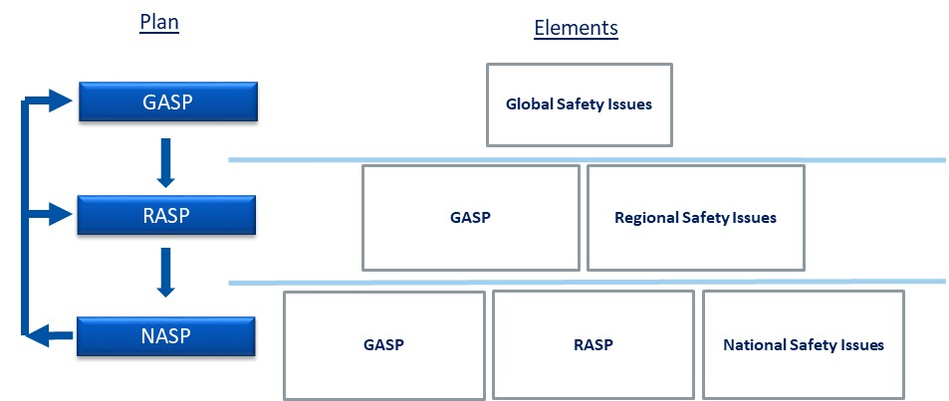
Figure 2: Relationship between the GASP, RASP and NASP

Regional Safety Issues, Goals and Targets
    - The identification of safety-related challenges and the prioritization of areas that require action are key steps in the aviation safety planning process. Safety data used to identify challenges and define priorities includes, but is not limited to: accident or incident investigations; safety reporting; continuing airworthiness reporting; operational performance monitoring; inspections, audits, surveys; and safety studies and reviews.

    - The AFI-RASP has been developed in alignment with the GASP and supports the GASP aspirational goal of zero fatalities by 2030 and beyond, and its objectives, goals, targets and indicators. The AFI-RASP serves to raise awareness of safety risks and consequences to States, industry and relevant stakeholders to commit and provide resources including human and financial, to making improvements in safety management, oversight capability and operational safety performance. It also provides a basis to facilitate information sharing between relevant stakeholders who can take actions or provide support to address issues.

- The AFI-RASP structure adheres closely to the GASP;
- A comprehensive gap analysis was undertaken to identify the existing gaps between the work by AASPG and the ICAO Manual: Doc 10131, ‘Manual on the Development of Regional and National Aviation Safety Plans;
- The AASPG safety strategy is aligned with GASP 2026-2028 Edition, and is included in Chapter 5 to the AFI-RASP; and
- The AFI-RASP SEIs were selected taking into consideration relevant SEIs for the region and in line with GASP 2026-2028 Edition as well as relevant work programmes of the AASPG, AFI-DGCA, etc.

    - The AFI-RASP addresses the following regional safety issues:

- Focus on the development of the current regional SEIs to address the global High-Risk Categories (G-HRCs) of LOC-I, CFIT, MAC, RE and RI, and other priorities as identified for the AFI region in a data-driven and strategic manner, which may include organizational challenges and emerging risks;
- Continue implementation support to States and industry, including the development of improved guidance materials as well as the organization of workshops and training to provide assistance and guidance to AFI States;
- Assist States in the implementation of SSP and SMS;
- Assist States in the development and implementation of NASPs;
- Promote regional government and industry collaboration for sharing best practices in safety management;
- Put in place a structure for the collection, analysis and sharing of safety and operational data in the region to support a comprehensive approach to risk management, and facilitate initiatives to develop regional data collection, and analysis;
- Support States in the enhancement of effective implementation scores in the areas of AIG, ANS and AGA;
- Support States in the development of their unmanned aircraft systems regulatory framework and related guidance material (civilian drones);
- Support States in matters related to the impact of security on safety;
- Consideration of the impacts of disruption events on aviation (e.g. COVID-19 pandemic);
- Support, monitor and report on the achievement of the regional safety goals, consistent with those in the GASP; and
- Coordinate all activities undertaken to address regional safety issues with RSOOs, RAIOs and COSCAPs, ensuring harmonization to the extent practicable.

    - States and industry are committed to the following efforts:

- States with SSCs to give priority to the resolution of the SSCs identified by the ICAO USOAP CMA Programme (this would call for the commitment of necessary resources available, including technical assistance from other States and Regional Programmes to resolve the SSCs promptly);
- Develop and implement a NASP, taking into consideration the AFI-RASP and the GASP (and other national plans within the State);
- Implement, as appropriate, the SEIs of GASP and AFI-RASP; and their respective actions;
- Monitor the achievement of the national safety goals, consistent with those in the GASP and the AFI RASP
- Give priority to the implementation of SSP and SMS;
- Use data-driven methodologies to identify HRCs, and implement collaborative solutions to reduce accident rates and fatalities in the region, and likewise accord priority to the implementation of respective SEIs;
- Consider various options to leverage ICAO-recognized industry assessment programmes such as the IATA Operational Safety Audit (IOSA), IATA Safety Audit for Ground Operations (ISAGO) and IATA Standard Safety Assessment Programme (ISSA). These options range from recognition of such programmes to encouraging registration by all applicable operators as a means to strengthen their safety management and compliance.
- Develop measures to respond effectively to disruption events to maintain a safe, resilient and sustainable level of operations;
- Establish a mechanism and measures to share, communicate and collaborate on effective mitigation measures and efforts to support safe resumption of operations following a disruption event.
- Share relevant safety information with the AASPG and ICAO (including national safety issues and the status of national safety goals and targets); and
- Actively participate in, and support the work of, the AASPG, by providing technical expertise and ensuring that adequate resources are available.
- Actively participate in, and contribute to, the AASPG to enhance safety in a coordinated manner; and
- Provide guidance material and training within industry (primarily via regional and international organizations) to address safety issues.

    - The GASP contains an aspirational safety goal to achieve and maintain zero fatalities in commercial operations by 2030 and beyond. This goal is deemed “aspirational” as it represents an ambition of achieving an even safer aviation system. The year 2030 has been selected as this aligns with the target year presented in the UN SDGs Agenda for Sustainable Development.

    - The AFI-RASP goals are the results toward which efforts in regional aviation safety are directed. They present the desired outcomes that AASPG’s Safety Strategy (as presented in the AFI-RASP) aims to produce. Each of the AFI-RASP goals contains specific targets. Targets are specific desired outcomes from the actions taken by States, the region and industry to achieve the goals, at a certain point of time. Each AFI-RASP target also includes indicators that States and other stakeholders may use to measure progress towards achieving the respective goal. Indicators are used to evaluate if the AFI-RASP yields the expected results by States, region and industry. The indicators provide evidence about whether the desired outcomes occurred and measure the progress in the activities related to the AFI-RASP targets.

    - To address the issues listed above and enhance aviation safety at the regional level, the 2026-2028 Edition of the AFI-RASP contains the following goals and targets, which are in alignment with the goals and targets of the 2026-2028 Edition of the GASP to ensure consistency:

Goal 1 of the AFI-RASP is to achieve a continuous reduction of operational safety risks. This reduction is achieved by a series of SEIs targeting R-HRCs. This goal addresses operational safety issues, which States, the region and industry face and are being mitigated as part of NASPs and AFI-RASP.

Target 1.1 calls for a decrease of the regional accident rate by 2028. This decrease is measured using a five-year rolling average and the year 2025 as a baseline. Indicators linked to this target are the accident rate (the number of accidents per million departures); fatal accident rate (number of fatal accidents per million departures); and the fatality rate (the number of fatalities per billion passengers carried).

Target 1.2 calls for a decrease of the regional rate of accidents and serious incidents for each of the five R-HRCs by 2028. This decrease is measured using a five-year rolling average and the year 2025 as a baseline. Indicators linked to this target are the accident rate by R-HRC; the serious incident rate by R-HRC; the percentage of accidents related to the R-HRCs compared to all accidents; and the percentage of serious incidents related to the R-HRCs compared to all serious incidents.

Target 1.3 calls for a decrease of the regional rate of accidents and serious incidents related to the other regional risk categories of occurrences by 2028. This decrease is measured using a five-year rolling average and the year 2025 as a baseline. Indicators linked to this target are the accident rate by other regional risk category of occurrence; the serious incident rate by other regional risk category of occurrence; the fatal accident rate by other regional risk category of occurrence; the fatality rate by other regional risk category of occurrence; and the injury rate (that is, the number of injuries per million passengers carried).

Goal 2 is aimed at States individually and seeks to strengthen their safety oversight capabilities. This goal calls for all States to progress in their implementation of the eight CEs and address the organizational challenges they face mainly the lack of sufficient financial resources, qualified technical personnel, and a regulatory process to address the resolution of safety issues when implementing a safety oversight system. The objective is to focus States’ attention on specific issues to be addressed, taking into consideration their limited resources.

Target 2.1 calls for all AFI States to commit, through their NASPs, the allocation of sufficient financial resources to each safety oversight authority to meet national and international obligations, with at least 70% of States having sufficient financial resources by 2028. One indicator, linked to this target, is the percentage of States with a “satisfactory” rating for the USOAP PQ 2.051.

Target 2.2 calls for all AFI States to improve their effective implementation (EI) score for qualified technical personnel (CE-4) and Technical Guidance, Tools, and provision of safety-critical information (CE-5) for aircraft accident and incident investigation (AIG) and for qualified technical personnel (CE-4) for aerodromes and ground aids (AGA) and Air Navigation Services (ANS), respectively, with a further commitment that no State has a score of less that the baseline global average, by 2028

Target 2.3 calls for all AFI States to improve their score for the EI of the resolution of safety issues (CE-8) in AGA, ANS and AIG, with a further commitment that no State has a score of less than the baseline global average, by 2028. One indicator, linked to this target, is the number of States that meet the EI score for the CE-8/AGA/ANS/AIG combination.

Target 2.4 calls for all AFI States to improve their EI score for CE-6 Licensing, certification, authorisation and approval obligations for PEL, OPS and AGA and CE-7 Surveillance obligations for ANS and AGA with a further commitment that no State has a score of less than the baseline global average by 2028.

Goal 3 is aimed at States individually and calls for the establishment and management of State safety programmes (SSPs).

Target 3.1 calls for all AFI States to assess the level of implementation of their SSP, by 2026. This is linked to findings from the analysis of global safety issues, which identified a low level of SSP implementation at the global level. There is a need to obtain more information from States to best understand the status of their SSP implementation and the challenges they face when establishing the programme. To do so, the SSP self-assessment, available on the USOAP CMA OLF, was considered the most adequate tool. All States should complete the self-assessment, even if they have not started implementing an SSP, as it will still provide them with valuable information. One indicator, linked to this target, is the percentage of States having completed their SSP PQ self-assessment, using the USOAP CMA OLF.

Target 3.2 calls for all AFI States to establish an SSP, by 2028. This is linked to the same findings from the analysis of global safety issues, noted for the previous target. The establishment of an SSP includes establishing a safety data collection and processing system (SDCPS) to capture and collect, store, aggregate, process and enable the analysis of safety data and safety information. Having an established SDCPS enables States to address deficiencies in the collection, analysis, and exchange of safety data and safety information and provides the foundation for safety intelligence to support safety management activities. Indicators linked to this target include the percentage of States having established an SSP and the percentage of States having established an SDCPS. In addition, another indicator focuses on the need for States to establish means to protect data and information collected for safety management purposes, as a key enabler for the establishment of an SSP.

Goal 4 calls for strengthening collaboration at the regional and national levels to address safety issues. The targets under this goal are meant to empower the region to identify and help individual States to put in place mechanisms to address safety issues. This aims at facilitating the achievement of GASP goals at the regional and national levels, thus contributing to the improvement of safety globally.

Target 4.1 calls for the region to identify States that need assistance to address safety issues, by 2026. The year 2026 was selected because it represents the end of the first year of the current GASP cycle. This gives States, needing assistance, sufficient lead-time to achieve the other targets in the GASP, set for 2028. Indicators linked to this target are the percentage of States in each region that need assistance to address each of the specific global safety issues.

Target 4.2 calls for the region to facilitate the required assistance to the identified states to address safety issues by 2028. This target is linked to Target 4.1 and presents a two-step approach to strengthen collaboration at the regional and national levels to address safety issues identified under that target. During the three-year GASP cycle, regions have time to provide targeted assistance to States, identified as needing assistance under the previous target, so they may achieve the GASP targets, set for 2028. Indicators linked to this target are the percentage of States in each region that receive the required assistance to address each of the specific safety issues, previously identified.

Target 4.3 calls for the region to implement a mechanism to make use of the information on operational safety risks and emerging issues for the purpose of aviation safety planning, by 2027. This target aims to build up the safety risk management capabilities of the AFI Region , to better equip it in identifying and addressing regional safety issues. Indicators linked to this target include the number of reports received via the Secure Portal on Operational Safety Risks and Emerging Issues; the percentage of SEIs completed by AASPG; and the number of regions implementing a mechanism to make use of the information on operational safety risks and emerging issues.

Goal 5 seeks to strengthen aviation safety planning. This new goal and its targets are in line with Assembly Resolution A41-6 and serve as the basis for the development, revision and implementation of a safety strategy at the national and regional levels, in line with the current edition of the GASP.

Target 5.1 calls for the AFI region to publish an updated AFI-RASP by end of 2026, taking into consideration the 2026–2028 edition of the GASP.. AFI-RASP addresses regional operational safety risks and organizational challenges. The publication of a current AFI-RASP, as the document containing the region’s strategic direction for the management of aviation safety at the regional level, allows for the allocation of resources dedicated to SEIs, through the development and implementation of that plan. Indicators linked to this target are, an updated AFI-RASP published by 2026; the number of industry partners consulted during the development of the AFI-RASP; and the number of industry partners providing safety information to assist in the development of the AFI-RASP.

Target 5.2 calls for all AFI States to publish an updated NASP by 2027, taking into consideration the 2026–2028 editions of GASP and AFI-RASP,. It is important to note that States having published a NASP should update it to align with the latest editions of AFI- RASP and the GASP. Indicators linked to this target are the number of States that published an updated NASP; number of NASPs developed in consultation with industry; and number of States reporting provision of safety information by industry to assist in the development of NASPs.

Goal 6 calls to expand the use of industry evaluation programmes and safety data sharing programmes. This goal acknowledges the value of such programmes in assisting service providers to enhance their safety performance and their readiness when undergoing compliance audits.

Target 6.1 calls for AFI States to maintain an increasing trend in its use of industry evaluation programmes and safety data sharing programmes by 2028. Indicators linked to this target are the number of service providers participating in the corresponding ICAO-recognized industry assessment programmes, as well as those participating in industry safety data sharing programmes.

For the purpose of the GASP, ICAO-recognized industry assessment programmes include the following:

a) Airports Council International (ACI) Airport Excellence (APEX) in Safety Programme;

b) Civil Air Navigation Services Organisation (CANSO) and European Organisation for the Safety of Air Navigation (EUROCONTROL) maturity assessment within the Standard of Excellence in Safety Management Systems;

c) Flight Safety Foundation (FSF) Basic Aviation Risk Standard (BARS);

d) International Air Transport Association (IATA) Operational Safety Audit (IOSA);

e) IATA Safety Audit for Ground Operations (ISAGO);

f) International Business Aviation Council (IBAC) International Standard for Business Aircraft Operations (IS-BAO); and
g) IBAC International Standard for Business Aircraft Handling (IS-BAH).

Operational Context

    - The Africa–Indian Ocean (AFI) Region comprises 48 States with diverse levels of economic development, aviation maturity, infrastructure, and regulatory capability. While some States are among the world's fastest-growing aviation markets, others have relatively low traffic volumes and limited infrastructure. Differences in safety oversight, institutional capacity, technological advancement, and investment present both opportunities and challenges in achieving a harmonized regional aviation safety system. The region also continues to face operational challenges arising from political instability, armed conflicts, humanitarian crises, and cross-border security concerns, which have resulted in temporary airspace restrictions, flight rerouting, disruptions to air navigation services, and increased operational risks. Nevertheless, regional cooperation through ICAO, the African Union (AU), the African Civil Aviation Commission (AFCAC), Regional Economic Communities (RECs), and Regional Safety Oversight Organizations (RSOOs) continues to support safe and efficient civil aviation operations.

    - Despite steady progress, significant differences remain in the implementation of ICAO Standards and Recommended Practices (SARPs). While several AFI States have achieved Effective Implementation (EI) scores above ICAO's 75 per cent target under the Universal Safety Oversight Audit Programme Continuous Monitoring Approach (USOAP CMA), many States remain below this benchmark due to shortages of qualified technical personnel, inadequate funding, limited inspector capacity, outdated aviation legislation, and insufficient oversight capabilities. In line with the Global Aviation Safety Plan (GASP), an increasing number of States are developing or updating National Aviation Safety Plans (NASPs) and strengthening State Safety Programmes (SSPs) and Safety Management Systems (SMS), demonstrating greater commitment to risk-based safety management and alignment with regional and global safety priorities.

    - Following the strong post-pandemic recovery, aviation activity across Africa is expected to continue growing steadily during the 2026–2028 planning period. Passenger traffic is forecast to increase by approximately 4–5 per cent annually, while cargo traffic is projected to grow by 3–4 per cent, driven by economic growth, urbanization, expanding middle-class populations, the African Continental Free Trade Area (AfCFTA), tourism recovery, and improved connectivity under the Single African Air Transport Market (SAATM). Growth is expected to be strongest in West, East, and Southern Africa, supported by airport expansion, fleet modernization, liberalized air services, low-cost carrier growth, e-commerce, agricultural exports, pharmaceutical logistics, and increasing intra-African trade.

    - African airlines are expected to continue modernizing their fleets through the acquisition of more fuel-efficient aircraft. At the same time, many African States are investing in airport modernization through new terminals, runway extensions, upgraded navigation systems, and improved passenger facilities. The region is also advancing Air Traffic Management (ATM) modernization through implementation of ICAO Aviation System Block Upgrades (ASBUs), Performance-Based Navigation (PBN), ADS-B surveillance, enhanced communications, digital aeronautical information management, and greater harmonization of Flight Information Region (FIR) procedures to improve safety, efficiency, and capacity.

    - Environmental sustainability is becoming an increasingly important priority as States implement Carbon Offsetting and Reduction Scheme for International Aviation (CORSIA), promote Sustainable Aviation Fuels (SAFs), improve operational efficiency, and introduce lower-emission aircraft. The continued implementation of SAATM is expected to increase market liberalization, airline competition, and cross-border operations while requiring stronger regulatory harmonization, enhanced safety oversight, effective inspector coordination, and mutual recognition of aviation safety capabilities. At the same time, cybersecurity has emerged as a growing concern as aviation systems become increasingly digitalized, prompting States to strengthen cybersecurity governance and resilience in accordance with ICAO's Aviation Cybersecurity Strategy.

    - Climate change and environmental hazards continue to present significant operational challenges across the AFI Region. Rising temperatures, droughts, flooding, tropical cyclones, sandstorms, volcanic ash, and changing weather patterns increasingly affect airport infrastructure, aircraft performance, and air traffic management. Wildlife hazards also remain a major concern due to the proximity of many aerodromes to wildlife habitats, agricultural activities, waste disposal sites, and migratory bird routes, necessitating stronger wildlife hazard management programmes. Overall, the AFI Region is expected to experience sustained aviation growth, improved connectivity, modernization of infrastructure, and enhanced safety management. However, continued efforts to strengthen safety oversight, improve infrastructure, enhance climate resilience and cybersecurity, and safely integrate emerging technologies will be essential to achieving the objectives of the Global Aviation Safety Plan (GASP) and the AFI Regional Aviation Safety Plan (AFI-RASP).

    - Common organizational challenges in the AFI region include:

    - The lack of political will in some States impede the full implementation of the Regional Offices’ work programmes – low level of commitment in implementing AASPG conclusions and decisions.

    - The political/security situation in some States impede the provision of required technical assistance, implementation of regional projects and the achievement of the regional safety, air navigation and security targets.
    - The lack of adequate financial and human resources in some States affect the level of effective implementation (EI) of the critical elements (CEs) of a State’s safety oversight system and SARPs; as well as attendance at the regional groups’ activities or activities organized by the ICAO Regional Offices.
    - Lack of States’ contribution of data or information to the AASPG Annual Report.
    - Low number of States that have developed their national aviation safety plans (NASPs).
    - Low response rate of States to ICAO State Letters;
    - Extended legislative and regulatory processes for revising Primary Aviation Laws and Regulations.
    - Insufficient availability of qualified and competent technical personnel, especially in the areas of aircraft accident investigation and aerodrome inspection.
    - The capability, effectiveness, and institutional independence of the authority responsible for the investigation of aircraft accidents and serious incidents.
    - Inadequate systems and processes for the collection, analysis, sharing, and utilization of safety data and safety information to support safety management activities.
    - The effectiveness and long-term sustainability of the State's safety oversight system.

CHAPTER 2. PURPOSE OF AASPG’S REGIONAL AVIATION SAFETY PLAN (AFI-RASP)

The AFI-RASP is the master planning document containing the strategic direction of the AFI region for the management of aviation safety for a period of three years (from 2026 to 2028). This plan provides a collaborative framework for the AFI Region, States and industry to manage operational safety risks and organizational challenges. It lists regional safety issues, sets regional aviation safety goals and targets, and presents a series of safety enhancement initiatives (SEIs) to address identified safety deficiencies and achieve the regional safety goals and targets.

The AFI-RASP addresses safety management from a regional perspective and includes several SEIs to address specific operational safety risks and recommended SEIs for individual States in the region. It is expected that States in the region adopt these SEIs and include them in their respective national aviation safety plans (NASP).

The AFI-RASP has been developed using international safety goals and targets and G-HRCs from the ICAO GASP (www.icao.int/gasp). These are highlighted in the text, where applicable. The SEIs listed in the AFI-RASP support the improvement of safety at the individual State level, for States in the region, and contribute to the enhancement of safety at the wider international level. All stakeholders are encouraged to support and implement the AFI-RASP as the regional strategy for the continuous improvement of aviation safety.

CHAPTER 3. AFI REGIONAL OPERATIONAL SAFETY RISKS

3.1 The AFI-RASP includes SEIs that address regional operational safety risks, derived from lessons learned from operational occurrences and from a data-driven approach. These SEIs include actions such as: policy development, targeted safety activities, safety data analysis, safety risk assessments, and safety promotion.
3.2 The AASPG Annual Report Team (AART), a Contributory Body of the AASPG publishes an Annual Report. Limited hard copies of the report are printed and the electronic copy is available in PDF format, on the ICAO Eastern and Southern African Regional Office website: http://www.icao.int/esaf/Pages/default.aspx. and the Western and Central African Regional Office website: http://www.icao.int/wacaf/Pages/default.aspx.

3.3 The summary of accidents that occurred in the AFI region involving scheduled commercial flights on aeroplanes with maximum certificated take-off mass over 5,700 Kg, accident rate and number of fatalities for the ten-year period (from 2015 to 2025) are shown in the table below.

Table-2: Air transport occurrences in the AFI region involving scheduled commercial flights on aeroplanes with maximum certificated take-off mass over 5,700 Kg
Year | Departures | Number of accidents | Accident rate  (per million departures) | Number of fatalities
2015 | 810K | 6 | 6.18 | 8
2016 | 851K | 7 | 8.23 | 1
2017 | 925K | 7 | 7.56 | 0
2018 | 969.9K | 5 | 5.16 | 20
2019 | 974.4K | 10 | 10.34 | 183
2020 | 549K | 2 | 3.64 | 0
2021 | 652K | 1 | 1.53 | 0
2022 | 970K | 6 | 7.01 | 24
2023 | 1043.7K | 4 | 3.83 | 0
2024 | 1041.7K | 5 | 4.8 | 2
2025 | 1031.9K | 4 | 3.88 | 0

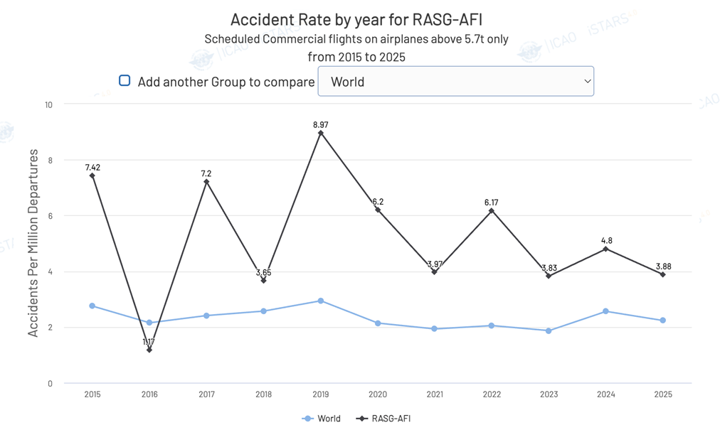

3.4 The accident rate in the AFI Region has been fluctuating over the ten-year period (2015 - 2025), but remained above the world average. Due to the relatively low traffic volume, compared to the other world regions, any one occurrence will result in a high accident rate. The ten-year average accident rate (from 2015 to 2025) for the AFI Region was 5.21, which was above the global average rate of 2.33 for the same period.
3.5 There was a positive trend in traffic volume in the last 5 years, which showed a steady recovery from the negative impact of the pandemic

Global Priorities
The GASP identifies the following global high-impact risk categories (G-HRCs) that have historically accounted for most accidents and fatalities which form the starting point for global safety planning and serve as guidance for regional and national frameworks:

• Controlled Flight into Terrain (CFIT)
• Loss of Control In-flight (LOC-I)
• Mid-Air Collision (MAC)
• Runway Excursion (RE)
• Runway Incursion (RI)

In addition, the GASP recognizes other risk categories of occurrences, which may ﻿not have a high fatality risk, such as the G-HRCs, but figure prominently in the most frequent types of accidents and serious incidents across ICAO regions. The other global risk categories of occurrences for 2026–2028 are as follows:

• Abnormal Runway Contact (ARC)
• System/Component Failure or malfunction – Non-Powerplant (SCF/NP)
• Turbulence encounter (TURB)

Regional Priorities

Based on results from the analysis of safety data and information, the Africa–Indian Ocean Aviation System Planning and implementation Group (AASPG), through the Safety Management and Oversight Sub-Group, identifies the main risk categories for the AFI Region. These priorities reflect the most frequent and high-impact threats to regional aviation safety.
Safety data and information collected in the AFI Region over the last 10 years, revealed the following main categories of occurrences associated with accidents and fatalities, in no particular order of priority:

• Loss of Control In-flight (LOC-I)
• Runway Excursion (RE)
• System/Component Failure or malfunction – Non-Powerplant (SCF/NP)
• Abnormal Runway Contact (ARC)
• Ground Handling (RAMP)

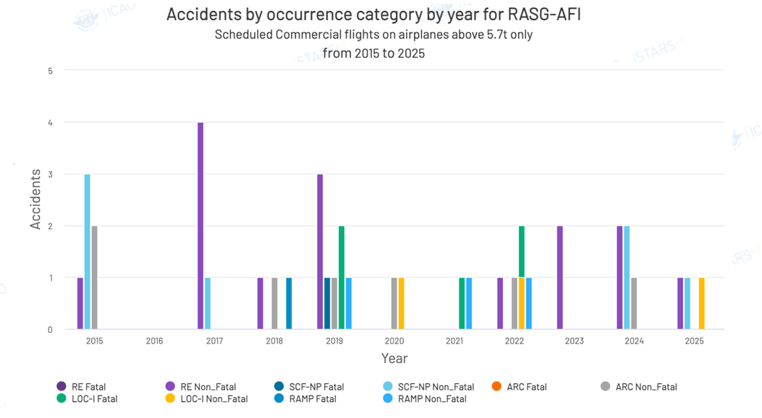
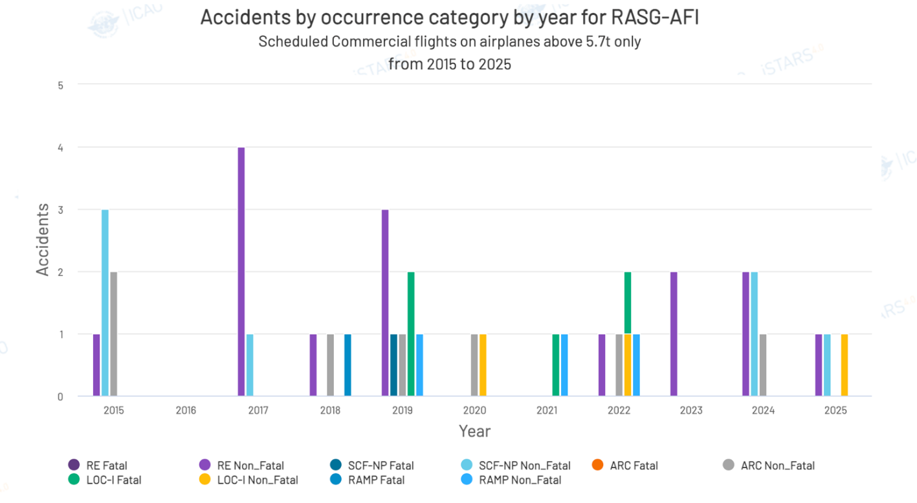

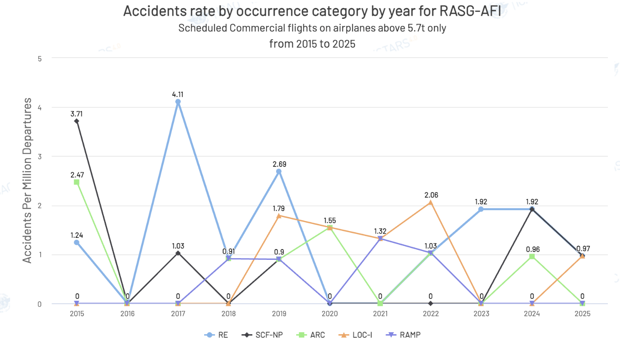

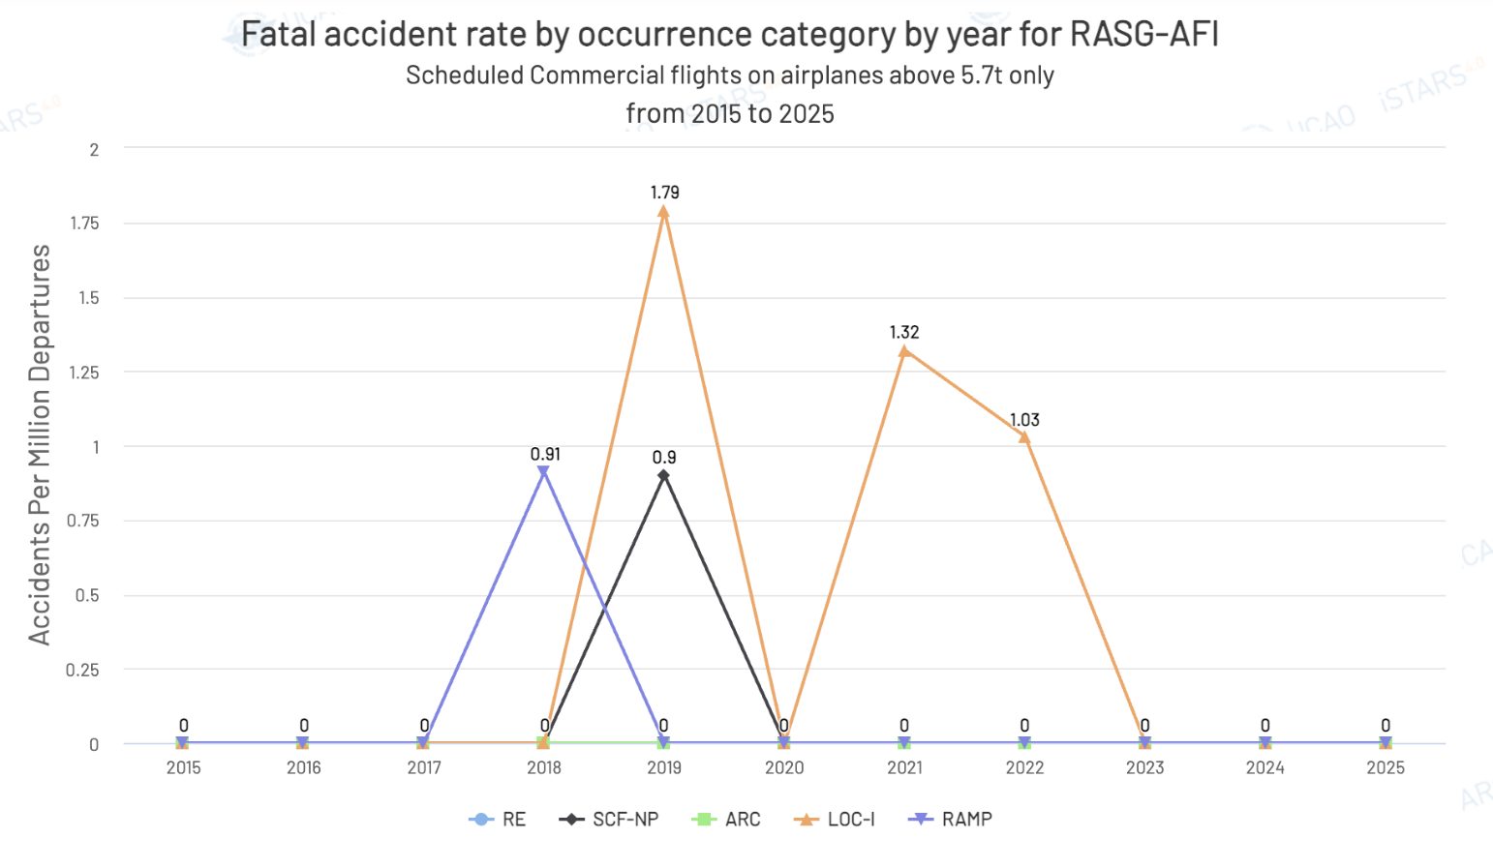

Considering the G-HRC and the main categories of occurrences in the AFI Region and associated fatality risk, the AASPG identified the following regional high-risk categories of occurrences (R-HRCs):

1. Controlled Flight into Terrain (CFIT);
2. Loss of Control In-Flight (LOC-I);
3. Mid-Air Collision (MAC);
4. Runway Excursion (RE);
5. Runway Incursion (RI);

In addition to the regional operational safety risks listed above, other risk categories of occurrences have been identified:

1.System/Component Failure or Malfunction – Non-Powerplant (SCF-NP);
2. Abnormal Runway Contact (ARC);
3. Ground Handling (RAMP)
4. Bird Strikes and Wildlife Hazard;
5. Large Height Deviation (LHD).

The aviation occurrence categories from the CAST/ICAO Common Taxonomy Team (CICTT) were used to assess risk categories in the process of determining regional operational safety risks. To address the regional operational safety risks listed above, AASPG identified the following contributing factors leading to R-HRCs:

R-HRC 1: Controlled Flight into Terrain (CFIT)

Controlled Flight Into Terrain is a situation where a properly functioning aircraft under the control of a fully qualified and certificated crew is flown into terrain with no apparent awareness on the part of the crew. Although no CFIT related accidents and fatalities were reported for the AFI region during the period 2015-2025, there should not be any complacency for not putting it under the safety radar, as it continues to be a global HRC. The following factors, although not exhaustive, could contribute to CFIT occurrence:

﻿– Flight in adverse environmental conditions
– Inaccurate approach design and inadequate documentation (for approaches with vertical guidance (APV) or localizer performance with vertical guidance (LPV)
– Phraseology used (standard versus non-standard)
– Pilot fatigue, sensory illusion and loss of situational awareness
– Global navigation satellite system (GNSS) radio frequency interference (RFI)

R-HRC 2: Loss of Control In-Flight (LOC-I)

Aircraft upset or loss of control in-flight has registered the highest number of fatalities in the AFI region during the period: 2018 - 2022. This is due to the high energy involved in such accidents. It includes uncontrolled collisions with terrain, but also occurrences where the aircraft deviated from the intended flight path or intended aircraft flight parameters, regardless of whether the flight crew realized the deviation and whether it was possible to recover or not. It also includes the triggering of stall warning and envelope protections. The following factors, although not exhaustive, could contribute to LOC-I occurrence;

﻿– Distraction
– Adverse weather
– Complacency
– Inadequate standard operating procedures (SOPs) for effective flight management
– Insufficient height above terrain for recovery
– Automation dependency leading to degraded pilot proficiency in manual flying, lack of awareness or competence in procedures for recovery from unusual aircraft attitudes
– Startle effect, inappropriate flight control inputs in response to sudden awareness of an abnormal aircraft state (such as bank angle, angle of attack or stall)
– GNSS RFI

R-HRC 3: Mid-Air Collision (MAC)

MAC refers to the potential collision of two aircraft in the air. It includes direct precursors such as separation minima infringements, genuine TCAS resolution advisories or airspace infringements. Although there have been no aeroplane mid-air collision accidents in recent years within the airspace of the AFI region, scenarios have been reported that constituted potential mid-air collision. Concerns over this key risk area has been raised by some AASPG States specifically in the context of collision risk posed by aircraft operating within the airspace around the horn of Africa, which are not subject to any coordination with related FIRs for airborne operation. This is one specific safety issue that is a main priority in this key risk area. However, additional data is needed for further analysis to identify the underlying safety issues. The following factors, although not exhaustive, could contribute to MAC occurrence:

﻿– Traffic conditions: considerations include traffic density, complexity and the mixture of aircraft types and capabilities
– Air traffic control (ATC) performance: factors such as workload, competence, teamwork and adherence to procedures. Additionally, the influence of the air navigation services provider’s (ANSP) safety management system (SMS)
– Flight crew training and organizational (corporate) culture: aspects such as workload management, competence, teamwork, adherence to procedures and the impact of the operator’s SMS
– ATC systems: elements such as flight data processing, communication systems, short-term conflict alert (STCA) systems, as well as the interaction between the human operators and the aircraft systems and the procurement policies of ANSPs
– Aircraft equipment: considerations include autopilot systems, transponders and airborne collision avoidance system (ACAS), as well as aircraft performance characteristics (such as rate-of-climb) and their physical dimension
– Surveillance systems: coverage and quality of surveillance technologies used to monitor aircraft positions and movements
– Flight plan processing: the efficiency and reliability of processes related to flight plan submission, approval and distribution
﻿– Airspace design: the complexity of airspace structure, route layouts and the extent of controlled
or uncontrolled airspace and proximity of military operational or training areas
– Flight in adverse environmental conditions that may influence conflict management and collision
avoidance
– GNSS RFI

R-HRC 4: Runway Excursion (RE)

Runway excursion covers materialized runway excursions, both at high and low speed, and occurrences where the flight crew had difficulties in maintaining the directional control of the aircraft or of the braking action during landing, where the landing occurred long, fast, off-centred or hard, or where the aircraft had technical problems with the landing gear (not locked, not extended or collapsed) during landing. 36.6% of accidents in the AFI region during the period: 2015 – 2025, were related to Runway Excursions. The following factors, although not exhaustive, could contribute to RE occurrence:

﻿– Ineffective SOPs
– Lack of adherence to SOPs
– Long/floated/bounced/firm/off-centre/crabbed landing
– Unstabilized approach
– Inadequate reporting of runway surface conditions
– Inadequate approach procedures design
– Inadequate regulatory oversight

R-HRC 5: Runway Incursion (RI)

A Runway Incursion refers to the incorrect presence of an aircraft, vehicle or person on an active runway or in its areas of protection; the accident outcome is runway collisions. No RI related accidents and fatalities were reported for the AFI region during the period 2015-2025, nevertheless States should remain vigilant with regards to the contributing factors, such as:

﻿– Operations in low visibility conditions
– Complex or inadequate aerodrome design, equipment and signage
– Diversity and complexity of traffic (such as multiple simultaneous line-ups)
– Conditional clearances
– Simultaneous use of intersecting runways
– Late issue of or late changes to departure clearances
– Unintentional deviations from ATC clearances by flight and ground crew
– Phraseology use (such as non-standard versus standard; call-sign confusion)
– Concurrent use of more than one language for ATC communications
– English language proficiency
– Inadequate manoeuvring area driver training and assessment programme

R-HRC 6: System/Component Failure or Malfunction – Non-Powerplant (SCF-NP)

System/Component Failure or alfunction – Non-Powerplant (SCF-NP) refers to failure or malfunction of an aircraft system or component other than the powerplant. Safety data related to accidents in the last 10 years revealed 8 accidents in the AFI region related to SCF-NP, being fatal one of the accident. In the last two years 3 accidents were reported.
The following factors, although not exhaustive, could contribute to SCF-NP occurrence:

﻿– Inadequate Maintenance Practices
﻿– Component Degradation
﻿– Human Performance:
﻿– Organizational and Regulatory Oversight
﻿– Reporting Deficiencies

R-HRC 7: Abnormal Runway Contact (ARC)

Abnormal Runway Contact (ARC) refers to any landing or takeoff involving abnormal runway or landing surface contact. Safety data related to accidents in the last 10 years revealed 7 non-fatal accidents in the AFI region related to ARC, The following factors, although not exhaustive, could contribute to ARC occurrence:

﻿– Pilot-Induced Oscillations (PIO)
﻿– Decision-Making and Go-Arounds
﻿– Human Factors and Distraction
﻿– Communication Failures
﻿– Weather Conditions
﻿– Training Gaps

R-HRC 8: Ground Handling (RAMP)

Ground Handling (RAMP) refers to occurrences during (or as a result of) ground handling operations. Safety data related to accidents in the last 10 years revealed 4 non-fatal accidents in the AFI region as a result of RAMP. The following factors, although not exhaustive, could contribute to RAMP occurrence:

﻿– Time and Operational Pressure
﻿– Congestion and Space Management
﻿– Interface Establishment
﻿– Aircraft "Settling"
﻿– Supervision and Experience
﻿– Pushback and Towing Issues
﻿– Unreported Damage

R-HRC 9: Bird and wildlife strikes (WILDBIRD)

Wildlife is primarily driven by three core survival needs: food, water, and shelter. When these overlap with aviation infrastructure, the risk of a collision spikes. The following factors, although not exhaustive, could contribute to WILD occurrence:

a) On-Airport Attractants
•Improper Grass Management
•Standing Water
•Structural Perches

b) Off-Airport and Environmental Factors
•Surrounding Land Use
•Geographic Migratory Routes
•Aircraft Speed and Altitude

R-HRC 10: Large Height Deviation (LHD)

A Large Height Deviation (LHD) is defined as any vertical displacement of 90 meters (300 feet) or more from the flight level expected or cleared by Air Traffic Control (ATC). The following factors, although not exhaustive, could contribute to LHD occurrence:
Operational and Coordination Errors (The Primary Drivers)
•ATC-to-ATC Coordination Breakdowns
•Pilot-Controller Communication Loops
•Flight Deck Interface Errors

Environmental and Meteorological Anomalies
•Severe Turbulence
•Convective Weather Avoidance
Aircraft Technical Contingencies
•Mechanical Degradation
•Altimetry and System Failure

Emerging Issues

Emerging issues include concepts of operations, technologies, public policies, business models or ideas that might impact safety in the future, for which insufficient data exists to complete typical data-driven analysis. Due to the lack of data, emerging issues cannot automatically be considered as operational safety risks. It is important that the international aviation community remain vigilant on emerging issues to identify hazards, collect relevant data and proactively develop mitigations to address any associated risks. The management of emerging issues, particularly by mitigating safety risks, can provide opportunities to foster innovation. The use of new technologies, procedures and operations should therefore be encouraged.

ICAO developed a dedicated site on its secure portal to collect information from States, regional and international organizations on emerging issues and operational safety risks, thereby contributing to the improvement of safety by facilitating the sharing and exchange of safety information. Stakeholders are requested to provide information on a regular basis and the information collected also serves to guide future editions of the GASP and AFI-RASP. Details on how regional entities and other stakeholders may use this information for regional and national aviation safety planning is found on the ICAO website at https://www.icao.int/safety/GASP/Pages/Secure-Portal.aspx.

Disruptive Events

A disruption event is a rare yet very significant event at a global, regional or national level, which adversely impacts aviation activities. Disruption events affect States, including safety and security authorities, as well as aircraft operators, operators of aerodromes, ATS providers, and industries dependent on aviation.

Disruption events are not typically aviation-centric but have significant impact on aviation operations. States should develop measures to respond effectively to disruption events to maintain a safe, resilient and sustainable level of operations. These include the management of change, communication and coordination plans with all relevant stakeholders at the national, regional and international levels.

The nature of disruption events, such as the recent COVID-19 pandemic and Ebola, can vary in complexity, scope, and duration and may affect the identification of hazards and management of safety risks. Recovery from a disruption event may also affect the operational safety risks. To the extent practicable, States should share and communicate hazards that may develop into disruption events. States and regions may also consider applying changes to safety plans in accordance with risk analyses. The policies, processes and mechanisms implemented for the SSP should support the management of disruption events.

To the extent practicable, States and regions should also establish a mechanism and measures to share, communicate and collaborate on effective mitigation measures and efforts to support safe resumption of operations following a disruption event.

Communicable diseases can have significant impact on aviation safety due to their potential to spread rapidly and affect both passengers and aircrew. AASPG Member States should develop and implement mechanism for managing the risks associated with communicable diseases in the aviation sector.

Note: While Bird/Wildlife Strikes and LHD are recognised in several NASPs as areas of safety concern, most occurrences within these categories did not reach accident or serious-incident severity. Nevertheless, considering the number of occurrences associated and risks for serious incidents and accidents, States should consider Bird/Wildlife and LHD Safety hazards when developing their National Aviation Safety Plans (NASPs).

CHAPTER 4 AFI REGIONAL ORGANIZATIONAL CHALLENGES
In addition to the regional operational safety risks listed in the AFI-RASP, The AASPG SMO Sub-group has identified regional organizational challenges and initiatives selected for the AFI-RASP. These are given priority in the AFI-RASP since they are aimed at enhancing and strengthening the management of aviation safety at the regional level.

The AFI Region contains(s) 48 States. 2 States have not yet received a USOAP audit. The AFI region has 77 CMA Audits and 121 Validation Activities. The current average USOAP score for States in the region is 61.13%, which is below the world EI 70.41%.

The eight critical elements (CEs) of a safety oversight system are defined by ICAO. The AFI Region is committed to the effective implementation of these eight CEs among all States in the region, as part of its overall safety oversight responsibilities, which emphasize AASPG’s commitment to safety in respect of its aviation activities. The eight CEs are presented in Figure 3 below.

Certain deficiencies in a specific CE of a safety oversight system are common to the majority of States in the region and considered a top concern. These deficiencies are addressed as a safety issue in the AFI-RASP because of their impact on the ability of States to fulfil their safety oversight responsibilities, which impacts the region as a whole.

Figure 3: Critical elements of a State’s safety oversight system

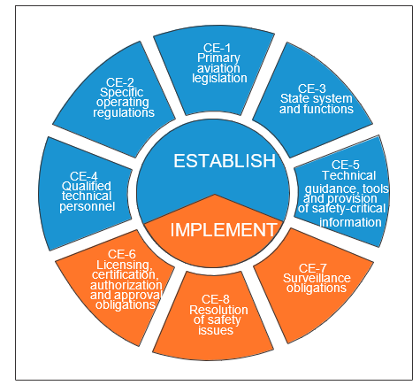

The latest ICAO activities, which aim to assess the effective implementation of the eight CEs of States’ individual safety oversight systems, as part of the ICAO Universal Safety Oversight Audit Programme (USOAP), have resulted in the following scores, compiled as an average for the AFI region as a whole:

Table 3: Overall, EI score and EI score by CE¹ for AASPG

 |  | Overall EI score for AASPG
 |  | 61.13% (15 June 2026) |  |  |  |  |  | Gasp Target  75%
 |  | EI score by CE for AASPG
CE-1 | CE-2 | CE-3 | CE-4 | CE-5 | CE-6 | CE-7 | CE-8
76.26 % | 74.60 % | 68.33 % | 60.36 % | 66.15 % | 59.61 % | 49.18 % | 34.87 %
 |  | EI score by audit area for AASPG
LEG | ORG | PEL | OPS | AIR | AIG | ANS | AGA | SSP
78.57 % | 70.51 % | 61.49 % | 61.58 % | 78.40 % | 47.98 % | 58.34 % | 54.25 % | 0.00%

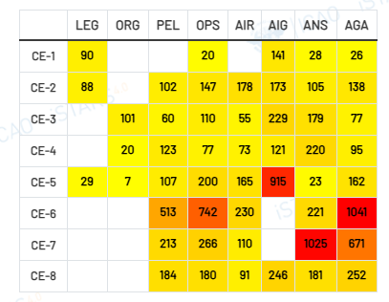

The analysis reveals also that while the region has achieved relatively mature levels of implementation in the legislative (LEG) and organizational (ORG) aspects of safety oversight. It further shows that CE-6 Licensing, certification, authorization and approval obligations, CE-7 Surveillance obligations and CE-8 Resolution of safety issues are the least performed Critical Elements and represent significant regional risk. It suggests that most of the States focus on certification and identifying deficiencies but struggle with continuous surveillance and timely implementation of corrective actions.

The following five other safety issues in the AASPG context were considered of the utmost priority because they are systemic issues which directly impact the ability of States to identify and assess safety risks and the effectiveness of safety risk controls and mitigations.

They were identified based on analysis from USOAP data, accident and incident investigation reports, safety oversight activities over the past eight years from States in the region, their state safety programmes, as well as on the basis of regional analysis conducted by the AASPG SMO Sub-group. These issues are typically organizational in nature and relate to challenges associated with the conduct of States’ safety oversight functions, implementation of SSP at the regional level, and the level of SMS implementation by industry in the region. They take into consideration organizational culture, policies and procedures within the civil aviation authorities, regional safety oversight organisations, aircraft accidents and incidents investigation authorities, and those of service providers. These safety issues are in line with those listed in the 2026-2028 edition of the GASP:

1) Lack of autonomy of Civil Aviation Authorities due to inadequate political will and government commitment.
2) Insufficient resources, including financial and human resources such as the inadequate number of qualified and experienced technical personnel to carry out safety oversight functions at the regional level.
3) Inadequate aircraft accident and incident investigation capabilities at the regional level. This was the area where States in the region received the lowest EI score during the most recent ICAO USOAP audits and was therefore placed as a high priority issue to resolve.
4) Inadequate Civil Aviation Authorities enforcement capabilities to ensure effective resolution of safety concerns and improve safety oversight performance under Critical Element 8.
5) Infrastructure gaps particularly in the areas of Aerodromes and Ground Aids and Air Navigation Services.

To address the issues listed above, the SMO Sub Group will implement a series of SEIs, some of which are derived from the ICAO ORG roadmap, contained in the GASP. The full list of the SEIs is presented in Appendix 1 to the AFI RASP.

CHAPTER 5 AASPG STRATEGIC DIRECTION FOR THE MANAGEMENT OF AVIATION SAFETY
The AFI-RASP presents the SEIs that were developed based on the ICAO GASP’s organizational challenges (ORG) roadmap and operational safety risks (OPS) roadmap as well as region-specific issues identified by AASPG members States and partners as well as others aviation stakeholders beyond AASPG. This plan is developed and maintained by AASPG, in particular the Safety Management and Oversight Sub-Group (SMO/SG), in coordination with all stakeholders and is updated at least every three years.

The AFI-RASP includes the following regional safety goals and targets, for the management of aviation safety, as well as a series of indicators to monitor the progress made towards their achievement. They are tied to the goals, targets and indicators listed in the 2026-2028 Edition of the GASP and include additional regional safety targets and indicators.

Table-1: AFI-RASP goals, targets and indicators

Goal | Target | Indicators | Link To Gasp
Goal 1:  Achieve a continuous reduction of operational safety risks | - By 2028, AFI States and industry to decrease the accident rate. | - Number of accidents per million departures (accident rate)  - Number of fatal accidents per million departures (fatal accident rate)  - Number of fatalities per Million passengers carried (fatality rate) | This goal is directly linked to Goal 1 and Target 1.1 of the GASP.
 | 1.2 By 2028, AFI Region, States and industry to decrease the rate of accidents and serious incidents for each regional high-risk category (R-HRCs) | 1.2.1 Number of CFIT accidents that occurred in the AFI Region per million departures (CFIT accident rate).  1.2.2 Number of LOC-I accidents that occurred in the AFI Region per million departures (LOC-I accident rate).  ﻿1.2.3 Number of MAC accidents that occurred in the AFI Region per million departures (MAC accident rate).  1.2.4 Number of RE accidents that occurred in the AFI Region per million departures (RE accident rate).  1.2.5 Number of RI accidents that occurred in the AFI Region per million departures (RI accident rate).  1.2.6 Percentage of serious incidents related to R-HRC compared to all serious incidents  NB. These occurrences involve scheduled commercial operations with aircraft of maximum mass of over 5700 kg. | This goal is directly linked to Goal 1 and Target 1.2 of the GASP.
 | 1.3 By 2028, AFI Region, States and industry to decrease the rate of accidents and serious incidents related to other regional risk categories (R-ORC) of occurrences. | 1.3.1 Number of SCF-NP accidents and serious incidents that occurred in the AFI Region per million departures (SCF-NP accident/incident rate).  1.3.2 Number of ARC accidents and serious incidents that occurred in the AFI Region per million departures (ARC accident/incident rate).  1.3.3 Number of Ground Handling (RAMP) accidents and serious incidents that occurred in the AFI Region per million departures (RAMP accident/incident rate).  1.3.4 Number of BWI accidents and serious incidents that occurred in the AFI Region per million departures (BWI accident/incident rate).  1.3.5 Fatal accident rate by other regional risk category of occurrence.  1.3.6 Number of injuries per million passengers carried (injury rate). | This goal is directly linked to Goal 1 and Target 1.3 of the GASP.
Goal 2: Strengthen States’ safety oversight capabilities | 2.1 By 2028, all AFI States to commit to national aviation safety plans that allocate to each safety oversight authority sufficient financial resources to meet national and international obligations, with at least 70% of States having sufficient financial resources. | 2.1.1 Percentage of AFI States with a “satisfactory” rating for the Universal Safety Oversight Audit Programme (USOAP) protocol question (PQ) 2.051 or recorded at least 75% progress in the State PQ Self-Assessment. | This goal is linked to Goal 2 and Target 2.1 of the GASP
Goal 2: Strengthen States’ safety oversight capabilities | 2.2 By 2028, all AFI States to improve their effective implementation (EI) score for qualified technical personnel (CE-4) and Technical Guidance, Tools, and provision of safety-critical information (CE-5) for aircraft accident and incident investigation (AIG) and for qualified technical personnel (CE-4) for aerodromes and ground aids (AGA) and Air Navigation Services (ANS), respectively, with a further commitment that no State has a score of ﻿less than the baseline global average. | 2.2.1 Number of AFI States that meet the EI score of equal to or greater than the baseline global average for CE-4 and CE-5/AIG  2.2.2 Number of AFI States that meet the EI score of equal to or greater than the baseline global average for CE-4/AGA  2.2.3 Number of States that meet the EI score of equal to or greater than the baseline global average for CE-4/ANS | This goal is linked to Goal 2 and Target 2.2 of the GASP
Goal 2: Strengthen States’ safety oversight capabilities | 2.3 By 2028, all AFI States to improve their EI score for the resolution of safety issues (CE-8) in AGA , ANS and AIG with a further commitment that no State has a score of less than the baseline global average. | 2.3.1 Number of States that meet the EI score of equal or greater than the baseline global average for CE-8/AGA  2.3.2 Number of States that meet the EI score of equal or greater than the baseline global average for CE-8/ANS  2.3.3 Number of States that meet the EI score of equal or greater than the baseline global average for CE-8/AIG | This goal is linked to Goal 2 and Target 2.3 of the GASP
Goal 2: Strengthen States’ safety oversight capabilities | 2.4 By 2028, all AFI States to improve their EI score for CE-6 (Licensing, certification, authorization and approval obligations for PEL, OPS and AGA and CE-7 Surveillance obligations for ANS and AGA with a further commitment that no State has a score of less than the baseline global average. | 2.4.1 Percentage of AFI States with EI scores for CE-6 for PEL, OPS and AGA at or above the baseline global average.  2.4.2 Percentage of AFI States with EI scores for CE-7 for ANS and AGA at or above the baseline global average.  2.4.3 AFI Regional average EI score for CE-6 and CE-7 compared with the 2025 baseline.  2.4.4 Percentage of AFI States that have implemented at least 80% of CAP actions related to deficiencies in CE-6 for PEL, OPS and AGA and CE-7 for ANS and AGA.
Goal 3:  Establish and manage safety programmes (SSPs) | - By 2026, all AFI States to assess the level of implementation of their SSP. | 3.1.1 Percentage of AFI States having completed their SSP PQ self-assessment, using the ICAO Online Framework (OLF). | This goal is directly linked to Goal 3 and Target 3.1 of the GASP
 | 3.2 By 2028, all AFI States to establish an SSP. | 3.2.1 Percentage of AFI States having established an SSP.  3.2.2 Percentage of AFI States having established a safety data collection and processing system (SDCPS).  3.2.3 Percentage of States having established a framework for the protection of safety data and safety information. | This goal is directly linked to Goal 3 and Target 3.2 of the GASP
Goal 4:  Strengthen collaboration at the regional and national levels to address safety issues. | 4.1 By 2026, all AFI States to report if they require assistance to address safety issues. | 4.1.1 Percentage of AFI States that need assistance to address the lack of sufficient financial resources for the safety oversight authority to meet its national and international obligations.  4.1.2 Percentage of AFI States that need assistance to address the lack of qualified technical personnel, primarily aircraft accident investigators and aerodrome inspectors.  4.1.3 Percentage of AFI States that need assistance to address the resolution of safety issues, primarily related to aerodrome operations.  4.1.4 Percentage of AFI States that need assistance to address a low level of SSP implementation.  4.1.5 Percentage of AFI States that need assistance to address deficiencies in safety data and safety information collection, analysis and exchange, to support safety management activities.  4.1.6 Percentage of AFI States that need assistance to address operational ﻿safety risks, including R-HRCs.  4.1.7 Percentage of AFI States that need assistance to address other safety issues. | This goal is linked to Goal 4 and Target 4.1 of the GASP
 | 4.2 By 2028, AFI region to facilitate the required assistance, to the identified States, to address safety issues. | 4.2.1 Percentage of AFI States that received assistance to address the lack of sufficient financial resources for the safety oversight authority to meet its national and international obligations.  4.2.2 Percentage of AFI States that received the required assistance to address the lack of qualified technical personnel, primarily aircraft accident investigators and aerodrome inspectors.  4.2.3 Percentage of AFI States that received the required assistance to address the resolution of safety issues, primarily related to aerodrome operations.  4.2.4 Percentage of AFI States that received the required assistance to address a low level of SSP implementation.  4.2.5 Percentage of AFI States that received the required assistance to address deficiencies in safety data and safety information collection, analysis and exchange, to support safety management activities.  4.2.6 Percentage of AFI States that received the required need assistance to address operational ﻿safety risks, including R-HRCs.  4.2.7 Percentage of AFI States that received the required assistance to address other safety issues. | This goal is directly linked to Goal 4 and Target 4.2 of the GASP
 | 4.3 By 2027, ﻿AFI region to implement a mechanism to make use of the information on operational safety risks and emerging issues for the purpose of aviation safety planning. | 4.3.1 Number of AFI States registered on the Secure Portal on Operational Safety Risks and Emerging Issues.  4.3.2 Number of reports received and validated via the Secure Portal on Operational Safety Risks and Emerging Issues.  4.3.3 Number of studies/analyses conducted by AASPG based on reports received via Secure Portal on Operational Safety Risks and Emerging Issues.  4.3.4 Percentage of safety enhancement initiatives completed by AASPG. | This goal is directly linked to Goal 4 and Target 4.3 of the GASP
Goal 5:  Strengthen aviation safety planning. | 5.1 By 2027, AFI States should provide technical assistance, upon request, to support other States in the development, updating, and timely publication of their National Aviation Safety Plans (NASPs). | 5.1.1 Number of States that requested for technical assistance to support the development or update of their NASPs.  5.1.2 Number of States that received technical assistance to support the development or update of their NASPs. | This goal is directly linked to Goal 5 and Target 5.1 of the GASP
 | 5.2 By 2027, all AFI States to publish an updated national aviation safety plan (NASP), taking into consideration the 2026-2028 edition of the GASP and the AFI RASP. | 5.2.1 Percentage of AFI States that published an updated NASP.  5.2.2 Number of NASPs developed in consultation with industry.  5.2.3 Number of States reporting provision of safety information by industry to assist in the development of NASPs. | This goal is linked to Goal 5 and Target 5.2 of the GASP
Goal 6:  Expand the use of industry evaluation programmes and safety data sharing programmes. | 6.1 By 2028, industry from AFI States to maintain an increasing trend in its use of industry safety assessment and safety data sharing programmes. | 6.1.1 Number of air operators within AFI that participated in IOSA as reported annually by IATA.  6.1.2 Number of service providers from AFI States participating in ISAGO as reported annually by IATA.  6.1.3 Number of service providers from AFI States participating in IDX as reported annually by IATA.  6.1.4 Number of service providers from AFI States participating in the APEX as reported annually by ACI Africa.  6.1.5 Number of service providers from AFI States participating in the CANSO Standard of Excellence as reported annually by CANSO. | This goal is directly linked to Goal 6 and Target 6.1 of the GASP

The AFI RASP includes an action plan, composed of a list of prioritized SEIs, that support the regional safety strategy. The list of prioritized SEIs will help to achieve the regional safety goals by addressing the regional safety issues identified in this plan, with specific actions for each of the regional operational safety risks and organizational challenges identified in chapter 3 and 4, respectively. These SEIs include actions such as policy development, capacity-building activities, safety data analysis, safety risk assessments and safety promotion. SEIs derived from the ICAO global aviation safety roadmap were identified to achieve the regional safety goals and targets presented in the AFI-RASP. Some of the regional SEIs are linked to overarching SEIs at the international level and help to enhance aviation safety at regional and global levels. The full list of the SEIs is presented in Appendices 1 and 2 to this AFI-RASP.
The SEIs in this plan are implemented through the working arrangements of the AASPG, activities conducted by Member States, international and regional organizations and industry, as well as the existing safety oversight capabilities and service providers’ safety management systems (SMS) at the individual States’ level.

The AFI-RASP also addresses emerging issues, which may stem from concepts of operations, new technologies, changes to public policies, new business models or ideas that might impact safety in the future, for which insufficient data exists to complete typical data-driven analysis. Due to the lack of data, emerging issues cannot automatically be considered as operational safety risks. It is important that AASPG remain vigilant on emerging issues to identify potential operational safety risks, collect relevant data and proactively develop mitigations to address them. The AFI-RASP identifies the following emerging issues, which were identified by AASPG for further analysis:

- Operation of RPAS within the vicinity of aerodromes;
- Frequency interference, in particular the use of 5G telecommunication system, especially within the vicinity of aerodromes;
- Laser strikes/attacks;
- The use of wind turbines for wind farming in the vicinity of aerodromes;
- Cyber security;
- The installation of solar farms in the vicinity of aerodromes. Note: Issue of glare and glint to ATC and pilots.
- Public health issues, e.g. Ebola, COVID-19, etc
- Skilled workforce shortages
- Infrastructure limitations
- Traffic patterns
- Political instability
- Environmental impact

Safety Enhancement Initiatives (SEIs)

ORGANIZATIONAL CHALLENGES (ORG) ROADMAP

STATES

Component 1— State safety oversight system

Phase 1—Establishment of a safety oversight framework (CE-1 to CE-5)
SEI-1 — Strategic allocation of resources to enable effective safety oversight.
SEI-2 — Implementation of a mechanism so that each safety oversight authority has sufficient financial resources to meet its national and international obligations.
SEI-3 — Implementation of a mechanism to ensure that each safety oversight authority has sufficient qualified technical personnel to meet its national and international obligations.
SEI-4 — Training for technical personnel to support effective safety oversight.
SEI-5 — Implementation of a process to ensure that the accident investigation authority has sufficient financial resources to investigate accidents and serious incidents.
SEI-6 — Establishment of minimum qualifications and experience requirements for investigators.

Phase 2—Implementation of a safety oversight system (CE-6 to CE-8)
SEI-7 — Strategic allocation of resources to enable effective safety oversight.
SEI-8 — Consistent coordination of regional programmes in establishing effective safety oversight capabilities.
SEI-9 — Corrective actions to resolve safety issues identified during surveillance activities.
SEI-10 — Allocation of industry resources to support effective safety oversight.

Component 2— State Safety Programme (SSP)
SEI-11 — Start of SSP implementation at the national level.
SEI-12 — Strategic allocation of resources to start SSP implementation.
SEI-13 — Strategic collaboration with key aviation stakeholders to complete SSP implementation.
SEI-14 — Advancement of safety risk management at the national level.
SEI-15 — Establishment of an independent accident and incident investigation authority, consistent with Annex 13 – Aircraft Accident and Incident Investigation.
SEI-16 — Development and issuance of safety recommendations from accident and incident investigations.
SEI-17 — Timely publication of final reports from aircraft accident and serious incident investigations, consistent with Annex 13 – Aircraft Accident and Incident Investigation.
SEI-18 — Allocation of resources to support safety performance measurement and monitoring and safety risk management capabilities.

REGIONS

Component 1 — State Safety Oversight System

Phase 1 — Establishment of a safety oversight framework (CE-1 to CE-5)
SEI-1 — Provision of assistance to States, to address safety issues and enhance safety in a coordinated manner.
SEI-2 — Establishment of an independent regional accident and incident investigation process, consistent with Annex 13 — Aircraft Accident and Incident Investigation.
SEI-3 — Consistent coordination of regional programmes in establishing effective safety oversight capabilities.
SEI-4 — Strategic collaboration with key aviation stakeholders to establish effective safety oversight systems.
SEI-5 — Provision of the safety information at the regional level.

Phase 2 — Implementation of a safety oversight system (CE-6 to CE-8)
SEI-6 — Continued implementation of and compliance with ICAO SARPs at the regional level
SEI-7 — Regional safety enhancement initiatives to support consistent coordination of regional programmes in implementing adequate safety oversight capabilities.
SEI-8 — Strategic collaboration with key aviation stakeholders to implement effective safety oversight systems.
SEI-9 — Continued provision of the primary source of regional safety information to ICAO by asking States to update all relevant documents and records as progress is made.

Component 2 — State Safety Programme
SEI-10 — Start of promotion of SSP implementation at the regional level.
SEI-11 — Regional safety enhancement initiatives to support consistent coordination of regional programmes for the implementation of SSPs.
SEI-12 — Strategic collaboration with key aviation stakeholders to support the implementation of SSPs.
SEI-13 — Availability of safety data and safety information to support safety management activities at the regional level.
SEI-14 — Regional allocation of resources to support safety performance measurement and monitoring and safety risk management capabilities.
SEI-15 — Regional collaboration with key aviation stakeholders to support safety performance measurement and monitoring, and safety risk management capabilities and methodologies.
SEI-16 — Advancement of safety risk management at the regional level.
SEI-17 - Ensure training and capacity building of key personnel in the implementation and maintenance of the SSP/SMS at the Regional level.

INDUSTRY

3.1 Component 1 — STATE SAFETY OVERSIGHT SYSTEM

Phase 1 — Establishment of a safety oversight framework (CE-1 to CE-5)
SEI-1 — Strategic collaboration with key aviation stakeholders to contribute to an effective safety oversight system.

Phase 2 — Implementation of a safety oversight system (CE-6 to CE-8)
SEI-2 — Improvement of industry compliance with applicable regulations
SEI-3 — Allocation of industry resources to enable effective safety oversight
SEI-4 — Strategic collaboration with key aviation stakeholders to contribute to an effective safety oversight system.

3.2 Component 2 — STATE SAFETY PROGRAMME (SSP)

SEI-5 — Improvement of industry compliance with applicable SMS requirements.
SEI-6 — Resources for service providers to effectively implement SMS.
SEI-7 — Strategic collaboration with key aviation stakeholders to complete SMS implementation at the regional and national levels.
SEI-8 — Availability of safety data and safety information to support safety management activities at the service provider level (step 1).
SEI-9 — Availability of safety data and safety information to support safety management activities at the service provider level (step 2).
SEI-10 — Allocation of industry resources to support the maintenance of SSP and the continuous improvement of SMS.
SEI-11 — Strategic collaboration with key aviation stakeholders to support the safety performance measurement and monitoring and safety risk management capabilities.
SEI-12 — Advancement of safety risk management at the service provider level.

______________________

PART-II. IMPLEMENTATION AND MONITORING

CHAPTER 6. REGIONAL AVIATION SAFETY ROADMAP

STRUCTURE OF THE ROADMAP

    - The regional aviation safety roadmap outlines specific SEIs associated with the AFI-RASP goals and targets, as well as the R-HRCs. Each SEI is supported by a set of actions. The roadmap includes specific SEIs directed to three different sets of stakeholders: individual States; regions; and industry. Successful achievement of the SEIs found in the roadmap relies upon the close collaboration and cooperation of all key aviation stakeholders. Key aviation stakeholders include, but are not limited to, ICAO, States, AASPG, regional safety oversight organizations (RSOOs), regional accident and incident investigation organizations (RAIOs), Cooperative Development of Operational Safety and Continuing Airworthiness Programmes (COSCAPs) and industry.

Note. – In the context of the AFI-RASP and the roadmap, the term “region” refers to a group of States and/or entities working together to enhance safety within a geographic area.

Note 2.– In the context of the AFI-RASP and the roadmap, the term “industry” refers to service providers, such as: operators of aeroplanes or helicopters; approved maintenance organizations; organizations responsible for the type design or manufacture of aircraft, engines or propellers; approved training organizations; air traffic services (ATS) providers; and operators of aerodromes, as well as non-governmental organizations (e.g. international organizations) and other entities that form part of the aviation industry, as appropriate.

    - The regional aviation safety roadmap is composed of two parts:

- Organizational challenges. This part of the roadmap (referred to as the ORG roadmap, presented in Appendix 1) provides SEIs to meet AFI-RASP goals (and associated targets) related to States’ safety oversight capabilities and the implementation of State safety programmes (SSPs), as well as industry’s implementation of SMS, and contains two distinct components, in line with the AFI-RASP goals, to address safety management responsibilities:

  - State safety oversight system; and

  - SSP, including service providers’ SMS.

- Operational safety risks. This part of the roadmap (referred to as the OPS roadmap, presented in Appendix 2) provides SEIs to meet the AFI-RASP goal (and associated target) related to a continuous reduction of operational safety risks, as well as actions to address the R-HRCs presented in the AFI-RASP.

Note. — Although the roadmap does not contain SEIs to address emerging issues, these should be noted as part of the AFI-RASP or NASP. Additional guidance on emerging issues is presented in the GASP.

ORGANIZATIONAL CHALLENGES (ORG) ROADMAP

    - The ORG roadmap addresses the organizational challenges identified in the RASP. It contains SEIs to address each of these challenges: lack of sufficient financial resources for the safety oversight authority to meet its national and international obligations; lack of qualified technical personnel (primarily aircraft accident investigators and aerodrome inspectors); lack of a regulatory process to address the resolution of safety issues (primarily related to aerodrome operations); low level of SSP implementation at the global level; and deficiencies in safety data and safety information collection, analysis and exchange to support safety management activities. The roadmap also addresses the RASP targets, including those related to: States’ safety oversight capabilities; collaboration at the regional and national levels to address safety issues; aviation safety planning; and the use of industry safety assessment and safety data sharing Programmes.

    - The SEIs should not be viewed as stand-alone activities. In many cases, they are interrelated and serve to meet several targets simultaneously. Therefore, the SEIs in the ORG roadmap may contribute to the achievement of multiple targets, including those related to the continuous reduction of operational safety risks. Appendix 1 provides tables listing the ORG roadmap SEIs and the targets they support.

OPERATIONAL SAFETY RISKS (OPS) ROADMAP

    - The OPS roadmap addresses operational safety risks and is based on the R-HRCs identified in the AFI-RASP. It contains examples of specific SEIs to address each of the five R-HRCs: controlled flight into terrain; loss of control inflight; mid-air collision; runway excursion; and runway incursion. The OPS roadmap also addresses the other risk categories of occurrences, such as System Component Failure/Malfunction – Non-Powerplant (SCF-NP), Abnormal Runway Contact (ARC), Ground Handling (RAMP), Bird Strikes and Wildlife Hazard; and Large Height Deviation (LHD). Unlike the ORG roadmap, the OPS roadmap is not divided into components or steps. SEIs can be accomplished in parallel. All the SEIs in the OPS roadmap contribute directly to the achievement of AFI-RASP Goal 1 and its specific targets,, which aims to achieve a continuous reduction of operational safety risks by targeting the R-HRCs.

    - The SEIs presented in the OPS roadmap should be implemented to mitigate the risks associated with the R-HRCs. The OPS roadmap identifies the SEIs for each R-HRC as well as the other regional risk categories of occurrences. This is not an exhaustive list. Stakeholders should conduct analyses of data and reports to validate the effectiveness of the implemented SEIs. In order to develop data collection and analysis capabilities, SSP and SMS should be implemented (refer to the SEIs in the ORG roadmap). Stakeholders can then derive contributing factors through data analysis. The OPS roadmap gives specific examples of potential contributing factors. These are not exhaustive and may not be applicable to all stakeholders or operational contexts. Based on the analysis, stakeholders may need to develop and implement further SEIs to mitigate any additional risks. Stakeholders should assess the effectiveness of the SEIs and may need to refine them in response to changes that may introduce new hazards.

    - The OPS roadmap is not a substitute for the safety risk management activities that need to be conducted by individual States as part of their SSP and by service providers through their SMS. A safety management approach to targeting the N-HRCs or R-HRCs can result in successful mitigation strategies. Once the SSP and SMS are implemented in accordance with Annex 19 – Safety Management and have reached a certain maturity level in terms of safety data analysis, stakeholders can refine their SEIs in relation to the R-HRCs suitable to their operational context. The OPS roadmap is supported by the ORG roadmap component related to SSP and SMS, which enables safety risk management and safety assurance processes to be implemented. Appendix 2 provides tables listing the OPS roadmap SEIs and the AFI-RASP targets they support.

CHAPTER 7. MONITORING IMPLEMENTATION

The Programme Review and Coordination Committee (PRCC) of the AASPG will continuously monitor the implementation of the SEIs listed in the AFI-RASP and measure safety performance of the regional civil aviation system, to ensure the intended results are achieved, using data from the ICAO USOAP CMA Online Framework, iSTARS, data from other partners; and the mechanisms presented in Appendix-4 to this plan; and provide comprehensive annual report on the status of implementation to the AASPG.

In addition to the above, SMO/SG will review the AFI-RASP every three years or earlier, if required, to keep the identified operational safety risks, safety issues and selected SEIs updated and relevant. The PRCC will review the safety performance of the initiatives listed in the AFI-RASP annually to ensure the achievement of regional safety goals and targets. The PRCC will seek the support of the AFCAC and ICAO to ensure the timely implementation of SEIs to address safety deficiencies and mitigate risks. Through close monitoring of the SEIs, the PRCC will make adjustments to the AFI-RASP and its initiatives, if needed, and update it accordingly.

In addition, the PRCC will use the indicators listed in Chapter 5 of this plan to measure safety performance of the civil aviation system and monitor each regional safety target. An annual safety report will be published to provide stakeholders with relevant up-to-date information on the progress made in achieving the regional safety goals and targets, as well as the implementation status of the SEIs.

In the event that the regional safety goals and targets are not met, the causes will be addressed and presented to stakeholders. If the PRCC identifies critical operational safety risks, reasonable measures will be taken to mitigate them as soon as practicable, possibly leading to an earlier revision of the AFI-RASP.

The PRCC adopted a standardized approach to facilitate reporting of information from individual States and other stakeholders at the regional level, and to improve the provision of information to the AASPG through performance reports provided by the SMO/SG, using a common monitoring tool, to the PRCC every 6 months. This allows the region to receive information and assess operational safety risks using common methodologies.

Any questions regarding the AFI-RASP and its initiatives, and further requests for information, may be addressed to the following:

The AASPG Secretariat
ICAO Regional Offices (ESAF/WACAF)
icaoesaf@icao.int/icaowacaf@icao.int
Tel: +254 020 7622 395 /+221 33 869 2424

. Safety information contained in voluntary safety reporting systems is established for the sole purpose of maintaining and improving safety, and qualifies for protection under Annex 19 — Safety Management.
. Developed by George T. Doran in 1981.

