FREQUENCY SPECTRUM MANAGEMENT PANEL (FSMP)

Ninth Working Group Meeting

Montréal, Canada, 22-30 August 2019

Agenda Item 2: WRC-19 Preparations
b) Discussion of expected future agenda item proposals from administrations

PROPOSED UPDATES TO ITU RR APPENDIX 27 IN SUPPORT OF A MODERNIZED HF AERONAUTICAL COMMUNICATIONS SYSTEM

(Prepared by Sai Kalyanaraman, Collins Aerospace)

SUMMARY
This paper provides some considerations for changes to update the ITU-R RR Appendix 27 in support of WideBand HF (WBHF) aeronautical communications. Feedback is sought from the FSMP on the proposed updates towards a WRC-23 agenda item and how the system could be implemented within the current HF spectrum rules at the ITU-R and nationally.

- INTRODUCTION
  - While HF Radio communications has been the primary long-range communication system for safe, efficient air travel over long range routes beyond the range of ground-based VHF radios; modern technology now provides alternate solutions, namely aeronautical mobile-satellite (R) service (AMS(R)S) satellite communications (SATCOM) which are now authorized by regulatory authorities for use in long-range aeronautical communications. Terrestrial and space-based systems work well together in a complementary and synergistic fashion to offer better performance, reliability and availability than either system alone. Having both space-based and terrestrial means of long-range communication, termed “link diversity,” mitigates single point of failure concerns associated with vulnerabilities which differ for each system (e.g., solar events, rain fade, jamming, hardware failures, etc.).

  - A next generation wideband HF radio system, “HF Next,” is being developed to address the limitations of today’s HF radio communications systems (i.e. intelligibility of analog voice communications and slow throughput of data over HFDL). In support this, HF radio regulations governing the allotment and use of HF aeronautical spectrum need to be updated.

  - At the Eighth Working Group Meeting of the FSMP, Working Paper xxx introduced the concept to modernize the way the HF aeronautical mobile (route) service (AM(R)S) spectrum is defined and governed by Appendix 27 of the ITU-R Radio Regulations. The United States has drafted a proposal for a WRC-23 future agenda item to update Appendix 27 and this has been submitted to CITEL for consideration. The objective of these updates is to allow use of multiple 3 kHz channel assignments as a single, wideband channel, and to allow for advanced modulations that would provide greater throughput of information (higher data rates) and maintain a robust, link-diverse communications architecture.
- DISCUSSION
  - The regulatory implementation of WBHF will rely on an overlay approach that will leverage regional negotiation similar to how the current HFDL system is administered. Wideband HF will continue to grow as it develops over the years as more users migrate to the system and wider channels can be implemented. Integrating the system into a rigid Appendix 27 allotment plan would preclude system scalability and result in a need to revise Appendix 27 each time a region adds a new channel to widen the bandwidth. To avoid such an overhead on ICAO and the ITU-R, the proposed plan would not revise the entire existing allotment plan, but create a framework in relevant Appendix 27 articles to allow flexibility in implementation away from the ITU-R (such as the necessary technical characteristics to support such waveforms and channel widths). This would also limit the necessary Appendix 27 updates, and with no changes required to the current AM(R)S frequency allocations in ITU-R RR Article V, be achievable in one WRC cycle.
  - It is anticipated that most of the allotment related discussions and updates would be addressed within ICAO (including regional channel planning) and then shared with ITU-R. Any updates/changes recommended at ITU WP 5B are expected to be liaised with ICAO FSMP and other relevant ICAO panels for review and feedback. FSMP stakeholders are encouraged to support the review of recommended updates and plan for updates to Appendix 27.
  - In support of this Appendix 27 update proposal, attached is an early copy of suggested updates to Appendix 27 in support of wideband HF. The goal of these recommended updates is to ensure that the changes support the necessary regulatory framework for WBHF while at the same time keeping the changes to a minimum to not impact the existing usage of aeronautical safety of life legacy HF users. These are provided to start an early discussion with ICAO on the way forward and seek feedback to ensure the potential future agenda item has a head start if approved for WRC-23.
- AVIATION INDUSTRY IMPLEMENTATION
  - The SARPS and relevant airborne receiver standards update will be addressed through the relevant ICAO panel and RTCA / Eurocae special committees. This item will also be introduced at the forthcoming DCIWG (Data Communication Infrastructure Working Group) in October of 2019 together with a request that a project team be setup towards ICAO SARPS update activities in support of WBHF. Relevant HF NEXT validation data will be provided in support of the ICAO SARPS development effort. Analysis of technical compatibility between the WBHF system and the current legacy use of airborne HF will be addressed through the SARPS development process. Once the SARPS process is underway, RTCA/Eurocae will be contacted in order to initiate an Airborne HF radio MOPS development effort in late 2020. A full-fledged rollout of the WBHF system worldwide is anticipated in 2026 with plans for initial system rollout by the end of 2023. In parallel with the WRC effort, a launch customer will be identified to initiate regional rollout and have preliminary ground station capability in support of WBHF by the end of 2023. Channels assigned under special agreements for the initial service are planned for use in the interim until the WRC effort is concluded.
  - Alternate WBHF approaches espoused by other radio and system designers are expected to co-exist alongside the briefed contiguous WBHF approach as long as the new entrants meet the out of band airborne HF spectral requirements and ensure compatibility with existing analog uses of HF. Proposed Appendix 27 updates should accommodate all of those approaches.
  - As a point of reference, Table D-II, taken from the openly available MIL-STD-188-110D, shows the theoretical data speeds that can be achieved with advanced modulation waveforms on contiguous channels utilized as a wide-band channel.

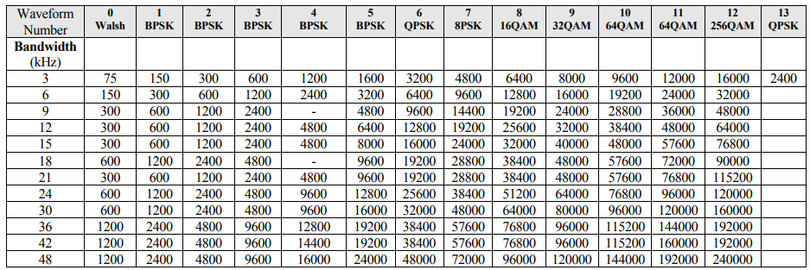

TABLE D-II from MIL-STD-188-110D
Modulation used to obtain each data rate.

- ACTION BY THE MEETING
  - The meeting is invited to:

    - Review this working paper and enclosed attachment with proposed updates to Appendix 27 of the ITU RR
    - Provide feedback on the proposed way forward
    - Support the proposed activities and direction for a new WRC-23 agenda item.

— END —
Attachment:

