FREQUENCY SPECTRUM MANGEMENT PANEL (FSMP)

Fourth Working Group meeting

Bangkok, Thailand, 29 March – 7 April 2017

Agenda Item 5: Development of (planned) material for ITU-R Studies

Reply Liaison Statement from ITU-R WP5B, titled:
Unmanned Aeronautical Vehicle System Characteristics and
Interference Environment

Presented by the Secretary

SUMMARY and ACTION
The attached liaison statement was received from ITU-R WP5B, in response to the liaison statement agreed by FSMP-WG/3, see FSMP-WG/3-WP04.
(the attached was also circulated to FSMP members by email on 19 Dec 2016)

Action: FSMP WG/4 is invited to review the attached and take action as appropriate.

 | Radiocommunication Study Groups |  | 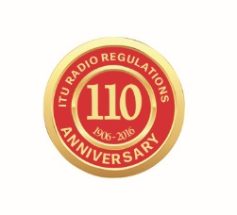
INTERNATIONAL TELECOMMUNICATION UNION
Source: Document 5B/TEMP/89
 |  | 18 November 2016
 |  | English only
Working Party 5B
Liaison statement to the International civil
aviation organization (icao)
reply liaison statement
Unmanned Aeronautical Vehicle System Characteristics and
Interference Environment

ITU-R Working Party 5B, at its meeting on 7-18 November 2016, considered your request for information with respect to the characteristics of unmanned aeronautical vehicle satellite links and the interference environment within which they will have to operate. Unfortunately, at this time Working Party 5B is not in a position to provide any characteristics however work has been initiated to identify such characteristics and we will inform you as and when they become available. WP 5B would appreciate if ICAO could indicate, where possible, the appendix 4 to the Radio Regulations reference for the data elements that have been provided in Documents 5B/115 and 5B/116 for which WP 5B were requested to provide values.

Status: For information
Contact: Loftur Jonasson Email: ljonasson@icao.int

______________

