 | International Civil Aviation Organization  WORKING PAPER
  FSMP-WG/04 WP/26
  2017-04-03
FREQUENCY SPECTRUM MANGEMENT PANEL (FSMP)

Fourth Working Group meeting

Bangkok, Thailand, 27 March – 7 April

Agenda Item 10: Any Other Business

Future ATM System

(Presented by John Mettrop)

SUMMARY
This working paper addresses the need to develop a vision of the global air traffic management system that ideally should be in place by 2060, the rationale for such a vision and the potential benefits
ACTION

- INTRODUCTION
  - At the 32nd meeting of WG-F I presented a paper that addressed the need to rationalise the radio systems used to support the current Air Traffic Management system. That paper highlighted the fact that aviation was one of the first industries to seek globally harmonised spectrum and adopted global harmonised radio systems, but noted that in recent years whilst the industry has still been good at developing systems it has either not deployed those systems or has only done so on a regional/national basis. This has resulted in aircraft becoming ever larger antenna farms as illustrates by the diagram below.
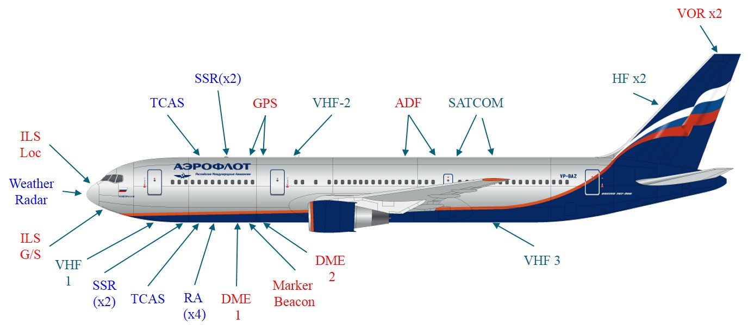
  - Additionally the incremental increase in the capacity of the air traffic management systems from the introduction of new systems has, on average, been reducing over time. This has led to a reluctance of airlines to fit additional equipment leading to protracted implementation as a result of needing better financial justification.
  - This paper builds on the one I presented at the 32nd meeting of WG F and provides a copy of a presentation gave within the UK Civil Aviation Authority on this same issue (See Appendix).
- discussion
  - Aviation was built on the principle of harmonized global solutions that were applicable throughout the world. As the aviation industry has developed so systems have been designed and incorporated into the air traffic management system in a way that has enabled growth the industry to florish. However that growth has varied between the different regions. This has led to diverging requirements in terms of required airspace capacity and hence separation standards. In turn this has led to the development of more sophisticated/accurate radio systems which have generally implemented in higher density regions but not in tother regions where there is not a need for such systems resulting in todays situation where there is noticeable divergence between the systems used regional to support the air traffic management system.
  - If we continue to progress in the current manner then aviation is in jeopardy of losing its global nature and becoming a region system. This may not affect aircraft that fly within a region it does have significant implications for those aircraft operators and equipment & airframe manufacturers that supply the global market and has contributed to the proliferation of aeronautical systems fitted to aircraft leading to extra costs.
  - The problem is not helped by system designers working in isolation to address ever decreasing gaps in the current ATM system. They are making decisions about the design of the system and the preferred frequency band of operation without necessarily any guidance from an overall aeronautical strategy or knowledge about the potential future capacity available within the frequency band selected. The frequency band 960-1 215 MHz is a good example of this where DME, IFF/SSR, ADS-B, TCAS, UAT, TCAN, WAM and MLAT have already been SARPed and there are advanced proposals to add LDACS, ADS-B via Satellite and command and control for remotely piloted aircraft.
  - For aviation to return, to the extent possible, to being a globally harmonized industry then it needs to ensure that the introduction of each new system will help convergence rather than divergence which hopefully in the long term will enable to reduction in the number of systems required. Noting that a reduction in the number of systems will not necessarily reduce the overall spectral requirement.
  - The global air navigation plan offers a framework by which a long term strategic plan can be devised, based on a vision of the future global air traffic management system, and implemented that will hopefully deliver a long term solution that will allow aviation to modernise its radio equipment in a globally harmonised manner. Such a strategy will have to not only address manned aviation needs but will also have to incorporate the needs of remotely piloted aircraft, drones and space planes whilst either maintaining or hopefully increasing the overall safety of the system.
  - For such actions to be effective there needs to be an understanding of how aircraft will be operated and managed in the future, and what radio systems, in broad terms, will be required to facilitate that management philosophy. Based on such an understanding a road map can be developed against which decisions about the development of new systems can be based thus ensuring they contribute rather than hinder progress to the future global system. The ICAO Global Air Navigation Capacity & Efficiency Plan - 2013–2028 could be one umbrella to be used to cover this activity according to technology roadmap and Blocks timeframe. Given the timeframe for an aircraft to go from drawing board to operation timescales for the Global Air Navigation Capacity & Efficiency Plan may need to be reconsidered.
  - If the industry are to be convinced of the merits of such an approach and commit resources to it’s development and implementation then a clear case needs to be made that considers the financial benefits that will accrue from both additional capacity, weight saving and rationalisation of ground infrastructure. Initial work, with the assistance of a number of WG-F members, would suggest that if you were able to remove the current ADF and HF fits from aircraft this would result in a weight save of around 80kg (assumes fitted with HF) for a short haul and 90kg for a long haul aircraft.
  - I hope, with the further assistance of those who have been involved and those who might wish to be involved to develop the analysis further. I would therefore ask members if they could contribute to completing the table contained in the annex to this document.
- Action by the Meeting
  - WG-F is invited to:-
- Comment on the presentation
- Support the further development of the ideas behind this paper
- Contribute to the completion of the table given in the annex to this document
— END —

Appendix

Annex

The following table should be filled out for a generic short & long haul aircraft
System | Equipment |  |  |  |  | Cockpit Display |  |  |  | Antenna |  |  |  |  | Total Weight
System | Number of Radios | Weight of Radio | Weight of Mounting Kit | Weight of Power Cable | Total | Number | Weight of Cabling | Weight of Specific Display | Total | Number | Weight of Coax Feeder | Weight of Antenna | Total | Drag | Total Weight
 |  | (kg) | (kg) | (kg) | (kg) |  | (kg) | (kg) | (kg) |  | (kg) | (kg) | (kg) |  | (kg)
NDB
HF
Marker Beacon
VOR
ILS Glidepath
ILS Localiser
VHF Comms
DME
TCAS
SSR
ADS-B
GNSS
Satellite Comms
Radio Altimeter
Weather Radar

