FREQUENCY SPECTRUM MANGEMENT PANEL (FSMP)
Third Meeting of the Working Group of FSMP
(FSMP-WG/3)
Montreal, Canada, 6 – 14 September 2016

Agenda Item 8: 5 GHz Band Planning

C-band Channel Measurement Campaign using Small Unmanned Aircraft
- Experimental measurement of air-to-air channel radio propagation -

(Presented by NICT)

SUMMARY
This information paper is intended to inform ICAO FSMP-WG of a summary of radio propagation measurement in C-band Control and Non-Payload Communications (CNPC) channels for unmanned aircraft systems (UAS).

- INTRODUCTION
  - At the first and second meetings of working group of FSMP, the information papers FSMP-WG/1-IP01 and FSMP-WG/2-IP03 provided an introduction of research and development of wireless relay communication system using multiple small unmanned aircrafts (UAs) and radio propagation measurements for C-band Control and Non-Payload Communications (CNPC) channels for UA systems. And we also invited WG members to provide their efforts or comments of the frequency usage that realize their safety operations of small or medium-sized UAs used locally as public or commercial applications.
  - The information paper introduces some experimental results of the air-to-air channel measurement using 5 GHz band allocated for CNPC links. National Institute of Information and Communications Technology (NICT) has conducted measurement campaigns for characterizing on radio propagation channel in UA system. The purposes of the campaigns are to provide the characteristics of the channel between small UAs and also to realize applications for disaster mitigation with multiple small-size UAs after a massive earthquake, tsunami, volcanic eruption, and so on. This paper presents a measurement result of our campaign on radio channel characteristics in C-band held in Japan in December 2015 and March 2016. In particular, we employed a fixed-wing UA in this experimental measurement.
  - This measurement was being conducted as a part of R&D on cooperative technologies and frequency sharing between UA systems based wireless relay systems and terrestrial networks supported by Ministry of Internal affairs and Communications (MIC), Japan.
- MEASUREMENT SETUP
  - This IP introduces the measurement in March2016 as shown in Table 1. The measurement environment is shown in Fig. 1. The flight area was set between hills. The elevation of hill is about 230 m. The ground surface has covered with sandy soil and coarse grass. The specifications of fixed-wing UA used in the measurement campaign are shown Tables 2. The specifications of the transceiver/receiver for C-band channel measurement are also shown in Table 3.

Table 1 Measurement environments and scenarios
Environment | UA-a (Transmitter) | UA-b (Receiver) | Flight altitude (AGL) | Location | Date
Hilly area | Fixed-wing  Over the ground | Fixed-wing  Over the ground | <700 m | Kagawa | 8-10, March 2016

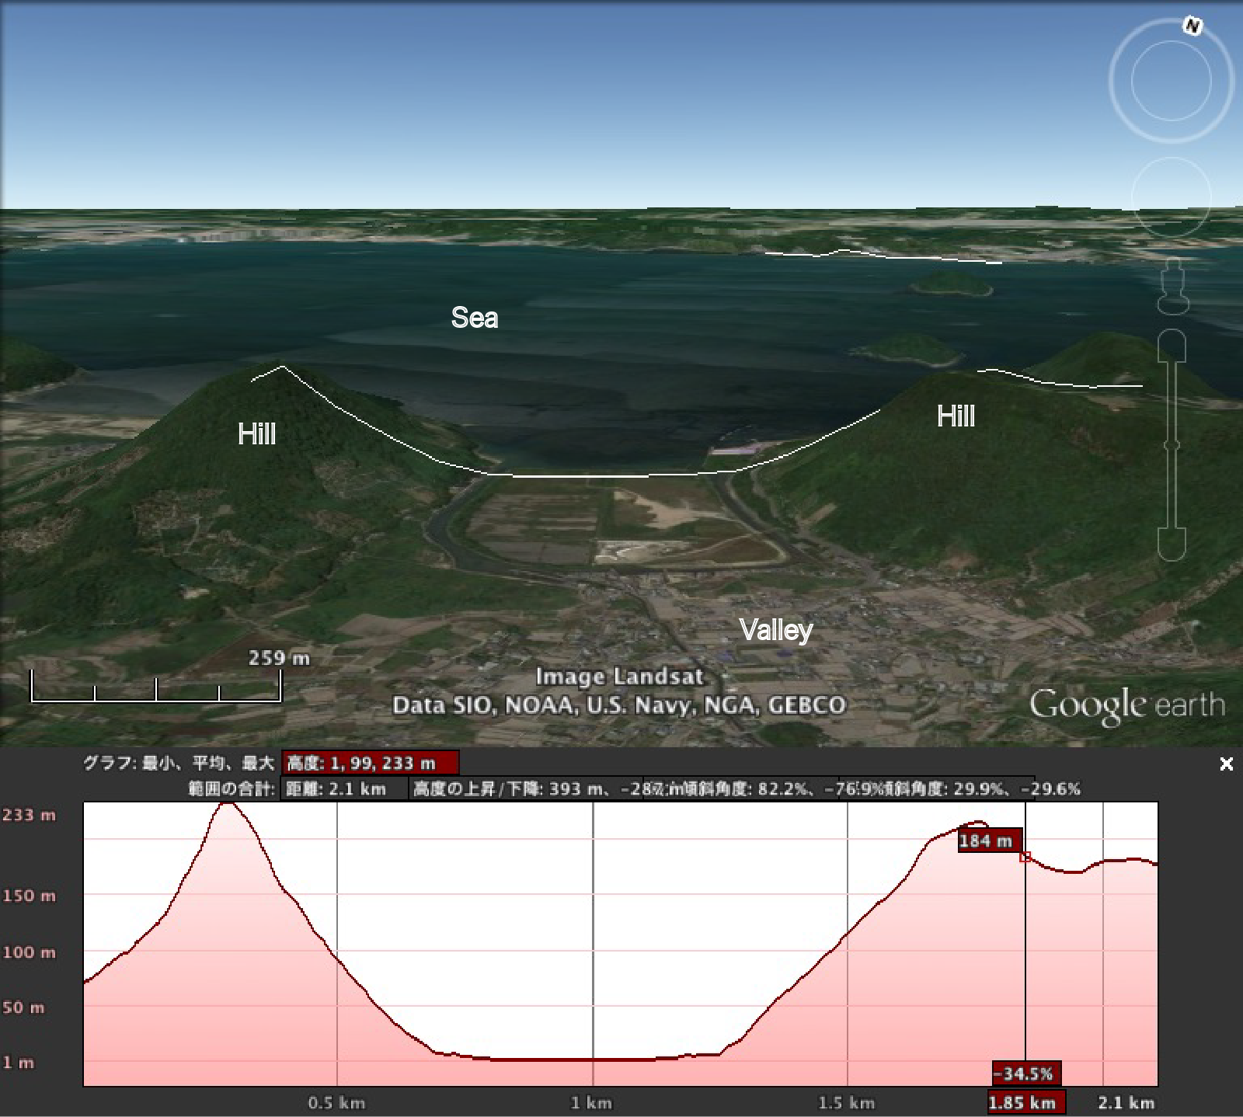

Figure 1 Measurement environment (Hilly area)

Table 2 Specification of fixed-wing UA used in the measurement campaign
Name | Puma-AE (Made by AeroVironment)
Wing span | 2.8 m
Weight | 5.9 kg
Normal endurance | 2-3 hours/flight
Driving power | Direct drive electric
Frequency of CNPC、Signal Power | 2GHz -band, 1W (Experimental test station)
Payload | 500 g

Table 3 Specification of transceiver in the measurement campaign
Frequency | f | MHz | 5035-5145 | Experimental test station
Bandwidth | Bn | MHz | 7
Antenna power | Pt | dBm | 30
Antenna gain (on-board) | Gt, Gr | dBi | 2.14 | Dipole antenna (VP)
Modulation |  |  | GMSK
Minimum sensitivity |  | dBm | -95

  - The deployment for the experimental measurement is shown in Fig.2. The horizontal distance between UA-a and UA-b varies from 100 m to 1100 m. The flight altitude of UAs varies from 150m to 700m. The elevation angle between UA-a and UAb changes from 88 degree and 0 degree. Therefore, the the received signal level is affected by the radiation pattern of antenna depending on the elevation angle. The measurement frequency was chosen as 5060 MHz in this environments.
- MEASUREMENT RESULTS
  - According to the three cases illustrated in Fig. 2, the corresponding power delay profiles and received signal level calculated from the measured baseband waveforms are illustrated in Fig. 3. For reference, each expected delay time of the ground reflected wave is plotted in Figs 3(a). The multi-path component appeared on the same times at the expected delay of the single ground reflected wave. Moreover, we observed one or more multi-path components at an altitude less than 150 m. It was revealed that the received signal of UA consists of the line-of-sight component and multi-path component formed predominately by the single ground reflected wave. In Figs.3(b), the moving average value of the received signal level of the measured signal and the two-ray model are also plotted as reference. The path loss of the measured received signal level tends to be the same as the path loss of free space path model using attenuation coefficient with 2.
- CONCLUSION
  - This IP presents a summary of a measurement for characterizing A2A radio propagation in C-band CNPC channels. The measurement was conducted to clarify the characteristics of the propagation based on the scenarios of deploying a small-size UAs. From the results, several characteristics of the propagation were obtained. For example, the maximum incoming path-delay time in the line-of-sight condition at an altitude less than 700 m was within 4 μsec. This means that the configuration of UA communication system using air-to-air channel, which operates CNPC link in the 5 GHz band , should allow 4 μsec delay time if an altitude is less than 700 m. Moreover, the influence of the co-channle interference of UA systems or other systems can be calculated by using measured path loss. Comprehensive propagation modeling for air-to-air channel is currently underway. The characteristics of channel models based on measurement results will be shown in the following meeting.

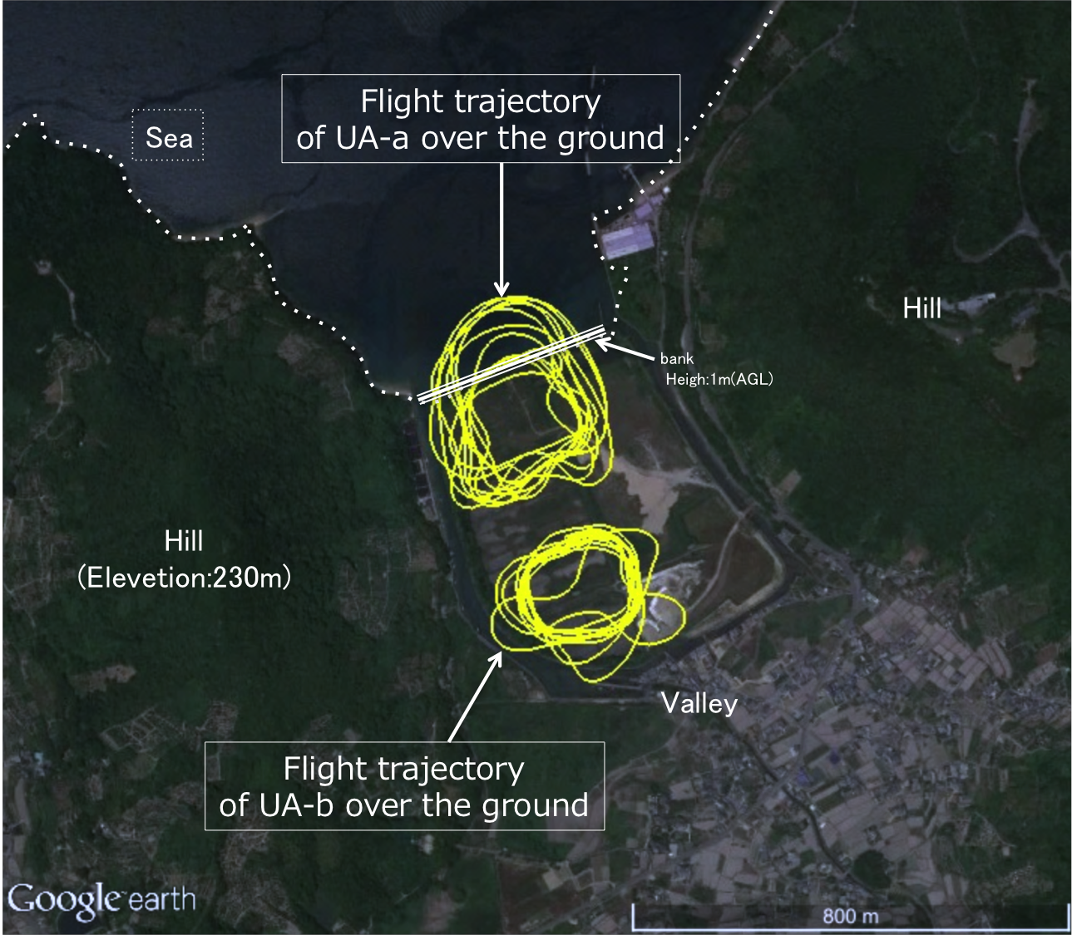
- Flight trajectory (Top of view of measurement environment)

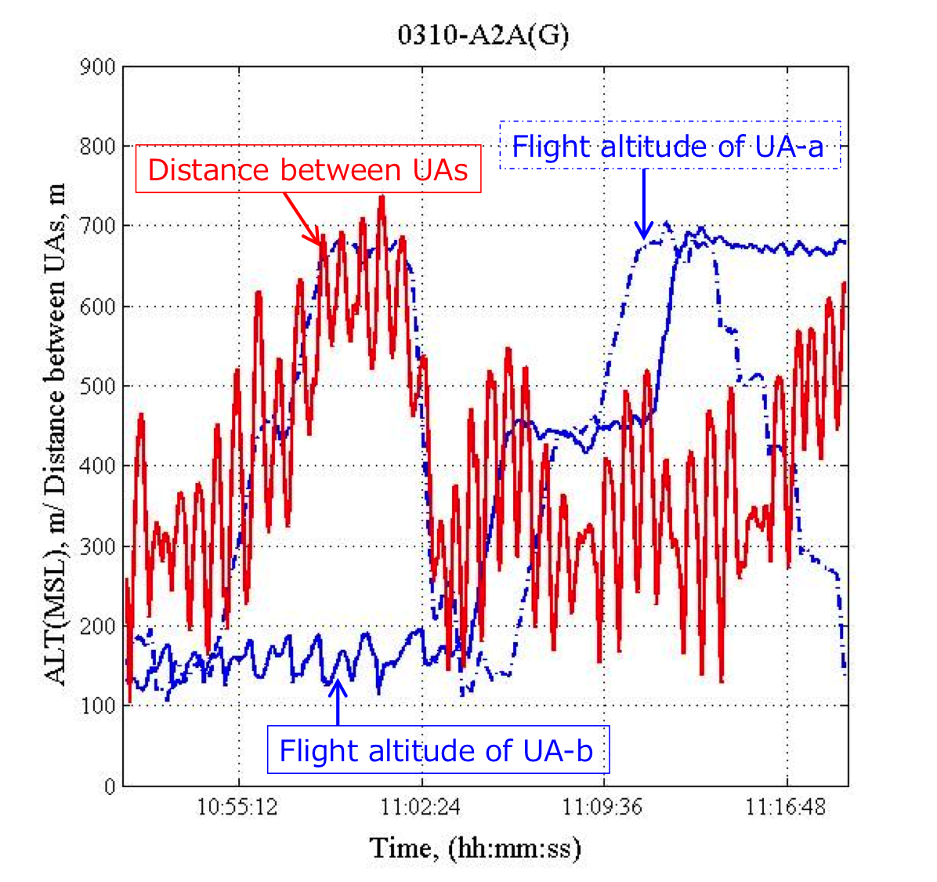
- Flight altitude and distance between UAs
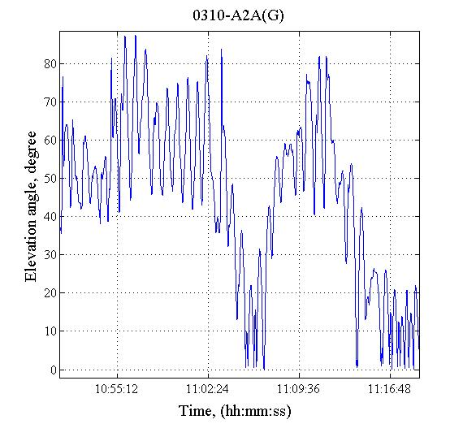
- Elevation angle between UAs

Figure 2 Deployment for this experimental measurement

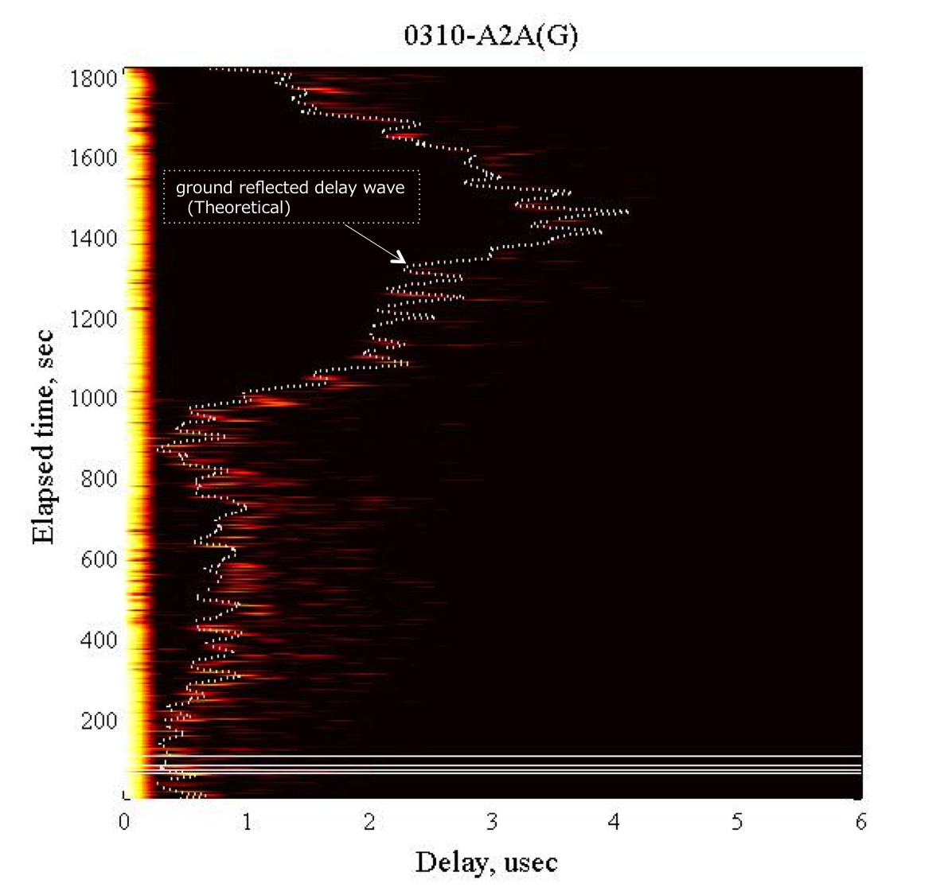
- Power delay profile

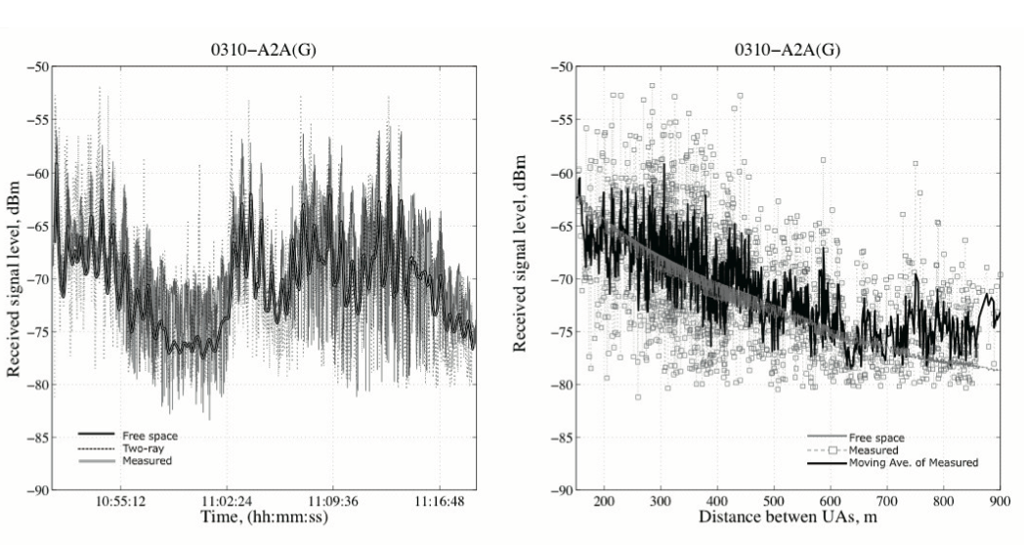

(b) Received signal level

Figure 3 Measurement results

— END —

