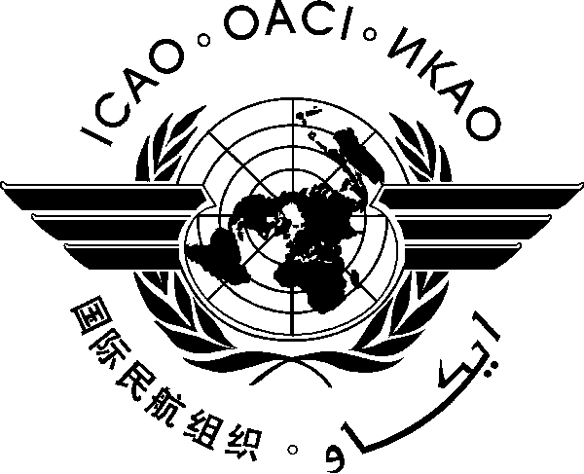
International Civil Aviation Organization

REGIONAL PREPARATORY GROUP (RPG) MEETING
FOR WRC-2023

Cairo, Egypt, 28-29 August 2023

PROVISIONAL AGENDA

- Introduction
- ITU/WRC process, results of WRC-19

- WRC-23: Aviation related topics and action plans to be implemented at the national and regional levels
- An overview of all aviation relevant agenda items to be addressed by WRC-23
- WRC-23 AI 1.6 – Radiocommunications for sub-orbital vehicles
- WRC-23 AI 1.7 – Space based VHF (AMS(R)S) allocation in the 117.975-137 MHz band
- WRC-23 AI 1.8 – Fixed Satellite Service allocations for RPAS C2 Link
- WRC-23 AI 1.9 – Wideband HF for aeronautical safety communications
- WRC-23 AI 1.10 – Potential new non-safety aeronautical mobile service allocations
- WRC-23 AI 9.2 – Difficulties or inconsistencies encountered in the application of the RR
- WRC-23 Agenda Items which may negatively affect spectrum access for aeronautical systems or services (1.1, 1.2, 1.3, 1.4, 1.11, 1.13, 1.15, 1.16, 1.17, 4, 8, 9.1 topic a, 9.1 topic b)

- Regional preparations for WRC-23
- The Arab Spectrum Management Group (ASMG) Preparation for the WRC-23
- Update from other Regional WRC preparatory groups

- Radio Altimeter and 5G issues (not on the specific agenda for WRC-23)
- Regional radar altimeter status
- New altimeter design and SARPS progress

- The reality of frequency management in MID: current practices and new challenges
- Aeronautical frequency management in the MID Region
- ICAO provisions: Handbook on Radio Frequency Spectrum Requirements for Civil Aviation (Doc 9718), Volumes I, and II

- Any other business
_ _ _ _ _ _ _ _ _ _ _ _

