FREQUENCY SPECTRUM MANAGEMENT PANEL (FSMP)

Nineteenth Working Group Meeting

Montréal, Canada, 15 to 26 July 2024

Agenda Item 8: Any Other Business

Questioning on the concept of hyperconnectivity

(Presented by Christian Fleury)

SUMMARY

The concept of hyperconnectivity is based on the ability to transmit data that are identified as "safety of life" over general commercial (satellite and terrestrial) links/networks that are not designed to support this type of applications, recognizing although that the current safety links would have the ability to face any event of failure of those general commercial links or networks.

This document attempts to identify a non-exhaustive list of possible side effects and questions that need to be answered.

- INTRODUCTION

The concept of hyperconnectivity is based on the ability to transmit data that are identified as "safety of life" application by general commercial (satellite and terrestrial) links/networks , or in the event of failure of those links/networks that are not designed to support this type of applications, while these types of links for “saftety of life” application are supported by an AMS(R)S or AM(R)S allocation which are dedicated for this matter. Contrary to links using AMS(R)S or AM(R)S allocation, the transit of data over general commercial links would not be subject to any priority or specific requirements in terms of latency, availability or reliability. The objective of the hyperconnectivity concept has been justified by providing a means of benefiting from the equipment and experience of the “Connected Aircraft” for passengers and, above all, by providing a low cost means to accommodate the growing need for larger volumes of data. This document attempts to identify a non-exhaustive list of questions that need to be answered.
- DISCUSSION
  - Historical context

Since the end of the 90s, digital technology has revolutionised the world at breakneck speed, leaving behind all those who failed to take the technological plunge. The aeronautical world has taken this technological turn for the passenger cabin for entertainment, but at a much slower pace for the cockpit. Very recently, to address the future lack of data transit capacity for safety with priority, Europe launched the IRIS programme, which is based on the INMARSAT network using an MSS allocation where AMS(R)S has priority over a portion of the ITU-R 5.357A band.

The concept of hyperconnectivity stems from the fact that the aeronautical world has been unable or unwilling to anticipate the ever-increasing need for ground-to-air data exchanges required to ensure the safety, regularity and optimisation of increasingly dense and demanding air traffic. It is likely that the main reason for this lack of anticipation is due to the difficult experience of implementing VDL Mod2.
  - Element for discussion

Figure 1

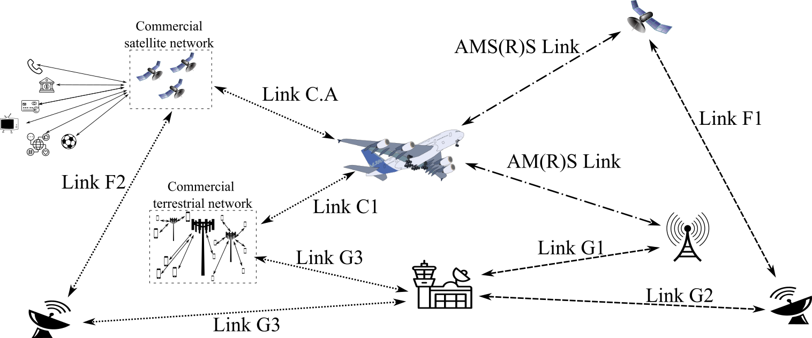

The figure above shows the different types and numbers of users benefit from the service provider between the commercial links (left side) and the safety links (on the right).

Figure 2 Figure 3

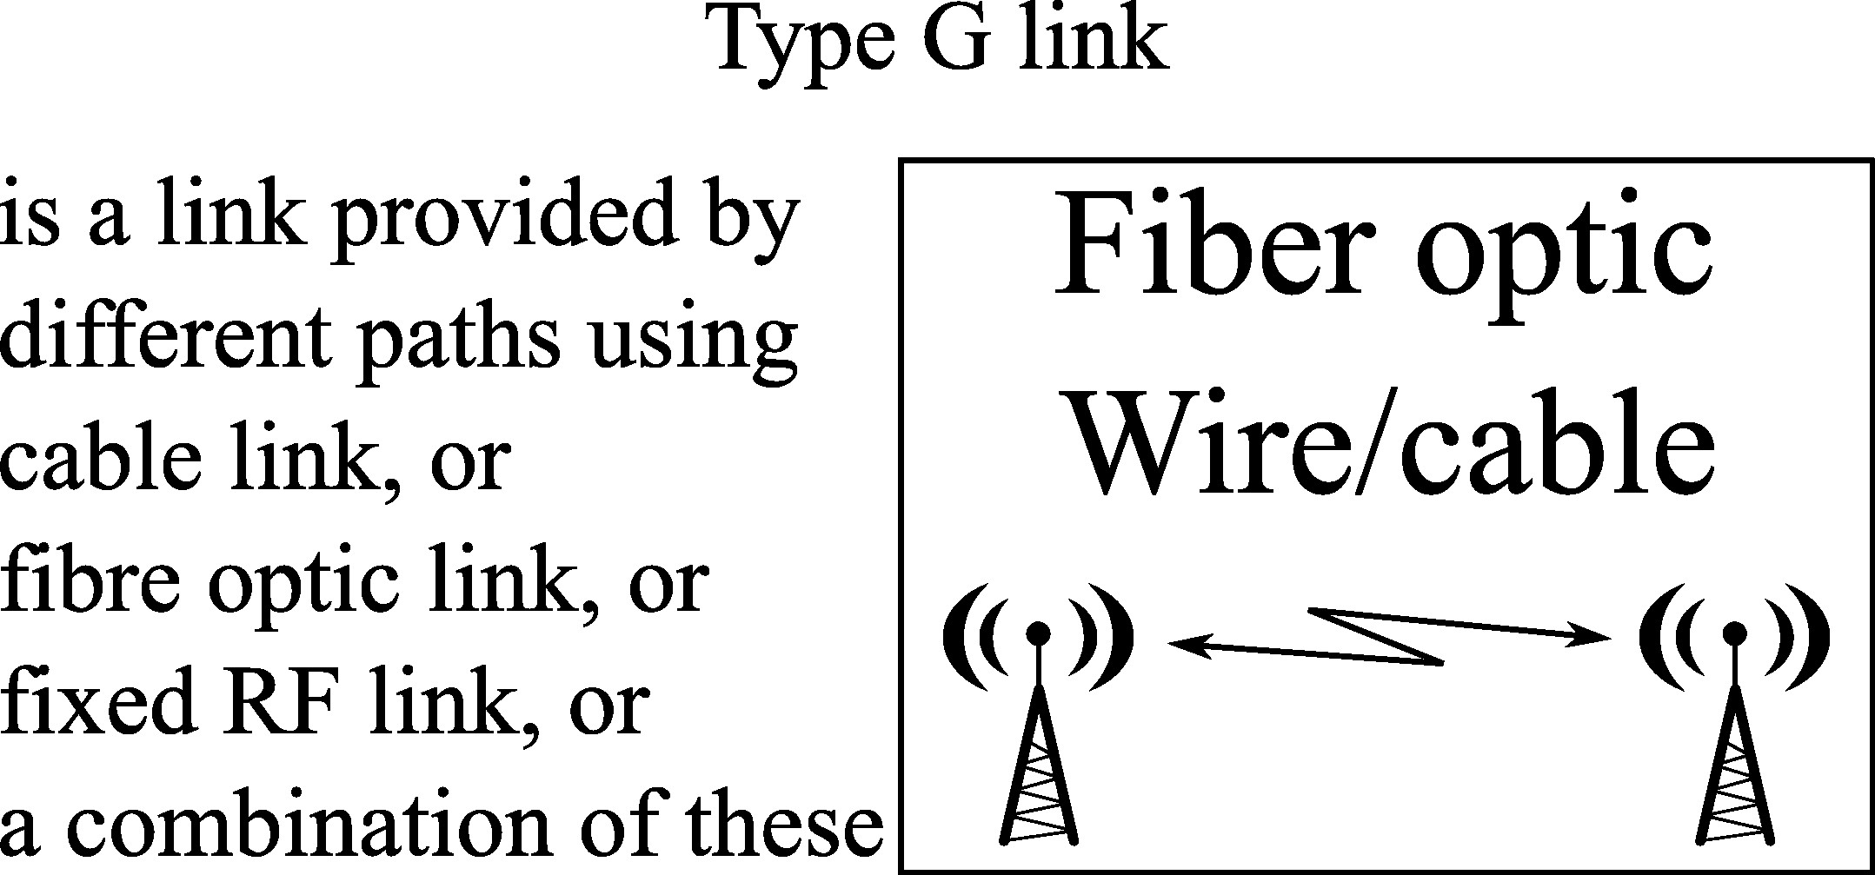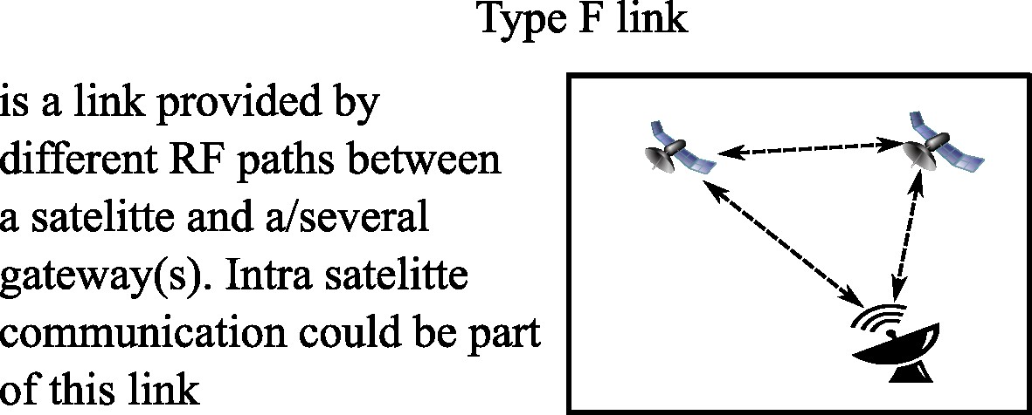
  - Questions about the regulatory aspect from international telecommunication unition (ITU)
    - Article 40. from ITU constitution and convention : International telecommunication services must give absolute priority to all telecommunications concerning safety of life at sea, on land, in the air or in outer space, as well as to epidemiological telecommunications of exceptional urgency of the World Health Organization.

Article 40 of the Constitution does not link telecommunications relating to the “safety of life” to any particular service. So whatever the service used, as soon as a telecommunication includes data relating to the “safety of life”, that telecommunication should be able to benefit from absolute priority over all other telecommunications. But in today's aeronautical reality, is this always the case? Data relating to the safety of human life may transit over fixed service networks (Link G1 & G2 of figure 1 & 2) or fixed/mobile satellite (Link F1 of figure 1 & 3). Although (to the best of our knowledge) this data does not have absolute priority on these networks, the necessary requirements for flight safety and regularity are typically ensured by the use of several simultaneous/redundant paths and also relevant knowledge and manageability of the links to ensure the quality of service requirements (including latency) imposed on service providers. In current use, we have therefore reinterpreted "absolute priority" in Article 40 as the reliability of "arrival on time".

The concept of hyperconnectivity is understood to extend the principal by considering that "safety-of-life telecommunication" could be supported by a set of links of different kinds, while continuing to use the existing systems ensuring that current air safety requirements (a pool of C1, C.A, AM(R)S and AMS(R)S links). In principle, this approach is consistent with the current philosophy, and could even provide an improvement!

Question: to confirm that the concept of hyperconnectivity would adress the "safety-of-life telecommunication" in cases of links of different natures, by mixing the use of commercial links and the use of the existing links disigned to ensure the current air safety requirements (a pool of C1, C.A, AM(R)S and AMS(R)S links), guaranteeing a continuous backup?

Question: To guarantee "arrival on time" does the concept of hyperconnectivity systematically solicite the link that meets current air safety requirements?

Question: How would be ensured that the used commercial links meet current air safety requirements?

Question: How the concept of hyperconnectivity could consider any back-up , if not used on a regular basis, as possible to retain maximum capacity in the event of a problem over a commercial network?

    - No. 4.10 of the Radiocommunication Regulation (R.R.) Member States recognize that the safety aspects of radionavigation and other safety services require special measures to ensure their freedom from harmful interference; it is necessary therefore to take this factor into account in the assignment and use of frequencies.

Article No. 4.10 of R.R. warns spectrum regulators of their responsibilities with regard to the assignment and use of frequencies. It should be noted however that Article No. 4.10 does not refer to any specific communication service, recognizing that Article No. 4.10 not applies for the data being transmitted over the general commercial links.

Questions:
- According to the stakeholders in the hyperconnected concept, 4.10 should not apply for the data being transmitted over the general commercial links. Does the aviation community agree that 4.10 does not apply to these safety data passing throught commercial links?

  - If YES :What would prevent some aviation stakeholders to ask the spectrum regulators to apply No. 4.10?
  - Is there any intention to elevate this topic to ITU-R?

- How would the use of commercial services to transmit “safety of life” data differ from WRC23 agenda item 1.8?
  - How can the transit of safety-of-life data be prevented from being used as an argument by the service provider expecting to benefit from priority over other users of the commercial frequency band from the ITU?
  - The question of liability was left open during the WRC23, with many countries expressing their opposition to this assumption of responsibility. How would this concept differ?
  - Other questions raised during WRC23 A.I 1.8…
    - ITU-R Article 44 Order of priority of communications

§ 1 The order of priority for communications in the aeronautical mobile service and the aeronautical mobile-satellite service shall be as follows, except where impracticable in a fully automated system in which, nevertheless, Category 1 shall receive priority:
- Distress calls, distress messages and distress traffic.
- Communications preceded by the urgency signal.
- Communications relating to radio direction-finding.
- Flight safety messages.
- Meteorological messages.
- Flight regularity messages.
- …

Question : The notion of priority to safety relevant messages is completely excluded from the hyperconnectivity concept and no requirements for priority are imposed to the service provider. How can this comply with Article 44?

    - Sustainability of AM(R)S and AMS(R)S allocations

In the majority of cases, frequency bands with an AM(R)S and/or AMS(R)S allocation are reserved for limited number of uses with special consideration when considering coexistence with other services in the frequency band. Thanks to R.R No. 4.10, these bands benefit of special measures to ensure the freedom from interference. The concept of hyperconnectivity would open a breach in this principle of the application of No. 4.10, for safety of life transmission by commercial links which by their nature do not benefit from No. 4.10.

Question: Recognizing that aeronautical systems under AM(R)S and AMS(R)S benefit from No. 4.10 putting some restriction on the limited resource of spectrum usage, how the concept of hyperconnectivity would transmit safety data by commercial links without the applicability of R.R. No. 4.10 and in a environement when interference would often occur?

Question: How to justify to the spectrum regulation the need to continue to have the AM(R)S and AMS(R)S allocations?
  - Possible side effects
    - Aeronautical communications R&D.

Question : Why should we continue to invest in the development of new aeronautical communication systems and standards, such as space based VHF and LDACs, since hyperconnectivity could compete with them at lower cost?
    - Volume of data.

The concept of hyper connectivity would serve to offset the growing need for the data required to operate a flight efficiently and safely. If the data transit capacity in the safety bands remains the same as it is today, due to the problem mentioned in 2.4.1, sooner or later we will reach the capacity of systems operating in the safety bands and we will not be able to withstand the slightest failure of a commercial system. In addition, the sudden increase in capacity, theoretically for low-cost data exchange, will inevitably lead to a slackening and consequent increase in the size of messages exchanged at aircraft level. The problem mentioned above could appear early and unanticipated.

Question: How can the above scenario be avoided?
    - Investment and sustainability of current communication systems.

For their economic health, airlines are looking to make savings. The concept of hyperconnectivity will encourage airlines to make the most of data exchange via these general commercial links, as they will be cheaper and have greater capacity. As a result, airlines will make less use of incumbent safety service providers, who will see their revenues shrink. In the best-case scenario, the aeronautical safety service providers will have to make drastic cost savings by limiting their investment, and may eventually not renew their equipment. In the worst-case scenario, they will stop providing the service because the cost will exceed the revenue.

Question: This scenario is perhaps a logical continuation of the evolution of “C” of the CNS. But is this the direction that the aviation community want to take, knowing that any return will be impossible?
    - Sovereignty

Several safety service providers share the "data safety" market. This micro niche market is exclusively dedicated to aviation, which can impose its own requirements. In the case of the hyperconnectivity concept, we will be considered as one (small?) consumer among many.

Question : Considering that aviation would only be one small variable among thousands of others in the overall business case equation, how can we guarantee that a generalist operator will not make a business decision, to stop providing this service to aviation, for economic or image reasons?

- ACTION BY THE MEETING

The meeting is invited :
- to note and review the contents of this working paper;
- To find relevent and acceptable arguments answers to the questions raise in the paragraphs 2.3 and 2.4 and their sub-paragraph; and to raise other questions.
— END —

