FREQUENCY SPECTRUM MANAGEMENT PANEL (FSMP)

Nineteenth Working Group Meeting

Montréal, Canada, 15 to 26 July 2024

Agenda Item 8: Any other business

Frequency band for RPAS DAA

(Presented by Guillaume Novella)

SUMMARY
This WP continues discussion regarding the identification of suitable frequency band(s) to accommodate on-board Detect and Avoid need for RPAS.

- INTRODUCTION
  - The standardization of Detect and Avoid for RPAS is being finalized within ICAO and RTCA as contained in the following deliverables:
- DAA SARPs
- DAA Manual (RPAS Panel)
- RTCA DO-365C: Minimum Operational Performance Standard (MOPS) for Detect and Avoid (DAA) Systems
- RTCA DO-366A: Minimum Operational Performance Standard (MOPS) for an Air-to-Air Primary Surveillance Radar (New version DO-366B – Revision of DO-366A in progress to take into account Class B2 - Low Swap Radar)
  - These standards address performance requirements for DAA systems, but do not address technical characteristics of DAA equipment. In particular, the frequency band appropriate to be used by RPAS DAA is not identified.
  - ICAO Annex 6 Vol IV contains the following provisions related to the requirements to have a DAA on-board RPA:

“6.20.2.1 The RPA shall be equipped with an automated system that performs appropriate collision avoidance manoeuvres, except when the collision avoidance responsibilities of the remote pilot can be adequately exercised using other means.

6.20.2.2 Notwithstanding the provisions in 6.20.2.1, the State of the Operator may approve RPAS operations without automated collision avoidance, based on the results of a specific safety risk assessment conducted by the operator which demonstrates how an equivalent level of safety will be maintained. The specific safety risk assessment shall include at least the:

a) integrity and performance of the C2 Link;

b) diversity of multiple C2 Links, if installed; and

c) reliability of other systems that are required to allow the remote pilot to exercise control of the RPA flight trajectory.”
  - The most appropriate way to comply with the above provisions is to implement an on-board DAA system. The identification of frequency for ground-based DAA would be easier since it can be achieved on a case by case basis due to local coverage and can be addressed when air-air DAA suitable frequency band(s) would have identified first. As a consequence, this WP only focusses on on-board DAA.
  - FSMP-WG18-IP06 initiated the identification process of suitable frequency band for RPAS DAA. This WP continues the discussion regarding the identification of suitable frequency band(s) to accommodate Detect and Avoid need for RPAS.
- DISCUSSION
  - Summary of previous work regarding DAA frequency band
    - ICAO work: DAA manual is performance oriented and does not contain technical characteristics. DAA manual contains the following statement concerning the frequency band to be used for air to air radar:

“3.3.1.6 Air-to-air radar (ATAR)

A DAA ATAR generate tracks for all intruders, cooperative and non-cooperative, within the radar detection volume. The radar should operate within designated frequency bands of the radionavigation service (RNS) or aeronautical radionavigation service (ARNS).

Note.— ICAO DOC 9718, Handbook on Radio Frequency Spectrum Requirements for Civil Aviation, also contains guidance and information relevant to designers and regulators. ITU-R Report M.2204, Characteristics and spectrum considerations for sense and avoid systems use on unmanned aircraft systems, provides details on the spectrum related aspects of air-to-air radars.”
    - RTCA work: DO-366A identifies radionavigation and aeronautical radionavigation frequency bands in Table 2-4:

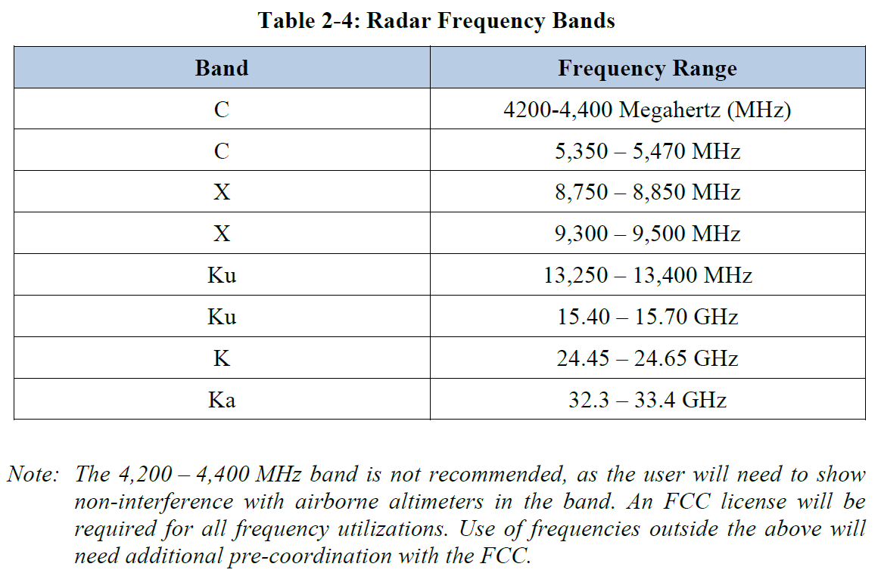

Further discussion concerning the suitability of each frequency band is given in Appendix A of DO-366A.
    - ITU work: ITU Report M.2204 “Characteristics and spectrum considerations for sense and avoid systems use on unmanned aircraft systems” was adopted in 2010 and its revision was considered since 2017, either with an update (see Annex 16 of WP 5B Chairman’s report R15-WP5B-C-712) or with an DAA handbook (see Annex 33 of WP 5B Chairman’s report R19-WP5B-C-355) to replace it.

In addition, two draft new ITU-R Recommendations (R23-WP5B-C-96 respectively Annex 8 and 7) about characteristics and protection criteria of DAA systems in the frequency bands 15.4 – 15.7 GHz and 24.45 – 24.65 GHz are under consideration within ITU-R Working Party 5B. Difficulties were expressed within ITU-R about the capability to coexist between on-board DAA operated under radionavigation service or aeronautical radionavigation and incumbent other services.
  - Requirement on RPAS DAA frequency band
    - The choice of RPAS air-to-air DAA frequency band should take into account the following considerations:
- Since the objective of the RPAS is to perform international IFR flights in non-segregated airspace, the RPAS air-to-air DAA frequency band should be harmonized on a worldwide basis.
- Due to the inherent safety nature of DAA system, the DAA frequency band should have suitable protection against harmful interference and should have an aeronautical radionavigation service (ARNS) allocation.
- Because of the difficulty to ensure the coexistence with other systems sharing the same frequency band and a safety system requiring protection in any point in space, the DAA frequency band should be chosen so that frequency management can be handled by civil aviation authorities taking into account the already deployed situation in other services.
  - Identification of suitable frequency band for RPAS DAA
    - The table below recaps the constraints of the different ARNS frequency bands to support RPAS air-to-air DAA.
Frequency band | Justifications | Suitability
4.2 – 4.4 GHz | Already widely used for radio-altimeters and WAICs, the coexistence with DAA would not be possible | Not suitable
5.35 – 5.47 GHz | This frequency band is identified for on-board weather radars. Ground meteorological and governmental radars are widely or planned to be deployed in that frequency band. Furthermore Earth exploration satellite service (active) operates in this frequency band. Due to the heavily usage, significant sharing and compatibility challenges already occurs between these systems. Coexistence between these systems and DAA would then not be possible. | Not suitable
8.75 – 8.85 GHz | This frequency band is limited to Doppler navigation aid centred on 8.8 GHz per RR footnote 5.470. However, DAA radars consider MFCW or pulse modulation which are not compatible with the Doppler restriction. ICAO handbook indicates that this frequency band is extensively used for airborne Doppler radar and ground mapping radar. In addition, some administrations impose that ARNS radars in this band to tolerate any interference from radiolocation service. | Not suitable
9.3 – 9.5 GHz | Most of on-board weather radars are deployed in this frequency band. This frequency band is also heavily used by governmental, aviation, maritime and weather applications. There are already significant compatibility challenges faced between the systems operated in incumbent services allocated in the frequency band. Additionally, the deployment of two air-to-air radars on the same aircraft would be hardly achievable. | Not suitable
13.25 – 13.4 GHz | ARNS systems operating in this frequency band are limited to Doppler navigation aids per RR footnote 5.497. However, DAA radars consider MFCW or pulse modulation which are not compatible with the Doppler restriction. ICAO handbook indicates that this frequency band is widely used for specialized applications such as continuous determination of ground speed and drift angle information of an aircraft with respect to the ground. In addition, this frequency band is shared with EESS (active) and space research (active). | Not suitable
15.4 – 15.7 GHz | This frequency band is used by radiolocation with limited deployment, other aeronautical radionavigation for local applications (precision approach radar and airport surveillance detection system) and fixed satellite service (FSS) uplink (in a sub-band) limited to feeder link stations. The DAA would have to comply with No. 5.511C in the frequency band 15,43-15,63 GHz and appropriate frequency management may address this point in the coordination area of RPA from FSS feeder link stations. | Suitable
24.45 – 24.65 GHz | This frequency band is not allocated to ARNS in Region 1, preventing to perform RPAS flight from/to/into this region. | Not suitable
32.3 – 33.4 GHz | This frequency band should be shared with maritime and land based radionavigation, as well as with the fixed (for high density application in accordance No. 5.547) and inter-satellite services. In addition, this frequency band is the main candidate to support EFVS that coordinates with fixed service in vicinity of airports.The coordination for on-board DAA with fixed service would not be possible. | Not suitable

    - Since the frequency band 15.4 – 15.7 GHz frequency band seems to be the best candidate to support worldwide RPAS on-board DAA, it is proposed to first focus on this frequency band to assess its capability to fulfill RPAS on-board DAA needs.
- ACTION BY THE MEETING
  - The meeting is invited to:
- note and review the contents of this working paper;
- Agree to start the analysis on the deployment of on-board DAA radars in the 15.4 – 15.7 GHz frequency band.
- adopt an action asking participants to provide operational and technical characteristics of ASDE radars and precision approach radars operating in the 15.4 – 15.7 GHz frequency band;
- Liaise to Surveillance Panel regarding the above mentionned action;
- Liaise to RPAS Panel in order to get technical characteristics of on-board DAA radars.

— END —

