Attachment B: Extract CEPT / PT1 January 2023

Compatibility assessment and scenario

Generic model : Physical near-collision scenario

Scenario configurations
Configuration 1: Worst height below runway elevation throughout the considered airport/region/country. This configuration option 1 is suggested to be used when emission sources locations are located relative to the OCS but height of emission sources are unknown.
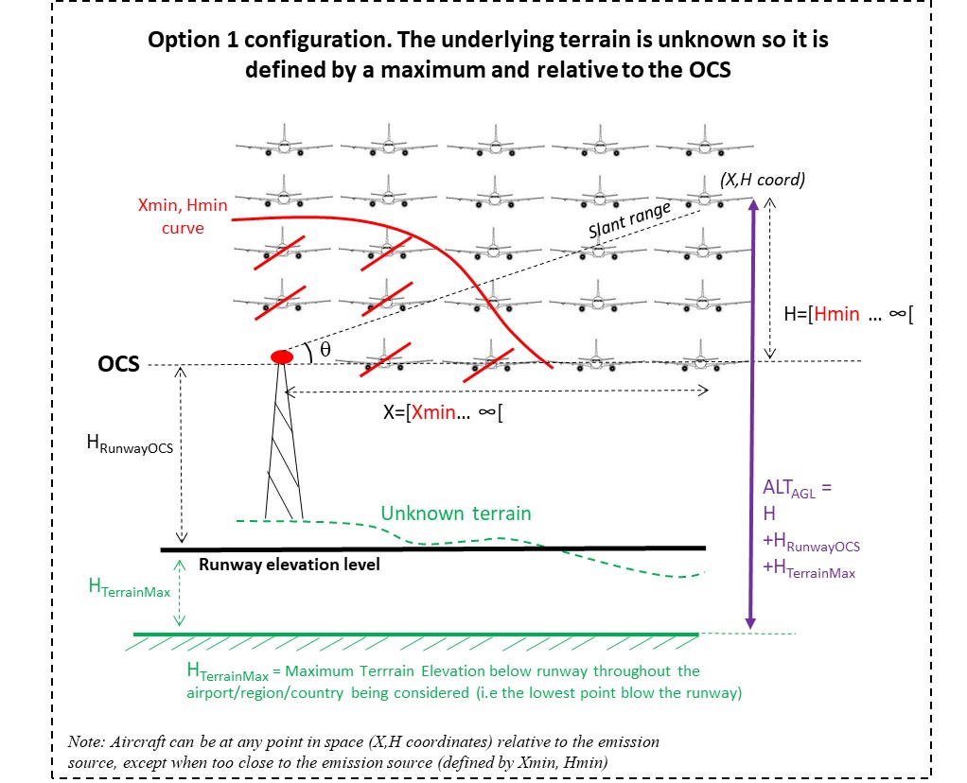
Configuration 2: Worst terrain slope starting at the foot of the mast/building at the airport/region/country. This configuration option 2 is suggested to be used when height of emission sources are known. It can be applied with or without OCS.
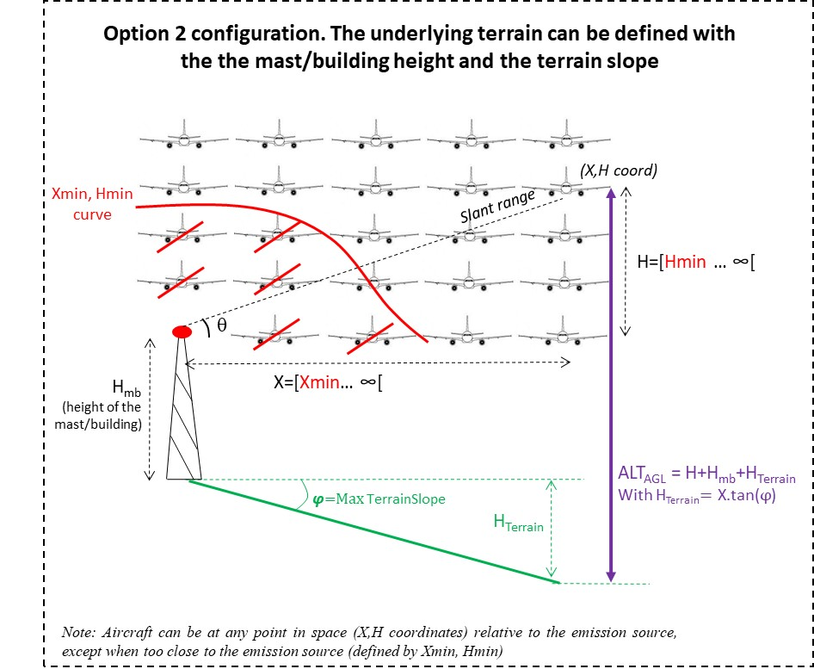
Details of the different steps to be considered in order to check the coexistence are included in the guidance document noting that the main target is to compare the computed pfd to the BAPFD that corresponds to the investigated scenario taking into account aircraft height above ground, IMT BS power and frequency.
It is important to note that scenarios considers wind shear, engine out, navigation sensor errors, and other rare normal operational scenarios where an additional radar altimeter loss of function could complicate beyond recovery.
When considering the Physical Near-Collision scenario, the greatest risk to successfully recovering from a non-normal situation (wind shear, engine out, etc.) can be a lack of sufficient altitude above the ground or an obstacle, coupled with an unknown or incorrect situational awareness of the altitude, which influences pilot actions during the flight crew’s trained procedural recovery.

Aircraft position parameters
- Minimum operational distances relative to the emission source (Xmin,Ymin): The minimum operational distances with the emission sources (Xmin,Ymin) that are needed by the model can merely be the minimum physical collision distance relative to the emission source (DPHY, HPHY).

- Vertical aircraft location relative to the emission source (H): Hmin is the vertical distance of the aircraft RA antenna relative to the emission source (H). The height H varies from Hmin up to the maximum RA range (e.g. 5000ft). Other parameters need to be taken into account, such as the aircraft altitude above ground since the RFI tolerance of RAs generally decreases with increasing altitude AGL.

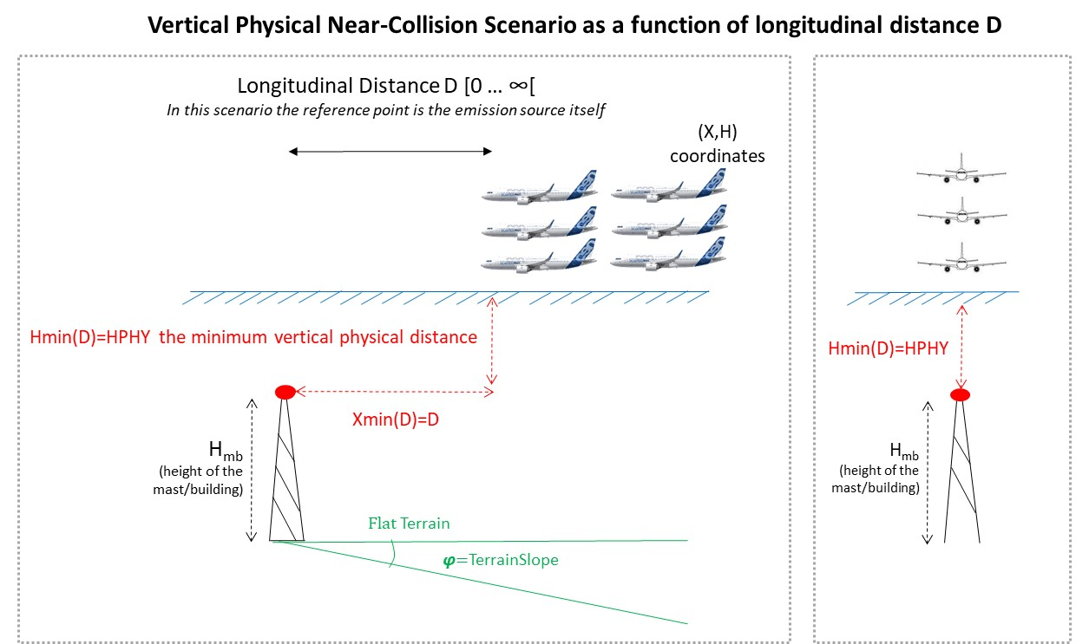

- Lateral/horizontal aircraft location relative to the emission source (X): The lateral position of the aircraft RA antenna relative to the emission source (X). It varies from the minimum lateral separation from the emission source (Xmin) up to a maximum value defined for the specific scenario (generally less than 3NM).

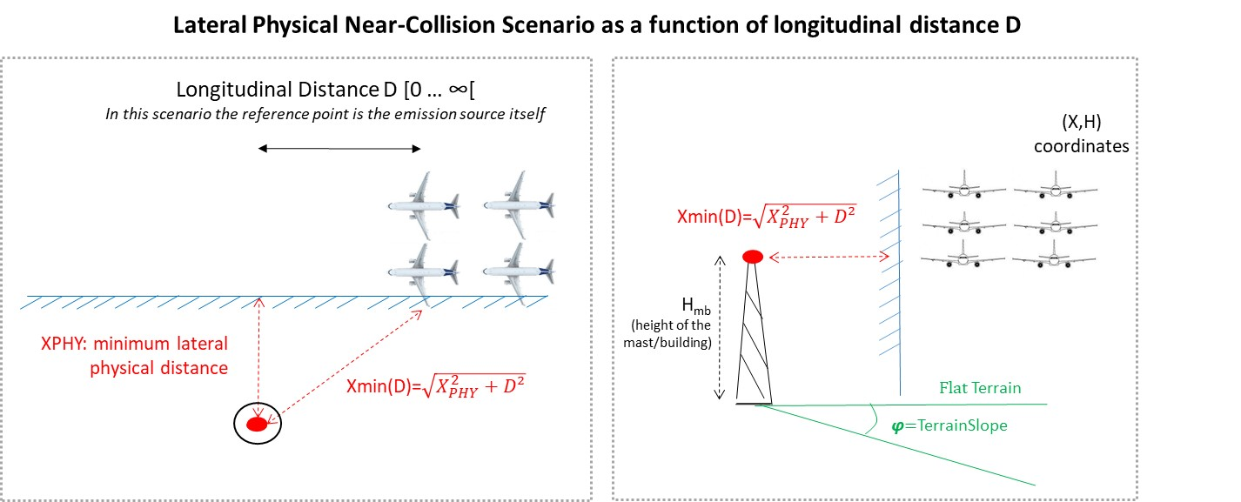

ILS worst case scenario
Based on the operational concept of low-visibility ILS automatic landings, if the aircraft deviates too far from the navigation guidance the operation must be stopped and the aircraft must perform a missed approach. This operation-specific requirement could be used to determine an operation-specific minimum distance that can be encountered with high enough probability to be of significance in the radar altimeter failure safety risk assessment. The example considers three different segments illustrating three different phase of operation to perform the approach and landing operation as described on the figure below.
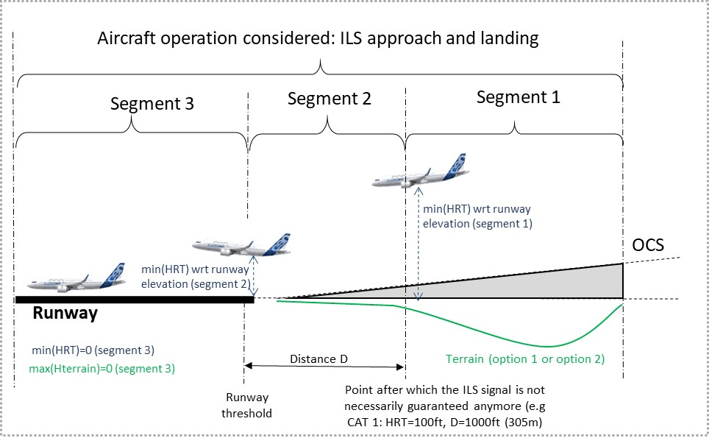
Segment 1 correspond to the phase after which the ILS signal is not guarantee (worst case d=100 ft), segment 2 is the landing phase and segment 3 is when the aircraft is just above the strip of the runway.
The minimum distance for each phase of the scenario is considered when interferer are located all along the boundary of the Obstacle Clearance Surface (OCS). Interferers are represented as red Dots on the figure below.
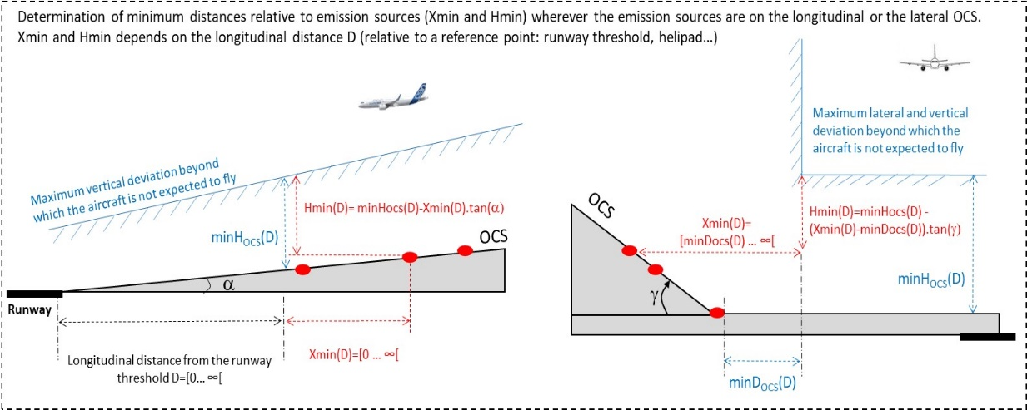
The following illustration includes an example of the vertical input of the model applicable to the ILS scenario.
