FREQUENCY SPECTRUM MANAGEMENT PANEL (FSMP)

Seventeenth Working Group Meeting

Cairo, Egypt – 30 August – 7 September 2023

Agenda Item 6 : Interference from Non-Aeronautical Sources – FSMP.004.03

VHF DATALINK INTERFERENCE FROM USB FAN

(Presented by Andrew Roy, ASRI. Report provided by Collins Aerospace)

SUMMARY
This paper provides a technical report of a USB fan that was found to interfere with VHF datalink services.

- INTRODUCTION
  - ASRI has received a technical report from Collins Aerospace after a VHF datalink interference investigation. Collins has agreed for the report to be shared with the wider aviation community to assist in awareness of these types of issues.
- DISCUSSION
  - In ASRI’s frequency management role for aeronautical VHF and HF channels in the United States, it receives and address multiple interference reports for voice and data services. More recently, it has seen a rise in the number of LED lighting interference complaints to VHF datalink services, caused by the broadband noise in the VHF band from LED power conversion circuitry.
  - This noise is high enough that the VDLM2 Carrier Sense Multiple Access (CSMA) power threshold for channel busy is exceeded, resulting in the aircraft avionics not being able to transmit. This leads to aircraft approaching airport gates and disappearing from the service providers network, as while the aircraft can still receive the messages from the close proximity ground stations, it is prevented from sending the ACK or any other messages.
  - While ASRI continues to receive these types of reports, ASRI has recently received a report of a previously unknown broadband interference source, a USB powered LED. The service provider affected has produced a report and ASRI has included it in Appendix A. What is concerning is that the power generated by a simple USB fan would be expected to interfere with an aircraft up to 800 meters away based on the sample tested.
- CONCLUSION
  - While the issue presented in the attached report has been addressed, it does reinforce that sources of interference can come from unexpected places. While work continues at RTCA and EUROCAE to make new VHF datalink receiver designs more robust to these types of interference through signal detection, it is likely that affected avionics will remain in operation for many years.

— END —

Collins Aerospace Test Report:
USB Fan Causing Interference on the VDL CSC
July 1, 2023

Background: Recently field maintenance investigated a report where a Collins VDLM2 ground station radio receiver was experiencing degraded receiver performance at an airport. Our maintenance team investigated and identified a potential interference problem which appeared to be caused by small USB desk top fans that were operated in an adjacent office. The interference was resolved by disconnecting the USB fans.

Based on continued interest, we found the same model of fan on-line and purchased one so that it could be tested by our engineering department with our radio lab. This informal report provides the results of this test effort. It is our assessment that the USB fan does not meet the performance standards set forth by FCC Part #15 as an unintentional emitter.

Test Records and Information:

Date tested: June 23, 2023
Tested by: Collins Aerospace
USB Fan Manufacturer: Dongguan Yateng Electronic Co., LTD
Model# F150

Initial notes:
- No CE marking on fan.
- Manual does not have the required compliance statement per Part 47 CFR 15.105(b)
- The box has CE symbol.
- The marking on the fan itself is minimal... Not even a manufacturer’s name...

FCC Industry Reference:
The specification for emissions for this type of device is governed by the Code of Federal regulations, title-47/chapter-I/subchapter-A/part-15/subpart-B/section-15.109. Reference: https://www.ecfr.gov/current/title-47/chapter-I/subchapter-A/part-15/subpart-B/section-15.109

5.109 Radiated emission limits.
(a) Except for Class A digital devices, the field strength of radiated emissions from unintentional radiators at a distance of 3 meters shall not exceed the following values:

Frequency of emission (MHz) | Field strength (microvolts/meter)
88–216 | 150
Section 15.5 of the FCC regulations also requires that the operation of an unintentional radiator must cease if it has been found to produce harmful interference to safety related communications.

Converting to dBm we get: 150 uV/m ~ -76.5 dBm

Test Results:

We measured -50dBm at ~3m, and verified measurements with two spectrum analyzers (keysight N2090B and Anritsu MS2034B). The measured emissions is 26 dB higher than the limit. The highest measurements were made with the USB cable extended; thereby, the cable acts as an antenna. Note that our measurements are not perfectly precise as our testing was not performed in a certified anechoic chamber and did not use a calibrated antenna. Nevertheless, our measurements are sufficient to confirm this device greatly exceeds the FCC allowed emissions for such a device.

Interpretation of Measured Test Results:

The table below adds 6dB for each doubling of distance based on the -50dBm measured at 3 meters. For solid VDL communications down to the required level of -98 dBm, we need a noise floor of -120dBm for interference free communications.

Distance in meters | Expected levels in dBm  For compliant device | Expected levels in dBm  For this fan
3 | -76 | -50
6 | -82 | -56
12 | -88 | -62
24 | -94 | -68
50 | -100 | -74
100 | -106 | -80
200 | -112 | -86
400 | -118 | -92
800 | -126 | -98

Extrapolating the data, we can expect that this device will continue to interfere with VDL communications at 800m.

Assessment/Next Steps:

This fan seems to violate FCC Part 15 emission standards by 26 dB measured at 3 meters.
We should advise the FCC with this report and also advise the FCC and L3 because it could impact the FAA DataComm program.

Attachments: Photos of the USB Fan and Spectrum Analyzer Measurements:

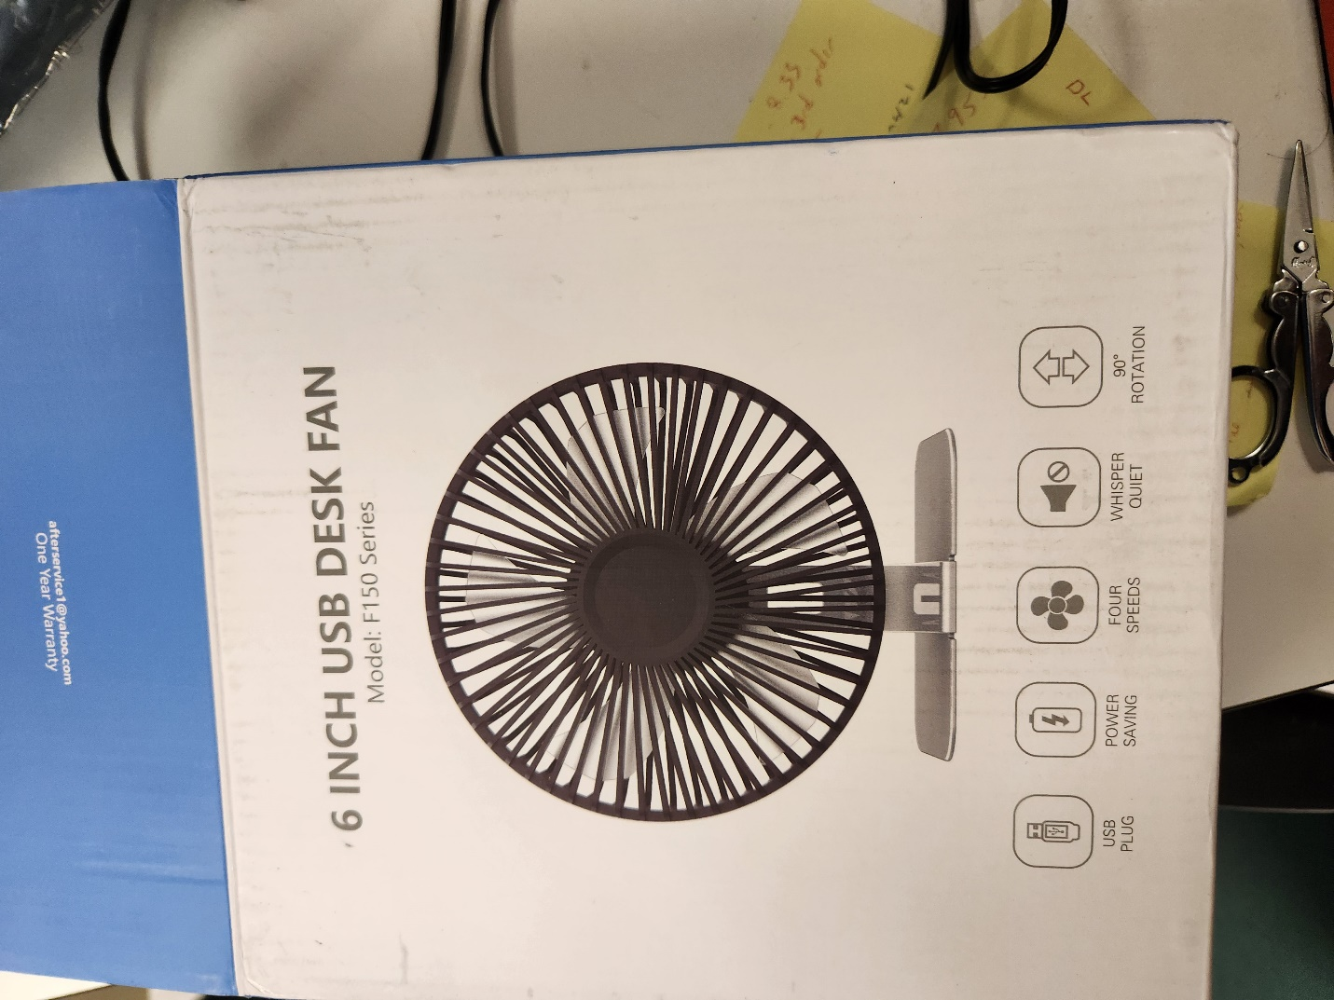
Figure 1: Fan Box Front Side
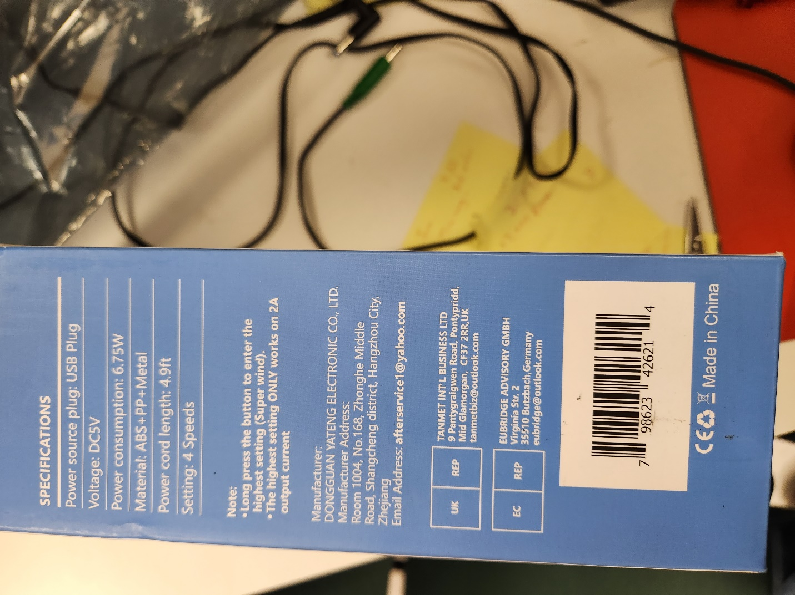
Figure 2: Fan Box back side
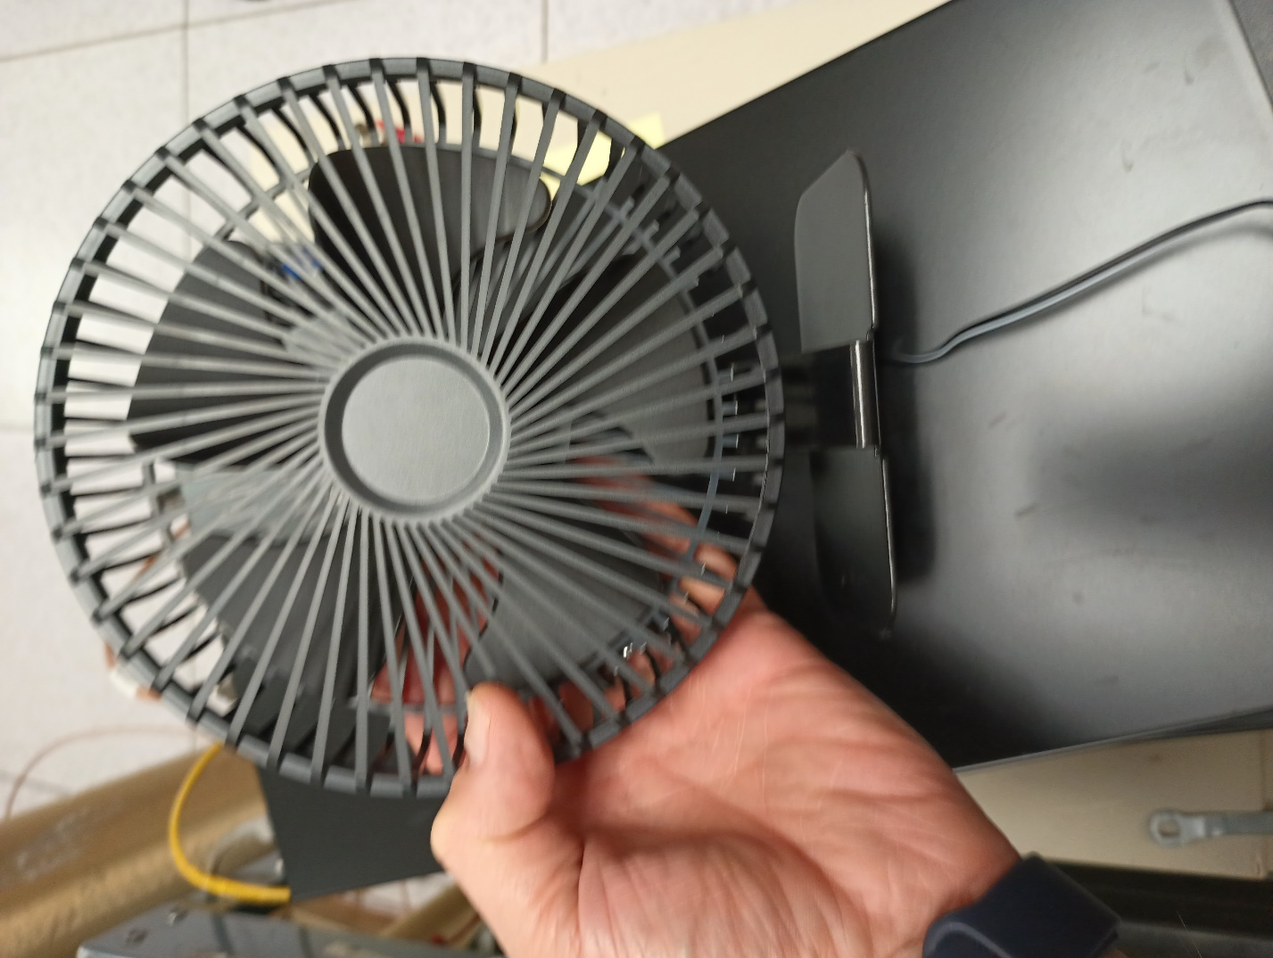
Figure 3: Picture of Fan
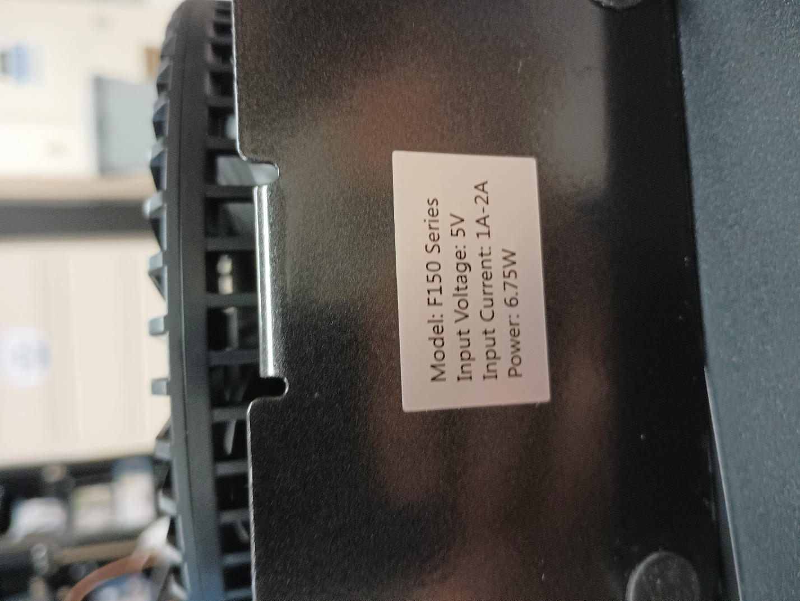
Figure 4: Markings on Fan Bottom
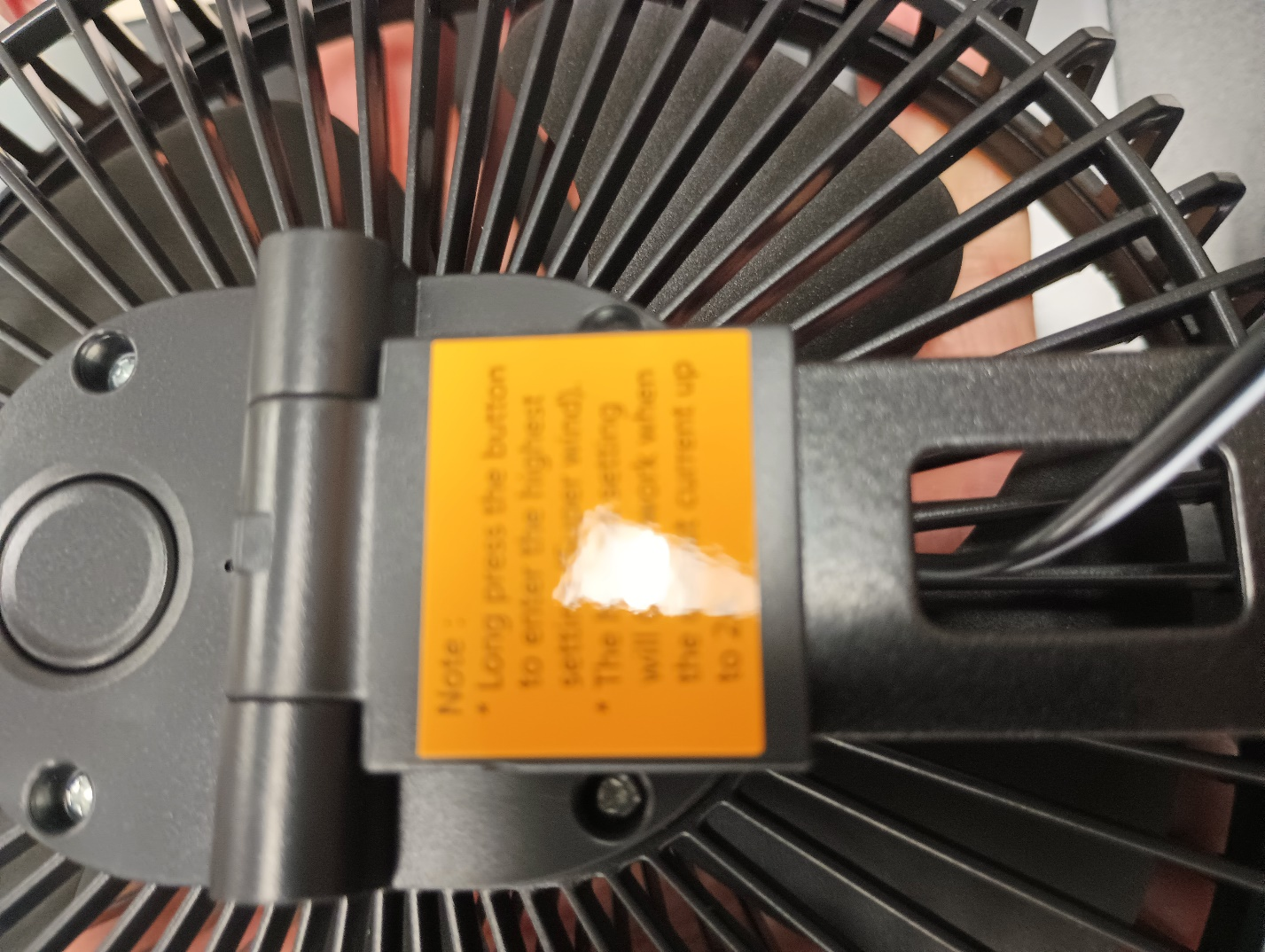
Figure 5: Other Marking on Fan
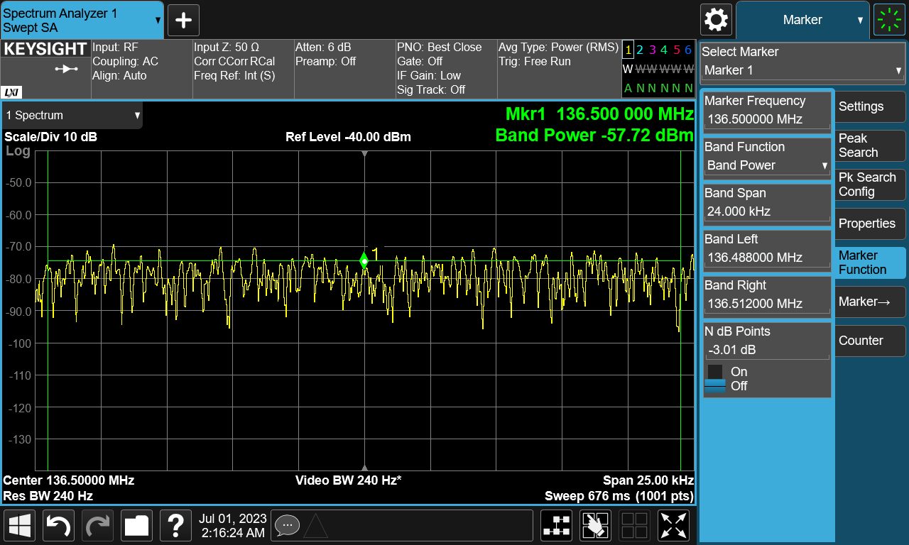
Figure 6: Fan Emissions in dBm, 25kHz BW; These are not the highest values measured.
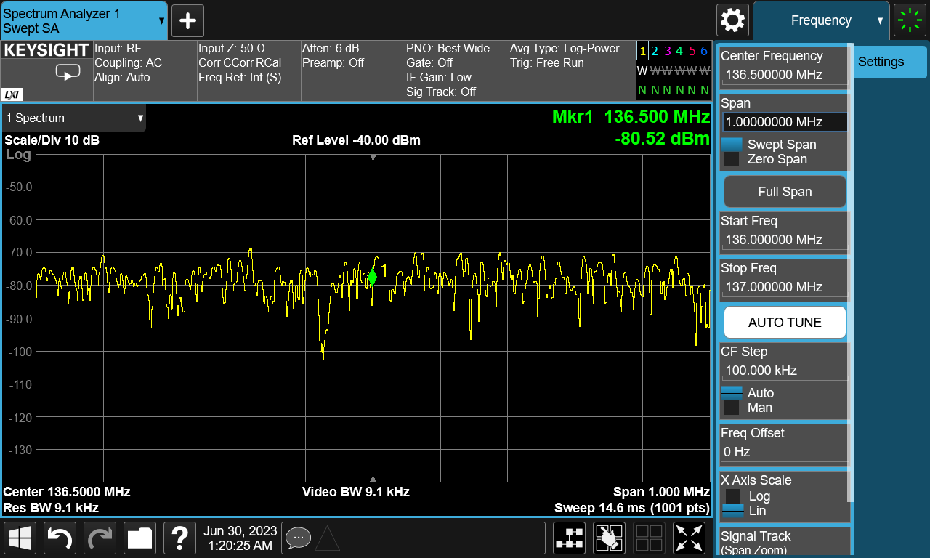
Figure 7: The emissions have a BW of more than 1MHz
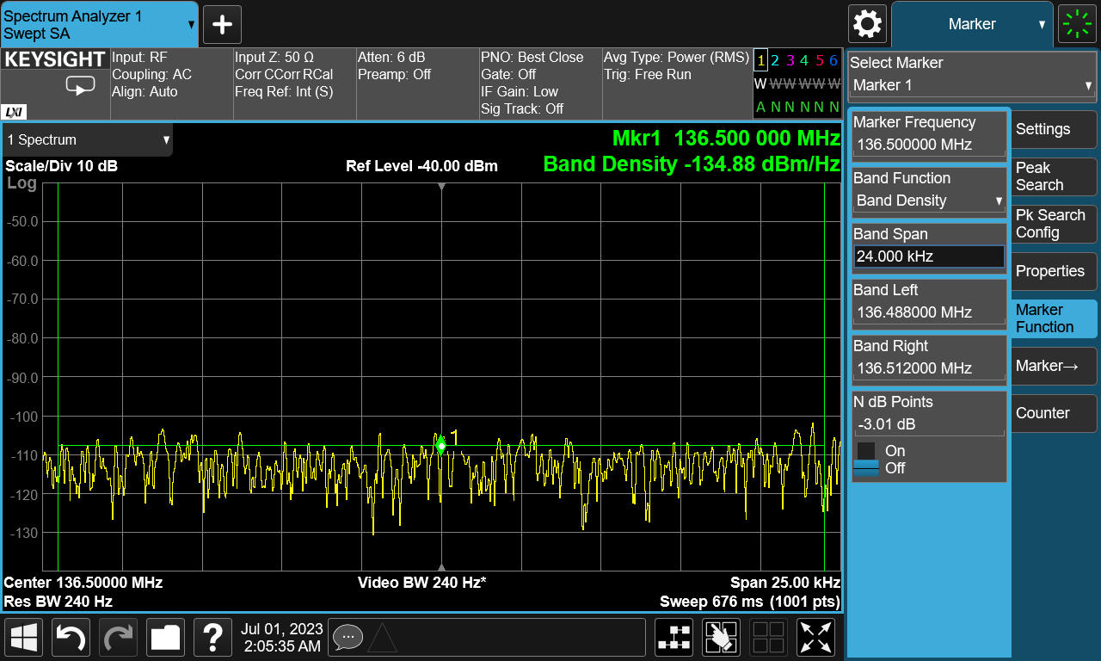
Figure 8: Noise Floor as Measured in the Lab

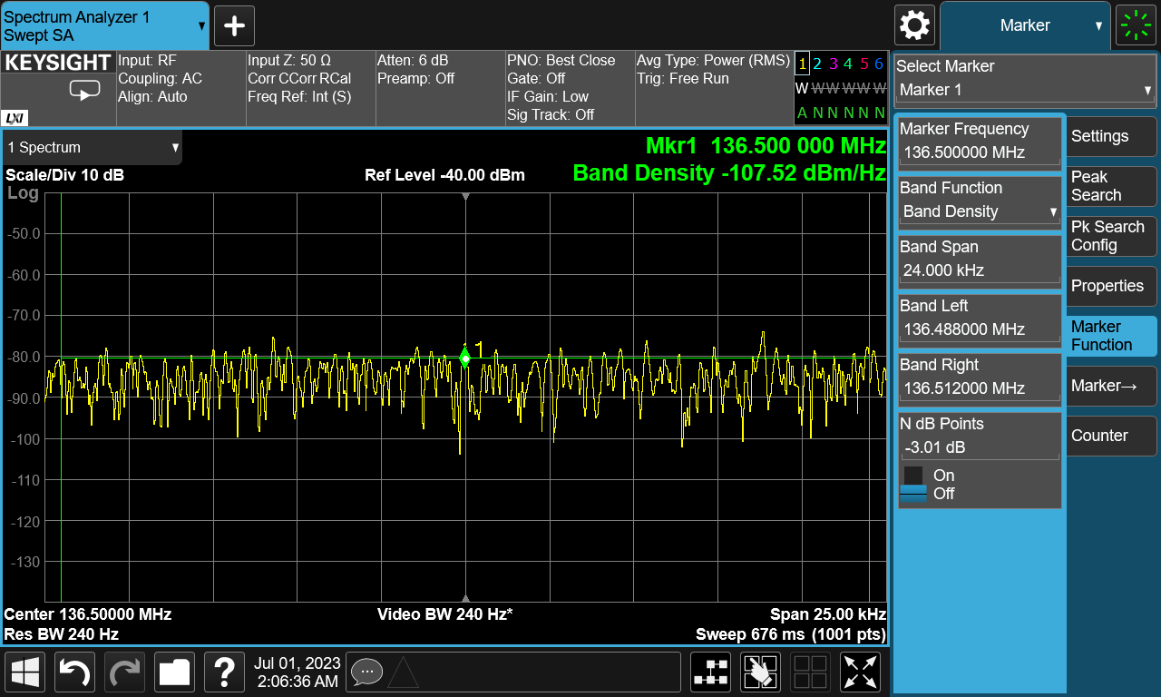
Figure 9: Noise measurement, Fan on, in dBm/Hz

