FREQUENCY SPECTRUM MANAGEMENT PANEL (FSMP)

Twentieth Working Group Meeting

Bangkok, Thailand, 26 February -7 March 2025

Agenda Item 5: Aeronautical Band Planning – FSMP.005.03
- 108 – 137 MHz

Approach to Multipath Impact on Space-Based VHF

(Presented by Jose Luis Chinchilla)

SUMMARY
This paper presents an approach to multipath impact on Space-Based VHF considering typical aircraft antenna, and example of spacecraft antenna pattern and the reflexion coeficents.

- INTRODUCTION
The multipath phenomenon is a very known phenomenon on the radiofrequency propagation model, nevertheless, this phenomenon depends on many factors that need to be consider for each expecific application.

This approach analyzes the impact of this phenomenon on the link budged for ground-based VHF and for space-based VHF systems in a comparative way.

This analysis intends to characterize better the multipath in the space–aircraft scenario and evaluate its expected impact, being the final goal to generate a statistical model that permits to obtain the performance with a more accurate characterization.

An approach is also done for the impact on data link for a ground-based VHF system to validate the methodology used as a first step before to analyze the impact on data link for a space-based VHF system.
- DISCUSSION
  - Introduction to the model
    - Enviroment description
Basically, VHF signals from/to the spacecraft can be reflected by the Earth surface and the fuselage and can interfere with the direct signal worsening the quality of the transmission, as shown in the following figure.
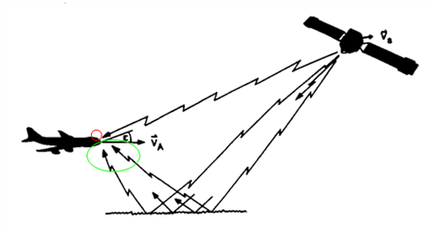
Figure 2-1: Multipath diagram
    - General hypotesis
In the simulation environment, the spacecraft is considered the transmitting station and the aircraft is considered to be the receiving entity. In the ground segment scenario, the ground station is the transmitting station.

The aircraft is located at a Flight Level 450 and the antenna used is representative of the A319 VHF1 (top mounting) with revolution symmetry.

The spacecraft is in a Sun Synchronous Orbit at 600 km altitude and the boresight of the antenna is pointing nadir. The antenna diagram of the spacecraft used is an isoflux diagram. The orbit is selected such that the spacecraft flights right over the aircraft at some point of the simulation.

The ground station is located at 15 m altitude and the antenna used is an ideal half wave dipole. The ground station position is selected such that the aircraft flights right over it at some point in the simulation.

The spacecraft transmitting power is assumed to be 1W so that the results are non-dimensional and can be easily scaled with the transmitting power.

Two rays from the spacecraft to the aircraft are simulated (direct and reflected):
- Direct ray: The direct signal travels a straight line with circular polarization from the transmitter to the receiver, suffering the following amplification/loses.
  - Transmitting antenna diagram, depending on the spacecraft-aircraft direction
  - Spreading losses due to travel distance and frequency
  - Crossing the atmosphere accounting for atmospheric and scintillation losses
  - Polarization losses (from circular to linear polarization)
  - Receiving antenna diagram, depending on the spacecraft-aircraft direction

- Reflected ray: The reflected signal travels from the transmitter to the receiver in a path bouncing on a point in the Earth’s surface such that the incidence angle equals the reflection angle. The ray follows two straight lines (from spacecraft to reflection point and from reflection point to the aircraft). The amplification/losses suffered are:
  - Transmitting antenna diagram, depending on the spacecraft-reflection point direction
  - Spreading losses due to travel distance and frequency (travel distance is the distance from spacecraft to the reflection point plus the distance from the reflection point to the aircraft)
  - Crossing the atmosphere accounting for atmospheric and scintillation losses (same as the direct ray as they occur in high layers of the atmosphere)
  - Reflection point. When the circularly polarized signal reflects on the Earth’s surface, each component (vertical and horizontal) suffer a change in amplitude and phase according to the diagrams of section 2.1.4. Starting on this point, only the vertical component is considered, as the aircraft antenna will receive only this component and the horizontal will be discarded.
  - Polarization losses (by only considering the vertical component)
  - Receiving antenna diagram, depending on the reflection point-aircraft direction.

- Combination. After both signals are received by the aircraft antenna, they are combined depending on the amplitude and phase of each signal, and is reflected as ‘Combination Loss’ or ‘Combination Gain’ depending on the sign criteria shown in the plots. The phase difference of both signals is computed based on the phase shift on the reflection, plus the phase delay due to the difference in path length by both signals.

    - Orbit/Altitude Hypotesis
- Orbit: Circular SSO at 600 km altitude:
- SSO inclination at 600 km is 97.8 deg
- Aircraft Height = 13.7 km (FL450) heading north
- Aircraft motion is negligible with respect to spacecraft motion
- Aircraft antenna diagram
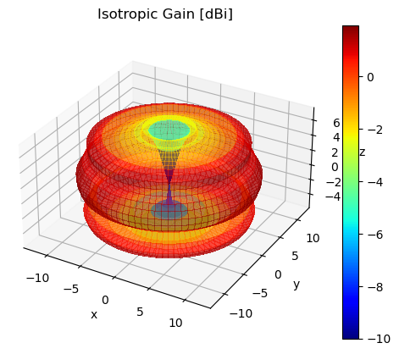
Figure 2-2: Aircraft Antenna 3D diagram model

- Spacecraft antenna diagram
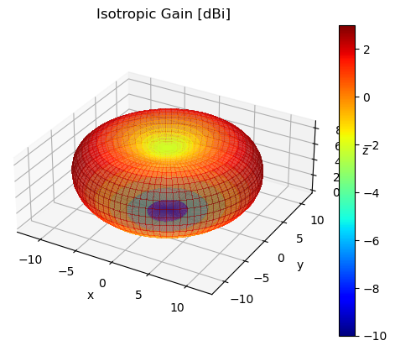
Figure 2-3: Spacecraft Antenna 3D diagram model
- Ground station Height = 15 m
- Ground station antenna diagram

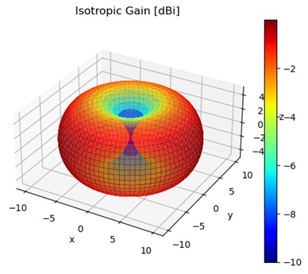
Figure 2-4: Graound stationt antenna 3D diagram model
- Spherical Earth with radius 6378 km
- Two ray propagation
- Polarization rotation from the ground reflection point to the aircraft is negligible.
- Refection coefficients used are the figure 1 of Recommendation ITU-R P.1008 Reflection from the Surface of the Earth, impact in both in amplitude and phase.

    - Reflexion Model
The reflection model used in this simulation is based in Recommendation ITU-R P.1008. Specular reflection is being considered from a plane Earth surface. Based on this hypothesis, the magnitude and phase of the reflection coefficient behave as follows, as a function of the reflection angle, the surface of incidence, and the frequency for vertical and horizontal polarization.
In the simulation, it is assumed that the surface of incidence is sea water, and the signal polarization is vertical. The magnitude and phase values for different frequencies and reflection angles in the simulation are obtained by interpolating the previous graphs.
When the signal hits the reflection surface, its amplitude is attenuated according to the magnitude diagram and the phase suffers a shift according to the phase angle diagram.

Note that the horizontal component of the circular polarization from the spacecraft, does not affect as the aircraft antenna has linear polarization and will only see the vertical component of the reflected signal. It is assumed that there is no rotation from the reflection point up to the aircraft antenna.
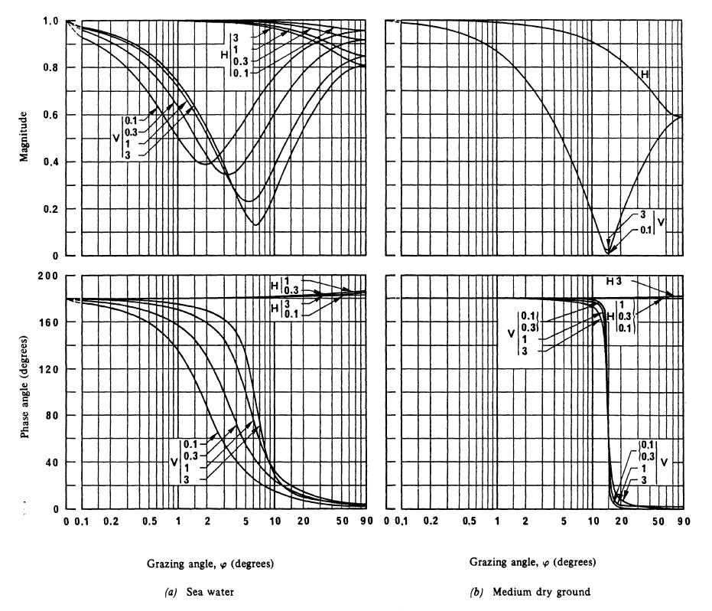
Figure 2-5: Magnitude and phase of reflection coefficients, figure 1 from ITU-R P.1008

    - Methodology
The proposed methodology to evaluate the effect of the propagation channel and in particular of the multipath in the VHF signal performances basically consists in several steps. The high level steps are:
- Analysis to characterize the VHF aeronautical mobile satellite (LEO) propagation channel at VHF aeronautical band. The analysis is divided in two steps:
  - Characterize the VHF aeronautical mobile satellite (LEO) propagation channel based on the two-ray model from ITU-R P.1008.
  - Statistical characterization of the propagation channel, covering especially the multipath and the propagation effects (ionospheric and tropospheric).
- Simulations to evaluation of the impact in the performances of the VDL Mode 2 reception process of the previously characterized propagation channel.
- Carry out test in the laboratory using a COTS aircraft radio and the satellite radio inserting a Satellite Simulator equipment in between. Planed to do.
- Carry out the test in the satellite environment to correlate as much as possible with simulations and laboratoryas. Planed to do.

      - First step: Characterize the VHF aeronautical mobile satellite (LEO) propagation channel based on the two-ray model.
A simulation is performed with a static aircraft heading north but in a static position and a spacecraft that flights right above the aircraft location. The simulation time span is from the moment when the spacecraft raises the horizon until it hides behind the horizon again.
At every instant the following computation is done:
- Position and attitude of the aircraft and spacecraft is known.
- It is assumed that the TX power of the spacecraft is normalized to 1W.
- The point in the Earth surface that reflects the ray from the spacecraft such that targets the aircraft is computed.
- The link is resolved for the direct and the indirect ray.
- Direct ray:
  - Gain of the spacecraft for the direct ray is computed.
  - Propagation losses are computed.
  - Gain of the aircraft for the direct ray are computed.
  - Delay from transmission to reception is computed on the direct path.
- Reflected ray:
  - Gain of the spacecraft for the reflected ray is computed.
  - Propagation losses up to the reflection point are computed.
  - The signal is reflected suffering an attenuation and phase shift due to the reflection parameters (Earth or water parameters need to be selected).
  - Propagation losses from the reflection point to the aircraft are computed.
  - Gain of the aircraft for the reflected ray are computed.
  - Delay from transmission to reception is computed in the reflected path.
- The following parameters are computed:
  - Distance and time difference for the two waves.
  - Doppler for each wave.
  - Tx and Rx antenna gains for each path.
  - Reflexion angle in Earth surface.
  - Losses associated to the reflection.
  - Losses of each ray from transmission to reception.

      - Methodology for the Simulations to Assess the Receiver Performance
Simulations to evaluation of the impact in the performances of the VDL Mode 2 reception process of the previously characterized propagation channel consists basically in the following steps:
- VDL2 transmitter block model to implement the physical layer transmitter functions generating random bits.
- VDL2 receiver block model to demodulate received signal.
- Channel model block that implements the time series from the Channel model characterization step described above, including the number of paths, reflected-to-direct ratio, path delay, phase / Doppler effect.
- Performance assessment based in the obtaintion of the uncoded BER.
- Carry out simulations for the ground to/from air scenario.
- Carry out simulations for the satellite to/from aircraft static scenarios (still on going, no results available yet).

  - Multipath impact in the Link Budget
    - Ground scenario outcome in the Link Budget
The ground station scenario is shown in the image below. An aircraft (red) flies over a ground station (blue) installed at 15 m over the sea level and continues its trajectory (green line) flying at FL450 altitude (13,7Km). For the analysis, it has been assumed a frequency of 137 MHz.

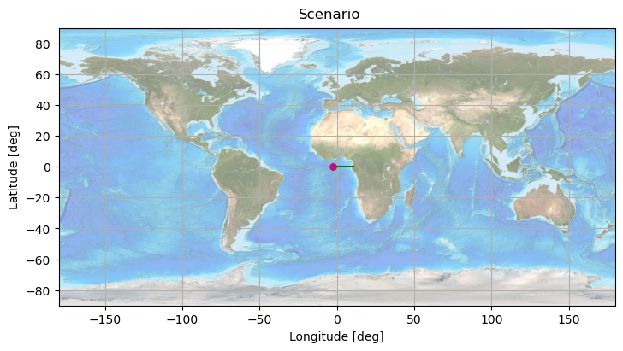
Figure 2-6 Ground segment scenario
The total gain difference for the direct and reflected signal is shown below.
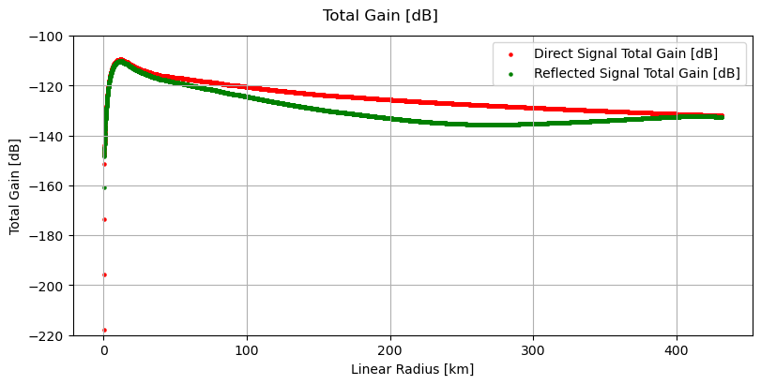
Figure 2-7 Ground segment scenario – Direct and Reflected Gain evolution
The total gain evolution for the ground segment is shown below.
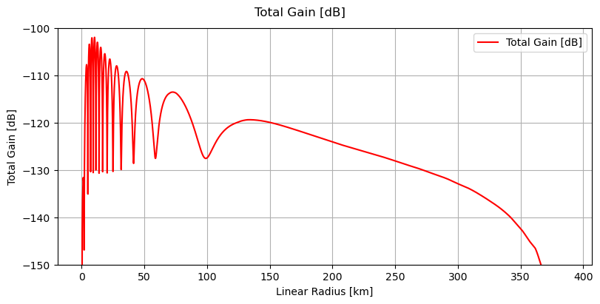
Figure 2-8 Ground segment scenario – Total Gain evolution
This gain ranges from about -130 dB to -100 dB (excluding the aircraft antenna´s null region) depending on if the signals interfere constructively or destructive. This means that the direct signal is associated with about 30 dB of uncertainty over the pass.

The gain cumulative function is shown below.
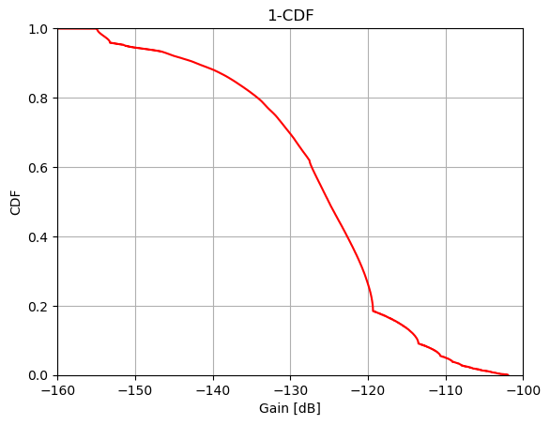
Figure 2-9 Ground segment scenario – CDF over Total Gain evolution - full range
This CDF have been calculate for the maximum coverage for a ground station at 15m altitude and the aircraft at FL450 resulting a maximum coverage on visibility of 385 Km.

As it can obtain, to achive 95% minimum probability of link availability, the maximum Gain (loss) in the link budget should be no more than 157 dB, but this is not possible when considering the minimum field strength at aircraft antenna.

As a first approach exercice, according to the Annex 10 Vol III, Part I, 6.3.5.2, the minimum field strength at aircraft antenna input is 20 uV/m.
- Minimum field strength = 20 uV/m = -119.74 dB(W/m2)
  - [Power flux density (dB(W/m²)) = 10log(electric field strength(V/m)² / 120pi)]
- Typical Ground station EIRP: 19 dBW (PTx: 100 W; Gain: 2dB; Feede Loss: 3 dB)
- Maximum attenuation: 139 dB
Considering a range where the attenuation is less than 139 dB, around 340 Km, the CDF calculation in this conditions outcomes a more realistic condition for a DOC designation, that is, with a range of 340 Km, the maximum attenuation is < 139 dB and in this case the link availability is close to 100% as show the next graphic.
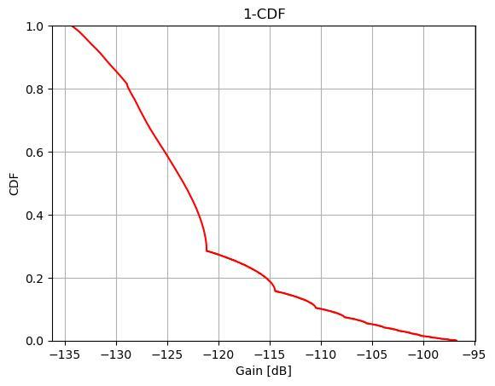
Figure 2-10 Ground segment scenario – CDF over Total Gain evolution 340 Km range (link budget closed)
The conclusion of Multipath effect on ground-based scenario is that to determine the DOC, this phenomena should be sonsidered. In this analysis case, to achieve the 95% link availability, the DOC should be for a range less than 340 Km.

    - Space scenario outcome in the Link Budget
The following image shows the scenario analysed, with a spacecraft (green) that flies over the zenith of the aircraft (red). The yellow point is the reflection point of the signal in the surface. For the analysis, it has been assumed a frequency of 137MHz.
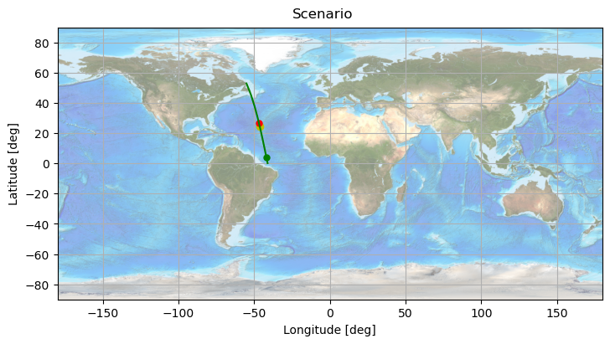
Figure 2-11 Space segment scenario

The gain (or losses) that each of the rays suffer is shown in the following image.

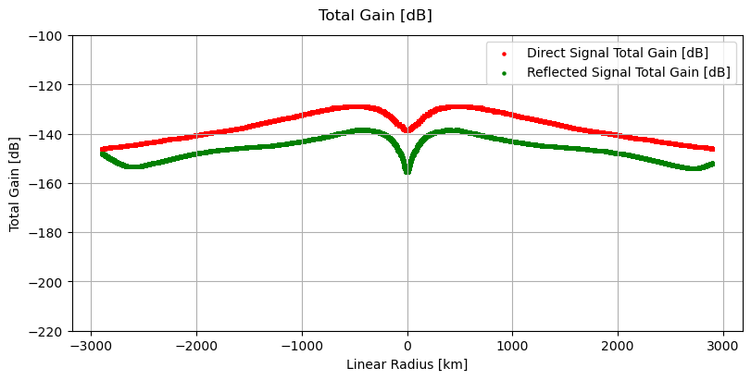
Figure 2-12 Space segment scenario – Direct and Reflected Gain evolution
The total gain is the one experienced by the signal from before it leaves the satellite's antenna to after it passes through the airplane's antenna is shown in the following image.

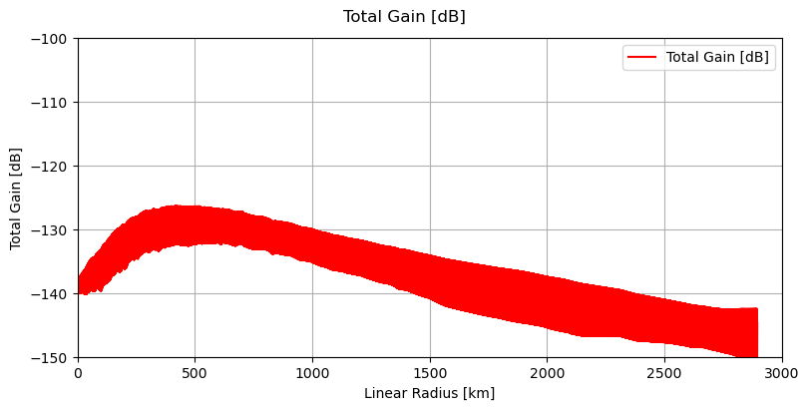
Figure 2-13 Space segment scenario – Total Gain evolution

The gain cumulative function is shown below
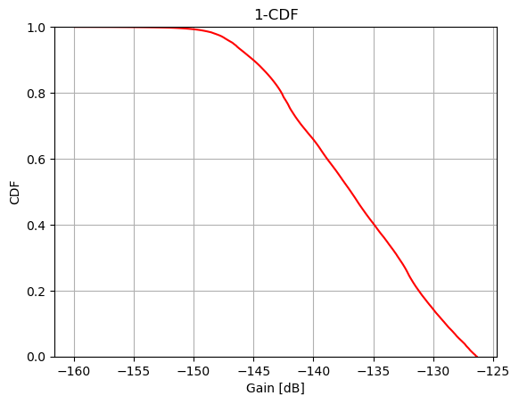
Figure 2-14 Space segment scenario – CDF over Total Gain evolution - full range

    - Conclusions on Multipath impact in the Link Budget
According to the Annex 10 Vol III, Part I, 6.3.5.2, the minimum field strength at aircraft antenna input is 20 uV/m. If we assume a space loss of 147 dB to cope with a minimum of CDF of 95% and a 5dB margin, the minimum EIRP equivalent should be:
- Minimum field strength = 20 uV/m = -119.74 dB(W/m2)
  - [Power flux density (dB(W/m²)) = 10log(electric field strength(V/m)² / 120pi)]
- Equivalent power flux captured by the antenna = -119.74 dB(W/m2) + (-4.19 dB for aircraft antenna @ 137MHz) = -93,9 dBm
- SAT EIRP (dBm)= 152 dB + (-93.9 dBm) = 58.1 dBm
- For a SAT antenna gain of 8 dBi, the transmitter power should be at least higher than 50.1 dBm or 20.1 dBW or 102,3 W.

Some approach conclusions, for the case under analysis, could be that:
- To cope with the multipath phenomenon, due to the aircraft antenna characteristic, the zenith angle of approximately -/-20º will be need to analyze case by case in function of satellite solution and in any case, this area of coverage should be assumed by other satellite of the constellation.
- The antenna gain should be with a minimum of 8 dBi.
- The antenna pattern should be designed considering the multipath phenomenon.
- The amplifier power should be with a minimum of 102 W
- The constellation design should consider the orbit altitude and antenna footprint characteristic.
Further studies should be done using different orbit altitudes and different antenna diagram pattern.

  - Multipath impact in the Data Link
    - Objetive
The objective of these simulations is to evaluate the effect of a multipath propagation channel in the performances of a VDL2 communication system, to obtain the uncoded BER degradation when simulations take into account the multipath channel analysed in previous sections.
The receiver demodulation process is simulated evaluating the uncoded BER performance of a standard D8PSK demodulator and assuming ideal synchronization in a “two-ray” channel environment .

    - Inputs
The inputs for these simulations are the channel impairments obtained as results from the analysis described in the previous sections, the channel characterization of a VHF aeronautical mobile propagation channel on a ground-based and space-based scenarios, based on a two-ray model. More specifically, the inputs are:
- DirectReflectedTimeDifference:
  - Time difference between reflected path (always longer distance) and direct path.
- PowerRatio:
  - Ratio between power that reaches the airplane from the reflected signal and power of the direct signal. Both are considering the satellite and ground antennas gain, common losses, spreading losses, reflection loss for reflected signal and the airplane’s antenna gain.
  - Amplitude Lineal Ratio: = 10^{-(K_R [dB]/20)}, being K_R [dB] the difference in dB of the Direct Power and the Reflected Power
- TotalPhaseShift composed of the PhaseShift coming from the path difference (including Doppler) and the phase shift from the reflection on ground.
- At this time no other impairments, such as complex fading process, have been applied.
These impairments are applied on the reflected signal and is added to the direct one to obtain the received signal based on a two-ray model.

    - Symulation scheme

Next figure shows the block diagram of the simulation scheme used to evaluate the effects of the characterized channel in the performances of a VDL2 communication system. For the characterization based in the two-ray model just the direct signal and the first tap are used.

These are the functions of the simulations scheme:
- Transmission of a VDL2 standard signal with random bits.
- Channel:
  - The reflected signal is generated from the direct one applying the channel effects resulting from characterization of channel (two-ray model in this case), as shown in the above figure. Note that no other impairments have been applied, that is “Complex Fading Process” blocks are not used.
  - The AWGN block adds white Gaussian noise. The power of this noise is adjusted for the Eb/N0 of the simulation scenario.
- VDL2 reception: the receiver is a VDL2 signal receiver for the direct signal based on the standard
- Finally, the received bits in the BER measurement block is compared to a delayed version of the transmitted bits to obtain the uncoded BER and de accumulated number of bit errors.

    - Simulation procedure
The simulations in this section are executed with evolution in time, using as inputs the time varying results from the two-ray model channel characterizations.
The receiver performance is categorized evaluating uncoded BER calculated at the reception of every bit during the previous 0.5 seconds:
- In the following graphs BER axis is logarithmic: the instants without value correspond to intervals of 0.5 second without errors.
As it is said, the simulations are executed using the previous results of the characterization of the channel model for both scenarios:
- Ground station to/from aircraft: to be used as comparison benchmark.
- LEO satellite to/from aircraft: this analysis will be done once the methodology is validated for ground scenario
    - Ground scenario simulation results
Next section shows the results from the simulations with evolution in time performed with the two-ray model channel characterization for ground scenario to be used as comparison benchmark:
- Ground scenario: ground station 15 m high and aircraft following Ecuador trajectory at FL 450 high (13.716 km).
- Characterization since aircraft flies over the ground station until the end of the coverage.
It should be noted that in this ground scenario the reflected-to-direct time delay reaches minimum values. In fact, the reflected-to-direct delay does not reach 5 % of the symbol duration.

      - BER impact for Eb/No= 15 dB
Uncoded BER vs. Direct-to-reflected power ratio (K_{R} [dB]):
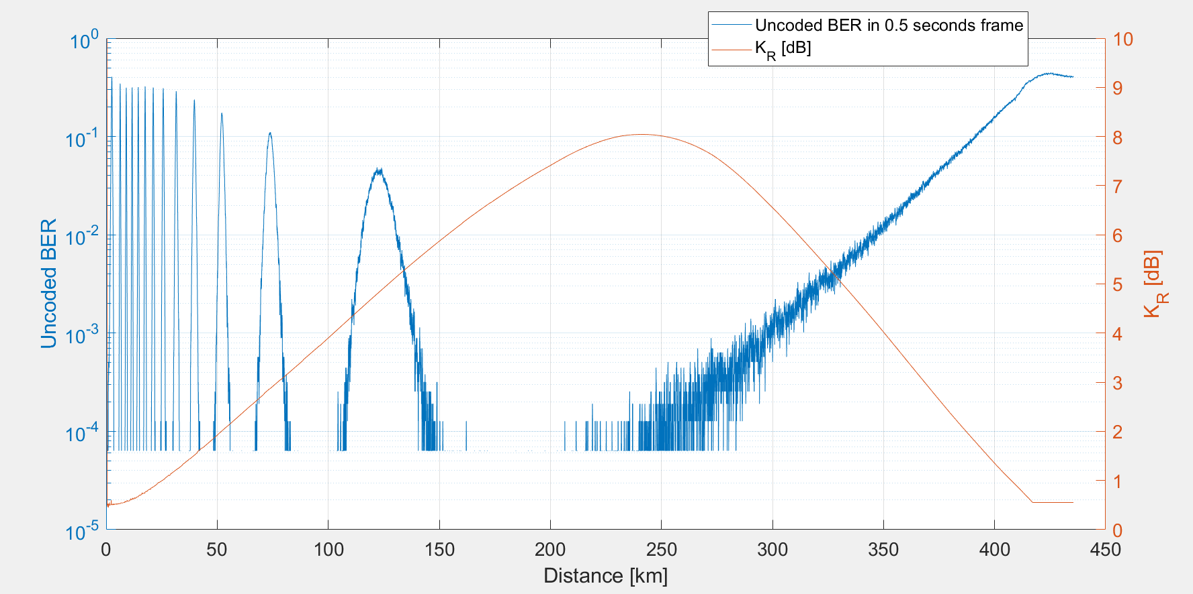
Figure 2-15 Ground segment scenario – BER (Eb/No: 15 dB) vs. Direct-to-reflected power ratio
Uncoded BER vs. Doppler difference [Hz]:

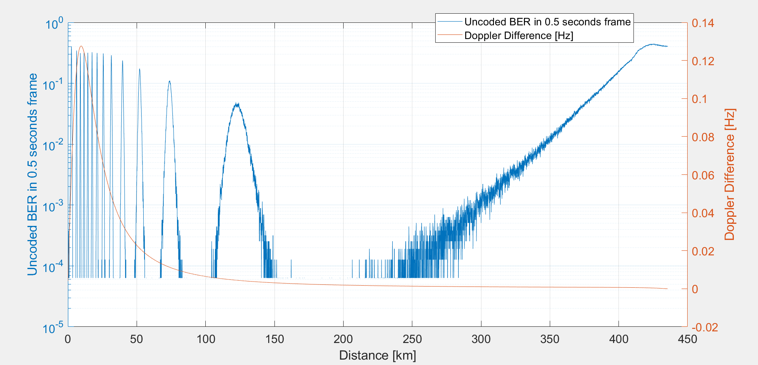
Figure 2-16 Ground segment scenario – BER (Eb/No: 15 dB) vs. Doppler different
Uncoded BER vs. Reflection phase shift [deg]:

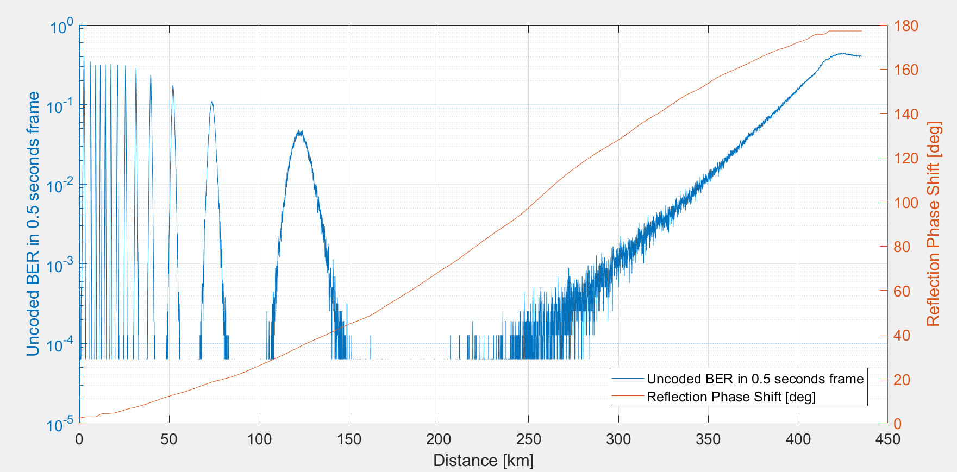
Figure 2-17 Ground segment scenario – BER (Eb/No: 15 dB) vs. Reflection phase shift
Uncoded BER vs. Total phase shift [deg] (due to path variation and reflection):

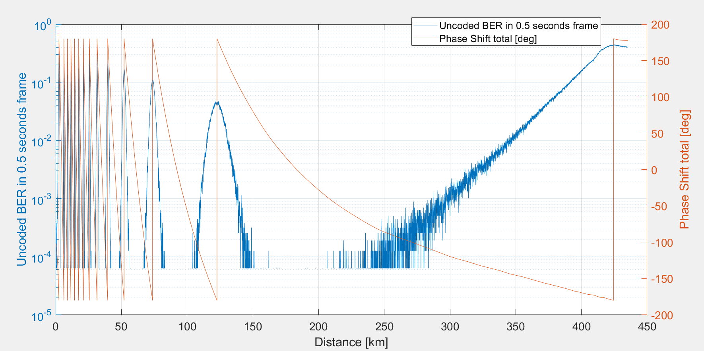
Figure 2-18 Ground segment scenario – BER (Eb/No: 15 dB) vs. Total phase shift
      - Cumulative Ditribution Function (CDF) for ground scenario simulation results
Next figure shows the Cumulative Distribution Function (CDF) of the uncoded BER calculated from 0 km to 385 km, the visibility limit at ground scenario conditions: ground station 15 m high and aircraft following Ecuador trajectory at FL 450 high (13.716 km).

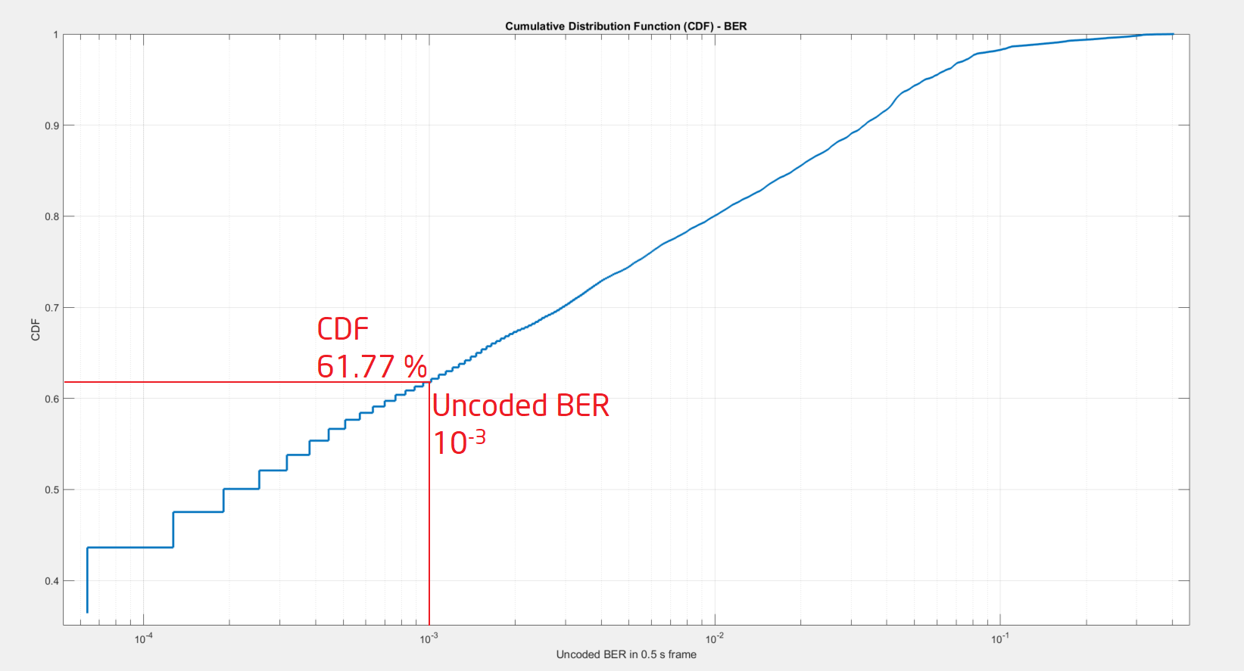
Figure 2-19 Ground segment scenario – BER (Eb/No: 15 dB) – CDF – Total range 385 Km
Next figure shows the Cumulative Distribution Function (CDF) of the uncoded BER calculated from 0 km to 340 km, the limit to cope with the fading effect.

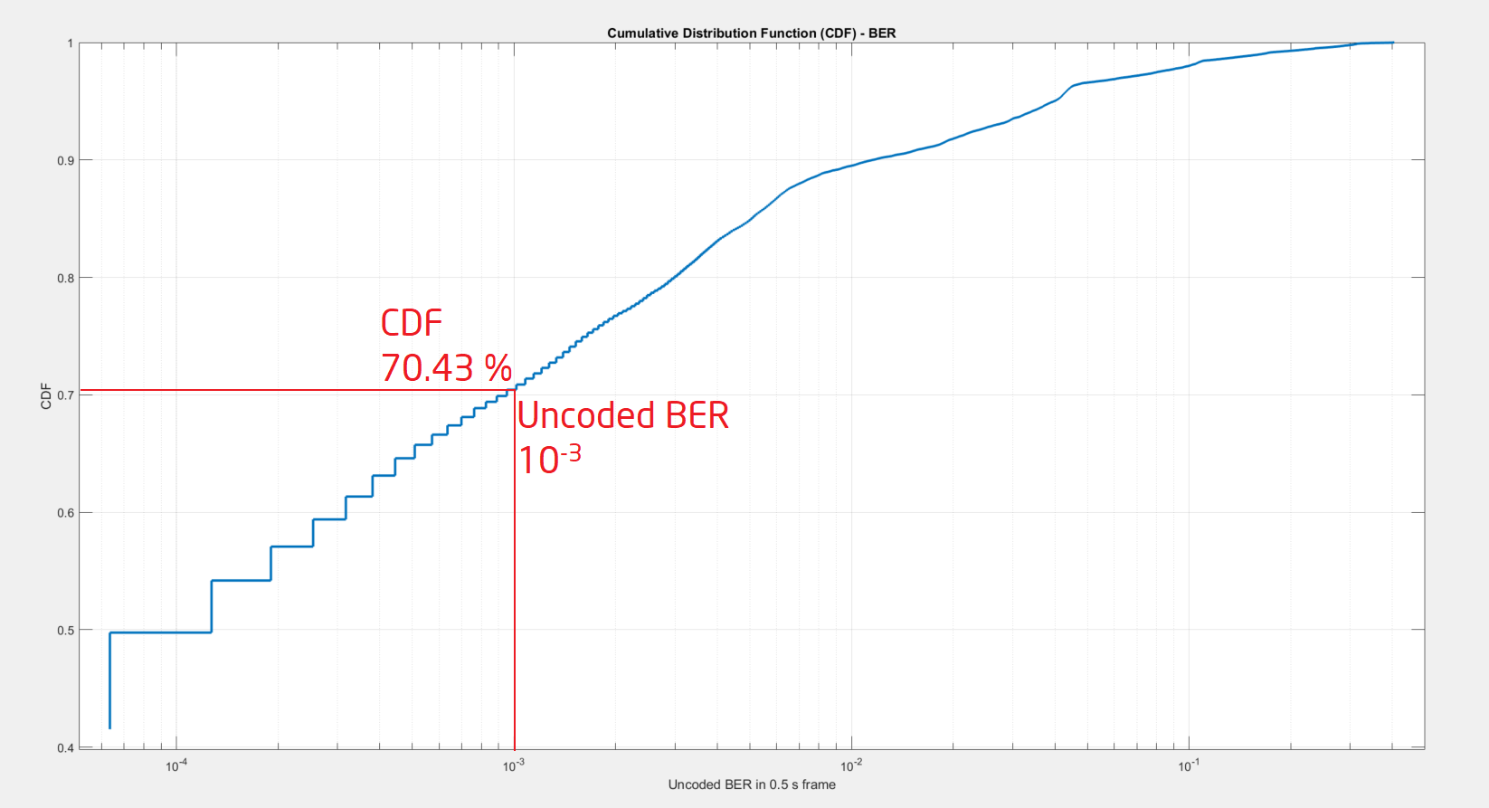
Figure 2-20 Ground segment scenario – BER (Eb/No: 15 dB) – CDF – 340 Km range

Next figure shows the Cumulative Distribution Function (CDF) of the uncoded BER calculated from 0 km to 250 km.

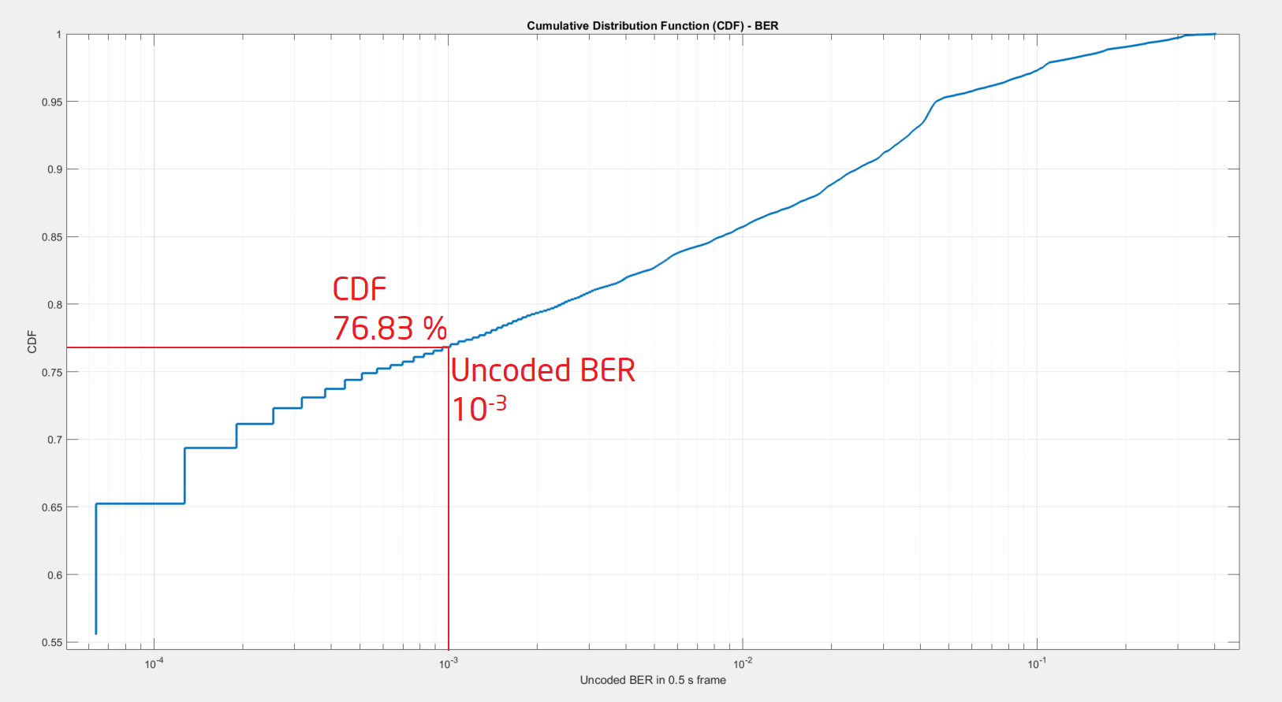
Figure 2-21 Ground segment scenario – BER (Eb/No: 15 dB) – CDF – 250 Km range
      - Conclusions on ground scenario simulation results
After the results of ground scenario simulations the following conclusions can be reached:
- According to the results of the simulations, the more important effect is the correlation between the BER variation and the total phase shift evolution (the sum of the phase shift originated by the path difference evolution and the one originated in the reflexion). The reflected-to-direct time delay has low values, the maximum value does not reach 5 % of the symbol duration.
- It can be seen in the results of the simulations (“Uncoded BER vs. Total Phase Shift” figure) that, when the phase difference between direct signal and reflected signal is close to 180º, the uncoded BER value is greatly negatively affected. It is a consequence of a destructive interference (direct signal and reflected signal with opposite signs).
- According the results of the simulations, as the aircraft approaches the edge of coverage, the total phase shift value tends to 180º and the direct-to-reflected power ratio is taking on increasingly lower values. All of this has the consequence that uncoded BER values are increasingly higher.

From the results of the simulations the cumulative distribution function (CDF) curve can be obtained and it shows that the uncoded BER value is under 10⁻³ just in the 61.77 % of the time since aircraft flies over the ground station until the visibility limit at ground scenario conditions (385 km) or 76.83% of the time for a 250 Km range.
- It will be very interesting to carry out a series of measurements to ensure that the performance in a real scenario is as far from those obtained results.
- CONCLUSION
This Information Paper presents a first approach to the study of the Multipath phenomenon applied to the case of VHF links in the band 117.975-137 MHz. This study has taken into account the typical characteristics of aircraft, ground stations and a model is proposed for the case of a space station. The reflection coefficients that affect the amplitude and phase of the signals as a function of the angle of reflection, polarization, frequency, and the type of surface where the reflection occurs have also been taken into account.

It is necessary to distinguish the two types of impact that this phenomenon produces on the signal link, first is on the periodic attenuation/gain in the signal when the direct and reflected signals are added constructively or destructively. Second is the impact that this phenomenon can have on phase-modulated signals as is the case of the D8PSK modulation of the VDLM2 protocol, in particular, the effect on the value of the Bit Error Rate (BER).

For the first type, the effect on signal amplitude, the conclusions, for both the terrestrial and space-based scenarios is that this phenomenon must be considered to designate the DOC for the terrestrial case and to designate the DOC also but principatelly on the design of the satellite solution for the links from space.

For the second type, the impact on the quality of data transmission, in the BER, the first results on the terrestrial scenario show worse results than expected and this is something that must be studied and checked before undertaking the studies from space, something necessary to ensure whether the model used is valid or not. It will be investigated whether these theoretical results are supported by any type of measurements in a real environment.

— END —

