FREQUENCY SPECTRUM MANAGEMENT PANEL (FSMP)

Twentieth Working Group Meeting

Bangkok, Thailand, 26th February – 7th March 2025

Agenda Item 5a: Aeronautical Band Planning (108 – 137) MHz

SB-VHF planning criteria

(Bertrand Despérier, Eurocontrol and José Luis Chinchilla, Spain)

SUMMARY
This paper outlines a methodology for developing new frequency planning criteria for Space-Based VHF (SB-VHF). It presents a step-by-step, top-down approach, starting from addressing interference at the operational level to calculate the separation distances required to ensure compatibility between SB-VHF and terrestrial VHF communications. The document also identifies the missing elements and necessary studies to finalize and implement these planning criteria effectively.

- INTRODUCTION
  - Since WRC23, ITU Radio Regulations permit the allocation of the Aeronautical Mobile-Satellite (Route) Service (AMS(R)S) in the 117.975–137 MHz AM(R)S frequency band.
  - The establishment of new frequency planning criteria for spacecraft transceivers is crucial to maintaining a safe and interference-free VHF communication environment across both terrestrial and space segments.
  - This is not, strictly speaking, a new criterion, as it remains applicable to DSB-AM radio systems. Instead, it represents new planning rules designed for an environment where ground station radios operate on low-orbiting platforms.
  - However, this new environment introduces implications that render the traditional frequency planning rules currently used for terrestrial systems unusable. Hence, the following recommendation from ICAO 9718 Volume II is entirely appropriate for the introduction of SB-VHF:
1.1.4 The frequency assignment planning criteria in this Handbook are only valid for the assumptions as specified. When system implementation is different from these assumptions, a more detailed compatibility analysis is required, taking into account actual system characteristics and radio wave propagation model(s).
  - This paper aims at summarize the process to establish these new planning rules that might be introduced in ICAO handbook 9718 Volume II in the future.
- OPERATIONAL CRITERIA
  - “Orbiting” Ground Stations
    - The concept of SB-VHF is to provide VHF communication with wide coverage anywhere in the world, addressing areas where terrestrial systems are limited by propagation constraints. Additionally, it aims to achieve this without requiring any changes to avionics; any necessary modifications should be implemented on the satellite side.
    - However, from an operational perspective, the use of space-based VHF is intended to remain transparent, ensuring a seamless experience for both pilots and controllers. Therefore, since ground stations are replaced by satellites, it is logical that, from an operational perspective, the interference tolerances for or from a satellite should be the same as those for or from a ground station since space based and ground based stations are equivalent.
    - The high-level interference criteria or operational criteria in a terrestrial context are as follows (FSMP-WG20/WP03 Revisiting VHF DSB-AM Frequency planning criterion):
 |  | Undesired
 |  | AIR | GROUND
Desired | AIR | Limited interference | - No squelch opening  - No intelligibility issue*
Desired | GROUND | - No squelch opening  - No intelligibility issue* | - No squelch opening  - No intelligibility issue*
* when a simultaneous unwanted transmission occur

    - Hence, in scenarios involving satellite-to-aircraft, satellite-to-ground station, and satellite-to-satellite communication, it must be ensured that for any elements involved — belonging to different services but operating on the same frequency (satellite, aircraft, and ground stations)— the following conditions are met:
- No squelch opening
- No intelligibility issue
    - For the aircraft-to-aircraft scenario, assuming no changes are made to the existing standards (e.g., the minimum signal-in-space level guaranteed by space-based systems remains the same as that of ground-based systems), the frequency planning rules as defined in ICAO Document 9718 applies.
    - Due to the range of a satellite it is highly likely that the determining factor will be the separation between the satellite and the aircraft. This separation may inherently provide sufficient margin to also ensure adequate separation between aircraft.
    - Let us now translate these interference or operational criteria into corresponding technical criteria in the next section.
- TECHNICAL CRITERIA
  - No squelch opening
    - The technical criteria is the maximum undesired signal level that ensures the squelch of an airborne or ground-based receiver is not triggered when the channel is idle in the desired area.
    - To determine this level, it is crucial to consider the diversity in receiver designs and behaviors. While the squelch threshold may be user-adjustable in some implementations, others lack this capability, relying solely on predefined settings. Furthermore, since SB-VHF is designed to integrate seamlessly with existing VHF DSB-AM terrestrial systems, dynamically adjusting the squelch level or altering the hardware's pre-configured settings in current equipment to accommodate SB-VHF is not a feasible solution.
    - Therefore, the focus should be on finding the minimum squelch threshold, which is typically set just above the receiver's sensitivity level.
    - While standards define minimum sensitivity levels, individual radios often exceed these specifications. However there is no specified limit on how much the minimum sensitivity can be exceeded.
    - ARINC 716 specifies a minimum sensitivity of 2 µV (approximately –101 dBm), but radios can achieve better performance, reaching lower sensitivity levels. This variability makes it impractical to establish a universal maximum undesired signal level that reliably prevents squelch activation across all existing receivers.
    - Given this diversity, the only viable way to determine the actual minimum squelch levels is to test a wide range of radios including airborne and ground currently available on the market. This empirical approach is necessary to account for the performance variations among different receiver models and manufacturers.
    - The lowest value (highest sensitivity) determined through testing should be adopted as the technical criterion to protect airborne and ground stations from being unintentionally unmuted. Separate criteria values (one for airborne receivers and another for ground-based receivers) may also be considered to reflect their distinct operational environments and requirements.
    - Conversely, the squelch level or sensitivity of space-based receivers must also be considered to protect ground operators using SB-VHF from undesired transmissions originating from airborne or ground-based sources.
    - Due to the unfavorable link budget between a satellite and an aircraft in space-based operations, the satellite's transmission power is increased compared to that of airborne or ground-based transmitters. Conversely, since the transmission power of airborne transmitters remains unchanged, the only way to compensate is by improving the sensitivity level and consequently, the minimum squelch triggering level at the space-based receiver compared to those of airborne or ground-based receivers.
  - No intelligibility issue when an unwanted transmission occurs
    - When a message is received, the squelch is opened, and if an unwanted transmission occurs simultaneously, maintaining good intelligibility requires that the desired-to-undesired signal level ratio remains above a certain threshold. The threshold specified in the standards (ICAO Doc 9718 Volume II) is 20 dB or 14 dB in congested areas.
    - The proposed approach for the D/U criterion is to use the minimum required field strength as the desired level in the D/U calculation, as it offers several advantages. Firstly, it represents a worst-case scenario, ensuring that no harmful interference occurs. Secondly, it eliminates the need for detailed characterization of desired ground transmitters, for which data such as accurate location and transmission power may be incomplete or unavailable in ICAO frequency databases like SAFIRE and Frequency Finder. Lastly, it aligns with the only other criterion, squelch opening, thereby ensuring consistency in the evaluation process.
    - Annex 10, Volume III recommends a minimum required signal field strength of 75 µV/m (30 µV/m for planning extended range) at the airborne antenna and 20 µV/m at the ground antenna.
    - On the airborne side, accounting for a 3 dB feeder loss between the antenna and the receiver, 0 dBi antenna gain, the minimum desired signal level at the receiver input is -85 dBm (-93 dBm for planning extended range).
    - On the ground side, considering a 3 dB feeder loss and a 2 dBi antenna gain, the minimum desired signal level at the receiver input is -94 dBm.
    - Hence it comes, the maximum undesired signal level at the receiver input should be:
 | D/U = 20 dB | D/U = 14 dB
AIR | -105 dBm  -113 dBm (extended range) | -99 dBm  -107 dBm (extended range)
GROUND | -114 dBm | -108 dBm

    - Since a 14 dB D/U ratio is generally considered sufficient to maintain good intelligibility, it can be used as a baseline. However, it may be possible to tolerate lower values, but this would need to be thoroughly verified. Retrieving past tests that established the 14 dB D/U benchmark would be highly valuable. Alternatively, recordings with varying levels of interference could be submitted to a listener panel, including pilots and controllers, to evaluate the impact and acceptability of lower D/U ratios on intelligibility.
    - Of course, a similar exercise could also be conducted for the space-based receiver. The minimum D/U ratio at the satellite level, as well as the minimum signal level at the satellite receiver, should be determined based on the Earth-to-space link budget and the specific characteristics of the satellite receiver.
  - Accomodating both criteria
    - Both technical criteria – i.e. no squelch opening and no intelligibility issue when an unwanted transmission occurs - need to be met.
    - On the airborne side: The maximum undesired signal level at the receiver, required to accommodate a 14 dB D/U ratio, appears to be higher than the minimum sensitivity, (excluding extended range scenario). As a result, the "no squelch opening" criterion becomes the dimensioning factor for airborne receivers.
    - On the ground side: The maximum undesired signal level tolerated is significantly lower, making it a potential dimensioning factor compared to the "no squelch opening" criterion. However, in practice, the protection of aircraft from satellite interference or the protection of satellites from aircraft transmissions could inherently ensure the protection of ground stations as well.
    - On the space side: As mentioned in the previous sections, each criterion must be clearly defined. This includes determining the minimum required field strength at the satellite receiver input, the minimum D/U ratio, and the minimum signal level necessary to trigger the satellite receiver squelch.

- PLANNING CRITERIA
  - A separation distance calculation
    - Once the technical criteria are established, the final step is to determine the conditions under which these criteria are met. In this case, considering transmitter power, cable losses, antenna radiation pattern, encompassing both azimuth and elevation angles and orbit characteristic, the link budget could be calculated determining the separation distance between undesired transmitters and desired receivers across all possible configurations for an specific space-based interference transmitter.
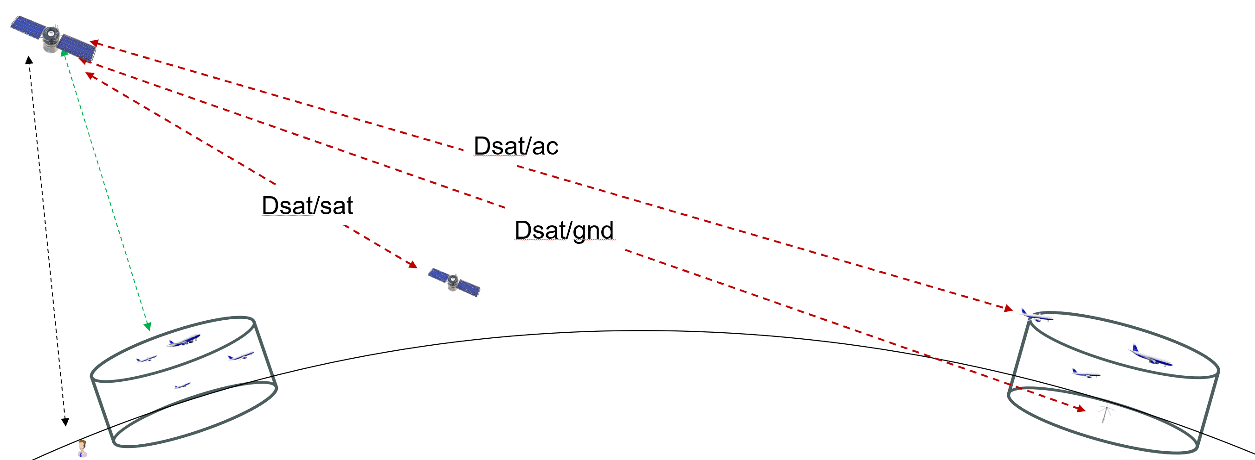

    - To proceed, the complete undesired signal path must be thoroughly characterized, as illustrated in the figure below:
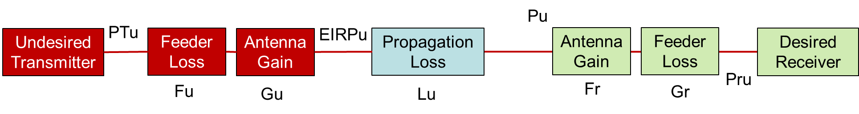
Pu = PTu – Fu + Gu – Lu
The following characteristics must be specified:
- PTu : Transmission Power (dBm)
Transmitter Characteristics including antenna pattern
- Fu : Feeder loss (dB)
- Gu : Antenna Gain (dBi)
- Lu : Transmission Loss (dB)
Propagation Model

  - Transmitter Characteristics including antenna pattern
    - For compatibility calculations, detailed transmitter characteristics need to be accurately determined. Parameters such as effective isotropic radiated power (EIRP), or transmitter power, cable losses, and antenna gain. Moreover, a comprehensive antenna radiation pattern, including azimuth and elevation angles, is inecessary for calculating attenuation as a function of direction.
    - For compatibility calculations, it is essential to accurately determine detailed transmitter characteristics, including parameters such as transmitter power, cable losses…. Additionally, a comprehensive antenna radiation pattern, encompassing both azimuth and elevation angles, is necessary for calculating attenuation as a function of direction, ensuring precise compatibility assessments.
    - Of course, the spatial DOCs must be specified, including the volume within which the satellite will transmit and the volume within which it will receive (if these volumes are different).
  - Propagation Model
    - The International Telecommunication Union (ITU) is developing and maintening propagation models, including those designed for space-to-Earth and space-to-mobile communications. However, none of these models currently address space-based VHF communications in a fully satisfactory manner.
    - Moreover, ITU Recommendation P.528-5, which is commonly used for VHF aeronautical systems, is limited to propagation within the troposphere, approximately up to 20 km in altitude, and therefore does not adequately account for the unique characteristics of space-based VHF communication.
    - Some ITU propagation models related to space to earth and/or space to mobile transmissions, could serve as a foundation for the development of a new propagation model tailored to the specific needs of space-based VHF communications.
    - However, there is an undeniable need to develop a dedicated propagation model specifically designed to address the unique requirements of space-based VHF communications. According to FSMP ToRs, it’s the role of the group to provide such input to the ITU-R.
- CONCLUSION
  - This working paper outlines a step-by-step approach for developing frequency planning criteria necessary for the successful implementation of Space-Based VHF. The methodology emphasizes translating operational requirements into technical criteria, ensuring compatibility and safety across terrestrial and space-based systems.
  - To complete the introduction of SB-VHF frequency planning criteria in Doc 9718, the following key tasks and elements need to be addressed:
- Establishing Technical Criteria:
  - Identify and test the squelch thresholds across a range of existing radio systems.
  - If there is an intention to decrease the minimum D/U value required, conduct empirical tests including listener panel to assess the adequacy of the new minimum D/U.
- Propagation Modeling:
  - Develop a specialized propagation model specifically designed for Space-Based VHF.
  - Conduct thorough testing and validation of the model using current or future orbiting satellites.
- It should be noted that the development of the criteria in ICAO Doc 9718 can proceed in parallel with the determination of final values (e.g., maximum interfering signal level) and the selection of the propagation model, which will be finalized for the initial ICAO 9718 release including SB-VHF.

  - The following elements should be provided in order to make proper frequency management including SB-VHF
- SB-VHF Transmitter/Receiver characteristics
  - Volumes in which the space stations operate both in transmission and reception
  - Transmitter/Receiver characteristics including maximum interferer signal level at the satellite. input.
  - Antenna patterns
- ACTION BY THE MEETING
  - The meeting is invited to:
- note and review the contents of this working paper;
- endorse the proposed methodolgy;
- support the input to ITU-R in developing/updating a progation model for space based VHF.; and
- aknowledge the required elements to develop frequency planning criteria for SB-VHF.
— END —

