FREQUENCY SPECTRUM MANAGEMENT PANEL (FSMP)

Thirteenth Working Group meeting

Web Meeting, 21– 25 February 2022

Agenda Item 3b) : Development of (planned) Material for ITU-R Studies on WRC-23 AI1.7 VHF AMS(R)S

Technical studies and laboratory tests performed by VOICE project implementing Satellite-Based CNS concept

(Presented by ENAIRE, Indra, SITA and EUROCONTROL)

SUMMARY
With the support of ICAO and the different Regional Groups of the ITU, the space-based VHF frequency allocation (under AI 10 of World Radiocommunication Conference 2019 (WRC-19)) was formally accepted as an agenda item for WRC 2023 (WRC-23).

A new subgroup under the DCIWG PT-T called FVSG has been created to work on reviewing ICAO Annex 10 SARPs and propose SARPs amendments, if required, in order to enable the future adoption of space-based VHF.

This paper presents an update information of the European initiative called VOICE with the objective of performing a proof of concept for the Satellite-Based CNS technology in real environment by end 2022 with the involvement of the following Organizations: ENAIRE, Indra, EUROCONTROL and SITA.

Finally, the outcomes of the technical studies and test/validations performed by this project are presneted in the AnnexA of this document.

- INTRODUCTION
  - Under WRC-23 agenda item 1.7, WP5B is developing a working document towards a preliminary draft new report ITU-R M.[SPACE-VHF], which latest version was sent to ICAO for review and comments. In addition, ITU-R is already drafting the material to be included in the Conference Preparatory Meeting (CPM) where methods to decide on the allocation are considered.
  - The World Radiocommunication Conference 2015 (WRC-15) approved the allocation of frequency for space-based Automatic Dependent Surveillance – Broadcast (ADS-B) services. Following the frequency allocation, space-based ADS-B has been implemented via a satellite constellation which overcame the line-of-sight (LOS) limitations of terrestrial ADS-B sensors. It has extended surveillance coverage over remote continental and oceanic airspace, without the need for aircraft avionics modification.
  - However, to apply radar-like separation for civil aircraft, surveillance must be complemented with effective communications. That is, space-based ADS-B has to be complemented with Direct Controller-Pilot Communications (DCPC) such as Very High Frequency (VHF) voice communication means, which is still lacking in most oceanic and remote continental areas.
  - During last meeting of the DCIWG WGW held by the end of October 2020, it was proposed to create a new subgroup under the DCIWG PT-T called FVSG that will work on reviewing ICAO Annex 10 SARPs and propose SARPs amendments, if required, in order to enable the future adoption of space-based VHF.
  - Currently, Terms of Reference (ToR) of this FVSG subgroup have already been presented during the last meeting of the DCIWG PT-T held on January 28 for their pre-approval that have been now sent to the DCIWG for its formal approval.
  - The FVSG will coordinate with FSMP on the joint ICAO/ITU works on the ITU-R study group 5B technical studies required according to resolution 428 (WRC19), as defined in agenda item 1.7 of WRC23, and other relevant content required in terms of aeronautical spectrum management.
  - The SESAR joint undertaking has launched the VLD2-Voice project called VOICE (Reduced separations and improved efficiency based on Vhf cOmmunICations over LEO satEllites) that intends to demonstrate that standard communication services such as VDL-2 and Voice communication (25 or 8.33 kHz channel spacing) can be provided by a LEO satellite constellation.

  - In this context of SESAR, Indra, ENAIRE, SITA and EUROCONTROL are working together in this project and developing the technical and operational description as well as the used cases that intends to be evaluated during the 2nd half of 2022.


  - 
  - The main objective of this project is to perform a proof of concept for this technology in real environment by end 2022. Future proof of concept activities are scheduled beyond the scope of this VLD in 2023.
  - This initiative aims to respond the needs of the ATM sector for infrastructure rationalization, providing ANS services and AOC in Oceanic and Remote areas in which current systems cannot provide today the required performances. To achieve this, the initiative is working on the development and implementation of a short-term global coverage satellite constellation.
  - This solution based in a Low Earth Orbit (LEO) constellation designed by ATM manufacturers and for ATM applications will add an overlapped infrastructure to the existing CNS ground infrastructure, solving major problems in the ATM sector such as continuity in oceanic regions, capacity, implementation costs, technology commonality or uniform application of standards and recommended practices. Furthermore, satellite-based solutions reduce the fragmentation of Ground based systems, reduce Technology deployment time and result in a reduction of need for investments on the ground infrastructure, resulting in lower costs for the users.
- HIGH LEVEL DESCRIPTION OF VOICE PROJECT IMPLEMENTING SATELLITE-BASED CNS CONCEPT
  - PROPOSED SOLUTION.
    - The Satellite Based-CNS (SB-CNS) concept is based on the use of existing Airborne equipment. The system will be able to interact with standard on-board ADS-B and VHF, both for Data Link using VDL-Mode 2 and the standard radio communication by VHF-Voice. No additional training for crew and ATCOs is required, as operation is the same as in continental areas.
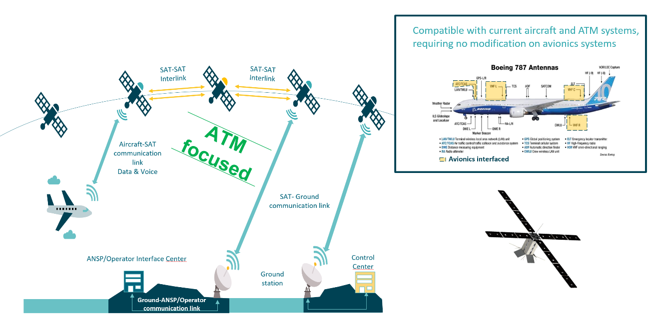
Figure 1. Proposed Solution.

  - SERVICES.
    - The architecture is created mainly with the aim to develop an ATM dedicated satellite constellation for the provision of ADS-B, datalink ATN, ACARS and VHF voice services for Oceanic and remote continental areas (Non Radar Airspace) services where 5NM separation distances are required and that today are not supported by surveillance (other than ADS-C) or VHF comms.
    - In the future, the system could also operate in Continental areas in RAD airspace as back up to provide separations up to 5NM. Dedicated coverage configurations can be provided for areas requiring back-up services.
    - This combination allows ANSPs to design their airspace to improve, not only the Capacity and Safety but also to allow airlines to operate over their "User Preferred Routes" with the benefit for fuel-saving for Airlines.
    - Constellation improves safety and maximizes operational benefits by applying new space emerging technology with the aim to end in quasi-continental operational procedures.
    - Also, the system allows agile technology roll-out and expansion. Future added-value services or technologies could be integrated in every update cycle initially scheduled for a 5 year period if the ITU radio regulation allows it.
    - For ANSPs, ground infrastructure will be initially complemented and in the future shared with this satellite-based infrastructure.
    - The proposed solution has been designed and developed to provide the following CNS services:
- Surveillance services provided through ADS-B.
- ATS Voice services.
- ATS Data services.
- AOC Data/Voice services.
- Other potential services.

  - SCHEDULE AND NEXT STEPS.
    - The below figure provides the timeline for activities:

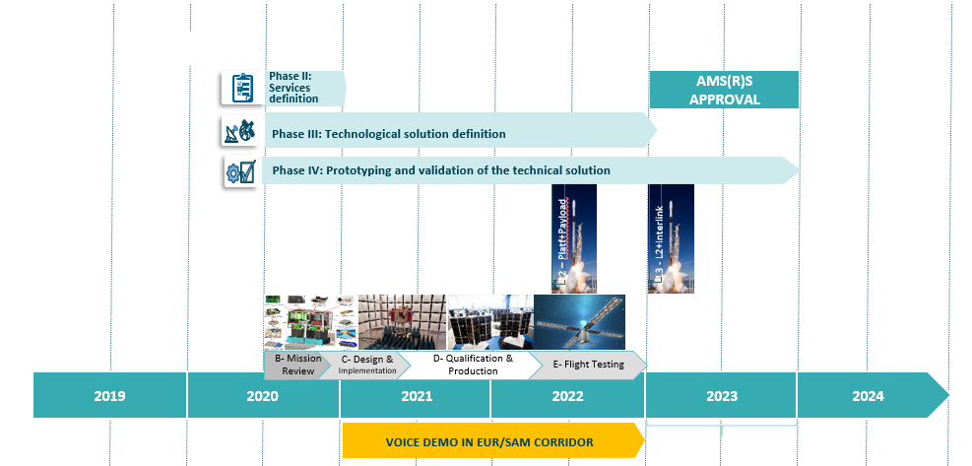
Figure -1. Short Term Calendar
    - An initial validation of the SB-CNS concept is going to be performed by end 2022 in a real environment.
    - FIRs affected by the exercise are:
- SAL oceanic (part of the exercise)
- Canarias (Part of the exercise)
    - The satellite will be in operation only when flying over the areas of interest. A specific protection mechanism will be develop to ensure that satellite transmission is switched off out of the areas involved in these trials. So, there will be no satellite coverage in the other parts of the globe.

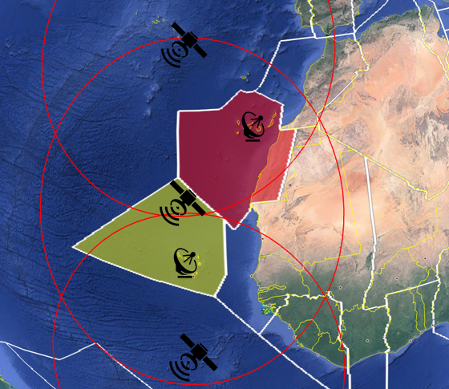
Figure-2. Area of the exercise.

    - Two (2) VDL-2 channels and one (1) VHF 25kHz channels are required for the initial tests.
    - Initially, on the exercise CSC will be used and then communications will be moved to another operational VDL-2 channel (SITA TERMINAL frequency, SITA ENROUTE frequency).
- OUTCOMES OF TECHNICAL STUDIES AND LABORATORY TEST PERFORMED BY VOICE PROJECT
    - For the project, Indra/ENAIRE/EUROCONTROL/SITA are performing a set of studies to analyze the compatibility of the AMS(R)S with AM(R)S in terms of in band, adjacent band and avionics compatibility.
    - In relation with Avionics compatibility, Indra, ENAIRE and SITA are carrying out laboratory tests to evaluate the effect of the satellite channel on the VHF airborne radios behaviour for both voice and data services. The final objective of the test is the validation that the airborne radios could operate with the Space based VHF system without modification as stated in the ITU Resolution 428 (WRC-19) and fulfilling the required performances. The test setup is basically composed of avionics equipment, ground radio equipment and a Satellite Channel Emulator. The Satellite Channel Emulator consists in an equipment that introduce the effects of the satellite channel, such as Doppler, dynamic attenuation, satellite amplifier effects, delay and delay variation, etc in the VHF transmitted signals. The considered test equipment is also used to measure the signal quality in the airborne reception impacted by the following effects:
- Satellite Doppler effect (frequency offset and frequency rate), emulating the frequency shift experienced by the signal due to the LEO satellite movement in its orbit.
- Free space path losses between the satellite and the aircraft
- Emulation of signal power variation due to the LEO satellite movement in its orbit
- Emulation of the ionospheric scintillation, based on available models.
    - Activities to be performed include but are not limited to:
- Compatibility studies :
  - within the AM(R)S band
  - out of the AM(R)S band 137 – 138 MHz
  - out of the AM(R)S band < 118 MHz, >138 MHz
and to define the technical constraints if any (e.g. power limitation)
- Studies on the satellite impact on the VHF links:
  - Evaluate impact of satellite channel higher propagation attenuation and scintillation to assess closure of VHF links as requested in ICAO SARPS.
- Studies on the satellite Doppler effect impact on VHF links:
  - Evaluate the impact of the satellite Doppler effect in airborne radios, taking into account currently defined ICAO SARPS specification for carrier frequency acquisition range
- Compatibility analysis for the use of space stations for transmission in the 136 - 137MHz frequency band & spectrum allocation:
  - Compatibility analysis for the use of space stations for transmission in the 136 – 137 MHz frequency band.
  - Definition of the Space based VHF CONOPS for operations in the 136 - 137 MHz frequency band.
  - Identification of any technical and operational constraint and their impacts on the satellite services.
- Studies for the use of Space Based VHF Voice and spectrum allocation:
  - Assessment of the number of channels required to serve defined FIRs.
  - Definition of the Space based VHF CONOPS.
- (PBCS) Performance over SB-CNS studies:
  - Evaluation of end-to-end performance to provide required communication performances.

    - It is also expected to perform in orbit demonstration in multiple scenarios (over oceanic airspace, in co-existence with terrestrial VDL stations, …), in operational conditions, to assess the impact of previously listed aspects (compatibility, Doppler, propagation, etc).
    - Expected outcomes of the activities include compatibility studies related to non-aeronautical systems in use in adjacent frequency bands will be also performed in liaison with ITU.
    - The outcome of the performed technical studies and tests/validations are collected in Annex A of this document.
- ACTION BY THE MEETING.
  - The FSMP members are invited to
- note the purpose of the VLD2-VOICE project to offer global communication VHF (voice and data) services for aviation;
- note the action from Indra/Enaire/EUROCONTROL/SITA to perform frequency compatibility studies, trials on lab for demonstrating avionics compatibility and orbit demonstration in multiple scenarios.
- note the outcomes of the technical studies and test/validations presented in this document.
— END —

ANNEX A
PowerPoint presentation with the outcomes of the technical studies and test/validations performed by VOICE project.

