FLIMSY 3
FLIMSY 3
[Source: Annex 20 to the Nov 2017 WP5B Chairman’s Report]
Working Document Towards a Preliminary Draft New
Report ITU-R M.[GADSS]
The global aeronautical distress and safety system
Scope
This report provides consideration on the concept of operations on global aeronautical distress and safety system as defined in version 6.0 and approved by Air Navigation Commission of International Civil Aviation Organization.
Keywords
Aviation, aeronautical, Distress
Glossary of abbreviations
AHWG Ad‐hoc working group
ConOps Concept of operations
GADSS Global aeronautical distress and safety system
ICAO International Civil Aviation Organization
SAR Search and rescue
WRC World Radiocommunication Conference
Related ITU Recommendations and Reports
None

1 Background
The International Civil Aviation Organization (ICAO) held a Special Meeting on global flight tracking of Aircraft in Montreal May 2014, and formed two groups to address the near-term priority to track airline flights, no matter their global location or destination. Those groups were an ICAO ad hoc Working Group (AHWG) to develop a concept of operations (ConOps) to support future development of a global aeronautical distress and safety system (GADSS) and an industry led group under the ICAO framework called the aircraft tracking task force to identify near term capabilities for normal flight tracking using existing technologies.
The AHWG developed the initial ConOps for the GADSS, which was endorsed by States at the high level safety conference in February 2015. The ConOps was further updated by the AHWG in 2015 to reflect the outcomes of the ICAO Council approval to develop new standards and recommended practices in the relation to the GADSS concept.

ITU Plenipotentiary Conference at Busan in October-November 2014, decided through Resolution 185, to instruct WRC-15, pursuant to No. 119 of the ITU Convention, to include in its agenda, as a matter of urgency, the consideration of global flight tracking, including, if appropriate, and consistent with ITU practices, various aspects of the matter, taking into account ITU-R studies.
WRC 15 agreed on:
– Resolution 425 (WRC-15) to facilitate the global flight tracking;
– Resolution 426 (WRC-15) for a new agenda item on global aeronautical distress and safety system.
Version 6.0 of the ConOps describes in particular the following functions:
– Aircraft tracking.
Typically leverages existing technologies to assist in the timely identification and location of aircraft. Provides an automated reporting function every 15 mins or less. Aircraft tracking may be accomplished by multiple different systems over the duration of a flight.
– Autonomous distress tracking.
An automated method of position reporting at intervals of one minute or less to support search and rescue (SAR), triggered by indications that an aircraft is in distress which may result in an accident. Distress tracking aims to establish the location of a potential accident site within a 6 nautical mile (11.1 km) radius.
– Post flight localization and recovery.
A combination of both the immediate need to locate and rescue possible survivors after an air accident using emergency location beacons and other methods to an accuracy of <1 nautical mile (<1.85 km), and the timely collection of aircraft components and data that will assist in the accident investigation.
– Procedures and information management.
The method of data collection and notification of flight tracking data to the relevant SAR, and rescue coordination centres.

The ConOps is the guidelines for the development of ICAO performance-based standards, outlining specific technical and operational requirements that an aircraft must meet. It does not identify specific systems proposed to contribute to GADSS. ICAO intends to use systems operating under appropriate existing allocations in accordance with the provisions of the RR, including the use of emergency position-indicating radio beacons operating in the 406-406.1 MHz frequency band.

2 Extracts from International Civil Aviation Organization concept of operations of the global aeronautical distress and safety system relative to frequency spectrum regulation

2.1 Introduction on global aeronautical distress and safety system concept of operations
The effectiveness of the current alerting of search and rescue services will be increased by addressing a number of key improvement areas, and by developing and implementing a globally integrated system, the GADSS, which addresses all phases of flight under all circumstances including distress.
Responding to the requirements and objectives, the GADSS ConOps specifies the high-level functions needed, with a description of users and usages of aircraft position information, in all airspaces, during all phases of flight, both normal and distress flight conditions including the timely and accurate location of an aircraft accident site and recovery of flight data.
Objectives of the GADSS are:
– Ensure timely detection of aircraft in distress
– To timely initiate SAR actions
– Ensure tracking of aircraft in distress and timely and accurate location of end of flight
– To accurately direct SAR actions
– Enable efficient and effective SAR operations
– Ensure timely retrieval of Flight Recorder Data
Figure 1 below gives a high level overview and identifies the main GADSS functions:
– Aircraft tracking function;
– Autonomous distress tracking function;
– Post flight localization and recovery function; and
– GADSS information management and procedures.
FIGURE 1
Main functions of global aeronautical distress and safety system
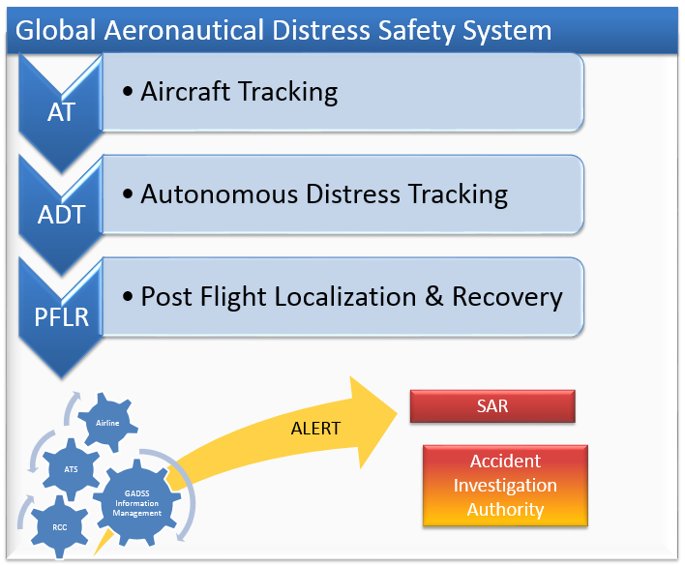

2.2 Frequency spectrum considerations
To ensure global interoperability and lawful operation of radio equipment on‐board aircraft, the equipment will conform to agreed performance standards, will operate in correct frequency bands, must be licensed by appropriate authorities, and be operated by licensed personnel if appropriate.

3 Spectrum needs and regulatory provisions for the introduction and use of the global aeronautical distress and safety system

3.1 Spectrum needs
Studies within ICAO in preparation for WRC-19 have determined that the GADSS requirements can be satisfied using existing systems operating within existing aeronautical frequency allocations and distress spectrum (e.g. 406.1 MHz) in accordance with the provisions of the RR.

3.2 Regulatory provisions
In accordance with invites 2 of ITU-R Resolution 426 (WRC-15), the following regulatory areas have been reviewed in order to determine if regulatory provisions were necessary to facilitate the introduction and use of GADSS.
Chapter VII Distress and Safety Communications
It has been analysed how to reflect the existence of GADSS in the RR by modifying Chapter VII or creating a new Chapter with a new Article describing GADSS and set forth appropriately the responsibility of ICAO and ITU in the definition of systems contributing to the GADSS. These provisions should:
– recognize GADSS but avoid any impact on GMDSS;
– introduce the definition of the GADSS, clarify its main functions and explain that this is a performance based concept, so the specific systems used to meet the GADSS requirements may vary across different aircraft;
– provide clarity that the detailed information on GADSS is contained in ICAO documents, rather than in the ITU RR;
– clarify that constituent systems used to meet GADSS requirements on a given aircraft may operate in various radiocommunication services already having allocations in the RR, and not necessarily only aeronautical ones. The specific service and type of spectrum is selected based on the GADSS function;
–
–

Additional Considerations:
In carrying out these studies ICAO identified that other aeronautical-related provisions within the RR may not reflect the current/future plans for aeronautical use. These are outside the scope of agenda item 1.10 and as a result no related WRC-19 action is proposed.

Examples of RR provisions that may need to be reviewed by a future competent Conference (post WRC-19) include:

Article 28 Radiodetermination services: Review whether provisions reflect current aviation practices. In particular, Appendix 12 power limits should be reviewed.

Article 36 Authority of the person responsible for the station: Review whether there are unintended impacts on automated systems and/or unmanned aircraft

Article 37 Operator’s certificates: Review whether there are unintended impacts on automated systems and/or unmanned aircraft. Also some provisions may be redundant given that Annex 1 to the Convention on Civil Aviation also specifies the needs for certificates.

Article 39 Inspection of stations: Review whether there are unintended impacts on automated systems and/or unmanned aircraft.

Article 42 Conditions to be observed by stations: Review whether there are unintended impacts on automated systems and/or unmanned aircraft.

Article 45 General communication procedure: Review whether there are unintended impacts on automated systems and/or unmanned aircraft.

“Global Aeronautical Distress and Safety System (GADSS) – Concept of Operations”, Version 6.0, International Civil Aviation Organization, July 6, 2017.

