FREQUENCY SPECTRUM MANAGEMENT PANEL (FSMP)

Twentieth Working Group Meeting

Bangkok, Thailand, 26th February – 7th March 2025

Agenda Item 5a: Aeronautical Band Planning 108 – 137 MHz

Revisiting VHF DSB-AM Frequency planning criteria

(Bertrand Despérier, Eurocontrol)

SUMMARY
This paper reviews the current VHF communication frequency planning criteria as outlined in ICAO Doc 9718, re-evaluating them from an operational perspective. Building on this foundation, it proposes a comprehensive frequency planning framework that could be reused.

INTRODUCTION
  - ICAO Doc 9718 - Handbook on Radio Frequency Spectrum Requirements for Civil Aviation, Volume 2, outlines the operational and technical aspects of frequency spectrum management, including planning rules for frequency separation for various aviation systems.
  - Frequency planning rules are typically based on operational and technical criteria. Many of these rules were established decades ago with simplicity in mind, as advanced computational tools were not yet available. However, the underlying rationale remains unexplained, which can lead to confusion when developing new rules.
  - Therefore, it is important to revisit these criteria and understand their practical implications, particularly regarding operational impact, in order to evaluate new planning rules suited to a different environment.
  - This paper considers only VHF DSB-AM co-channel criteria. While adjacent channel criteria should be revisited at a later stage, they are significantly less restrictive in comparison

PROTECTING VHF VOICE COMMUNICATIONS
  - The protection of VHF voice communications is proposed as the fundamental criterion for operational and safety planning, with the rationale outlined below.
  - ICAO Doc 9718, Volume II, states in its introduction that “Frequency assignment planning for aeronautical radio communication and navigation systems is based on the need to provide protection from harmful interference throughout the designated operational coverage.” However, it does not define what constitutes harmful interference specifically for a VHF communication operational system. Therefore, it seems reasonable to establish a concrete definition of harmful interference tailored to the needs of VHF COM systems.
  - The International Telecommunication Union (ITU), through its Radio Regulations (RR), defines harmful interference in Article 1, No. 1.169 as follows::
“Interference which endangers the functioning of a radionavigation service or other safety services or seriously degrades, obstructs, or repeatedly interrupts a radiocommunication service operating in accordance with the Radio Regulations.”
  - Pilots and controllers communicate on a VHF channel through a push-to-talk (PTT) system, following a "listen before talk" procedure to prevent simultaneous transmissions. This procedure ensures effective communication preventing harmful interference caused by overlapping transmissions.
  - Two types of harmful interferences that may occur between two different VHF COM services operating on the same frequency can be defined: The voice degradation (intelligibility issue) and the unwanted unmuting of radios (Squelch opening).
  - Voice degradation (intelligibility issue)
    - When two users operate on the same channel simultaneously, signal overlap can occur. This may lead to parties not being able to understand each other due the communication signal being harmfully interfered
    - As illustrated in the following figure, consider two services, Service 1 and Service 2, both operating on the same frequency and used by four operators: A, B, C, and D. Operators A and B use Service 1, while C and D use Service 2. In this scenario, when A is speaking to B and C is simultaneously speaking to D, B will receive transmissions from both A and C at the same time, making it difficult for B to understand A clearly.
    - Considering A as the desired signal and C as the undesired one, it is clear that the ability of B to understand A depends on the desired-to-undesired (D/U) signal ratio. Therefore, the D/U signal ratio appears to be the effective criterion for preventing this type of interference.
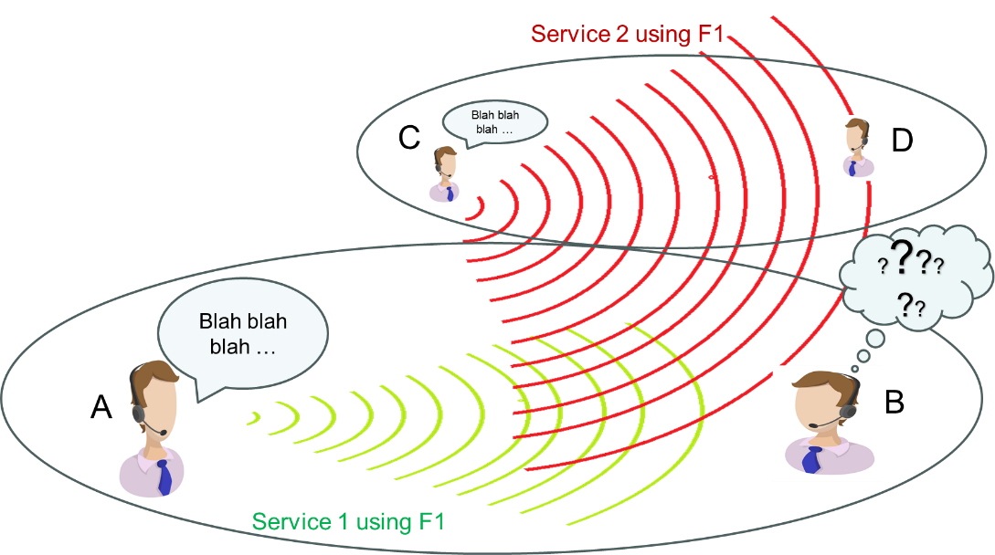
Figure 1- Voice degradation
  - Unwanted unmuting (squelch opening)
    - Squelch opening arises when a receiver’s squelch circuit, which suppresses noise when no useful signal is detected, may unmute in response to unwanted transmissions.
    - Based on the previous example, the following figure illustrates the situation. Service 1 is free from any transmission, while C (or another operator from Service 2) is transmitting, causing B’s radio to unmute.
    - When an aircraft or ground receiver experiences squelch breaks, it interprets the channel as active, leading to disrupted communications and possible response delays that may potentially endanger Service 2.
    - Unwanted radio unmuting is triggered by the level of the undesired signal received and the radio's unmute threshold. Consequently, setting a maximum allowable level for the undesired signal at the intended receiver would be an effective criterion to prevent unwanted unmuting.
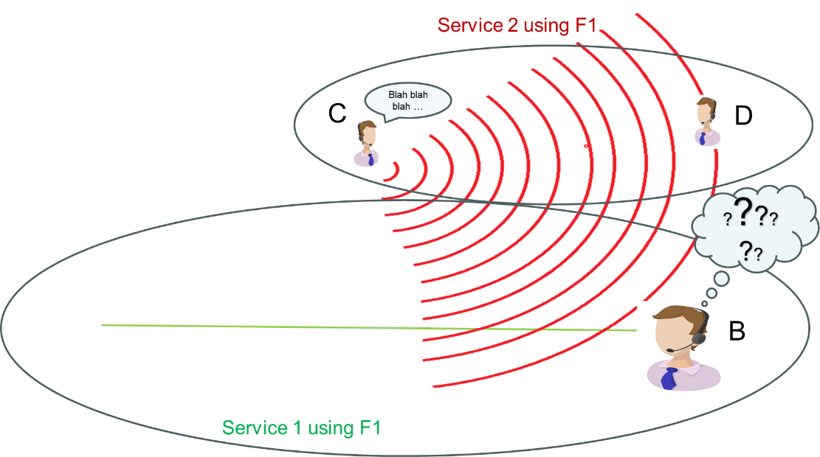
Figure 2- Unwanted unmuting
    - Unwanted unmuting affects ground and airborne operators differently. From the pilot point of view most of the communications that take place on the channel are not addressed to him. A pilot awaiting a clear channel to communicate may face delays due to any unwanted transmissions, which artificially increase the channel load. This can cause the pilot to postpone its transmission, potentially resulting in increased communication delays.
    - Party Line Effects: In aviation, all aircraft in a given area may hear transmissions on a frequency to understand the overall communication context. However, interference from outside sources may disrupts this "party line," impairing situational awareness.
    - Unwanted unmuting during flight may be acceptable within certain limits, which depend on the number of affecting and affected aircraft and the duration of the interference. However, the precise level at which such interference remains acceptable has not been formally quantified.
    - A ground operator / air traffic controller expect all downlink communications to be be addressed to him, hence any message received but addressed to another ground operator can be really problematic and therefore unwanted unmuting and is highly disruptive. Unwanted squelch breaks introduce noise or partial transmissions, distracting ATCOs and making it harder to focus on the aircraft they are managing.
    - Any interference that causes ATCOs to miss critical information compromises their control over aircraft movements, raising safety concerns. Clear, uninterrupted communication is essential for air traffic controllers (ATCOs) to safely manage air traffic. Hence frequency planning criteria should prevent any aircraft of another service to unmute the ground radio(s).

ANALYSIS OF CURRENT VHF VOICE FREQUENCY PLANNING RULES AND CRITERIA
  - The Co channel frequency planning rule for VHF COM frequencies is defined in ICAO DOC 9718 as follows:
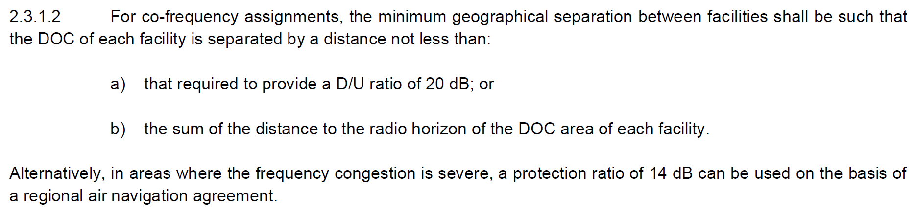

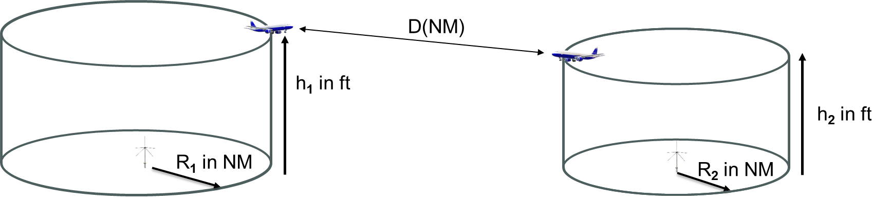
Figure 3- Air to Air Separation between 2 service volumes operating on the same frequency
  - According to the planning rule, the minimum distance between 2 services operating on co channel is, depending if 20dB or 14dB is considered:
- 14dB: $D=MIN\left[5.MAX\left(R_{1},R_{2}\right),1.23.\left(\sqrt{h_{1}},\sqrt{h_{2}}\right)\right]$
- 20 dB: $D=MIN\left[10.MAX\left(R_{1},R_{2}\right),1.23.\left(\sqrt{h_{1}},\sqrt{h_{2}}\right)\right]$

  - This is the only co-channel planning rule defined in ICAO Doc 9718, and it applies solely to aircraft-to-aircraft scenarios. The reason for this focus is explained in the document, as it represents the most restrictive factor in co-channel frequency planning
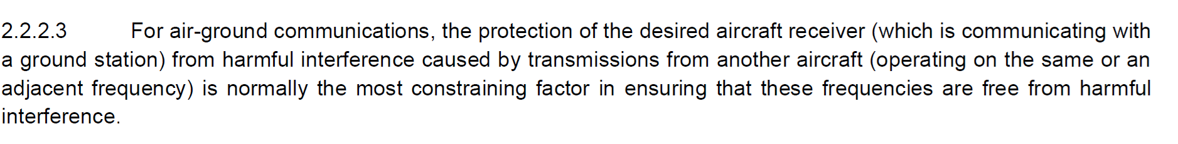

  - The analysis performed hereafter is based on the following finformation available in the appendix:
- ITU-R P.528-5 aeronautical propagation model
- Maximum undesired signal level at the desired receiver (unmuting)
- Minimum desired to undesired signal ratio at the desired receiver input
- Definition of DOCs for various services in ICAO EUR region
  - The following three scenarios are analysed: aircraft-to-airacrft, aircraft-to-ground and ground-to-ground, where the unmuting and the D/U is analysed based on the following assumptions:
Ground station transmission power (25w) | 44 dBm
Ground station antenna gain | 2 dBi
Ground station cable loss | 3 dB
Ground station sensitivity | -101 dBm
Aircraft station transmission power (25W) | 44 dBm
Aircraft station antenna gain | 0 dBi
Aircraft station cable loss | 3 dB
Aircarft station sensitivity | ~ -101 dBm
Unwanted signal basic propagation loss time availability | 5%
  - Aircraft to. Aircraft Scenarios
    - Based on the typical DOC, let’s examine what the planning rule implies in terms of potential undesired signal reception level and the resulting D/U ratio.
    - The table below, corresponding to Table 2.8 in Section 2.8.2.1 of Doc 9718, but applying 5:1 distance ratio rather than 10:1 distance ratio, outlines the minimum distances required between two services according to the planning rule.
- Green highlights cases where the 5:1 distance ratio is less than the sum of the RLOS.
- Orange indicates cases where the 5:1 distance ratio exceeds the sum of the RLOS
    - Note that any case involving a polygonal area rather than a circular DOC (ACCs in the table) inherently applies the rule using the sum of the radio horizon distances as the separation criterion.
Figure 4- Separation Distance in NM between DOCs (Min distance between AC at the top edge of each DOC)
    - The table below provides the propagation losses caluculated between aircraft at at the top edge of each DOC at that minimum distance according to P.528-5 at 5% time percentage.

Figure 5- Minimum Attenuation ( dB) between DOCs (Min attenuation between ACs at the top edge of each DOC)
    - Given the path loss above, an airborne transmitter power of 25 W (44 dBm), a 3 dB feeder loss at both the transmitter output and receiver input, and 0 dB antenna gain, the table below presents the undesired signal levels expected at the input of the desired receiver for various services.
Figure 6- Undesired signal level received in dBm (Between AC at the top edge of each DOC)
    - For most if not all of the level received in the table, the receiver’s squelch should be lifted and the radio unmuted.
    - However, for all “sum of Radio Horizon” scenarios (in orange in the table), it is important to note that the undesired signal level decreases rapidly, dropping approximately 0.5 dB per nautical mile (NM) at a constant altitude or around 0.7 dB per 100 feet of altitude at a constant distance.
    - Therefore, in these cases, potential interference is confined to the top edge of the volumes, making it statistically highly unlikely to occur as stated in the paragraph below:
    - It could also be stated that, in addition to the probability of the aircraft's position, the likelihood of one aircraft transmitting precisely at the point of positional conjunction further reduces the probability of interference occurring.
    - For 5-to-1 (or 14 dB) scenarios (highlighted in green in the tables), the number of aircraft potentially within the RLOS (Radio Line of Sight) from others within both volumes is significantly higher, implying a greater likelihood of potential interference. Nevertheless the number of potentially impacting and impacted aircraft remains limited.
    - The figure below illustrates the scenario of two tower assignments (25 NM radius and 4000 ft ceiling) operating on the same channel, separated by the minimum allowable distance as per frequency planning rule.
    - An aircraft positioned at the top edge of the undesired volume at point A, as illustrated in the figure, will have a Radio Line of Sight (RLOS) to any aircraft located within the red area. More broadly, any aircraft within the orange area will be within RLOS of aircraft in the desired area; however, the size of the red area will vary depending on the position of the aircraft.
    - Conversely, aircraft in the green areas will always be beyond the RLOS of aircraft in the other volume, ensuring no direct line-of-sight interference between them.
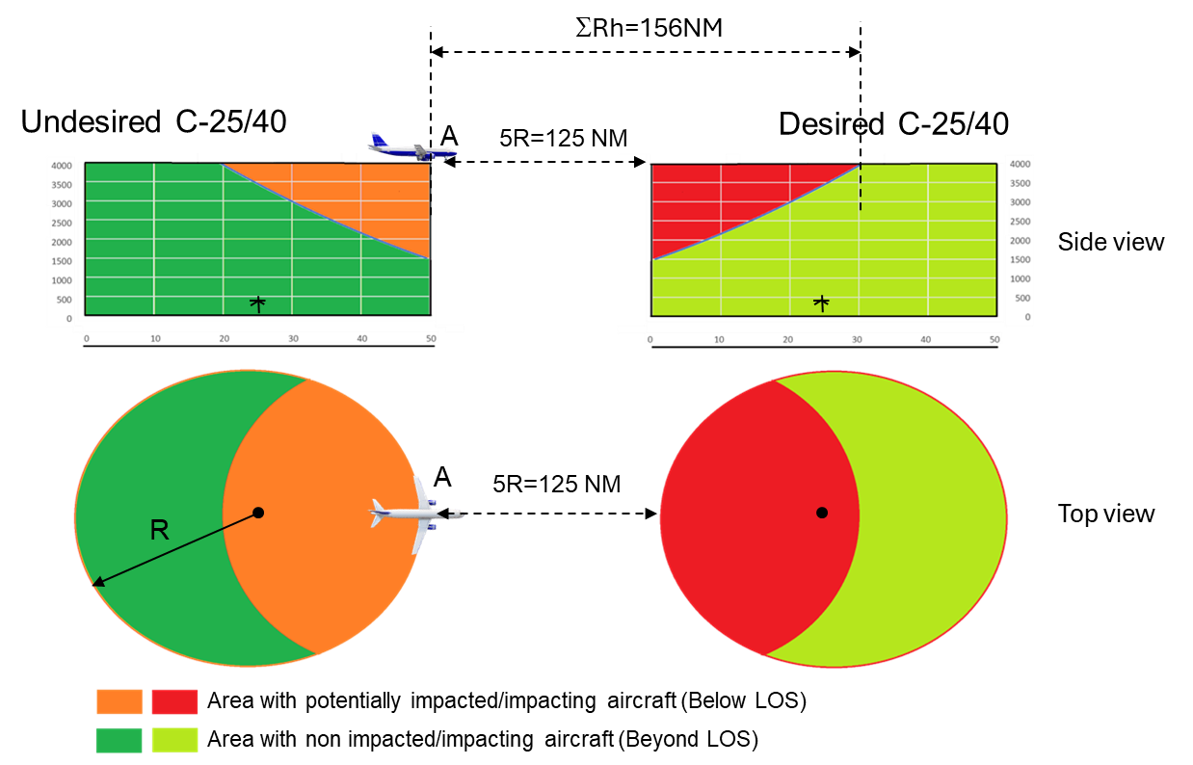
Figure 7- C-25/40 Vs C-25/40 Impacting and impacted areas
    - Let’s examine the minimum Desired-to-Undesired (D/U) ratio calculated between two aircraft located at the top edge of each volume, as determined using two methods described in Section 3.3
    - The following tables present:
- The "Real D/U," which assumes equal desired and undesired transmitted EIRPs and uses the P.528-5 propagation model at 5% time.
- The D/U calculated based on the 5-to-1 distance ratio, as specified by the planning rule.

UNDESIRED
DESIRED
Figure 8- "Real” D/U (dB), assuming equal EIRPs, P.528-5 at 5% time

UNDESIRED
DESIRED
Figure 9- D/U (dB) based on 5 to 1 distance ratio
    - There are differences between the two D/U calculation methods, ranging from 1 to 2 dB in the within-RLOS scenarios (green/yellow cells) to as much as 6 or 7 dB in the beyond-RLOS scenarios. The 5 to 1 method appears to be overly conservative compared to results obtained from a more realistic propagation model such as P.528-5.
    - It is important to note that the assumption of equal EIRPs is incorrect in practice, particularly for large DOC services, where the transmitting power can reach up to 50W. As a result, the "real D/U" values can increase by up to 3 dB when ACC is the desired service. Hence, as an example, the minimum D/U value observed in the Figure 10 would be 8 dB instead of 5 dB.
    - This demonstrates that referring to a "14 dB criterion" is a misuse of terminology. The 14 dB value applies only to specific cases (yellow cells in figure 11) and is even not the absolute minimum value observed across all scenarios.
    - What is important to note is that in scenarios where some aircraft are within the RLOS of others (green cells), radios will likely be unmuted. However, the "D/U" ratio will still ensure good intelligibility of the exchanged messages.
    - For other cases where the D/U ratio appears low, the undesired signal level decreases rapidly (~0.5 dB per nautical mile and ~0.7 dB per 100 feet), making any interference effects highly unlikely, transient, and temporary.
    - In the aircraft-to-aircraft scenario, interference is generally tolerated but remains unlikely to occur, except in congested areas where the 5:1 planning rule is applied. In these cases, while some aircraft radios may unmute due to transmissions outside the Designated Operational Coverage (DOC), communication between ground and air remains intelligible.

  - Aircraft to Ground scenarios
    - ICAO Doc 9718 does not specifically mention criteria for protecting a ground radio receiver of one service from transmissions by aircraft in another service. This omission is logical, as stated in Section 2.7.1.1, because the ground station is typically located well within the Designated Operational Coverage (DOC) and, being on the ground, is inherently protected from external aircraft interference when aircraft within the DOC are protected from external transmissions.
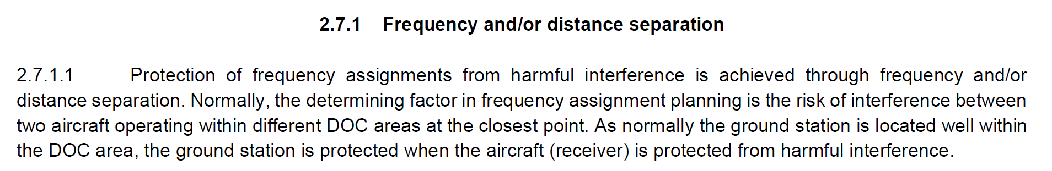
    - However, as discussed in the previous section, aircraft are not "fully" protected from external aircraft, meaning that some level of interference may be tolerated. With this in mind, let us examine the practical implications of the frequency planning rule on ground station protection against aircraft transmission and vice versa.
    - The case involving broadcast stations, where the ground station is exclusively a transmitter and the airborne station is solely a receiver, will be addressed separately.

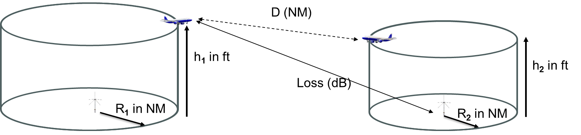
Figure 10- Air top Ground separation
    - Non Broadcast services
    - The table below presents the propagation losses calculated between an aircraft positioned at the top edge of one DOC and a ground station equipped with a 20 m high (65 ft) antenna, located in the other DOC at the minimum separation distance. These values are determined using the P.528-5 model at a 5% time percentage.
AIR

GROUND
Figure 11- Path Loss based on P.528-5 @5% between Aircraft and ground station
    - Assuming an EIRP of 41 dBm, 0 dB antenna gain, and a 3 dB feeder loss at the receiver, the undesired signal power level at the receiver is presented in the following table
AIR
GROUND
Figure 12- Undesired level received at the Ground receiver input assuming P.528-5 path loss, 41 dB EIRP 3dB feeder loss and 2dBi antenna gain.
    - In most of the cases, the undesired signal level received is far below the minimum one that could trigger any type of interference down to the noise level. That applies obviously in any RLOS or “20dB” scenarios.
    - When considering 5-to-1 (14 dB) scenarios, only four cases may present potential issues, as the undesired signal level could fall within the receiver's sensitivity range (yellow cases). The most critical scenario involves an aircraft flying at 10,000 feet and separated by 125 NM from an AFIS volume. In this case, although the AFIS ground station is beyond the radio horizon, the separation distance is sufficient to prevent squelch opening. The three other cases, with a signal level of -101 dBm, are more marginal.
    - In practice, however, frequency planning separation distances are always greater than the minimum required, ensuring sufficient margins. Additionally, if a ground controller were to experience such interference, alternative solutions would be implemented to resolve the issue.
    - Broadcast services
    - Broadcast service planning is unique in that it is the only case where calculations explicitly account for the distance between the aircraft and the ground station.
    - In a broadcast service, the ground station is exclusively a transmitter, and the aircraft is solely a receiver. Therefore, the only concern is to protect the aircraft from ground transmissions, rather than the other way around.
    - When calculating the required separation distance between a broadcast service and a non-broadcast service, the dimensional distance refers to the distance needed to protect the broadcast service from interference caused by the non-broadcast service. These distances are provided in the table below.
Figure 13- Minimum Separation distance (NM) for broadcast vs. non broadcast services.
    - In all the cases outlined below, the broadcast station is well beyond the Radio Line of Sight (RLOS) of the nearest possible aircraft in the non-broadcast service. As a result, the undesired power received by the non-broadcast service aircraft is negligible, effectively buried within the noise floor.
    - In all the cases outlined below, the broadcast station is well beyond the Radio Line of Sight of the nearest possible aircraft in the non-broadcast service. As a result, the undesired power received by the non-broadcast service aircraft is negligible, effectively buried within the noise floor.
    - The same princ;lipmle applies to broadcast-to-broadcast scenarios. The minimum distances between the Designated Operational Coverages for these cases are provided below. Similarly, the signal level received by any aircraft in one service from the ground station of the other service is negligible.
Figure 14- Minimum Separation (NM) for broadcast vs. broadcast services.
    - Air-to-ground scenario: by applying the frequency planning rules outlined in ICAO documents (Doc 9718 and EUR Doc 11), no interference of any kind is expected to occur between an aircraft and a ground station.
  - Ground to Ground scenarios
    - Based on the explanations in the previous sections, it is clear that for any service involving aircraft in flight, the current separation planning rules ensure that the ground stations of two co-channel services are positioned well beyond each other’s radio horizon, effectively isolating them completely.
    - The only cases of concern involve ground services also named Aerodrome Surface (AS). AS have their own allotment or sub-band. These are defined as circular services with a 5 NM radius and an altitude limit of up to 100 feet.
    - Thus, the minimum separation distance between the coverage areas of two Aerodrome Surface (AS) services is 24.6 NM, and the minimum distance between their ground stations is approximately 35 NM. At this distance, the propagation loss is approximately 139 dB, assuming the ground stations have an antenna height of 100 feet.
    - As stated in ICAO Doc 9718 volume II section 2.7.2.6.1, “Aerodrome surface (AS) communications provide an essential safety service. If the separation distance is not sufficient, clearances or other instructions that are intended to be used solely on a nearby (“undesired”) aerodrome can be understood as a valid instruction on the desired aerodrome.
    - In practice, challenges may arise from nearby airports that operate multiple AS services, particularly large international airports located in close proximity to each other. In such cases, the number of available AS services may be limited, or special implementations may be required to prevent any interference.
    - Nevertheless, under the current frequency planning rules defined in Doc 9718 and EUR Doc 11, no interference of any kind is expected to occur between ground stations when ATC services are involved.

CONCLUSION
The table below summarizes the interference criteria for the various elements, both airborne and ground-based, derived from current frequency planning rules and practical implementations.

 |  | Undesired
 |  | AIR | GROUND
Desired | AIR | Limited interference | - No squelch opening  - No intelligibility issue*
Desired | GROUND | - No squelch opening  - No intelligibility issue* | - No squelch opening  - No intelligibility issue*
* when a simultaneous unwanted transmission occur

ACTION BY THE MEETING
The meeting is invited to:

- note and review the contents of this working paper;
- Understand the importance of the considerations related to the high level criteria such as squelch and inteligibility issue for the development of new planning criteria for the VHF COM voice and;
- Consider their incorporation into a future edition of Document 9718, Volume II.
— END —

APPENDIX
- Propagation Model

ITU-R P.528-5 is an ITU recommendation that provides a method for predicting propagation loss in the VHF and UHF frequency bands (roughly 100 MHz to 3 GHz) for aeronautical services. The model takes into account factors such as earth geometry (curvature), atmospheric effects (tropospheric refraction, scattering), diffraction, using ”smooth earth” condition, (No terrain)

It is used to estimate the basic transmission loss between ground-based and airborne stations (or between two airborne stations), supporting coverage planning, link budget calculations, and interference analyses in aeronautical communication systems.

The “time percentage” indicates the fraction of time during which the predicted basic transmission loss is met or not exceeded. In other words, it reflects the percentage of time the service is available.

For example, a transmission loss given for 90% time would mean that the path loss will be at or below that predicted value 90% of the time (or, equivalently, the signal level is at or above the corresponding threshold 90 % of the rime).

Care should be taken in assessing wanted-to-unwanted scenarios. For a 95% time availability of the wanted signal, a 5% (100%-95%) time availability should be taken for the unwanted one, as specified in ICAO Doc 9718, representing the worst-case scenario for interference (i.e., minimal attenuation) of the undesired signal.
- Maximum undesired signal level at the desired receiver input (unmuting)
Even if the squelch threshold may be user-adjustable or system-set value to determines the signal strength required to unmute the audio. We should consider its minimum value which is set just above the receiver’s level of sensitivity.
Although standards define a minimum sensitivity, radios are free to exceed that performance. For example, ARINC 716 specifies a minimum sensitivity of 2 µV (approximately –101 dBm), yet some radios may achieve 1 µV (about –107 dBm) or even lower signal levels. Consequently, it is impossible to establish a universal maximum undesired signal level that avoids squelch activation on the basis of the standards.
However, it is highly unlikely that radio sensitivity exceeds -107 dBm. Therefore, with a transmission power of 44 dBm, an EIRP of 41 dBm, and a 3 dB loss at reception, a propagation loss of 146 dB should suffice to ensure the radio remains unmuted.
- Minimum Desired to undesired signal ratio at the desired receiver input
The D/U ratio seems to be a fundamental measure used to maintain signal clarity by ensuring that the desired signal strength is substantially higher than the undesired signal.
However several approaches to measure D/U can be considered: (as explained in section ICAO 9718 Volume II section 2.2.3)
Real D/U Ratio: Requires knowledge of ground station positions and Effective Isotropic Radiated Power (EIRP) levels of the desired and undesired transmitters. Desired and undesired signal level at the receiving antenna are calculated based on a propagation model such as ITU P.528-5.
Minimum Field Strength-Based D/U: this method sets interference thresholds based on standard minimum field strength values. As a minimum field strength of 75 µV/m (around -82 dBm) in the air and 20 µV/m (-93 dBm) on the ground are defined in ICAO Annex 10 Volume III and and ICAO 9718 Volume II section 2.3.2, D/U values correspond to maximum permissible levels of undesired signal power at the desired antenna. At a D/U of 20 dB and 14 dB, maximum undesired power levels would be:
- In Air: -102 dBm (20 dB D/U) and -96 dBm (14 dB D/U)
- On Ground: -113 dBm (20 dB D/U) and -107 dBm (14 dB D/U)
Distance Ratio-Based D/U: in free-space propagation, attenuation grows with the square of the distance, often referred to as the inverse-square law. Assuming EIRPs of desired and undesired transmitters are equal, it gives: D/U = 20.log(d_{u}/d_{d}) where d_{u} is the distance between the undesired transmitter and the desired receiver and d_{d} is the distance between the desired transmitter and the desired receiver. It gives:
- If $D/U≥20dB$, d_{u} >=10.d_{d} (10:1 distance ratio)
- If $D/U≥14dB$, d_{u} >=5.d_{d} (5:1 distance ratio)
- Typical services
The table below presents the typical Designated Operational Coverages (DOCs) for various service types in the ICAO EUR region, as outlined in DOC9718, Section 2.6.3, Table 2-5.
These DOCs will be used for calculations in the following sections. Notably, even if DOCs from non-EUR regions were applied, the reasoning and results would remain the same.
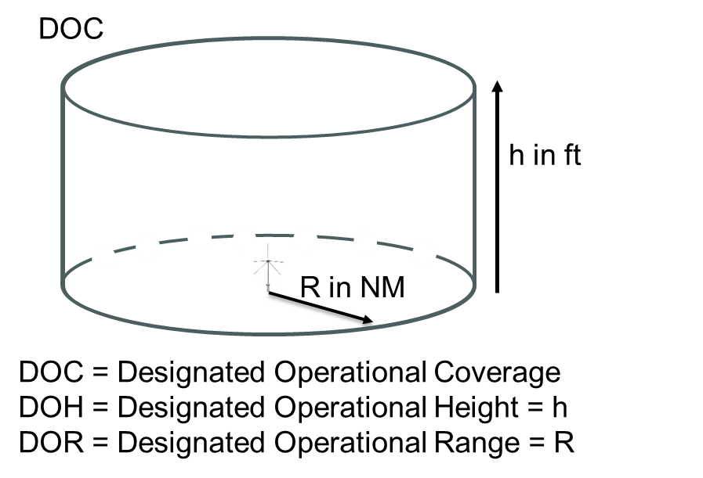
Service | DOR (NM) | DOH (ft)
AFIS | 16 | 3000
TWR | 25 | 4000
APP-L | 25 | 10000
APP-I | 40 | 15000
APP-U | 50 | 25000
ACC/LL | Area 120* | 15000
ACC-L/FIS | Area 155* | 25000
ACC-I | Area 185* | 35000
ACC-U | Area 200* | 45000
VOLMET | 261 | 45000
ATIS | 60 | 20000
Figure 15- Typical services

Calculation are done according EUR Doc 11. There is a difference of 5NM when considering RLOS of the ground between EUR Doc 11 and Doc 9718
ITU-R P.528-5 considers the use of a time availability of 95% for the computation of reliable services, leading to the 5% of time availability criteria for the interferenrer.
With a 2 μV signal, amplitude modulated 30% at 1 kHz, the signal-plus-noise-to-noise ratio should be 6 dB.

