FREQUENCY SPECTRUM MANAGEMENT PANEL (FSMP)

Twentieth Working Group Meeting

Bangkok, Thailand, 26th February – 7th March 2025

Agenda Item 5a: Aeronautical Band Planning 108-137 MHz

Space Based VHF Spectrum Impact

(Bertrand Despérier - EUROCONTROL)

SUMMARY
This document examines the potential impact of Space-Based VHF (SB-VHF) communication on the aeronautical VHF band (118–137 MHz), focusing on Europe. It highlights significant congestion in the band, particularly for 25 kHz channel assignments. SB-VHF is shown to have much lower spectrum efficiency compared to terrestrial systems in continental regions. The analysis demonstrates that SB-VHF should not be used in Europe to replace current services and should concentrate on remote or oceanic areas. Recommendations include developing validated propagation models and dynamic footprint assessments to refine the analysis and ensure sustainable spectrum management.

- SCOPE
  - This paper provides an initial analysis of the impact that Space-Based VHF (SB-VHF) voice communication may have on the aeronautical VHF band (118–137 MHz) globally, with a specific focus on the ICAO EUR region.
  - It evaluates the potential use of SB-VHF by existing services in Europe, comparing its "frequency planning efficiency" to that of current terrestrial services.
  - While separation planning criteria applicable to SB-VHF are yet to be defined, simple assumptions can offer valuable insights into the impact of allocating space-based channels for services in remote airspace, such as the North Atlantic, on existing European terrestrial services.
  - The assumptions and calculations in this paper are based on the FSMP-WG19-WP16_SB-VHF SARPs Validation Report, the current SAFIRE database, and the ICAO global database.
- FREQUENCY PLANNING CONSIDERATIONS
  - Curent VHF congestion situation in Europe
    - The VHF COM band (118–137 MHz) has been congested for many years in western Europe. While the introduction and widespread adoption of 8.33 kHz channel spacing has provided additional capacity, this improvement applies only to 8.33 kHz frequency assignments. The congestion for new 25 kHz frequency assignments remains unchanged without a major re planning exercise.
    - The current congestion of 25 kHz frequency assignments can be illustrated as follows: Define a service volume as a cylinder with a specified radius, and height, and move this cylinder across Europe. At each location (centre of the volume), calculate the number of available frequencies for such service volume, represented by a corresponding colour.
    - A Tower service typically covers a cylindrical volume with a radius of 25 NM and a height of 4 000 feet. In contrast, an ACC service, which is polygonal in shape, can be approximated as a cylinder with a radius ranging from 50 NM to 100 NM and a height of 45 000 feet. The map below illustrates the congestion levels associated with each type of service.
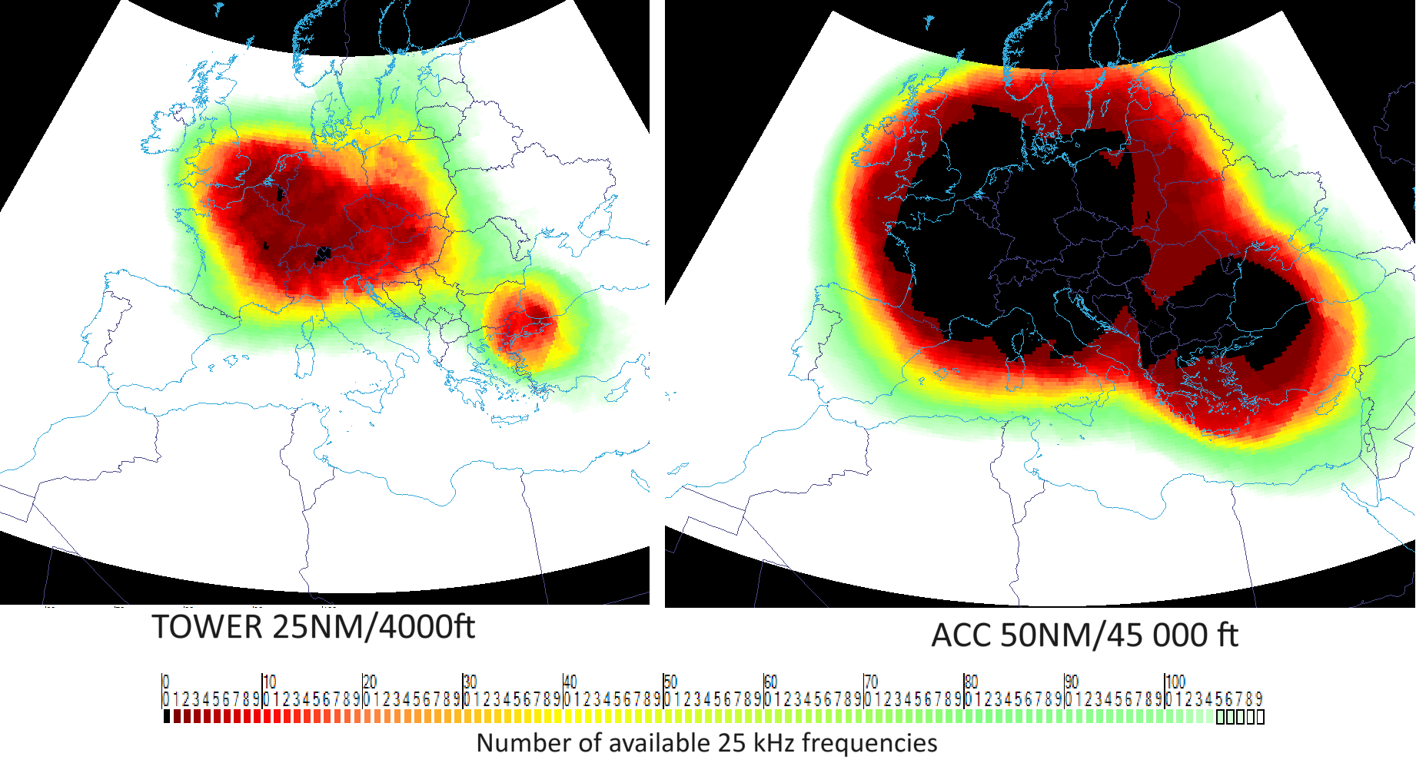
Figure 1: 25kHz Frequency congestion in Europe

    - Black indicates that no channel is immediately available for the service. While it is still possible to allocate a frequency, this requires shifting (i.e. changing) the frequencies of one or more existing assignments. Such adjustments are time-consuming and incur additional costs.
    - It is evident that congestion levels are primarily influenced by the type of service, particularly its height. The higher the altitude of the aircraft, the greater the congestion. Currently, the maximum height of a service volume considered for frequency planning is limited to 45 000 feet.
  - Separation Criteria
    - The geographical separation between facilities operating on the same frequency is determined to ensure that the desired-to-undesired (D/U) signal ratio exceeds 20 dB or by maintaining a separation distance at least equal to the sum of the radio horizons of the associated service volumes. In regions experiencing high congestion, the acceptable D/U ratio may, in some cases, be reduced to 14 dB. Within the ICAO EUR region, the 14 dB ratio is applied exclusively to circular (cylindrical) services.
    - In practice, the sum of the radio horizon distances is widely used globally, as it is typically reached before achieving a 20 dB or even a 14 dB D/U ratio. This approach does not rely on detailed knowledge of ground transmitter power and ensures that the receiver squelch in the desired service is not unintentionally activated by transmissions from the undesired service.
    - In the ICAO EUR region, the separation distance between two services, where one is an area service (polygonal service), is calculated as the sum of the radio horizons of both services, based on their respective maximum heights.
  - Space-based VHF frequency planning considerations
    - This section extrapolates the existing separation criteria to space-based VHF communication.
    - The radio horizon extends beyond the optical horizon due to the refraction of radio waves in the troposphere, which is approximately 8 to 15 km thick. However, for a satellite at an altitude of 600 km, the troposphere’s thickness becomes negligible in comparison. As a result, the satellite’s coverage can be effectively approximated as being limited by the optical horizon rather than the radio horizon.
    - To protect an aircraft operating on the same frequency from satellite VHF transmissions, the sum of the satellite’s optical horizon and the aircraft’s radio horizon can be used as an initial approximation. Furthermore, due to the asymmetry in the link budget, ensuring protection for the aircraft from satellite transmissions inherently protects the satellite from interference caused by aircraft transmissions.
    - For a satellite orbiting 600 km above Earth, the optical horizon extends to approximately 2830 km (1528 NM). Although this altitude has been considered in that paper, an increased altitude would significantly increase that distance.
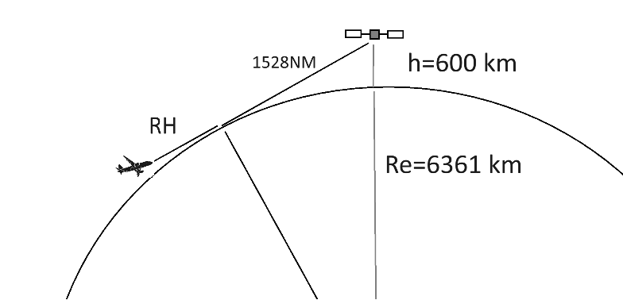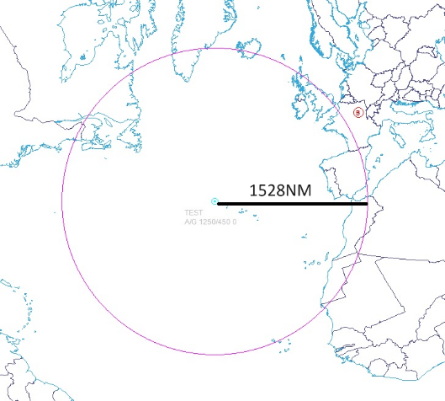
Figure 2: Satellite static footprint and distance separation criteria

    - The downlink budget (from the satellite to the aircraft) for a 0° elevation angle—corresponding to the 1 528 NM horizon distance on the ground—provided in Table 3.2 of the validation document [4], shows a received power of -93.4 dBm. Given that an aircraft receiver’s squelch is activated for signals stronger than a threshold between -101 dBm and -107 dBm, any aircraft located within the combined range of its radio horizon and the satellite’s optical horizon will have its squelch activated whenever the satellite transmits.
    - Because the satellite is in constant motion, its actual footprint depends on its trajectory and the specific times it is transmitting. Consequently, the effective footprint is significantly larger than the static approximation presented above.

Start Tx
End Tx
Satellite trajectory
Real footprint
Figure 3: Satellite real footprint

  - Spectrum efficiency and continental operations
    - The spectrum efficiency, or planning efficiency, of a VHF COM frequency assignment can be defined as the ratio of its Designated Operational Coverage (DOC) to its footprint.
    - In the figure below, the satellite is depicted as being positioned directly above and at the centre of the DOC. In practice, the satellite will transmit at lower elevation angles. However, this representation is intended to facilitate a straightforward comparison of the two different footprints.
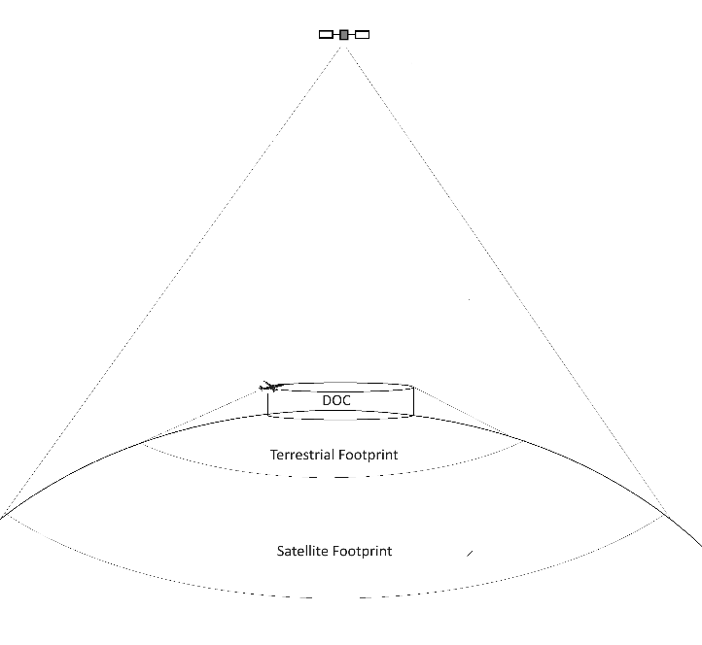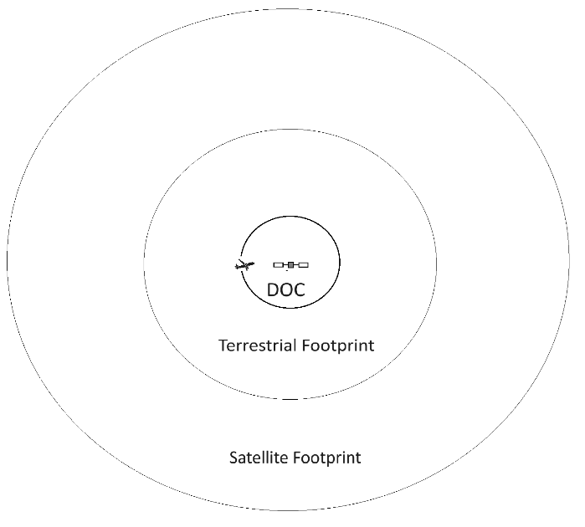
Figure 4: Satellite vs terrestrial footprint

    - The footprint of a terrestrial frequency assignment is determined by the coverage area of aircraft located at the top edge of the Designated Operational Coverage (DOC).
    - Additionally, if 8.33 kHz frequency spacing is considered the baseline, a single 25 kHz assignment will effectively have its footprint tripled. This is because a 25 kHz channel occupies the equivalent spectrum of three 8.33 kHz channels
    - For instance, a Tower frequency assignment is typically represented as a cylinder with a radius of 25 NM and a height of 4000 feet. The area of the DOC projected onto the ground is calculated as ${25}^{2}.π=1963 {NM}^{2}.$ The footprint, however, is determined by the radio horizon of an aircraft at the top edge of the DOC. Using the formula for the radio horizon, it comes $π.(25+1.23\sqrt{4000}))^{2}= 33195 {NM}^{2}$. The spectrum efficiency for this Tower assignment is given by the ratio of coverage to footprint: $1963/33195 ≈ 6\%$ in 8.33 and 2% in 25kHz.
    - By comparison, the minimum footprint of a satellite, as described in the previous section, is $π×15282 = 7334940 {NM}^{2}$. For such a satellite assignment, the spectrum efficiency would be at most: $1963/(3×7334940) ≈ 0.009\%$.
    - A similar analysis can be conducted for larger DOCs, such as those associated with ACC frequency assignments. Considering the current maximum height of 45000 feet, and modelling the ACC service as a cylinder with varying radii, the table below summarizes the spectrum efficiency for 8.33 kHz and 25kHz terrestrial versus 25 kHz satellite systems:
Radius (NM) | Terrestrial efficiency @8.33kHz | Terrestrial efficiency @25kHz | Maximum SB efficiency @25kHz
50 | 2.6% | 0.9% | 0.04%
100 | 7.7% | 2.6% | 0.15%
150 | 13.3% | 4.4% | 0.33%
200 | 18.8% | 6.3% | 0.59%
250 | 23.9% | 8.0% | 0.93%

    - ACC frequency assignments represent some of the largest DOCs in Europe. It is important to highlight that the spectrum efficiency of a satellite-based VHF system will always be significantly lower than that of a terrestrial VHF system for services operating over continental regions.
    - To illustrate this difference, the following map highlights the disparity in footprint size for a large service within the Madrid FIR. While such a terrestrial service would need to operate as a climax system (i.e. ER extended range service with 3 legs in this example) and therefore remain in 25 kHz channel spacing, the difference in impact between the two systems remains substantial.

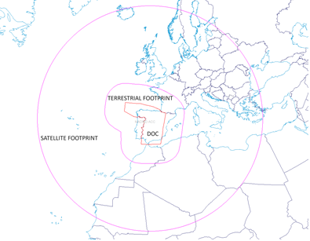
Figure 5: Footprint comparison, a practical case

    - In the ICAO EUR region, there are 698 "standard" 25 kHz channels available for use. When focusing on western Europe specifically, a total of 9,680 services are assigned to these channels, including both 25 kHz and 8.33 kHz assignments. This results in an average of more than 14 services per channel, and there is still capacity for new assignments. In contrast, when considering the footprint of SB-VHF services, it becomes evident that only one satellite service could be assigned per 25 kHz channel in this region.
    - Therefore, SB-VHF services should be avoided over Europe for existing services, as ground-based infrastructure is fully capable of meeting operational needs. In general, SB-VHF could only be considered for use in remote and oceanic areas where terrestrial infrastructure is unavailable or impractical to deploy.
  - The search for satellite VHF frequencies
    - Using the separation criteria outlined in the previous section—the sum of the satellite’s optical horizon and the terrestrial services’ radio horizon—and frequency data from SAFIRE and the ICAO global database, we can now analyse the availability of frequencies at any location where the satellite is transmitting globally.
    - It is important to note that the frequency databases do not include data from the ICAO NAM region (Canada and the USA). This limitation affects the analysis, as it is highly likely that the eastern coast of North America operates a significant number of 25 kHz frequencies. Without this data, the full extent of this analysis cannot be accurately assessed.
    - The analysis is based on a static SB-VHF footprint rather than the real one as explained in section 2.3.6. This approach minimizes the potential congestion that could occur in reality, as the satellite’s footprint constantly changes due to its movement, potentially affecting frequency availability also minimizing the potential congestion around the globe.
    - As outlined in Section 1, frequency availability is depicted using a colour scale, with black indicating areas where no frequencies are available. This visualization highlights regions where satellite access to the VHF COM spectrum could encounter significant challenges.
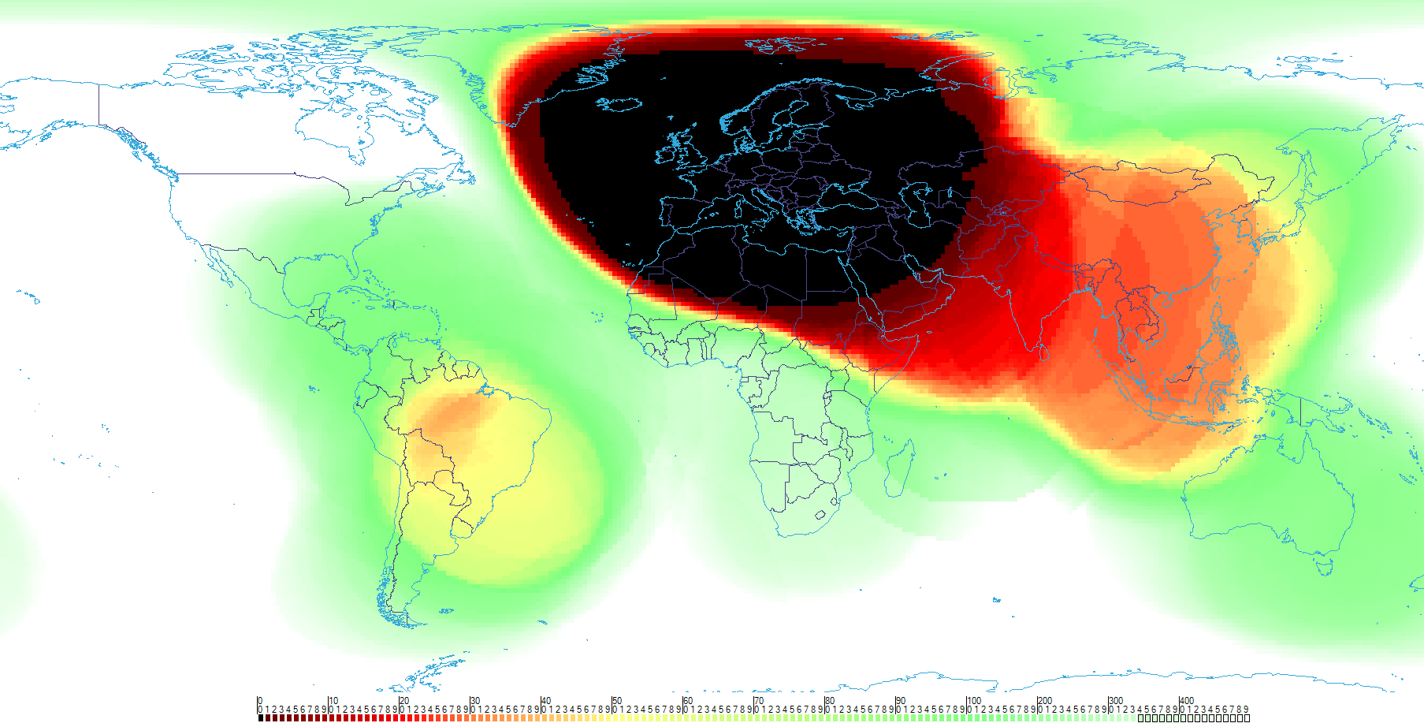
Figure 6: Frequency availability for SB-VHF

    - It can be observed that a satellite operating above most of the ICAO EUR region but also ICAO MID region and a large part of the North Atlantic would not find any frequency directly available.
    - A limited number of frequencies would be available over the APAC region, spanning from Mongolia in the north to Indonesia in the south. This highlights potential spectrum constraints in this area.
    - If data from NAM was available, it is highly probable that the black spot would extend westward, or at least a dark spot would appear on the west side of the Atlantic.
  - Interregional coordination
    - As outlined throughout this paper, the extensive coverage of SB-VHF could have a significant impact across multiple ICAO regions.
    - Consequently, frequency allocation in certain areas will require coordination with regions that were previously isolated from a VHF point of view. For example, assigning a frequency in the North Atlantic will necessitate coordination and data exchange between both Europe and North America.
    - This may represent a fundamental shift in global aviation frequency management, potentially requiring a more integrated worldwide approach for inter-regional frequency assignment coordination.
    - Enhancing these processes may be necessary, and such processes could benefit from ideally being defined in ICAO Annex 10, Volume V, rather than in regional frequency management manuals.
    - This working paper does not propose a solution to this evolving challenge but seeks to initiate a discussion and highlight the need for this group to address this question in the future.
- CONCLUSION
  - This paper provides a preliminary assessment of the potential impact of SB-VHF on the aeronautical VHF spectrum globally, with a particular focus on Europe.
  - While this assessment can be further refined based on the precise planning rules selected, a validated space VHF propagation model, and the real dynamic footprint of SB-VHF and/or detailed satellite characteristics, the overall impact is expected to remain significant. This is due to the nature of VHF planning rules, the high altitude of satellites, and the practical challenges in employing highly directive antennas at VHF frequencies.
  - Specifically, the analysis demonstrates that deploying SB-VHF frequencies in Europe would be highly inefficient compared to the current terrestrial services. Moreover, remote regions such as the Atlantic Ocean or parts of Africa could significantly affect the frequencies used for ATC operations over continental Europe, further exacerbating the challenges.
  - Therefore, the frequency management aspects of SB-VHF must be carefully considered in the ongoing validation assessments to ensure efficient and sustainable spectrum use.
- ACTION BY THE MEETING
  - The meeting is invited to:
- note and review the contents of this working paper;
- consider, the results as initials but
- endorse the methodology to assess SB-VHF spectrum impact
- Initiate a discussion on how SB-VHF frequency coordination could be managed at an inter-regional level.
- REFERENCES

[1] ICAO EUR DOC 11.

[2] ICAO DOC 9718 Volume II

[3] ICAO Annex 10 Volume V.

[4] FSMP-WG19-WP16_SB-VHF SARPs Validation Report.

— END —

