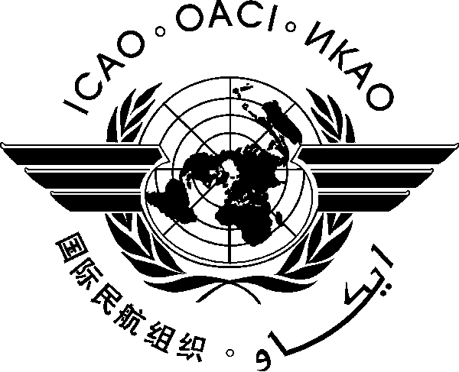

REPORT OF

THE WORKSHOP ON ITU WORLD RADIOCOMMUNICATION CONFERENCE 2027 (WRC-27 WORKSHOP)

Paris, France, 06-07 October 2025

1. Introduction

  - The Workshop on ITU World Radiocommunication Conference 2027 (WRC-27 Workshop) was held in the ICAO EUR/NAT Regional Office, Paris, France from 06 to 07 October 2025. The workshop was organized in conjunction with the following meetings.
- Twenty-Eighth Meeting of the Radio Frequency Function Group (RAFT/28) and Thirty-First Meeting of ICAO Frequency Management Group (FMG/31) (06-10 October 2025)
- Twenty First Working Group Meeting of the Frequency Spectrum Management Panel (Paris, France, 06-17 October 2025)

  - The objective of the workshop was to provide the background and information to States/Administrations in preparing their delegations for the WRC-27, and address other spectrum issues of vital importance to the international aviation community.

2. Opening of the Meeting

2.1 Mr. Andrew Roy, Chairperson of the Frequency Spectrum Management Panel, gave a welcome address to all participants and expressed appreciation to the EUR/NAT ICAO office for hosting the workshop. He highlighted the objective of the workshop and the importance of securing the availability of an adequate frequency spectrum free from harmful interference. He also expressed appreciation to the administrations and international organizations for their active support in promoting and supporting the ICAO WRC-27 position to the ITU. Ms. Mie Utsunomiya, technical officer (TO) CNS, ICAO Headquarters, acted as Secretary, assisted by Mr. Abbas Niknejad, Regional Officer CNS of the ICAO EUR/NAT Office and by Mr. Mohamed Iheb Hamdi, Regional Officer, Aerodromes and Ground Aids & MID Region CNS and Cybersecurity Coordinator.

3. Agenda of the Workshop

3.1 The draft Agenda items of the workshop attached to the letter of invitation were adopted by the workshop without change.

- Introduction
- WRC-27: Agenda items of major concerns for the aviation community and action plans to be implemented at the national and regional levels
- Regional preparations for WRC-27
- Radio Altimeter and 5G issues
- Issue of GNSS Interference
- management in EUR/NAT and MID: current practices and new challenges
- Any other business

4. Organization, Working arrangement, Language and Documentation

4.1 The Group met as a single body. The working language was English inclusive of all documentation and this report.

5. Agenda

5.1 Agenda Item 1: Introduction

5.1.1 Under this agenda, following topics were reviewed and discussed.

Presentation Title | Presenter
ITU/WRC process, results of WRC-23 and Preparation for future WRCs | Secretariat
An overview of all aviation relevant agenda items to be addressed by WRC-27 | Mr. Andrew Roy, ASRI  FSMP chairperson,
ITU Preparatory process towards WRC-27 | Mr. Nikolai Vassiliev, ITU

5.2 Agenda Item 2: WRC-27: Aviation related topics and action plans to be implemented at the national and regional levels

    - The workshop received a number of presentations as follows, on the important WRC-27 agenda items relevant to aviation.

Presentation Title | Presenter
WRC-27 Agenda Item 1.5 – limiting non-GSO | Mr. Christian Fleury, France
WRC-27 Agenda Item 1.7 – IMT/Radio altimeter Radio Altimeter | Mr. Andrew Roy, ASRI
WRC-27 Agenda Item 1.9 – AM(OR)S | Mr. Christian Fleury, France
WRC-27 Agenda Item 1.11 – Space-to-Space links | Mr. Damon Ladson, USA
WRC-27 Agenda Item 1.12 – MSS | Mr. Damon Ladson, USA
WRC-27 Agenda Item 1.13 – Space based IMT | Mr. Abed Ferr, Canada
WRC-27 Agenda Item 1.15 – Lunar communications | Mr. Guillaume Novella, France
WRC-27 Agenda Item 1.16 – Radio Quiet Zones | Mr. Christian Fleury, France
WRC-27 Agenda Item 1.17 – Space Weather Sensors | Mr. Guillaume Novella, France
WRC-27 Agenda Item 1.18 – Unwanted emission above 76 GHz | Mr. Katsuyuki Arakawa, Japan
WRC-27 Agenda Item 4 – Res 676 (WRC-23) | Mr. Laurent Azoulai, ICCAIA
WRC-27 Agenda Item 9.1 – UAS C2 Link | Mr. Guillaume Novella, France
WRC-27 Agenda Item 9.2 – GMDSS | Mr. Damon Ladson, USA
WRC-27 Agenda Item 10 – Future Agenda Items and WRC Planning | Mr. Guillaume Novella, France

5.2.2 Noting serious concerns from different particpants on the progress of WRC-27 Agenda item 1.7 and its relevant ITU-R studies related to the radio altimeter, the States/Administrations were urged to follow ICAO Assembly Resolution A41-7 (which is amended at the 42nd Assembly) to strongly support both the ICAO frequency spectrum strategy and position at WRCs. Specifically the States/Administrations were encouraged to communicate with radio regulatory authorities for ensuring, to the maximum extent possible, that the ICAO position was accounted for in the development of national and regional positions. It has also highly recommended that delegations to regional conferences, ITU study groups and WRCs include experts from their civil aviation authorities and other civil aviation stakeholders who are fully prepared to represent aviation interests.

5.3 Agenda Item 3: Regional preparations for WRC-27

5.3.1 Under this agenda, following topics were reviewed and discussed.

Presentation Title | Presenter
CEPT Conference Preparatory Group (CPG) Preliminary CEPT Positions for WRC-27 | Mr. Jérome ANDRE, ANFR, France
Inter-American Telecommunication Commission (CITEL) | Mr. Damon Ladson, USA
Status of African Telecommunication Union (ATU) preparations for WRC-27 | Ms. Lisa Tele, South Africa
Regional Preparation for WRC-27 Asia/Pacific Region | (Mr. Chainan Chaisompong, Thailand)

  - Agenda Item 4: Radio Altimeter and 5G issues

    - Concerns on the potential interference from 5G to radio altimeter were raised under this agenda and following topics were reviewed and discussed. The workshop was informed that there are several regional and States measures have been implemented.

Presentation Title | Presenter
EU roadmap for safe co-existence between mobile networks (5G) and radio altimeters  - Appendix_EU-Roadmap | Mr. Francisco SALABERT CARDONA (EC-DGMOVE), and  Mr. Hette Hoekema (EASA)
Protection of Radio Altimeter Systems from Potential Interference from 5G C-band Communications Networks | Mr. Faris Alzahrani, General Authority of Civil Aviation (GACA), Saudi Arabia
FSMP EUR-MID workhosp Radio Altimeters | Mr. Andrew Roy, ASRI

  - Agenda Item 5: Issue of GNSS Interference

    - Through the presentation (GNSS Interference), the workshop was informed the increasing number of incidents of observed GNSS interference, globally, and the implications for air navigation safety and security. Serious concerns regarding the impact of GNSS interference on the safety and security of air navigation systems were expressed by the participants of the workshop and States/Administrations were encouraged to monitor the issues and take into account comprehensive and well-coordinated approach to address this pressing issue.

  - Agenda Item 6: The reality of frequency management in EUR and MID: current practices and new challenges

    - Under this agenda item, the following topics were reviewed and discussed.

Presentation Title | Presenter
Frequency Management in the EUR Region | Abbas Niknejad  (ICAO EUR/NAT Office)
Aeronautical frequency management in the MID Region | Mohamed Iheb Hamdi,  (ICAO MID Office)
Relevant ICAO provisions | Mie Utsunomiya (ICAO HQ)

Agenda Item 6: Any other business

6.1 Noting along with the progress of the studies, and that there might be some updates to the ICAO position, it was requested by participants for aviation community to organize an additional remote workshop/waibner in 2027 to understand such updates. The workshop ended with thanks to all participants from Member States/Administrations/Organizations for their contributions and active participation to the workshop and preparation of WRC-27.

_ _ _ _ _ _ _ _ _ _

