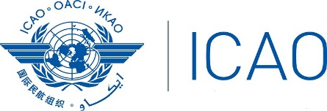

Fifth Meeting of the Africa-Indian Ocean Regional Aviation Safety Group (RASG-AFI/5)
(Accra, Ghana, 29 July – 2 August 2019)

Title …………..

(Presented by……..)

SUMMARY
This working paper presents ……..

Action by the Meeting …...
Strategic Objectives

1 INTRODUCTION

1.1
.

2. DISCUSSION

2.1.
.

3 ACTION BY THE MEETING

3.1 The meeting is invited to …..

