International Civil Aviation Organization

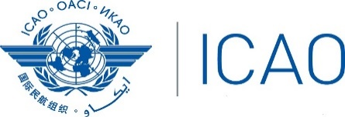

Western and Central African (WACAF) Regional Office

LOSS OF CONTROL IN-FLIGHT (LOC-I) AND UPSET PREVENTION AND RECOVERY TRAINING (UPRT) WORKSHOP
(Lagos, Nigeria, 18 – 19 November, 2019)

REGISTRATION FORM

PLEASE PRINT OR TYPE CLEARLY

1. Name in full: ___________________________________________________________
Mr. / Mrs. / Ms (as should appear in the official listing and name tag)

2. Title or Official Position: ___________________________________________________________

3. State/Organization: ___________________________________________________________

4. Mailing Address: ___________________________________________________________

___________________________________________________________

5. Contact Details:
Telephone Number: ____________________________________________________

Mobile Number: _____________________________________________________

E-mail: _____________________________________________________

6. Hotel ___________________________________________________________

Date: ………….........................……….... Signature…………...............................................……….

After completing, please send to: ICAO WACAF Office at the following e-mail address: icaowacaf@icao.int and copy kjammeh@icao.int.

Note: Participants are expected to make their own hotel/visa arrangements.

