Attachment C

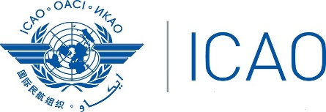 International Civil Aviation Organization
Western and Central Africa Office

Workshop on Regional Contingency Plan Development and Implementation Coordination for Western and Central Africa (Accra, Ghana, from 29 October to 2 November 2018)

Registration Form

First Name (in full): _____________________________________________________________

Family Name (in full): __________________________________________________________

Title: _________________________________________________________________________

Administration/Organization: ______________________________________________________

Address: ______________________________________________________________________

City and Country: ________________________________________________________________

Telephone: ______________________________________________________________________

E-mail: _________________________________________________________________________

Hotel: ___________________________________________________________________

Return to: ICAOWACAF@icao.int
ATaylor@icao.int
amane@icao.int

