Terms of Reference Runway Safety Team of Hamad (OTHH) and Doha (OTBD) International Airports
Runway Safety Team Terms of Reference | ToR Version No: | 2.0
 | ToR Date: | 01 Feb 2022
 | ToR Review Date: | 01 Feb 2023
- Purpose | - Scope of Oversight
- Develop an action plan for runway safety  - Conduct joint incident investigation on operational issues (including runway incursions and excursions, unstable approaches and go-arounds  - Advise management as appropriate on potential runway safety issues  - Recommend strategies for hazard removal and mitigation of residual risk  - Future joint risk assessments to consider impact of environment, procedures, technology and human factors | - Doha International Airport Runway 15/33:  - Fixed Wing and Rotary Wing Operation including training flights  - Hamad International Airport Runway 16L/34R  - Fixed Wing, Rotary Wing Operation on request  - Hamad International Airport Runway 16R/34L  - Fixed Wing, Rotary Wing Operation on request
.
- Frequency of Meeting |  | - Member Organizations
- The Runway Safety Meeting shall be held quarterly. |  | - Aerodrome Operator OTHH and OTBD, represented by HIA-Safety (Chair of the RS Team)  - Air Navigation Service Provider (QCAA-AND, Co-Chair of the RS Team)  - QCAA-AND Safety Unit  - QCAA-AND TWR Operations  - QCAA-AND TWR Representative (OTBD)  - QCAA-AND Training Section  - Rescue and Fire Fighting Service OTHH and OTBD, represented by QCAA-ARFFS  - Aerodrome Engineering and Maintenance  - HIA / DIA - FM (Civil Works & AGL)  - QCAA-FM (Radar, Navigational Aids & Communication).  - Operators at OTHH and OTBD, represented by:  - Qatar Airways  - Qatar Executive Jet  - Amiri Flight  - Qatar Emiri Airforce  - Gulf Helicopters  - Qatar Aeronautical College  - QCAA Aerodrome Standards and Safety Section - participating as an Observer.
- Objectives
 | Identify potential runway safety issues, including the need for establishment of hot spots or other problem areas at OTHH and OTBD aerodrome and the review of the relevant entries of the AIP for accuracy;
 | Develop and run local awareness campaigns, at suitable periods, including at the start of a busy season or before an unusual event, that focus on local issues, for example, producing and distributing local hot spot maps(e.g. impact of construction sites) , or other guidance material such as FOD control as considered necessary;
 | Monitor the number, type and, the severity of runway incursions; disseminate safety recommendations delivered from accident and incident investigation findings as well as other relevant lessons learned e.g. from operational experience and best risk mitigation practices; share good practices to prevent runway incursions or excursions;
 | Assist in verifying that communications between air traffic controllers, or other Air Traffic Services personnel, pilots, and vehicle drivers are satisfactory, or if any improvements could be suggested;
 | Make observations on a regular basis in different weather and light conditions to assess whether all runway entrances and visual aids are adequate, correctly located and understandable by all parties concerned, with no possible ambiguity of their meaning, or identify potential aerodrome design issues;
 | Understand the operating difficulties of personnel working in other areas, and recommend areas for improvement;
 | Review joint assessments on procedures on a regular basis to ensure that the procedures employed by different companies at the aerodrome are integrated and effective, so as to minimize the risk of runway incursions;
 | Develop of joint, initial and recurrent, training programs and familiarization on runway incursion and excursion prevention, for all relevant personnel (vehicle drivers and other personnel operating on the maneuvering area, pilots, Air Traffic Services personnel) ;
 | Provide advice prior to the implementation of changes to the aerodrome, practices and procedures to identify potential for runway incursion or excursion;
 | Assess the effectiveness of implemented operational solutions periodically;
 | Periodically review compliance related safety cases, aerodrome certificate alternative means of compliance and deviations.

- Standing Agenda Items | - Inputs |  | - Outputs
1. Welcome  2. Minutes of Previous Meeting  3. Data Sharing  4. Previous Business  5. New Business  6. Action Log  7. Any Other Business  8. Date for next meeting  Possible visit to member locations or to the maneuvering areas of OTHH and OTBD (as deemed necessary) | 1. Minutes from previous meetings  2. Safety Data  3. Action Plans and Updates  4. Aerodrome Input, Experiences and Initiatives  5. Air Operators Input, Experiences and Initiatives  6. Regulatory and guidance documentation  7. Best practice documentation |  | 1. Minutes  2. Recommendations  3. Date, time and venue for next meeting
- Ground Rules
1. All actions to be completed on time and in full;
2. Minutes of the meetings to be completed and distributed within one week;
3. Agenda items to be submitted at least 1 week in advance of the meetings;
4. Any relevant paperwork on major topics circulated at least one week before the meeting;
5. Meetings to start and finish on schedule.
- Chairman position is held by: |  | - Co-Chairman position is held by:
- Stefan Ivanov- Manager Aviation Safety, Compliance & Proficiency, MATAR  - Aimilia Kalomoirou – MATAR Manager Airfield Operations, MATAR  - Haseeb Koonarithoombath – Aerodrome Standards Compliance Specialist, MATAR |  | - Nasser Al-Khalaf - Head of Air Traffic Operations, QCAA  - Franz Sammueller- TWR-AMS Advisor, QCAA
- Role of Co-Chairman
- Support the Chairman in above mentioned roles
- To act in place of the Chairman if he is unable to plan, facilitate, etc.

- Consultation, Decision Making and Conflict Resolution Process | - Governance and Protection of Safety Data, Safety Reports and Safety Information | - Documentation and Reporting Requirements
- Discussion  - Assessment  - Proposal to Management (each member)  - Coordination  - Resolution with blessing of Management | - List of signed Non-Disclosure Agreements (NDAs) Not yet applicable  - House Rule: Anyone who comes to the meeting is free to use information from the discussion, but is not allowed to reveal who made any comment. It is designed to increase openness of discussion. | Updates on the following occurrence categories at each meeting by concerned member:  - Abnormal Runway Contact  - Bird Strike  - Ground Collision  - Ground Handling  - Runway Excursion  - Runway Incursion  - Loss of Control on Ground  - Collision with Obstacles  - Undershoot/Overshot
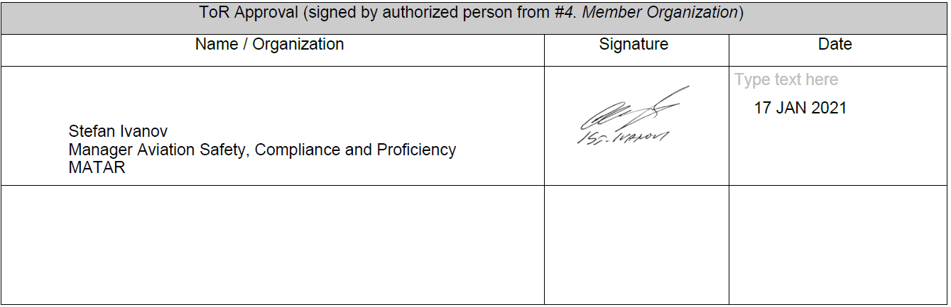

ToR Approval (signed by authorized person from Member Organization)
Name / Organization | Signature | Date

