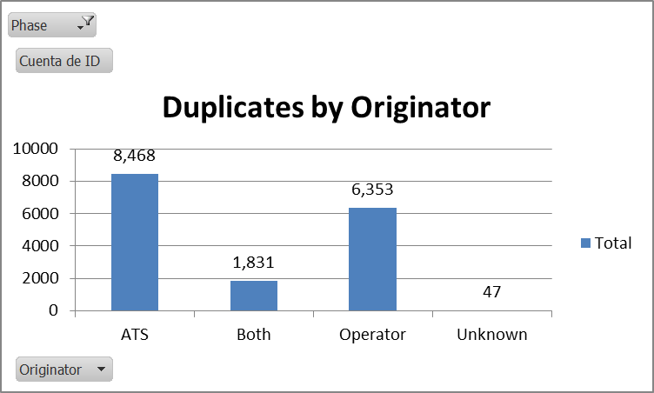

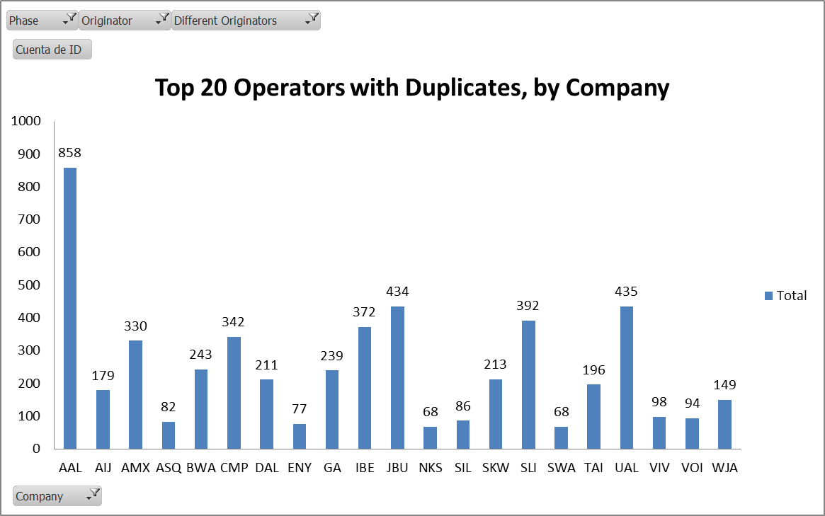
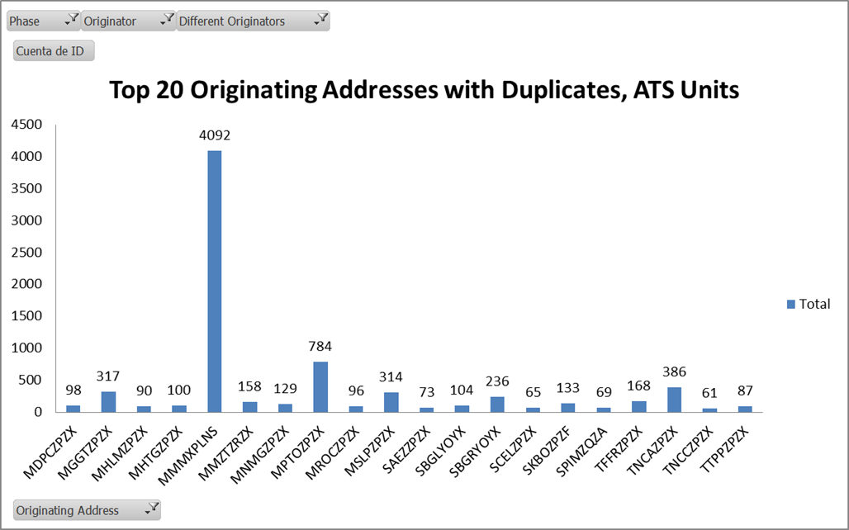

Address (Operator) | Total
CYKFNSSW | 5
CYYCMPEX | 1
CYYZWJAO | 1
CYYZXNST | 8
CYYZXXSK | 1
EDDFAEAX | 4
EDDFCFGO | 10
EDDFDLHD | 1
EDDFGECO | 1
EDDFNAXX | 1
EDDFQTRX | 2
EDDVTUIO | 15
EGCCMYTX | 6
EGKKVIRW | 8
EGLFGMAX | 6
EGLLBAWC | 3
EGLLBAWH | 7
EHAMKLMF | 9
EHAMMPHO | 1
ELLXCLXO | 3
FAORZPZX | 1
GOOYFDPA | 1
KABQASHD | 2
KAUSZXBT | 1
KBEZYYXX | 5
KBWIXAAE | 1
KCBEXAAK | 1
KCHIUALS | 1
KCMHEJAA | 12
KDENFFTD | 1
KDENXLDB | 1
KDENXLOS | 1
KFATAAYD | 12
KGSODYAD | 1
KHOUARCW | 5
KHOUITPX | 1
KHOUXBOO | 2
KJFKBUD | 4
KJFKGTIW | 6
KKAPYYXX | 1
KLAXPCXX | 3
KLINABXD | 1
KMEMFDXB | 2
KMEMFDXD | 2
KMIASGHO | 1
KMOWNWSX | 1
KMXONOSP | 1
KNPAXAAF | 3
KOENXLQS | 1
KSDFUPDL | 1
KSDFUPSI | 5
KSDFUPSY | 3
KSEAASAB | 14
KSFOVRDX | 8
KSNAXGSX | 5
KSRQXAAD | 1
KSTLGJSO | 1
KYIPCKSH | 1
LEPAEVEX | 1
LFBOAFMI | 11
LFPGAFRW | 6
LFPOCAJX | 1
LIRFBPAO | 4
LSGGDGXX | 1
LSZHSWRW | 1
LTBATHYW | 3
MMCZXMXO | 3
MMMDXMXO | 5
MMMXSVIX | 2
MMMXTAOX | 14
MMMXXMXO | 1
MMMYSLIX | 2
MMSPESFO | 1
MMTOXMEA | 7
MMUNXMXO | 12
MMVRXMXO | 1
MPTOZPZX | 1
RKSSKALO | 8
SAEZARGO | 2
SBSPAZUW | 2
SBSPTAMO | 12
SCELLANW | 6
SKBOZPZX | 1
SYCJZPSD | 2
TBPBZPZX | 2
TFFRZPZX | 1
TGPYATOM | 5
TTPPSELX | 5
UWLWIEPN | 4
VHHHCPAO | 6
YSSYQFAA | 1
ZBAAUDXX | 5
Total general | 346

Address (ATS Unit) | Total
CZQXZQZX | 1
EGWUYWYO | 2
FAORZPZX | 5
FNLUZPZX | 2
GOOOZIZX | 1
KANDYFYX | 3
KBDRYFYX | 2
KBTVYFYX | 2
KCXOYFYX | 3
KDCAYFYX | 2
KDCMYYYX | 1
KDENYFYX | 1
KFTWYFYX | 5
KGNVYFYX | 1
KHHRYFYX | 3
KIPTYFYX | 1
KISPYFYX | 1
KMCNYFYX | 2
KMIVYFYX | 1
KPIEYFYX | 3
KPRCYFYX | 3
KRCHYXYX | 13
KRNOYFYX | 2
KZCRZQZX | 2
KZCZZQZX | 2
KZMAZPZX | 1
LETOZPZX | 2
LTBDZPZX | 1
MBPVZTZX | 14
MDCSZQZX | 1
MDLRZPZX | 1
MDSTZPZX | 10
MGGTZQZX | 2
MHLCZPZX | 2
MHROZPZX | 8
MKJKZQZX | 1
MKJPYOYX | 10
MMEXZRZX | 9
MMTPZTZX | 6
MMTYZRZX | 6
MNMGZTZX | 1
MPDAZPZX | 2
MPZLZQZX | 6
MRLBZPZX | 12
MSLPZQZX | 1
MTEGZQZX | 5
MUFHZQZX | 1
MUFHZRZX | 1
MUGMYXYX | 4
MUSCZPZX | 2
MUVRZPZX | 2
MWCRYOYX | 3
MYNNYFYX | 2
SBBEYOYX | 2
SBEGYOYX | 3
SBELYOYX | 1
SBORYOYX | 1
SCDAZPZX | 1
SEFGZQZX | 8
SEGUZPZX | 15
SKBGZPZF | 1
SKBOZPZX | 5
SKBPYOYX | 1
SKBQZPZF | 1
SKBQZPZX | 3
SKBZZPZF | 1
SKCGZPZF | 1
SKCLZPZF | 5
SKEDZQZX | 1
SKRGZPZF | 13
SKRGZPZX | 1
SKSPZPZX | 1
SLVRZPZX | 9
SMJPYFYX | 1
SMJPZFZX | 3
SPIMZQZX | 1
SUMUZPZX | 1
SVBCZPZX | 3
SVCSYFYB | 1
SVCSZPZX | 7
SVCSZTZX | 1
SVJCZPZX | 4
SVJCZTZX | 1
SVJPZPZX | 1
SVMCYFYA | 1
SVMCZPZX | 5
SVMGYFYX | 1
SVMGZPZX | 3
SVMIYFYX | 4
SVMIZTZX | 1
SVMTZPZX | 1
SVVAZPZX | 8
SYCJYAYX | 1
SYCJZPSD | 1
SYGCZQZX | 3
SYGOYMYX | 1
SYGOZTZX | 4
SYSCZPZS | 1
TAPAZPZX | 10
TDCFZPZX | 1
TDPDZPZX | 2
TFFFZTZX | 1
TFFGZPZX | 3
TFFJZPZX | 4
TGPYZPZX | 1
TKPKZPZX | 3
TLPCZPZX | 2
TLPLZPZX | 5
TNCAZTZX | 1
TNCBZPZF | 1
TNCBZPZX | 9
TNCFZQZA | 1
TNCFZQZX | 14
TQPFZTZX | 11
TRPGZPZX | 1
TTPPZQZX | 1
TTZPZQZX | 5
TUPJZTZX | 8
ZSSSZPZX | 7
Total general | 404

