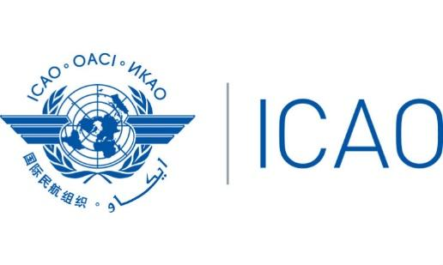
International Civil Aviation Organization
South American Office

Fifty-Sixth Pan America — Regional Aviation Safety Team Meeting
(PA-RAST/56)
Miami, Florida, United States – 23 al 25 August 2022

REGISTRATION FORM

1. | Position in your Delegation:  (Please select one option) sale | Chief Delegate |  |  |  | Delegate
 |  | Adviser |  |  |  | Observer
2. | Country / Organization
4. | Name
5. | Official Position or Title
6. | Official Telephone
7. | Mobile (to contact you in case of an emergency)
8. | Official E-mail
13. | Emergency contact information in your country of origin |  | Name
 |  |  | Relationship
 |  |  | Telephone

Please send this form to:
E-mail: icaosam@icao.int

