Common Acronyms  “ANS/ATS Safety Inspector Workshop” |  |  | 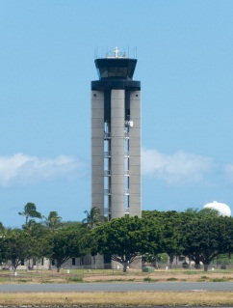

ANS | Air Navigation Services
ANSP | Air Navigation Service Provider
AOV | FAA Air Traffic Safety Oversight Service
ATC | Air Traffic Control
ATCS | FAA Air Traffic Control Specialist
ATO | FAA Air Traffic Organization
ATS | Air Traffic Service(s)
ATSI | FAA Air Traffic Safety Inspector
ATSS | FAA Airway Transportation Systems Specialist (ATSEP – maintenance technician)
CFIT | Controlled Flight Into Terrain
FAA | U.S. Federal Aviation Administration
FAA Order | Orders establish policy, delegate authority, and assign responsibility in specified areas. Orders are usually applicable to all FAA employees and contractors.
FARs | U.S. Federal Aviation Regulations  (contained in Title 14, Aeronautics and Space, of the U.S. Code of Federal Regulations)
ICAO | International Civil Aviation Organization
MOC | Measure of Compliance
NAS | U.S. National Airspace System
OE | Operational Error (airprox)
PQ | Protocol Question, used during ICAO USOAP audits
RAE | Risk Analysis Event
RAV | Risk Analysis Valuation
RI | Runway Incursion
SMS | Safety Management System
SOP | Standard Operating Procedure
SRM | Safety Risk Management
SRMD | FAA Safety Risk Management Document (also known as a “safety case”, or “safety assessment”)
USOAP | ICAO Universal Safety Oversight Audit Program

