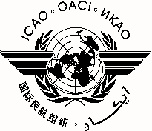 |  | RASG-PA/7
 | International Civil Aviation Organization
 | North American, Central American and Caribbean Office (NACC)
 | Seventh Regional Aviation Safety Group — Pan America Annual Plenary
 | (RASG-PA/7)
 | Willemstad, Curaçao, 11 – 12 September 2014

REGISTRATION FORM

1. | Name
2. | Position
3. | Organization
4. | Country
5. | Telephone
6. | E-mail

Please send this form to:
E-mail: icaonacc@icao.int

Note:

For the Fifth Pan American Aviation Safety Summit, two (2) complementary registrations per State are available. The registration for the Summit is at the following link: http://www.alta.aero/safety/2014/registration.php.

