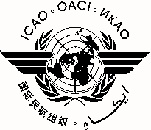 |  | MEVA III TF/3
 | International Civil Aviation Organization
 | North American, Central American and Caribbean Office (NACC)
 | Third MEVA III Task Force Meeting
 | (MEVA III TF/3)
 | Mexico City, Mexico, 23 to 26 September 2014

REGISTRATION FORM

1. | Name
2. | Position
3. | Organization
4. | Country
5. | Telephone
6. | E-mail

Please send this form to:
E-mail: icaonacc@icao.int

