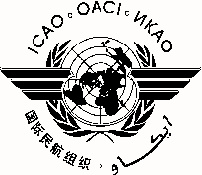
International Civil Aviation Organization
North American, Central American and Caribbean Office (NACC)
Aerodrome Inspectors Workshop - GREPECAS Project F1 CAR Activity
Port-of-Spain, Trinidad and Tobago, 9 to 13 June 2014

REGISTRATION FORM

1. | Name
2. | Position
3. | Organization
4. | Country
5. | Telephone
6. | E-mail

Please send this form to:
E-mail: icaonacc@icao.int

