In order to participate as an exhibitor and/or sponsor, please complete pages 1-5.

- Company Information

Company Name
Industry Sector(s)
Contact Person | Salutation Mr. Mrs. Ms. Dr.
First Name
Last Name
Title
Address
City |  | Province/State
Postal / Zip Code |  | Country
Tel No. |  | Fax No.
Email Address

Important Information

- ICAO’s criteria for the selection of a sponsor or exhibitors will depend on the region and industry sector, meeting and addressing the Strategic Objectives and/or the No Country Left Behind (NCLB) campaign;
- The Workshops may not be commercially oriented;
- The Workshops must be verified and approved by ICAO;
- The use of the ICAO brand/logo is strictly prohibited without formal approval;
- Company’s representatives and staff may not enter into the Assembly Hall area during the 39th Assembly (September 27 – October 5), however they may engage in network activities within the “Workshop Zone”.

Please note that all companies interested must be approved by the Office of the Secretary General.

- Exhibition Fees
Indicate below the size of the exhibition space and the booth number which has been assigned to you via email from your event Project Manager. To see a list of exhibition services included with your rental, please see Appendix B. To view the exhibition floor plan and booth spaces, please see Appendix C (IWAF/2 only) and Appendix D (A39).
Exhibition opportunities

Exhibition booths (1-52) are only available on September 26.

Dates | Event | Booths | Dimensions | Indicate your booth No. number below | Selection | Cost
26 September | IWAF/2 Only | See Appendix C | -- |  |  | $3,500
26 - 27 September | IWAF/2 and A39 | 26 Sept.: See Appendix C  27 Sept.: See Appendix D | 8’ x 8’ |  |  | $10,000
28 -30 September | A39 | See Appendix D | 8’ x 8’ |  |  | $10,000
3 - 5 October | A39 | See Appendix D | 8’ x 8’ |  |  | $10,000

3. Exhibition Requirements

Please note that for this special event, all booth spaces will include a modular booth, facia and choice of furniture. Any additional requirements must be ordered through the official supplier and at additional costs.
4. Workshops (Very limited availability)

A 30-minute presentation (including Q&A period) on a subject related to ICAO Strategic Objectives and/or the No Country Left Behind campaign, to be held during the A39.

Sponsorships and Workshops will be allocated based on meeting selection criteria and approval of the Office of the Secretary General. Only exhibitors and/or sponsors can reserve a Workshop. See the table above for the available dates. Please select the same dates as the ones that are selected for the exhibition.

Workshops
A 30 minute presentation on a subject related to ICAO Strategic Objectives and/or
the No Country Left Behind (NCLB) campaign

Dates | * Time | Select | Fee
September 27 | TBD |  | $5,000
Between September 28 to September 30 | TBD |  | $5,000
Between October 3 to October 5 | TBD |  | $5,000
* Your ICAO Project Manager will assign your company a time slot.

5. Sponsorship Fees – Hospitality Events
To see a list of sponsorship privileges, please see Appendix A.

Exhibition at IWAF2 & Day 1 of A39
26 – 27 September 2016
On the evening of September 26, exhibitors/sponsors will be re-located in the “Workshop Zone”.
Please note that the ICAO 39th Assembly (A39) is a non-commercial environment (September 27 – October 5).

Event No. | Sponsorships | Hospitality Event | Booth Included | Selection | Day | Time | Cost
1 | Platinum | Cocktail Reception  This sponsorship package includes a booth space at the IWAF/2 event and Day 1 of A39 | ✓ |  | Sunday, September 25th | 18:00 20:00 | $25,500
2 | Platinum | Cocktail Reception  This sponsorship package includes a booth space at the IWAF/2 event and Day 1 of A39 | ✓ |  | Monday, September 26th | 18:00 20:00 | $29,500
3 | Gold | Lunch  This sponsorship package includes a booth space at the IWAF/2 event and Day 1 of A39 | ✓ |  | Monday, September 26th | 12:30 14:00 | $25,500
4 | Silver | Continental Breakfast  (IWAF/2 only) | Not included |  | Monday, September 26th | 7:00 8:30 | $8,500
5 | Bronze | Coffee Break  (IWAF/2 only) | Not Included |  | Monday,  September 26th | 10:30 11:00 | $6,000
6 | Bronze | Coffee Break  (IWAF/2 only) | Not Included |  | Monday, September 26th | 15:15 15:45 | $6,000

*Times are subject to change.

Promotional Offers (IWAF/2 only) |  | Fee
Lanyard (ICAO & Customer Logo) |  | Contact us
USB Key (ICAO & Customer Logo) |  | Contact us
Gift or personalised promotional item (ICAO & Customer Logo) |  | Contact us

Requirements for payment
Payments must be made prior to the event and will be due upon receipt of the invoice. Methods of payment are: cheque, bank transfer or major credit card. If payment is not received within fourteen (14) days, ICAO may not guarantee the customer’s first choice for the booth number or the sponsorship slot.

Note: Hospitality events will take place in the exhibition area (See Appendix C & D). ICAO will make arrangements to cater and pay for the hospitality events with recommended local caterers.

Total Fee

6. Program Directory
A logo, description of your company’s products/services and contact information will be included in the Program. Please complete the form below and send it by email to MCR@icao.int.

Corporate Logo
Please send us via email your company corporate logo. The resolution must be at least 300 dpi in one of the following formats:
(1) .ai;
(2) .eps.

7. Contact Information and Description
Please complete the table below. All the fields are mandatory and the company description, products or services cannot exceed more than 100 words.

Company Name
Salutation | Mr. Mrs. Ms. Dr.
First Name
Last Name
Email Address
Website Address
Company Description
(Max 100 words)

8. Invoicing and Payment
Upon receipt of the duly completed form, ICAO will remit an invoice for the event Sponsorship/Exhibition fee; which will be sent by e-mail in a pdf format and the original will be mailed to the sponsor/exhibitor.

Please select one of the following payments below. We prefer payment by credit card.

 | Bank Transfer |  | Cheque
 | Visa |  | Master Card |  | American Express

For payment by major credit cards, please provide your credit card details below.

Card Number |  | Expiry Date
Card holder Number
Signature

9. Promotional Material
Exhibitors are prohibited from placing flyers, pamphlets, brochures and other promotional items (i.e. Pens, USB sticks, mugs, memo pads, etc.) on tables or stands other than their own. These tables or stands are reserved for ICAO. Exhibitors may use their assigned tables to display their collateral materials.

Promotional materials must not promote military applications or make reference to the Republic of Taiwan.

10. Transportation and Customs Clearance
ICAO will not be responsible for any transportation and customs clearance of the exhibit’s material.

Please, ensure that box 5 (Purchase’s name and address) of the Canada customs clearance form is completed by your company of shipping/transportation.

To view the Canada customs invoices form : http://www.cbsa-asfc.gc.ca/publications/forms-formulaires/ci1.pdf.

11. Cancellation Policy
This form may be cancelled by the form signatory, with no penalty, within seven calendar days of receiving the confirmation receipt of the form from ICAO. If the request for cancellation is received by ICAO later than seven, but within 15 calendar days of receiving the confirmation, the sponsor/exhibitor must pay, as a penalty charge, 25% of the applicable fee. Cancellations made after this 15-day period will be subject to a penalty charge of 50% of the fee. If the cancellation is, however, made during the 14 calendar days prior to the opening date of the event, the penalty will be 100% of the fee.

12. Acceptance
The undersigned hereby certifies that the terms and conditions set forth in this form to sponsor and/or to exhibit at the IWAF/2 and/or the 39th Assembly, to be held in ICAO Headquarters, 26 September – October 5th 2016.

Signature: _______________________________________________ Date:

13. Return the form
Confirmation of the allocated exhibition spaces(s) (if applicable) will be guaranteed by return of this duly completed and signed form and payment of the fee. Please return the form by email (scan or pdf format) to MCR@icao.int.

Appendix A - Sponsorship Privileges
The table below shows the privileges for each type of sponsorship.

Privileges | Sponsorship
 | Platinum | Gold | Silver | Bronze | Delegate Bag
Complimentary prime location single exhibition space) at IWAF/2 (1,2 and 13-16) and Day 1 of A39 (#1 – 3) | ✓
ONLY FOR IWAF/2
Sponsor's logo and hyper link on the ICAO event website | ✓ | ✓ | ✓
Up to three single sheets of printed promotional material  (8½×11 inch or A4) inserted into the delegate bags or folder | ✓ | ✓ | 1 sheet |  | ✓
Recognition by the event moderator during the opening and closing ceremonies | ✓ | ✓ | ✓ | ✓ | ✓
Prime visibility in the Program of the  sponsor’s name, logo and company’s products/services | ✓ | ✓ | ✓ | ✓ | ✓
Display of sponsor's logo in the venue areas | ✓ | ✓ | ✓ | ✓
Sponsor’s name and logo on the Event auditorium screen | ✓ | ✓ | ✓ | ✓ | ✓
Invitation to the hospitality event with sponsor name and logo on the Event auditorium screen | ✓ | ✓ | ✓ | ✓
Display of sponsor’s logo during the event being sponsored | ✓ | ✓ | ✓ | ✓
Free delegate or exhibitor passes and folder or delegate bag.  Please note that only 2 exhibitor passes will be issued for day 1 of A39. | 6* | 4* | 3* | 2* | 2*

Appendix B – Exhibitors Services
Services | Included | Not Included | Comments
At ICAO
Carpeting the Event exhibition space(s) | ✓ |  | Exhibition areas are carpeted. The ICAO building is air conditioned.
Electricity supply (one outlet per single space) with an extension cable and a multi-socket power bar | ✓ |  | 110V for a maximum of 15 ampere.
Unlimited wireless Internet connection | ✓
24-hour security of public areas | ✓ |  | Special security measures will be in place. ICAO is not, however, responsible for any loss or damage of property in the exhibition areas.
Exhibitor’s logo, contact, URL and description of the company’s products/services in the program directory | ✓
Free delegate or exhibitor passes and folder or delegate bag | ✓ |  | Two free pass each single Event exhibition space. Only applicable for IWAF/2.  Note for the Assembly 39th Session: only Workshop Zone passes will be issued.
Invitation to sponsored, coffee breaks, lunches and cocktail receptions | ✓ |  | Only for exhibitors holding delegate or exhibitor passes.
Daily cleaning of public areas | ✓
Official Service Providers Appointed by ICAO
Materials handling, advance warehouse storage, rental of extra furniture, chairs, tables, graphic banners, electrical accessories, transformers |  | ✓ | Should be arranged through the ICAO appointed official exhibition services provider.
Transportation and customs services |  | ✓ | Should be arranged through the ICAO appointed official customs broker.
Audio visual equipment, laptops, TV, DVD players, |  | ✓ | Should be arranged through the ICAO appointed official audio visual supplier.
Exhibition Booth Construction
Exhibition booth that are 4’x6’, 4’x8’,6’x8’ or 8’x8’ | ✓ |  | Must use the services of GES (Official service provider) for any additional requirements.

Appendix C – Floor plan IWAF/2 Only – 26 September 2016

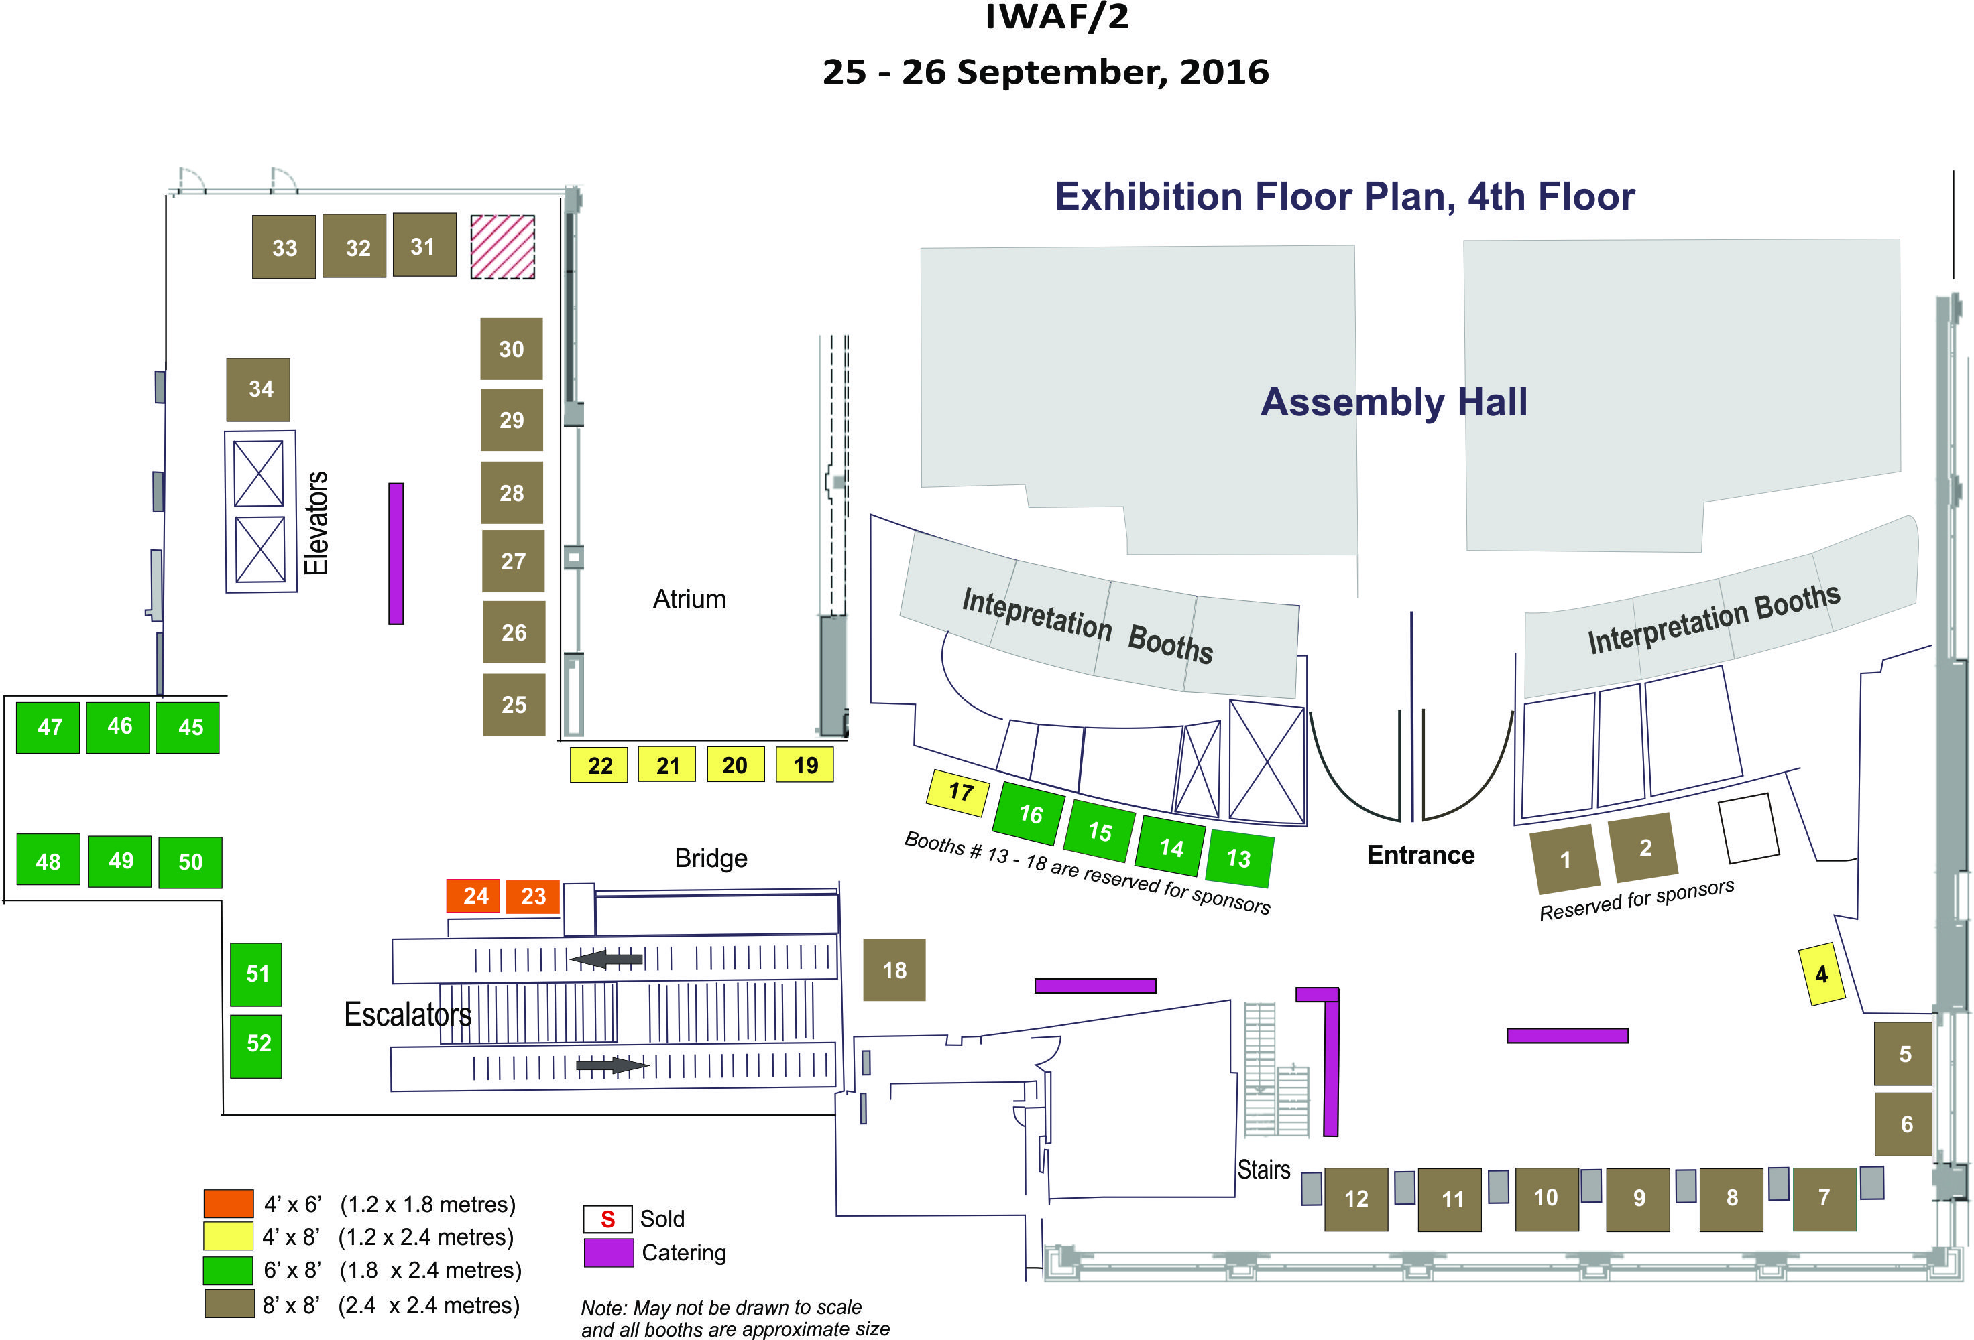

Appendix D – Floor plan A39 – 27 September to 5 October 2016

