To participate as an exhibitor at this event, please complete pages 1-3

- Confirmation: Confirmation of the exhibitor agreement will be guaranteed by return of this duly completed and signed agreement and payment of the total cost.

Company Name
Contact Person | Salutation Mr. Mrs. Ms. Dr.
First Name
Last Name
Title
Address
City |  | Province
Postal / Zip Code |  | Country
Tel No. |  | Fax No.
Email Address

- Booking an Exhibition Space

Please select your choice for the exhibition space and the booth number.
To view a list of the exhibition floor plan and booth space, please see Appendix A

 | Booth No | Dimensions in Metres | Selection | Booth Space Number | Cost  USD
 | 5,7,9 | 3.4 X 2.6 |  |  | $3,750
 | 1,2,3,4,6,8 | 4.5 X 2.6 |  |  | $4,950
Note: The price above are for booth rental only.

Promotion Material Distribution | Cost
Confirmation has been received from ICAO for one single sheet of printed promotional material ( 8.5” x 11” or A4 ) to be inserted into the promotion bag. | $1,500

Total Cost (Exhibitor Booth & Promotion Material)

- Exhibition Construction

A company renting a booth space may construct their own booth (ie. Pop-Up Banner, Table, Chairs, Bar Stools, Magazine Stand, Laptops, LED screen, etc) but must follow the rules as outlined by the City Conference Centre, Stockholm.
Please see link: http://www.stoccc.se/wp-content/uploads/2015/06/rules-for-exhibitions.pdf

If you wish for a contractor to build your booth, please contact Kostas Grintzos at kostas@cityexpo.se
Or visit: http://www.cityexpo.se/EN/Services.htm

.

- Program Directory
A logo, description of your company’s products/services and contact information will be included in the Symposium Directory. Please complete this form and email to Mr. Harvey Wong, hwong@icao.int

Corporate Logo
Please send us via email your company corporate logo. The resolution must be at least 300 dpi in one of the following formats:
(1) .jpg;
(2) .tif; or
(3) .bmp
(4) .eps

Contact Information and Description
Please complete the table below. All the fields are mandatory and the company description, products or services cannot exceed more the 100 words.

Company Name
Salutation | Mr. Mrs. Ms. Dr.
First Name
Last Name
Email Address
Website Address
Company Description
Max 100 words

- Invoicing and Payment
Following receipt of the duly completed Exhibitor Agreement, ICAO will prepare an invoice for the Symposium exhibition fee.
A copy of the invoice will be sent by e-mail in a pdf format and the original will be posted to the sponsor/exhibitor.
Payment will be due within 14 days of receipt of the invoice and can be made by bank transfer, cheque or credit card as indicated below. Please select one of the following payments below. We prefer payment by credit card.

 | Bank Transfer |  | Cheque
 | American Express |  | Master Card |  | Visa

For payment with major credit cards, please provide your credit card details below.

Card Number |  | Expiry Date
Card Holder Number
Signature

- Promotional Material
Exhibitors are prohibited from placing flyers, pamphlets, brochures and other promotional items on tables or stands other than their own stand. Promotional materials must not promote military applications or make reference to the Republic of Taiwan

- Cancellation Policy
This Exhibitor Agreement may be cancelled by the Agreement signatory, with no penalty, within seven calendar days of receiving the confirmation receipt of the Agreement from ICAO. If the request for cancellation is received by ICAO later than seven, but within 15 calendar days of receiving the confirmation, the exhibitor must pay, as a penalty charge, 25% of the applicable fee. Cancellations made after this 15-day period will be subject to a penalty charge of 50% of the fee. If the cancellation is, however, made during the 14 calendar days prior to the opening date of the event, the penalty will be 100% of the fee.

- Acceptance
The undersigned hereby certifies that the information set forth in this exhibitor agreement is accurate and agrees with the above cancellation policy and promotional material policy.

Signature: _______________________________________________ Date:

- Return the Agreement
Confirmation of the allocated exhibition spaces(s) will be guaranteed by return of this duly completed and signed exhibitor agreement and payment of the fee.
Please return the agreement by email (scan or pdf format) to Harvey Wong, hwong@icao.int

Appendix A: Exhibition Floor Plan – Pillar Hall – First Floor
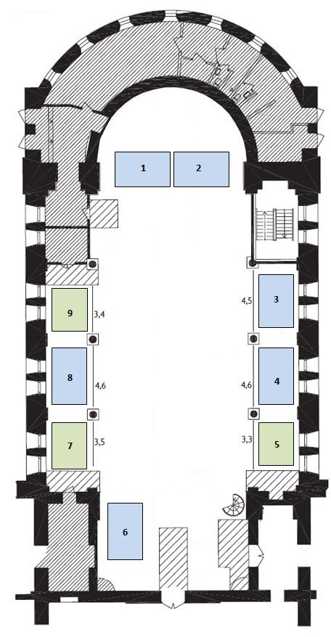

Note: May not be drawn to scale. All booths are approximate size
4.6m X 2.6m
3.4m X 2.6m

