To participate as an exhibitor at an ICAO Event, please complete pages 1-3

- Confirmation: Confirmation of the sponsorship agreement will be guaranteed by return of this duly completed and signed agreement and payment of the total fee.

Company Name
Contact Person | Salutation Mr. Mrs. Ms. Dr.
First Name
Last Name
Title
Address
City |  | Province/State
Postal / Zip Code |  | Country
Tel No. |  | Fax No.
Email Address

- Sponsorship Fees – Hospitality Events See Sponsorship Privileges Appendix A.

Event No. | Select Event No. | Sponsor Category | Hospitality Event | Day | Approximate Time * | Fee in $USD
1 |  | Platinum | Welcome Reception | Monday | 17:30 – 19:30 | $29,900
2 |  | Platinum | Cocktail Reception | Tuesday | 17:30 – 19:30 | $29,900
3 |  | Gold | Lunch | Monday | 12:30 – 14:00 | $18,500
4 |  | Gold | Lunch | Tuesday | 12:30 – 14:00 | $18,500
5 |  | Gold | Lunch | Wednesday | 12:30 – 14:00 | $18,500
6 |  | Bronze | Coffee/Refreshments | Monday | 10:30 – 11:00 | $4,500
7 |  | Bronze | Coffee/Refreshments | Monday | 15:15 – 15:45 | $4,500
8 |  | Bronze | Coffee/Refreshments | Tuesday | 10:30 – 11:00 | $4,500
9 |  | Bronze | Coffee/Refreshments | Tuesday | 15:15 – 15:45 | $4,500
10 |  | Bronze | Coffee/Refreshments | Wednesday | 10:30 – 11:00 | $4,500
11 |  | Bronze | Coffee/Refreshments | Wednesday | 15:15 – 15:45 | $4,500

Delegate Bag |  | Fee
Confirmation has been received from ICAO to sponsor the delegate bag |  | $7,500
Promotional Material Distribution |  | Fee
Confirmation has been received from ICAO for one single sheet of printed promotional material  ( 8.5” x 11” or A4 ) to be inserted into the delegate bag. |  | $1,500

Total Fee

Note: Hospitality events will take place in the exhibition area. (See Appendix B)
ICAO will make arrangements to cater and pay for the hospitality events with recommended local caterers.
* Time subject to change.

- Program Directory
A logo, description of your company’s products/services and contact information will be included in the Symposium Directory. Please complete this form and email to Mr. Harvey Wong, hwong@icao.int

Corporate Logo
Please send us via email your company corporate logo. The resolution must be at least 300 dpi in one of the following formats:
(1) .jpg;
(2) .tif; or
(3) .bmp
(4) .eps

Contact Information and Description
Please complete the table below. All the fields are mandatory and the company description, products or services cannot exceed more the 100 words.

Company Name
Salutation | Mr. Mrs. Ms. Dr.
First Name
Last Name
Email Address
Website Address
Company Description
Max 100 words

- Invoicing and Payment
Following receipt of the duly completed Sponsorship Agreement, ICAO will prepare an invoice for the symposium sponsorship fee. A copy of the invoice will be sent by e-mail in a pdf format and the original will be posted to the sponsor/exhibitor.

Payment will be due within 14 days of receipt of the invoice and can be made by bank transfer, cheque or credit card as indicated below. Please select one of the following payments below. We prefer payment by credit card.

 | Bank Transfer |  | Cheque
 | Visa |  | Master Card

For payment with major credit cards, please provide your credit card details below.

Card Number |  | Expiry Date
Card holder Number
Signature

- Promotional Material
Exhibitors are prohibited from placing flyers, pamphlets, brochures and other promotional items on tables or stands other than their own. Promotional materials must not promote military applications or make reference to the Republic of Taiwan

ICAO Conference Print Services
ICAO now offers exhibitors and sponsors a complete support program, which includes document printing, display and poster printing as well as our rapid turnaround print on demand services. To learn more, please refer to page 4.

- Cancellation Policy
This Sponsor Agreement may be cancelled by the Agreement signatory, with no penalty, within seven calendar days of receiving the confirmation receipt of the Agreement from ICAO. If the request for cancellation is received by ICAO later than seven, but within 15 calendar days of receiving the confirmation, the sponsor must pay, as a penalty charge, 25% of the applicable fee. Cancellations made after this 15-day period will be subject to a penalty charge of 50% of the fee. If the cancellation is, however, made during the 14 calendar days prior to the opening date of the event, the penalty will be 100% of the fee.

- Acceptance
The undersigned hereby certifies that the information set forth in this sponsorship agreement is accurate and agrees with the above payment and cancellation policy.

Signature: _______________________________________________ Date:

- Return the Agreement
Save the duly completed and signed Agreement and return it by e-mail in a pdf format to Mr. Harvey Wong hwong@icao.int or return it by facsimile: +1 514-954-6769

ICAO CONFERENCE PRINT SERVICES
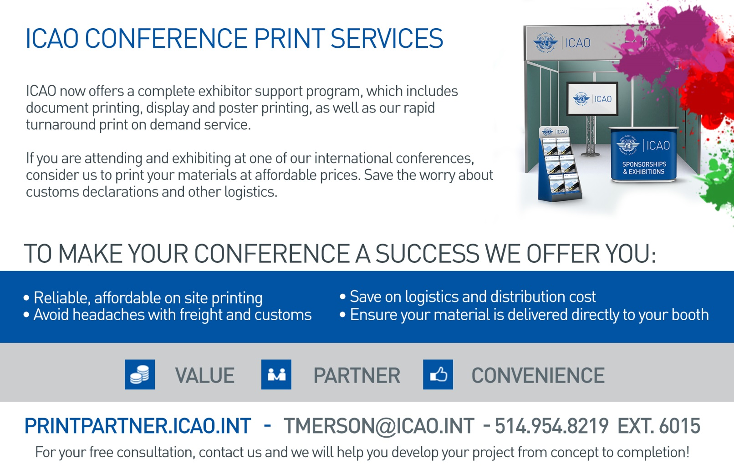

Appendix A – Sponsorship Privileges
The table below shows the privileges for each type of sponsorship

Privileges | Sponsorship
 | Platinum | Gold | Bronze | Delegate Bag
Sponsor's logo and hyper link on the ICAO event website | ✓ | ✓
Fifteen-minute non-commercial presentation to the delegates prior to the sponsored reception or lunch | ✓ | ✓
Complimentary prime location double exhibition space | ✓ | ✓
Up to three single sheets of printed promotional material  (8½×11 inch or A4) inserted into the delegate bags | ✓ | ✓ |  | ✓
Recognition by the event moderator during the opening and closing ceremonies | ✓ | ✓ | ✓ | ✓
Prime visibility in the Symposium directory of the  sponsor’s name, logo and company’s products/services | ✓ | ✓ | ✓ | ✓
Display of sponsors' logos in the venue areas | ✓ | ✓ | ✓ | ✓
Sponsors’ names and logos on the Symposium auditorium screen | ✓ | ✓ | ✓ | ✓
Invitation to the hospitality event with sponsor name and logo on the Symposium auditorium screen | ✓ | ✓ | ✓
Display of sponsor’s logo during the event being sponsored | ✓ | ✓ | ✓
Free delegate or exhibitor passes and delegate bag | 6 | 4 | 1 | 2

Appendix B – Exhibition Floor Plan

