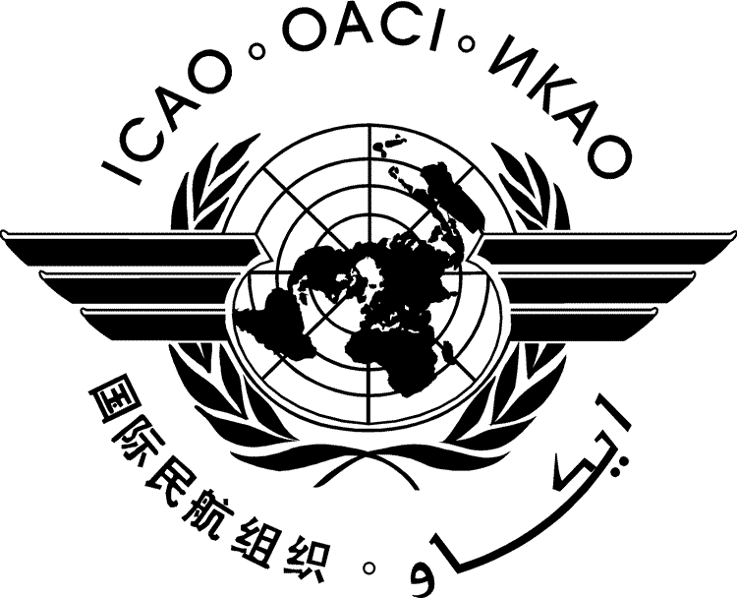 | International Civil Aviation Organization  WORKING PAPER | HLM-LTAG-WP/XX  ../../22
HIGH-LEVEL MEETING
ON THE FEASIBILITY OF A LONG-TERM ASPIRATIONAL GOAL FOR INTERNATIONAL AVIATION CO₂ EMISSIONS REDUCTIONS (HLM-LTAG)

Montréal, 19 to 22 July 2022

Agenda Item | 1: | CO₂ emissions reduction scenarios and options for a long-term global aspirational goal for international aviation
Agenda Item | 2: | Means of implementation for a long-term global aspirational goal for international aviation
Agenda Item | 3: | Means of monitoring progress and next steps
Agenda Item | 4: | Conclusions and Recommendations of the Meeting

TITLE

(Presented by the xxxx)

SUMMARY

Action by the Meeting is in paragraph 2.

- INTRODUCTION
  - ...
- ACTION BY THE HLM-LTAG
  - The HLM-LTAG is invited to:

— — — — — — — —

HLM-LTAG-WP/XX
Appendix A
English only

APPENDIX A

TITLE

- ….

— END —

