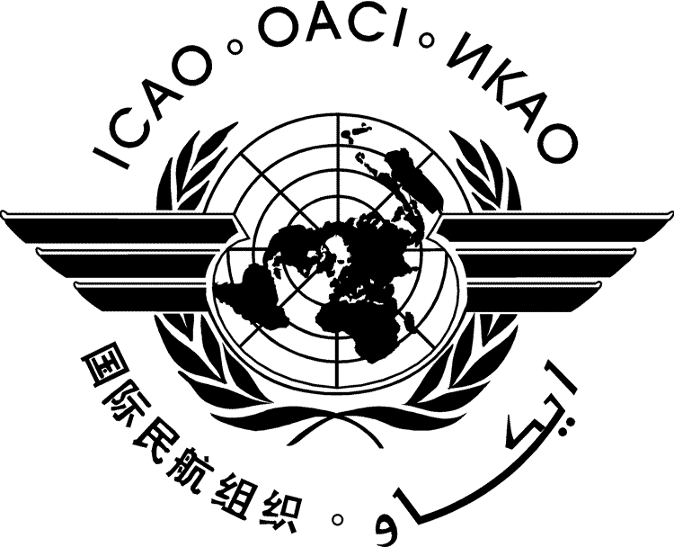 |  | HLM-LTAG-IP/xxx  ../../22  English only
HIGH-LEVEL MEETING
ON THE FEASIBILITY OF A LONG-TERM ASPIRATIONAL GOAL FOR INTERNATIONAL AVIATION CO₂ EMISSIONS REDUCTIONS (HLM-LTAG)

Montréal, 19 to 22 July 2022

Agenda Item | 1: | CO₂ emissions reduction scenarios and options for a long-term global aspirational goal for international aviation
Agenda Item | 2: | Means of implementation for a long-term global aspirational goal for international aviation
Agenda Item | 3: | Means of monitoring progress and next steps
Agenda Item | 4: | Conclusions and Recommendations of the Meeting

TITLE

(Presented by xxx)

- INTRODUCTION
  - ...

— END —

