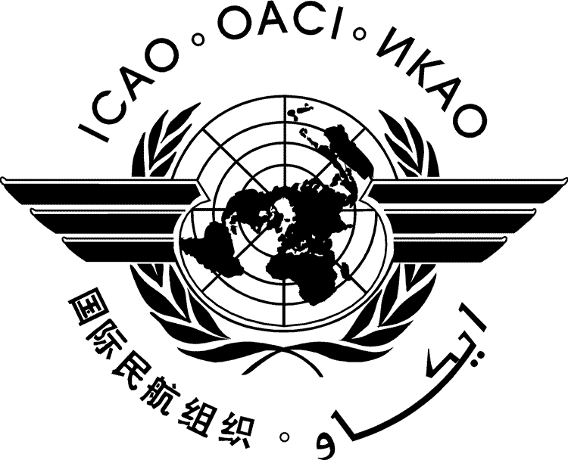 | International Civil Aviation Organization  INFORMATION PAPER | HLCAS/2-IP/xx  ../../18
SECOND HIGH-LEVEL CONFERENCE ON AVIATION SECURITY (HLCAS/2)

Montréal, 29 to 30 November 2018

Agenda Item | 1: | Aviation security threat and risk context
Agenda Item | 2: | Future approaches to managing aviation security risks
Agenda Item | 3: | Global Aviation Security Plan (GASeP)
Agenda Item | 4: | Achieving better synergies with other areas
Agenda Item | 5: | Ensuring sustainability of security measures

[TITLE]

(Presented by [State])

INFORMATION PAPER

SUMMARY
- INTRODUCTION
  - ...

— END —

