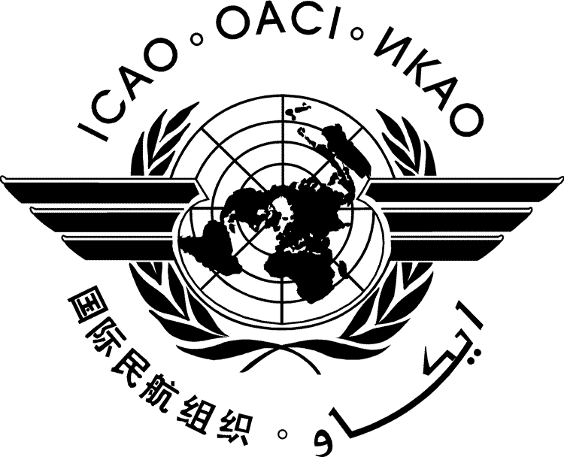 | International Civil Aviation Organization  WORKING PAPER | HLCAS/2-WP/xx  ../../18
SECOND HIGH-LEVEL CONFERENCE ON AVIATION SECURITY (HLCAS/2)

Montréal, 29 to 30 November 2018

Agenda Item | 1: | Aviation security threat and risk context
Agenda Item | 2: | Future approaches to managing aviation security risks
Agenda Item | 3: | Global Aviation Security Plan (GASeP)
Agenda Item | 4: | Achieving better synergies with other areas
Agenda Item | 5: | Ensuring sustainability of security measures

[TITLE]

(Presented by [State])

SUMMARY
Action by the High-level Conference on Aviation Security is in paragraph ‎2.
- INTRODUCTION
  - ...
- action bY the high-level conference
  - The High-level Conference on Aviation Security is invited to…

— END —

