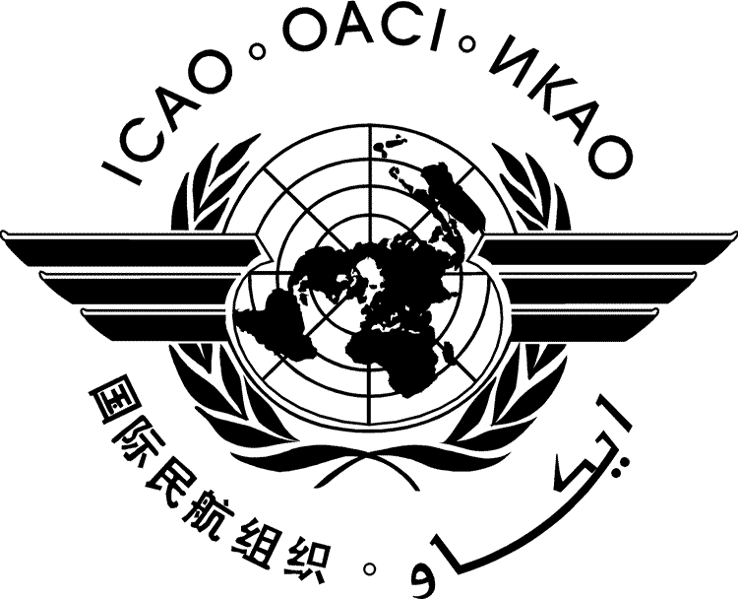 | International Civil Aviation Organization  WORKING PAPER | CAAF/3-WP/xx  ../../23
THIRD CONFERENCE ON AVIATION AND ALTERNATIVE FUELS
(CAAF/3)

Dubai, United Arab Emirates, 20 to 24 November 2023

Agenda Item | 1: | Setting the scene– Latest developments in cleaner energy technology for international aviation and its contribution to the Long-Term Global Aspirational Goal
Agenda Item | 2: | Supporting policies to promote the development and deployment of cleaner energy for aviation
Agenda Item | 3: | Assistance and capacity building for cleaner energy
Agenda Item | 4: | Financing cleaner energy
Agenda Item | 5: | Reviewing the 2050 ICAO Vision for SAF, including LCAF and other cleaner energy for aviation, in order to define a global framework

TITLE

(Presented by xxxxx)

SUMMARY

…..
Action by the Conference is in paragraph 4.

- INTRODUCTION
  - ...
  - …
- …..
  - …..
- ….
  - ….
- ACTION BY THE CAAF/3
  - The CAAF/3 is invited to:
- …;
- …; and
- ….

— — — — — — — —

CAAF/3-WP/xx
Appendix A
English only

APPENDIX A

TITLE

……

— END —

