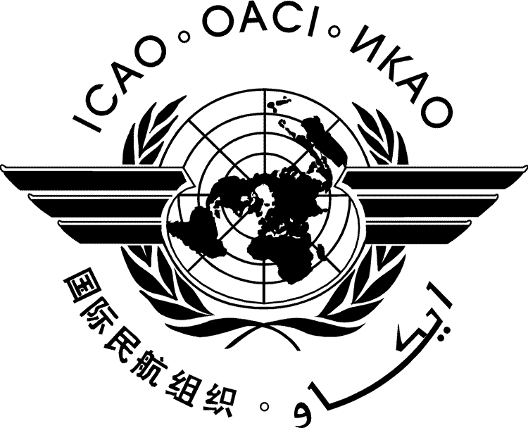 |  | CAAF/2-IP/xxxx  ../../17
CONFERENCE ON AVIATION AND ALTERNATIVE FUELS

Mexico City, Mexico, 11 to 13 October 2017

Agenda Item | 1: | Developments in research and certification of aviation alternative fuels
Agenda Item | 2: | Financing and assistance programmes for aviation alternative fuels
Agenda Item | 3: | Challenges and policy making
Agenda Item | 4: | Defining the ICAO vision on aviation alternative fuels and future objectives

[TITLE]

(Presented by …)

SUMMARY

- INTRODUCTION
  - ...

