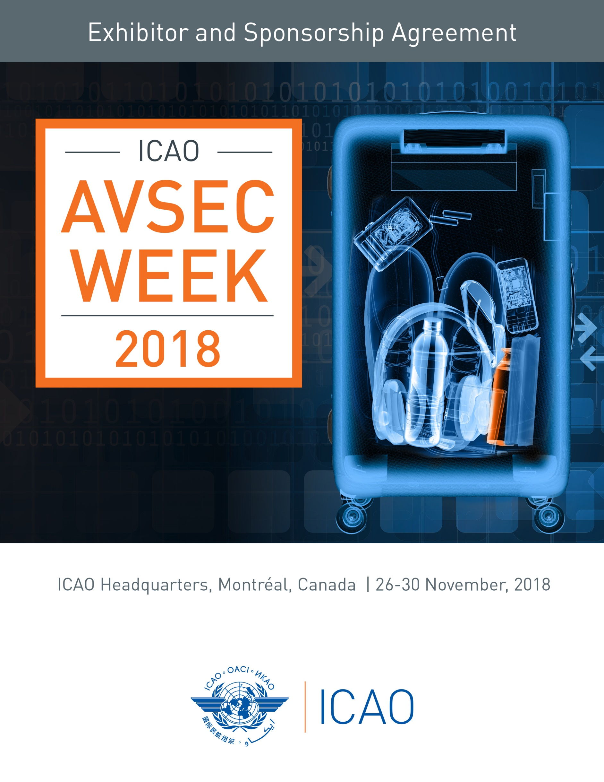

 | November 26 | Industry Day: Sky-Talk presentations from industry leaders and security experts.
 | November 27 - 28 | AVSEC Symposium
 | November 29 - 30 | HLCAS (High Level Conference on Aviation Security)

To participate, please return pages 1-5.

- Company Information:

Company Name
Contact Person | Salutation Mr. Mrs. Ms. Dr.
First Name
Last Name
Title
Address
City |  | Province
Postal / Zip Code |  | Country
Tel No. |  | Fax No.
Email Address

- ICAO Sky Talks Presentation – Monday, November 26

In addition to a live audience, each Sky-Talk presentation will consist of a video tape and a live stream.
The presentation will be made available for viewing in the ICAO commercial website, Uniting Aviation.
Through our social platforms, the video and live stream will reach thousands of global aviation professionals online.

The duration for each Sky Talk Presentation is 20 minutes followed by a Q&A, if time permits.
Sky Talks are only available for exhibitors and sponsors. Presentation must be pre-approved by ICAO

To view sponsorship privileges, please see appendix B

Sky Talk Presentations and Sponsorships
Monday, November 26
Sponsorships | Hospitality | Select | Time | Cost
Bronze Sponsor | Breakfast Coffee Break |  | 07:30 – 09:00 | $2,000
Silver Sponsor | Coffee Break |  | 10:10 – 10:40 | $2,500
Gold Sponsor | Lunch |  | 11:50 – 13:30 | $8,000
Silver Sponsor | Coffee Break |  | 15:15 – 15:45 | $2,500
Platinum Sponsor | Reception |  | 17:00 – 19:00 | $12,000
Sky Talk Presentation |  | Select | #Time | Cost
Sky Talk Presentation #1 |  |  | Morning | $5,000
Sky Talk Presentation #2 |  |  | Morning | $5,000
Sky Talk Presentation #3 |  |  | Morning | $5,000
Sky Talk Presentation #4 |  |  | Afternoon | $5,000
Sky Talk Presentation #5 |  |  | Afternoon | $5,000
Sky Talk Presentation #6 |  |  | Afternoon | $5,000

# Time to be confirmed

- AVSEC Symposium Sponsorship Opportunities

AVSEC Symposium Sponsorships
27 – 28 November
 | No. | Select | Booth No. | Sponsorship | Hospitality | Date | Time | Cost
 | 1 |  | Prime Location | Platinum | Cocktail Reception | November 27 | 17:30 – 19:30 | $24,500
 | 2 |  | Prime Location | Platinum | Cocktail Reception | November 28 | 17:30 – 19:30 | $24,500
 | 3 |  | Prime Location | Gold | Lunch | November 27 | 12:30 – 14:00 | $21,000
 | 4 |  | Prime Location | Gold | Lunch | November 28 | 12:30 – 14:00 | $21,000
 | 5 |  | Not Included | Silver | Coffee / Refreshments | November 27 | 10:00 – 10:30 | $5,000
 | 6 |  | Not Included | Silver | Coffee / Refreshments | November 28 | 10:00 – 10:30 | $5,000
 | 7 |  | Not included | Silver | Coffee / Refreshments | November 27 | 15:30 – 16:00 | $5,000
 | 8 |  | Not Included | Silver | Coffee / Refreshments | November 28 | 15:30 – 16:00 | $5,000
 | 9 |  | Not Included | Bronze | # Coffee Networking Zone | November 27 | 07:30 – 09:00 | $3,000
 | 10 |  | Not Included | Bronze | # Coffee Networking Zone | November 28 | 07:30 – 09:00 | $3,000
 | HLCAS (High Level Conference on Aviation Security) 29-30 November: For sponsorship opportunities, please contact mcr@icao.int

Note: Prime booth location is included in the price of the Platinum and Gold Sponsorship.
# Please refer to network zone on the floor plan.

- Booking an Exhibition Space

Indicate below the booth number that has been assigned to you via email from your event project manager.
If you have not received one, please contact mcr@icao.int

To see a list of exhibition services provided by ICAO, please see Appendix A.
To view a list of the exhibition floor plan and booth space, please see Appendix C.

 | Exhibition Booth Space
 | AVSEC  ( Aviation Security ) Symposium  26 – 28 November |  |  |  |  | & HLCAS  ( High Level Conference on Aviation Security )  29 – 30 November
 | Booth No | Dimensions in feet  (W x D) | Select | Select Booth No. | Cost | Select | Additional Cost
 | # Prime Location | 10’ × 10’ |  |  | Free |  | Free
 | # Prime Location | 8’ x 6’ |  |  | Free |  | Free
 | 5 - 12 | 7’ x 8’ |  |  | $6,000 |  | $2,000
 | 25 - 29 | 10’ ×10’ |  |  | $5,000 |  | $1,500
 | 51, 52 | 8’ x 6’ |  |  | $5,000 |  | $1,500
 | 4, 17 | 8’ x 4’ |  |  | $5,000 |  | $1,500
 | 31 - 34 | 7’ x 8’ |  |  | $4,500 |  | $1,000

# Prime location booths are reserved for Platinum and Gold Sponsors
Please note that the price is only for the rental of the booth space, with the services shown as included in Appendix A.
It does not include booth construction services and other opt-in services

& Industry and exhibitors may not attend the conference. Only government officials and member states may attend the conference. Exhibitors may keep their booths during the conference. Two (2) extra days at an additional cost.

- Exhibition Requirements
Please select your choice.
 | Booth Rental Space | Selection | Requirements
 | 8’ x 8‘ (2.4 x 2.4 metre) or smaller |  | Exhibitor must use ICAO’s recommended exhibition service provider
 | 10’ x 10‘ (3 x 3 metre) or larger |  | Exhibitor will use ICAO’s recommended exhibition service provider
 | 10’ x 10’ (3 x 3 metre) or larger |  | Exhibitors will construct their own booth space. (See restrictions below)

Restrictions:
- Display back panel walls must not exceed 8 feet (2.5 metres) in height.
- Side panels must not extend more than 10 feet (3 metres) from the back wall and more than 3 feet (1 metre) in height.

- Promotions

 |  | PROMOTIONS | COST
 |  | Delegate bag. (sponsor’s logo, ICAO logo, and name of the event) | $8,500
 |  | Lanyards. (sponsor’s logo, ICAO logo and name of the event) | $8,500
 |  | USB Key (Company information in the USB and sponsored logo on the key) | $8,500
 |  | Sponsorship mobile app | $8,500
 |  | One full-page color advertisement in the program directory. | $2,000
 |  | Security equipment demo/presentation – on the atrium level | Please contact  mcr@icao.int
 |  | For customized promotion

- Program Directory

A logo, description of your company’s products/services and contact information will be included in the Symposium Directory. Please submit your company information (in word format) and corporate logo by email to mcr@icao.int

Company Information
- Company Name
- Salutation:
- First name:
- Last name:
- Email Address;
- Website Address:
- Company Description: Maximum 100 words.

Corporate Logo:
The resolution must be a minimum of 300 dpi in one of the following formats. (JPEG, EPS, AI, BMP)

- Invoicing and Payment

Total Payment USD

Following receipt of the duly completed agreement form, ICAO will email the customer a copy of the invoice in
pdf format and the original invoice will be mailed to the sponsor/exhibitor.

Due Date: Invoice must be paid in full within 14 days upon receipt of the invoice.
Payment Options: Bank transfer, cheque or credit card.
Non Payment: Failure to make payment may result in the cancellation of the agreement and the reserved space/sponsorship will be subject to resale.

Please select one of the following payments below. (ICAO’s preferred method of payment is by credit card)

 | Bank Transfer |  | Cheque
 | American Express |  | Master Card |  | Visa

For payment with major credit cards, please provide your credit card details below.

Card Number |  | Expiry Date
Card Holder Number
Signature

- Transportation and Customs Clearance
International In bound shipment:

ICAO is not responsible for any transportation and customs clearance fee for the exhibition materials.
All materials shipping to ICAO should be prepaid in full with your carrier. ICAO will not accept COD shipments.

- Withdrawal Policy

The exhibition booking or sponsorship may be withdrawn by the agreement signatory, in accordance with this provision.
Only a written withdrawal notice sent by email to mcr@icao.int with a copy to your ICAO project manager shall have effect.

The withdrawal notice shall be deemed to have been given on the date such notice is received by ICAO at the
mcr@icao.int inbox.

Withdrawal notices received in good order will be acknowledged in writing by ICAO.
In the event of withdrawal, refunds shall apply as follows:

If the cancellation request is: | Refund
More than 29 days before the start date of the event | Full refund
Between 22 to 28 days before the start date of the event | 75% refund
Between 14 to 21 days before the start date of the event | 50% refund
Less than 14 days before the start date of the event | No refund

- Terms and Conditions

- By submitting this signed Exhibitor / Sponsor Agreement application form, the applicant whose information is completed at paragraph 1 (the “Applicant”) agrees with the International Civil Aviation Organization, headquartered at 999 Robert-Bourassa Boulevard, Montreal, Quebec, Canada, H3C 5H7 (“ICAO”), to abide by the Terms and Conditions set out herein. Applicants for exhibition space shall be referred to as “Exhibitors” and sponsorship Applicants shall be referred to as “Sponsors”.
- ICAO shall be under no obligation whatsoever in connection with any application, until written acknowledgement of ICAO’s acceptance of the application form. In particular, ICAO shall be under no obligation to accept an application form. For Exhibitors, the exhibition space is guaranteed only upon ICAO’s written acknowledgement and payment by the Exhibitor in accordance with paragraph 7 of this form.
- The person signing the Acceptance below represents and warrants that he or she is duly authorized to sign on behalf of the Applicant and that the Agreement shall be binding on the Applicant.
- All payments shall be made to ICAO in US Dollars only. If the invoice is not paid by the due date, ICAO may in its sole discretion, cancel the sponsorship and/or exhibition rental space.
- All materials shipping to ICAO should be prepaid in full with the carrier. COD shipments shall not be acceptable to ICAO.
- The rights and obligations of the Applicant under this Agreement shall be non-assignable and non-transferable, except with the express written consent of ICAO.
- Exhibitors and Sponsors shall confine all business, demonstrations, exhibitions, canvassing, and distribution of printed matter or other items exclusively to the assigned booth space. No overflow into the aisles shall be permitted, due to fire and safety regulations. Promotional materials shall not promote military applications or name or make any reference to territories not formally recognised by the United Nations as sovereign states.
- ICAO makes no representations or warranties with respect to the demographic nature and/or number of exhibitors and/or attendees that will attend the event.
- ICAO accepts no responsibility or liability for any loss, damage or personal injury, arising in connection with this Agreement and the associated event(s). The Exhibitor should therefore make its own insurance arrangements in accordance with its requirements, risks and expectations. The Exhibitor shall indemnify, save and hold harmless ICAO and its employees or agents, from and against any claims, actions, losses, damages, expenses and costs whatsoever arising from the Exhibitor’s acts or omissions.
- Nothing in or relating to this Agreement shall be deemed a waiver, express or implied, of any immunity from suit or legal process or any privilege, exemption or other immunity enjoyed or which may be enjoyed by ICAO, its Officials and staff, under international or national laws.
- The Applicant shall ensure compliance with the following:
  - Applicant’s products and services must not go against or perceived to go against ICAO’s 5 strategic objectives or the NCLB (No Country Left Behind) initiative.
  - The Applicant shall be in good financial standing with ICAO with no outstanding debts.
  - The Applicant shall not use the ICAO brand, logo or intellectual property, except with the express written approval of ICAO.
  - Exhibiting or sponsoring the event will not pose any conflict of interest.
  - The Applicant’s participation may not be perceived as being negative to Member States or regions.
  - The Applicant should contribute, provide value and share knowledge with Member States and the civil aviation industry.

- Return the Agreement Form

The character of the exhibitor and/or sponsor is subject to the approval of ICAO.
Confirmation of the allocated exhibition spaces(s) and/or sponsorship will be guaranteed by return of this duly completed and signed agreement form and full payment. Please return the agreement by email (scan or pdf format) to mcr@icao.int

- Acceptance

The information set forth in this exhibitor/sponsorship agreement is accurate.
I have read, understood and agree to abide to the terms and conditions as set forth in this agreement.

Signature: _______________________________________________ Date:

Appendix A: Exhibition Services
Services | Included | Not Included | Comments
Exhibition Booth Construction
Exhibition booth space: 8’x8’ or smaller. |  | ✓ | Must use the services of ICAO’s recommended exhibition service provider to construct the booth and provide basic setup
Exhibition booth space: 10’x10’ or larger. |  | ✓ | May construct their own booth or use the services of ICAO’s recommend exhibition service provider
At ICAO
Carpet at the exhibition space(s). | ✓ |  | Exhibition areas are carpeted.  The ICAO building is air conditioned.
Electricity supply (one outlet per single space) with an extension cable and a multi-socket power bar. | ✓ |  | 110V for a maximum of 15 ampere.
Unlimited wireless Internet connection. | ✓
24-hour security. | ✓ |  | Special security measures will be in place. ICAO is not responsible for any loss or damage of property in the exhibition areas.
Exhibitor’s logo, contact, url and description of the company’s products/services in the program directory. | ✓
Complimentary exhibition pass. | ✓ |  | Two free exhibitor passes.
Access into the assembly hall. | ✓
Invitation to all hospitality events.  (reception, coffee, lunch, workshops) | ✓
Daily cleaning of public areas. | ✓
Recommended Service Providers
Materials handling, advance warehouse storage, rental of extra furniture, chairs, tables, graphic banners, electrical accessories, transformers. |  | ✓ | Should be arranged through the ICAO recommended exhibition service providers.
Transportation and customs services. |  | ✓ | Should be arranged through the ICAO recommended customs broker.
Audio visual equipment, laptops, TV, DVD players. |  | ✓ | Should be arranged through the ICAO recommended audio visual supplier.

Appendix B: Sponsorship Privileges during Sky Talk Presentation
Date: Monday November 26 Industry Day

Privileges | Platinum | Gold | Silver | Bronze
Company profile in the ICAO Uniting Aviation website. | ✓
Prime visibility in the symposium directory /program displaying the sponsor’s name, logo, contact name, company description and company URL. | ✓ | ✓
Display of the sponsor's logo during the sponsored event outside of the assembly hall. TV monitors and display stands. | ✓ | ✓ | ✓
Half page advertisement in the program | ✓ | ✓ | ✓ | ✓

Sponsorship Privileges during AVSEC Symposium.
Dates: November 27 – 28

Privileges | Platinum | Gold | Silver | Bronze
Fifteen-minute non-commercial presentation to the delegates in the assembly hall prior to the sponsored reception or sponsored lunch break. | ✓ | ✓
Sponsor's logo and hyper link on the ICAO event website. | ✓ | ✓
Company profile in the ICAO Uniting Aviation website. | ✓ | ✓
Complimentary prime location exhibition space. | ✓ | ✓
Number of free promotional sheets to be inserted into the delegate bag or event folder. (8 1/2 x 11 inches or A4). | 3 | 2 | 1
If there are no delegate bags or folders available, advertisement pages will be available in the program directory. | 2 full page | 1 full page | ½ page
Recognition by the event moderator or MC during the opening and closing ceremonies and before the sponsored event. | ✓ | ✓ | ✓ | ✓
Display of the sponsor's name and logo on the main auditorium screen. | ✓ | ✓ | ✓ | ✓
Display of the sponsor's logo during the sponsored event outside of the assembly hall. TV monitors and display stands. | ✓ | ✓ | ✓ | ✓
Prime visibility in the symposium directory /program displaying the sponsor’s name, logo, contact name, company description and company URL. | ✓ | ✓ | ✓ | ✓
Invitation to all hospitality events. (reception, coffee, lunch, workshops) | ✓ | ✓ | ✓ | ✓
Access into the assembly hall. November 27-28 | ✓ | ✓ | ✓ | ✓
Number of complimentary passes only for symposium. | 6 | 4 | 2 | 1

Appendix C: Floor Plan

