To participate as a vendor or as a promotional item sponsor, please complete pages 1-3.

- Confirmation: Confirmation of the vendor agreement will be guaranteed by return of this duly completed and signed agreement and payment of the total cost.

Company Name
Contact Person | Salutation Mr. Mrs. Ms. Dr.
First Name
Last Name
Title
Address
City |  | Province
Postal / Zip Code |  | Country
Tel No. |  | Fax No.
Email Address

- Booking a vendor package
Vendor benefits
- Opportunity to present your company’s solutions to the delegates during the social events.
- Benefit from an exhibition space* to promote your company’s products and services where you can meet directly with the delegates.
- Logo and company description in the event programme distributed to all the delegates.
- Logo and Web link on the event webpage.
- Mention of your company/logo on the event social media pages (Facebook, Twitter and LinkedIn).
- Your company mentioned in the event newsletter.
- One (1) table and two (2) chairs.
- Four (4) complimentary exhibitor passes.

*Does not include the booth construction.

Indicate below the booth number of preference. To see the floor plan, please see Appendix A – Floor plan.
 | Booth No | Dimensions in Feet | Dimensions in Metres | Selection | Booth Space Number (s) | Cost  USD
 |  | 8’ x 8’ | 2.4 x 2.4 |  |  | $5,500

- Booking a speaking slot for a 15-minute presentation
 | Speaking Slots Number | Day | Select your number(s) |  | Cost  USD
 | 1 | 20 November |  |  | $3,000
 | 2 | 21 November |  |  | $3,000
 | 3 | 22 November |  |  | $3,000

- Booking a promotional item
Sponsor benefits
- Opportunity to network with the delegates during the social events.
- Benefit from the opportunity of being seen as a company and brand via the promotional item sponsored.
- Logo and company description in the event programme distributed to all the delegates.
- Logo and Web link on the event webpage.
- Mention of your company/logo on the event social media pages (Facebook, Twitter and LinkedIn).
- Your company mentioned in the event newsletter.
- Two (2) complimentary event passes.

Select below the promotional item of your choice.
Promotional items |  | Fee | Select
Delegate/Event bag – Sponsor to supply the bag used for all delegates |  | $4,000
Lanyards – Sponsor to supply lanyards which is used to hold the photo ID badge |  | $4,000
USB Key – Sponsor to supply USB Keys |  | $4,000
One page (A4 or 8.5 x 11) promotional material to be inserted in the event bag*  *Must be a vendor to take advantage of this offer. |  | $1,500

Total Fee

- Exhibition Requirements
A company renting a booth space may construct their own booth (e.g. pop-up banner, table, chairs, bar stools, magazine stands, laptops, LED screen, etc.) but must follow the rules as outlined by the Marina Bay Sands Hotel, Singapore. Please note that ICAO and the hotel will not be responsible for any transportation and customs clearance of the exhibit’s material.

- Program Directory
A logo, description of your company’s products/services and contact information will be included in the Symposium Directory. Please complete this form and email your project managers (Ms. Alexandra Paré at apare@icao.int and Ms. Virginie Leblanc at vleblanc@icao.int).

Corporate Logo
Please send us via email your company corporate logo. The resolution must be at least 300 dpi in one of the following formats:
(1) .jpg;
(2) .tif;
(3) .bmp;
(4) .eps.

Contact information and company description to be included in the event programme
Please complete the table below. All the fields are mandatory and the company description, products or services cannot exceed more than 150 words.

Company Name
Salutation | Mr. Mrs. Ms. Dr.
First Name
Last Name
Email Address
Website Address
Company Description
Max 150 words

- Invoicing and Payment
Following receipt of the duly completed Vendor Agreement, ICAO will prepare an invoice for the Symposium exhibition fee.
A copy of the invoice will be sent by e-mail in a pdf format and the original will be posted to the vendor.

Payment will be due within 14 days of receipt of the invoice and can be made by bank transfer, cheque or credit card as indicated below. If payment is not received within fourteen (14) days, ICAO may not guarantee the customer’s first choice for the booth number. Please select one of the following payments below. We prefer payment by credit card.

 | Bank Transfer |  | Cheque
 | American Express |  | Master Card |  | Visa

For payment with major credit cards, please provide your credit card details below.

Card Number |  | Expiry Date
Card Holder Number
Signature

- Promotional Material
Vendors are prohibited from placing flyers, pamphlets, brochures and other promotional items (i.e. Pens, USB sticks, mugs, memo pads, etc.) on tables or stands other than their own. Vendors may use their assigned tables to display their collateral materials.

Promotional materials must not promote military applications or make reference to the Republic of Taiwan

- Cancellation Policy
This Vendor Agreement may be cancelled by the Vendor Agreement signatory, with no penalty, within seven calendar days of receiving the confirmation receipt of the Agreement from ICAO. If the request for cancellation is received by ICAO later than seven, but within 15 calendar days of receiving the confirmation, the exhibitor must pay, as a penalty charge, 25% of the applicable fee. Cancellations made after this 15-day period will be subject to a penalty charge of 50% of the fee. If the cancellation is, however, made during the 14 calendar days prior to the opening date of the event, the penalty will be 100% of the fee.

- Acceptance
The undersigned hereby certifies that the information set forth in this Vendor Agreement is accurate and agrees with the above cancellation policy and promotional material policy.

Signature: _______________________________________________ Date:

- Return the Agreement
Confirmation of the allocated exhibition spaces(s) will be guaranteed by return of this duly completed and signed Vendor Agreement and payment of the fee.

Please return the agreement by email (scan or PDF format) to Alexandra Paré, apare@icao.int and Virginie Leblanc, vleblanc@icao.int.

- Appendix A – Floor plan*
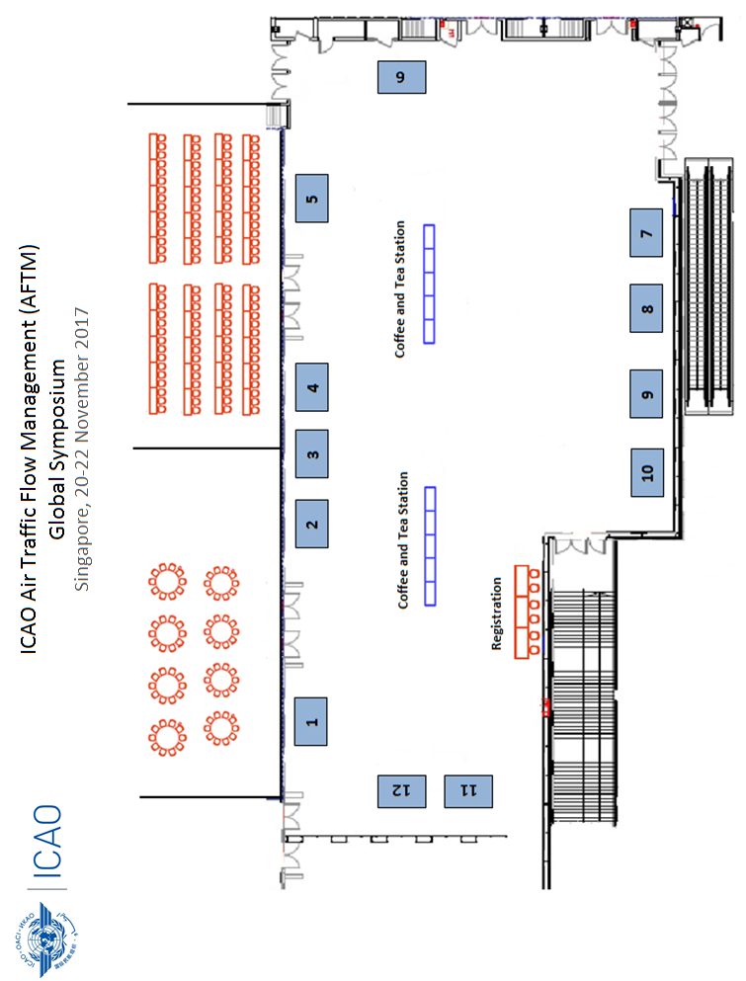

*Floor plan subject to change

