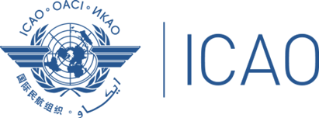
ICAO Regional Workshop on New Global Reporting Format for Runway Surface Condition (Nairobi, Kenya, 14-15 August 2019)

REGISTRATION FORM

First Name (in full)
Surname (in full)
Designation (function)
Country
Organization
Telephone
Email :
Hotel Reservation

Please provide all the requested information
and return by email to: icaoesaf@icao.int, copy rmuhanji@icao.int

