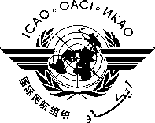

UNIVERSAL SAFETY OVERSIGHT AUDIT PROGRAMME (USOAP) CONTINUOUS MONITORING APPROACH (CMA) REGIONAL WORKSHOP FOR THE EASTERN AND SOUTHERN AFRICAN (ESAF) REGION (NAIROBI, KENYA, 29 – 31 MARCH 2016)

ATTENDANCE NOTIFICATION AND REGISTRATION FORM
- Please fill and forward the form in the same (MS Word) format. Do not fax, scan or change format to PDF.
- Insert information in the grey empty boxes
- Where appropriate, click to make the appropriate selection
- Surname

- Given Name (s)

- Job Title

- State/Organization

- Mailing Address

- Telephone

- Fax

- E-mail address

- Hotel

-------

